Lesson Plan
Carrying Cargo: Exploring non-covalent interactions between proteins and small molecules in blood transport

Grade level: 9-12

Objectives:
After completion, students will understand how the hydrophobic and hydrophilic interactions between proteins and small molecules are utilized in transporting of lipids and other substances in the blood

Summary:
Students use the data and the information from the RCSB.org and PDB101.RCSB.org websites to learn about the function of serum albumin and to examine the protein in 3D. They explore the structural features and the non-covalent interactions that are employed by the protein to carry fatty acids in the blood.

NGSS Standards
Science & Engineering Practices:
- Engaging in argument from evidence
- Obtaining, evaluating and communicating information
- Developing and using models
Disciplinary Core Ideas:
- LS1A: Structure and Function
Crosscutting Concepts:
- Patterns
In addition:
Students gain experience in collecting information from a data driven website. They practice analyzing and collecting information through applying various visualization techniques to the same set of data. They explore models generated by scientific experiments and use tools designed for advanced scientific analysis.

Materials/resources:
• Computer with Internet access. Resources to be accessed throughout the lesson
- Molecule of the Month on Serum Albumin: from the top menu of pdb101.rcsb.org, choose Molecule of the Month and access Serum Albumin article by title
Direct access link: https://pdb101.rcsb.org/motm/37
- Serum Albumin Structure 1e7i: go to rcsb.org and enter 1e7i into the search bar
Direct access link: https://www.rcsb.org/structure/1E7I
- Mol* tutorial: from the top menu of pdb101.rcsb.org choose Browse, go to Structure and Structure Determination then to Visualizing Molecules and locate among the Learning Resources: Exploring PDB structures in 3D with Mol* (MolStar)
Direct access link: http://pdb101.rcsb.org/learn/videos/exploring-pdb-structures-in-3d-with-molstar
• Student worksheet (provided with the lesson plan)
• Possible use of projected/shared computer screen

Preexisting knowledge:
Students understand:
- proteins are polymers made up of amino acids and that the polymer chain forms the elements of secondary structure and folds into a specific 3D shape
- amino acids side chains fall into three distinctive groups (hydrophobic, hydrophilic, charged) depending on how they interact with water, and other side chains and molecules
- basics of the hydrophilic and hydrophobic interactions and the concept of covalent and non-covalent interaction (this information might be also reviewed before the first step of the activity)
- the main conventions in 3D representations of proteins (cartoon, surface) and atoms (ball and stick, spacefill)

Note: This information might be taught/reviewed using PDB-101 video What is a Protein?
(pdb101.rcsb.org > Learn > Videos or http://pdb101.rcsb.org/learn/videos/what-is-a-protein-video)
In addition, TedEd lesson created by Alison Ackroyd https://ed.ted.com/on/xdk2WHce#watch offers questions for assessment.

Preparation:
Students familiarize themselves with the contents of the tutorial Exploring PDB structures in 3D with Mol* to allow for full focus on the activity during class time. This can be assigned as homework. The tutorial should be used as aid throughout the lesson as well.

LESSON ACTIVITIES:
Students can enter their answer and evaluations/predictions on the enclosed Student Worksheet. Students can work individually or in groups. The teacher helps students along and makes sure they stay on track. The teacher also facilitates in class discussions and assessment activities

COLLECTING INFORMATION
Introducing the FUNCTION of serum albumin with Molecule of the Month article
Students access the Molecule of the Month article Serum Albumin on PDB-101. They read only the Introduction and Carrying Fatty Acids sections and answer question 1 (as numbered on student worksheet):

- What is the function of serum albumin? Why is it important to have appropriate levels of this protein in the blood plasma?
Answer:
- Serum albumin is the carrier of fatty acids in the blood. Fatty acids are the building blocks for lipids. Lipids form the lipid bilayer membranes around and inside the cells. Fatty acids may also be broken down inside cells to form ATP, an important source of energy for our bodies. When we need energy or building materials for bilayer membranes, fat cells release fatty acids into the blood. Serum albumin picks them up and delivers them to distant parts of the body.

Using the RCSB.org Structure Summary page to collect information about the STRUCTURE of serum albumin
In this part of the lesson, students will explore a 3D model from the Protein Data Bank (PDB).
If students are not familiar with the Protein Data Bank, the teacher may introduce it briefly touching on the following points:
- PDB is a database collecting information about the 3D coordinates of atoms making up protein structures
- The structures are determined all over the world by different scientific experiments then submitted to the PDB archive
- There are 4 PDB data centers all over the world that curate the data, maintain the archive, and provide access to them along with tools for search and analysis free of charge. One of the centers is RCSB providing access through rcsb.org
- Rcsb.org is a high-level research resource so students should not feel discouraged if information is hard to locate
- PDB-101 is the educational portal of RCSB that creates educational resources building on the data from the Protein Data Bank

Students access the Structure Summary page for the serum albumin structure 1e7i.
Students use the Macromolecules section to answer question 2:
- How many chains does the protein have?
Answer:
- The protein has 1 chain (chain A)

Introducing Stearic Acid
Students go to the Small Molecules section on the Structure Summary page, analyze the information, and answer question 3:
- How many types of small molecules (ligands) interact with the polymer?
Answer:
- One type, stearic acid

Students access the Ligand summary page through the ligand ID link, analyze the information, and answer question 4:
- What atoms/how many of them is the ligand made of? How are they arranged?
Answer:
- The ligand is made up of 2 oxygen atoms and 18 carbon atoms. The oxygen atoms are covalently bound to one terminal carbon atom, and the carbon atoms are arranged in a long chain.

Students review the answers in class with teacher’s facilitation and point to supporting data

EVALUATING INFORMATION AND CREATING PREDICTIONS
Students evaluate the small molecule model structure and predict the key features of its components and answer question 5:
- If you were to use the words “head” and “tail” to describe the ligand, how would you describe the arrangement of the atoms within them? The small molecule is called stearic ACID. Which part makes it an ACID? How would the acid behave in water solution? What charge would it carry? How would the tail behave in the water? Would it carry any charge?
Answer
- The 2 oxygens covalently bound to the carbon atoms could be described as the ‘head’, the carbon atoms arranged in a long chain might be described as the ‘tail’. The ACID part is the COO head. It will be ionized and carry negative charge and interact strongly with water. The tail would not carry any charge. The tail would be not interacting with water and would try to find other hydrophobic particles to shield itself from water.

Based on the first hypothesis, students predict the transport environment for the ligand and answer question 6. The teacher might display the image below on the overhead projector for reference. The teacher explains that the students will create a schematic model of the interactions they predict. The model can be hand-drawn or created using any computer software.
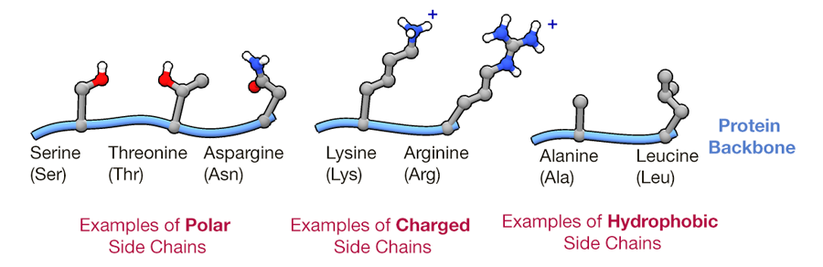
- Why does this lipid need a transport protein to be carried in the water-based blood plasma? What type of amino acids (hydrophobic, hydrophilic, or charged) would need to be present on the outside of the protein? What about in the core of the protein? What types of amino acid side chains in the carrier protein would the ‘head’ interact with: polar, charged, or hydrophobic? What types of amino acid side chains in the carrier protein would the ‘tail’ interact with: polar, charged, or hydrophobic? Explain why. Draw a model of a transport protein with stearic acid and highlight these interactions.
Answer
- The hydrophobic tail will have to be shielded away from the water, that’s why this molecule needs a carrier protein. The protein would need mostly polar or charged residues on the outside to interact with surrounding water molecules and hydrophobic residues on the inside to accommodate the tails. The oxygens in the head can be exposed to the surrounding water in the blood plasma, creating H-O hydrogen bonds, and can also create hydrogen bonds with the hydrogens on the polar and charged residues. Example how a model of these interaction can be drawn is shown below. However, students should use their creativity and original ideas to develop the model, so showing them an example is not recommended.

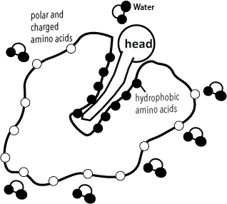

ENGAGING IN ARGUMENT FROM EVIDENCE:
Sharing and discussing predictions
Students share their predictions and models in class while the teacher facilitates the discussion and asks additional questions. The teacher can share a Google presentation with the students for them to insert their images (if created digitally) or photos of the images if hand-drawn to share with the class via overhead projector. The images can be used in support of their arguments. At this stage students share arguments for their predictions, but they don’t know whether their predictions are right or wrong.

COLLECTING MORE DETAILED INFORMATION AND EVALUATING PREDICTIONS
Exploring the 3D structure of serum albumin with Mol*
Students access the 3D view of serum albumin from the Structure Summary page. They explore the features of the 3D structure and answer the questions 7 and 8. Students might save the images from Mol* to use in the next step.

- What elements of secondary structure are predominant? What does the overall shape of the protein resemble?
- Evaluate your predictions from previous part of the lesson: what types of amino acids are present on the outside of the protein? What kind of amino acids make up the core of the protein? Why? You can change the polymer representation to spacefill and the color theme to hydrophobicity to evaluate your predictions (see Mol* tutorial section 7 and 10)

Answers:
- Alpha helices are the predominant element of the 3D structure, the overall 3D shape resembles a heart

- The amino acids on the outside are mostly hydrophilic to interact with the surrounding water in the blood plasma. The amino acids in the core are predominantly hydrophobic to hold the 3D structure stable and to create the environment for the hydrophobic tails of the lipids to be transported. Example image below shows the protein with the hydrophobicity color theme applied. Hydrophobic residues are in shades of green to light yellow, the residues that are more likely to interact with water are shown in different shades from dark yellow to red.
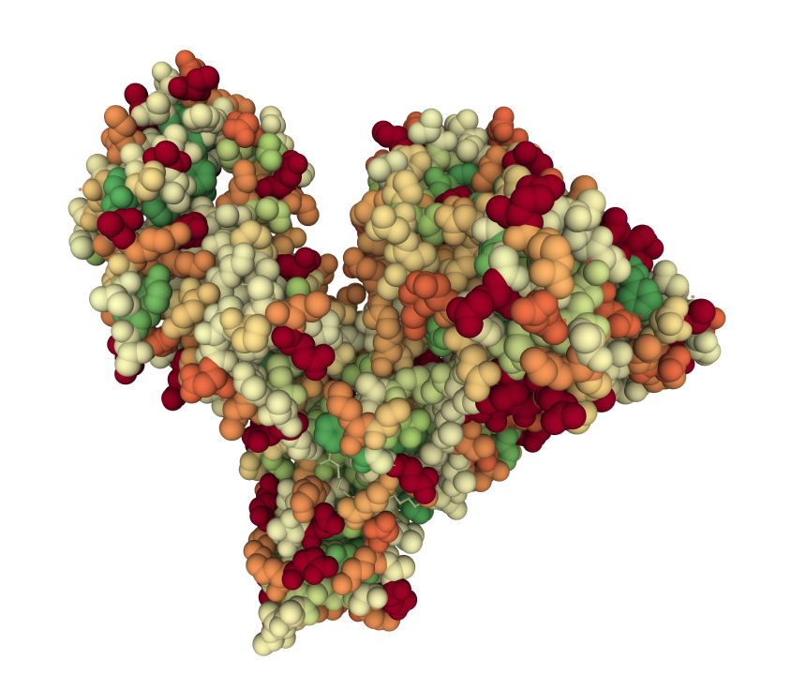
Assessment:
Students review the answers in class with teacher’s facilitation and point to supporting data using saved images as evidence

Exploring the polymer ligand interaction in 3D
As the students explore the protein in 3D, they answer the questions 9, 10, and 11. Students might save images to use in the next to share with the class to support their arguments in the assessment step that follows

- How many ligands can you spot interacting with the protein? (you might change the ligand representation to spacefill and apply different colors to them using sections in order to help you spot all of them). Two ligands are overlapping. Do you think both of those orientations can happen at the same time? How many ligands total can this protein transport? Click on any of the ligands to zoom in and observe interactions.
- What types of amino acids does the ‘head’ interact with? What non-covalent interactions do you observe? What types of amino acid side chains does the ‘tail’ interact with? What non-covalent interactions do you observe? Click on other ligands and observe the interactions. What do you notice?
- Change the representation for the polymer to gaussian surface and the representation of ligand to spacefill (see Mol* tutorial section 7). What overall structural features do you observe when looking at the protein in this representation?

Answers:
- There are 8 ligands shown inside the model. The overlapping ligands have the heads on the opposite side which means they can enter the protein in either orientation. The model can effectively interact with 7 ligands.
Note: with this question the teacher could provide a bit of background if students are confused: Crystallography captures snapshots of molecules, and sometimes, different molecules in the crystal lattice can be bound in different orientations. The overlapped ligand is an example--in some albumin molecules in the crystal lattice it binds one way, in other albumin molecules it binds the opposite way. The crystallographers include both orientations in the coordinate set. The image below shows the serum albumin crystal lattice and can be used as visual aid in the classroom
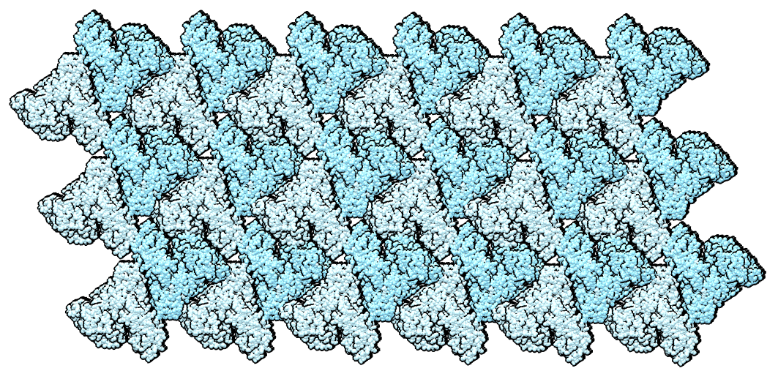

- The oxygens in the “head” form hydrogen bonds with neighboring polar and charged amino acid side chains and waters. The carbons in the tail form hydrophobic interactions with hydrophobic side chains carbons. The number of interactions and the specific amino acids are different for each ligand, although the head always interacts with polar and charged amio acids and the tails always interacts with hydrophobic amino acids.

- The ligands fit very tightly with the protein (as seen in the example of an image that can be saved using suggested molecular representation). Possible image saved for this stage below.

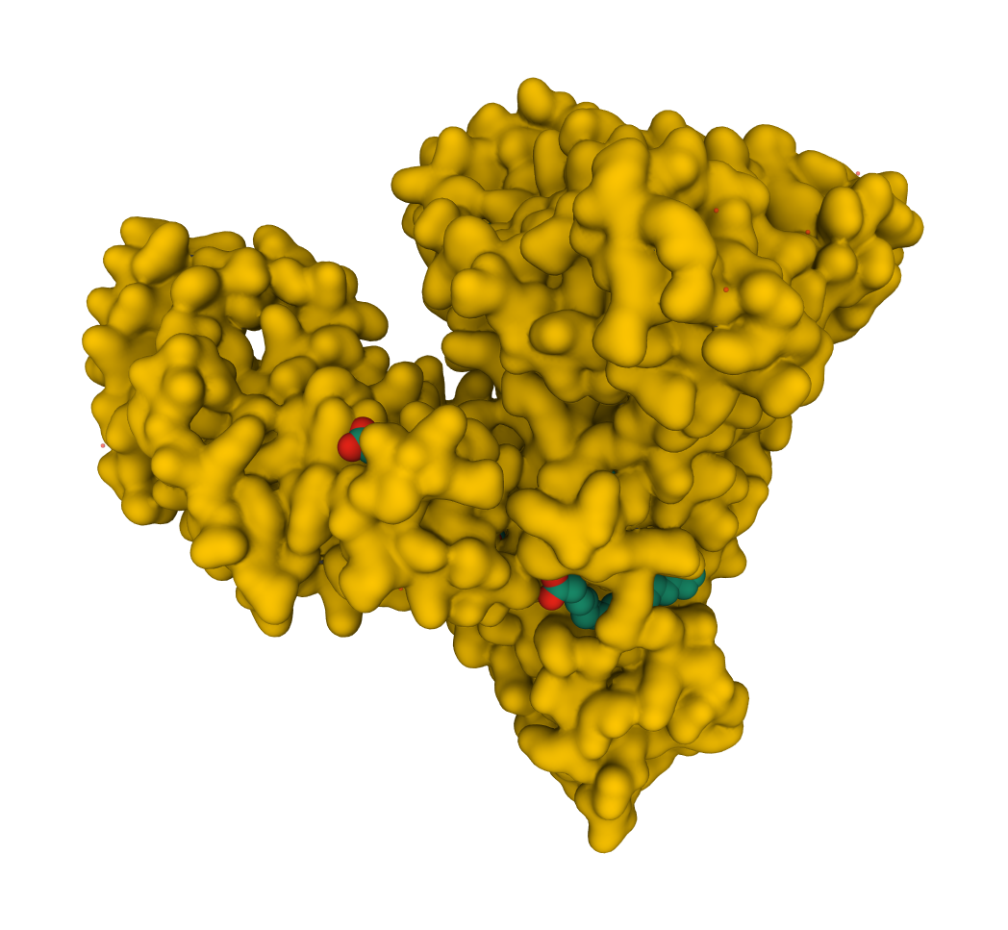

Students review the answers in class with teacher’s facilitation and point to supporting data.

FINAL CONCLUSIONS
Students answer question 12, in class discussion follows

- Summarize how the shape of serum albumin is optimal for its function of transporting of fatty acids in the blood plasma. Compare with your hypothesis.
Answer:
- The protein has hydrophilic amino acids on the outside and is fairly small which helps it to interact with water in the blood. The hydrophobic amino acids create tunnels that accommodate the hydrophobic tails of the ligand. The fact that it can transport up to 7 ligands makes it very efficient.

REVIEW AND EXPAND ON THE KNOWLEDGE
Students finish reading the Molecule of the Month article. Much of the information in the article provides is a review of the observations made while interacting with the 3D model. Students then answer question 13 which highlights the new information they obtained

- What other substance can serum albumin carry in the blood? What other blood transport proteins does the Molecule of the Month article mention and what ligands do they transport? Use the PDB IDs to access these proteins on rcsb.org and observe the interactions with the ligands in 3D.
Answer
- The protein can also carry ibuprofen and arachidonic acid. Other examples of transport proteins are transferrin carrying iron and transthyretin which carries thyroid hormone.

Optional:
Students can explore additional serum albumin structures interacting with other ligands (e.g. PDB ID 6u4x –with ibuprofen, or PDB ID 6mdq-with testosterone) and explore the 3D interactions.

