Atoms, Bonds, and Molecules, in the PDB
Authors: Thirth Patel, Rutgers University, NJ and Shuchismita Dutta, Rutgers University, NJ

Lesson Overview:
This document reviews some key concepts related to atoms (and their types), how they form covalent and non-covalent bonds to make biomolecular building blocks and macromolecules of various types. Key vocabulary terms related to these topics are introduced in the context of macromolecular structures available from the Protein Data Bank (PDB).

ASBMB Learning Objectives
(https://www.asbmb.org/education/core-concept-teaching-strategies/foundational-concepts/structure-function)

2. Structure is determined by several factors
- Students should be able to recognize the repeating units in biological macromolecules and be able to discuss the structural impacts of the covalent and noncovalent interactions involved (Introductory).
______________________________
This document begins by discussing Atoms, builds up to Molecules (building blocks and their polymers), and reviews the types of interactions between atoms in molecules.

Atoms

What are they?
- An atom is the smallest unit that is visible in biomolecular structures.
- They are made up of protons, neutrons, and electrons.
- While protons and neutrons are found in the nucleus (at the center of atoms), electrons orbit around the nucleus.
- Protons have a positive charge; neutrons are neutral in charge; and electrons a negative charge. Protons and electrons attract each other in an atom.
- Protons and neutrons each have a mass of 1 amu (atomic mass unit), while electrons have a negligible mass. The number of protons in the nucleus determines the type of the atom - i.e., it determines what element the atom is.

Where can you find them?
- Although all molecules are made of them, atoms are very small in size and invisible. Various experimental approaches (like X-ray crystallography, NMR, CryoEM) are used to determine where in the molecule these atoms are located and how they are linked to each other. The molecular structures available from the Protein Data Bank (PDB) provide 3D coordinates for each of the atoms that make up the biomolecule being studied.
- Atoms are often represented as a dot or a small sphere (or ball) in the visualization of the biomolecular coordinates.

Types of Atoms seen in Biological Molecules:
- Different elements (i.e., types of atoms) that make up everything in the universe have been organized into a periodic table based on some common properties (see Figure 1).
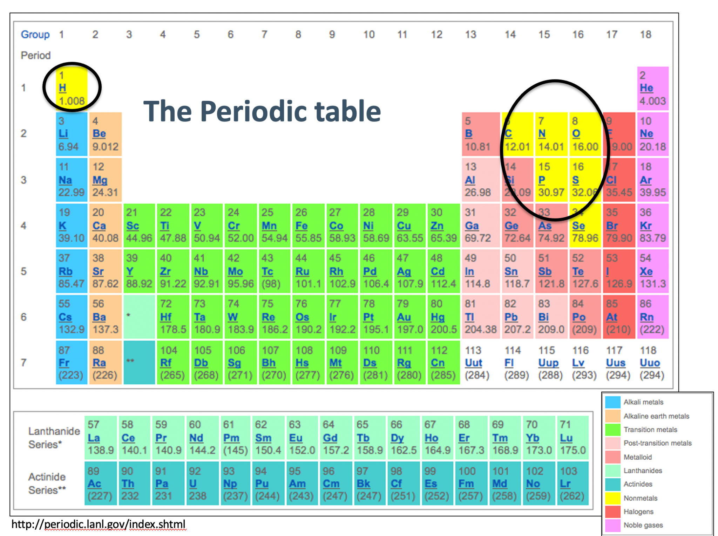
Figure 1: A figure of the periodic table highlighting the most common elements found in biology (maintained by the wwPDB). Image from https://pubchem.ncbi.nlm.nih.gov/periodic-table/#view=table

- The most common elements in biological molecules such as proteins and nucleic acids are Carbon (C), Hydrogen (H), Nitrogen (N), Oxygen (O), Phosphorus (P), and Sulfur (S) (circled in Figure 1).
- Each atom type (element) has unique properties that allow them to form only certain types of bonds.
- When visualizing these molecules different types of atoms are colored in different colors following the CPK conventions for rapid identification - i.e., oxygens (O) are colored red, hydrogens (H) are colored white, nitrogen (N) atoms are colored blue, sulfur (S) is colored yellow, phosphorous (P) is colored orange, and carbon (C) is colored gray/black. Some molecular visualization software may use other colors for C atoms. See Figure 2.
- Unique interactions between atoms of these elements determine the properties and functions of the molecules they form.
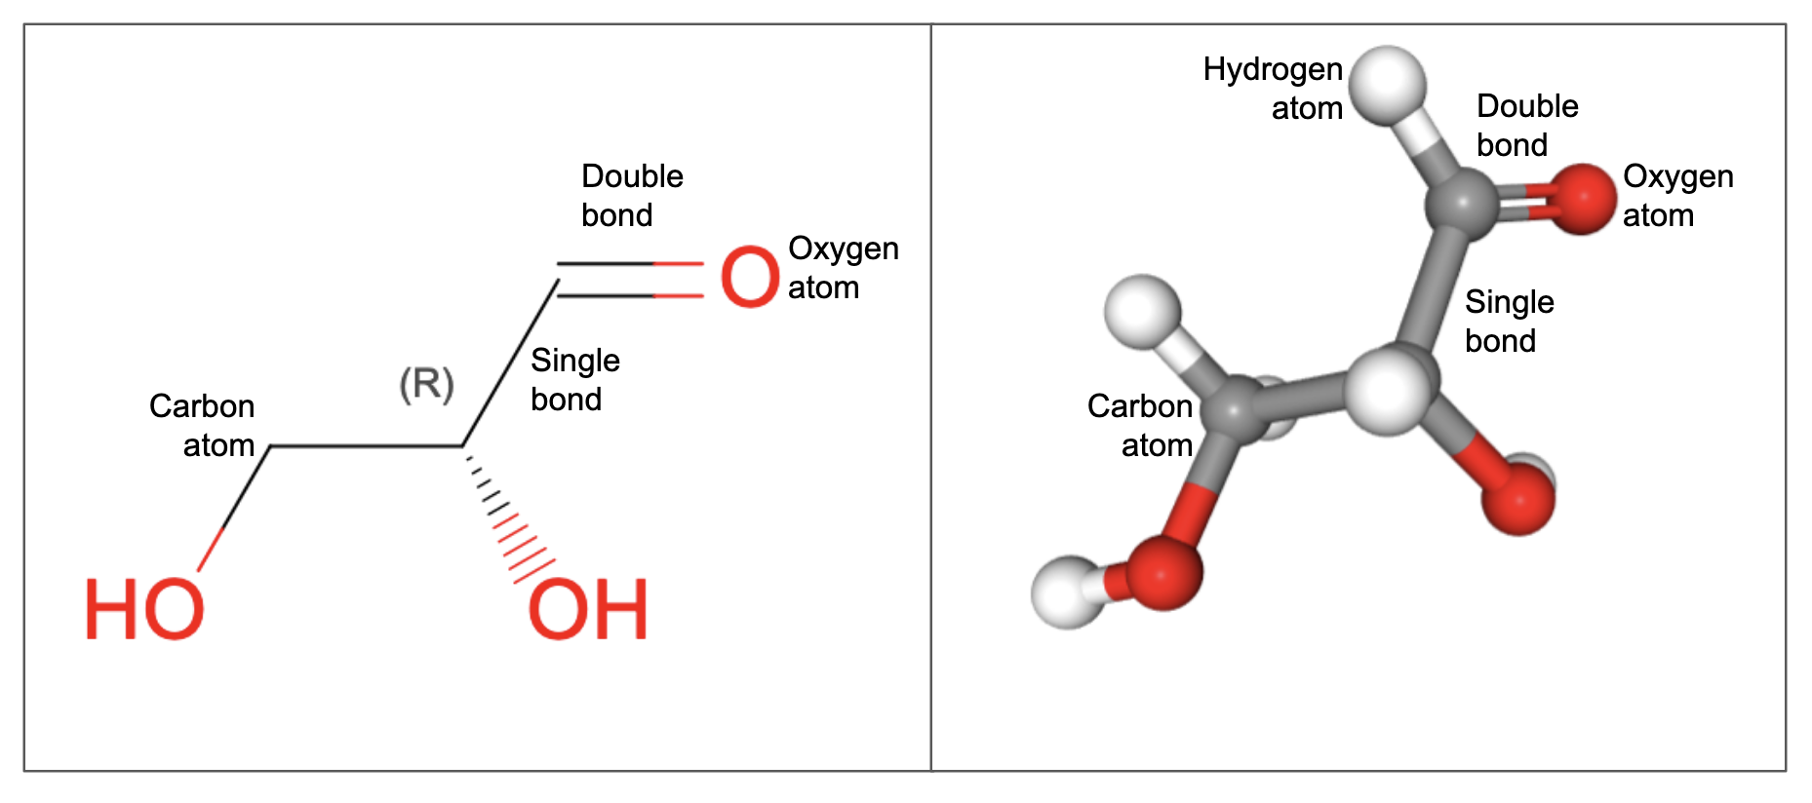
Figure 2: Structure of Glyceraldehyde (chemical component ID 3GR). Left panel shows 2D chemical drawing while the right panel shows 3D structure. Hydrogen atoms are not shown in the 3D chemical drawing but explicitly shown in the 3D structure (right). Carbon is colored gray/black, oxygen is red and hydrogen is white (right)
Note: In addition to the non-metal atoms described here, many metals [e.g., iron (Fe), zinc (Zn), magnesium (Mg), and Calcium (Ca)] also play key roles in biology but are not discussed in detail here.

Bonds
Atoms interact with each other to form bonds in many different ways - both covalent or noncovalent bonds found between different atoms in molecules are discussed here:

Covalent bonds:

What is it?
- This type of bond is formed between two atoms when they share their electrons.
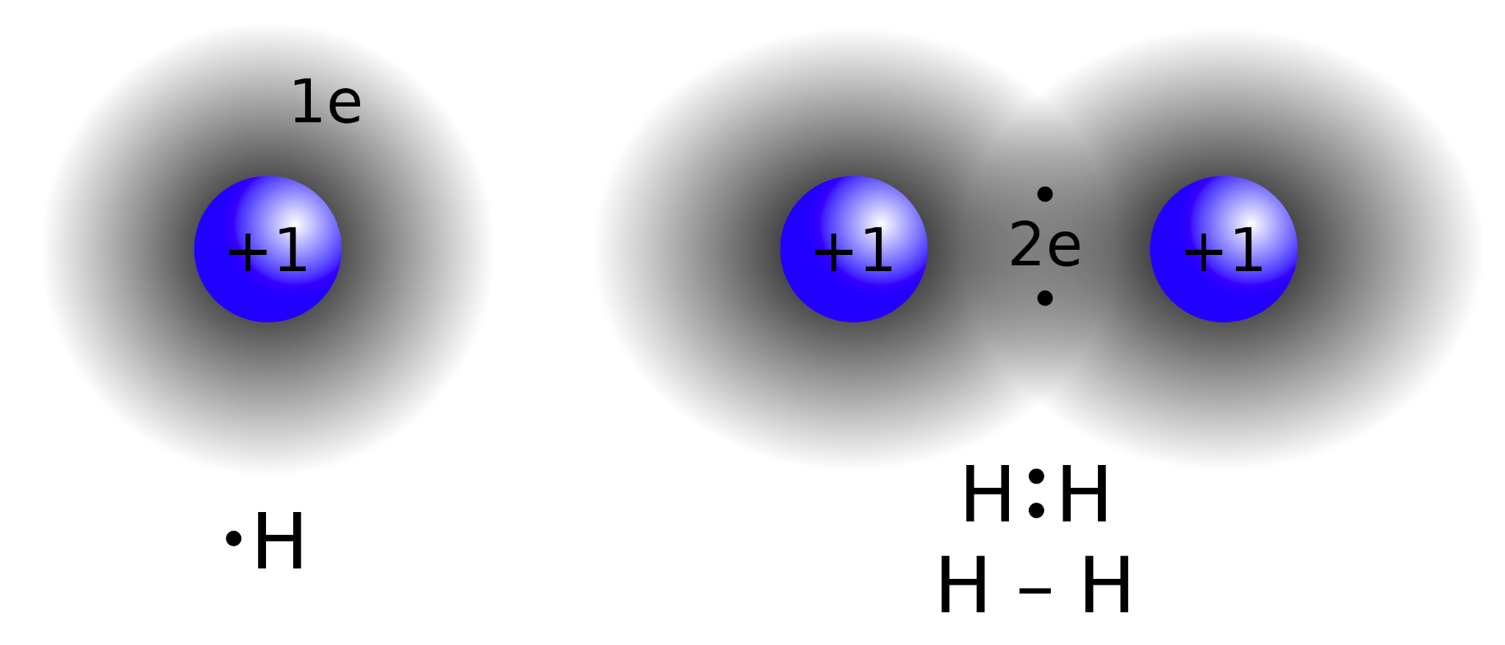
Figure 3: Illustration of electron sharing to form covalent bonds.

Where can you find it?
  - Covalent bonds between specific atoms make up small molecules such as amino acids, monosaccharides, fatty acids, nucleotides (all building blocks for various types of biomolecules) and other small molecules (like cofactors, complex ions, and inhibitors).
  - Many of the small molecules are covalently linked to others to form polymers of macromolecules (e.g., amino acids make proteins, nucleotides make nucleic acids like DNA and RNA, monosaccharides make polysaccharides and carbohydrates, while fatty acids interact with alcohols to form a variety of lipids).

Bond Properties:
- Bond order
  - Depending on the number of pairs of electrons shared between two atoms forming it, covalent bonds may have different bond orders - i.e., bond order 1 or single bond, bond order 2 or double bond, bond order three or triple bond (see examples in Figure 2).
  - A reference list of bond lengths (for single, double, and triple bonds between atoms commonly seen in biomolecules) is available. Significant deviations from these values may indicate specific distortions (e.g., in a transition state) or more commonly errors in the molecular structure being examined.
  - Between a specific set of atoms (e.g., between two carbon atoms) the length of a single bond (denoted as a single line or stick drawn between the atoms) is slightly longer than a double bond (denoted as two lines between the atoms), which in turn is longer than a triple bond (usually denoted as three lines between the atoms).
  - Single bonds support rotation around the bond, while double and triple bonds are more rigid and do not allow rotation around them.
- Conformation
  - Spatial arrangements of atoms in a molecule that can be obtained by rotation of the atoms about a single bond. No bond breakage is required to change conformation.

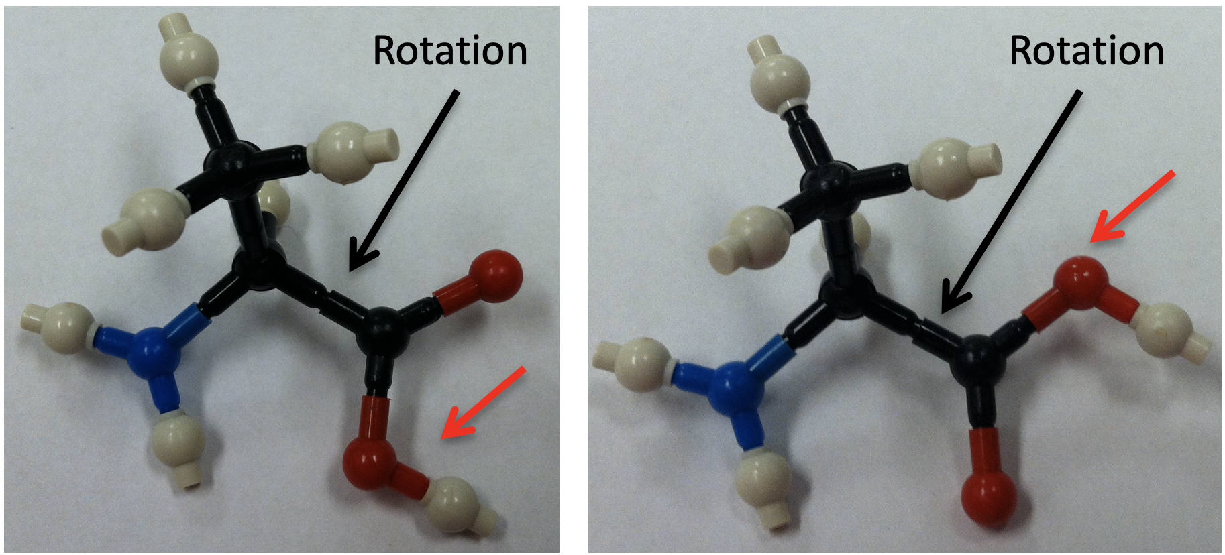
Figure 3: 3D- physical model of Alanine showing the impact of rotation about a specific covalent bond. The O marked with a red arrow occupies a different spatial location in relation with the blue atom on the left of the molecule
  - Not only does the spatial orientation within an amino acid change, rotation about a specific single bond can change the conformation of the whole molecule. The relative orientation of all atoms or parts of a molecule connected to the atoms forming the rotated bond may change with the rotation. For example in Figure 4, aligning two different conformers shows that when the beginning part of the protein chains (called N-terminus) is lined up, the other end of the protein (called C-terminus) does not overlap. Note that the rotation about one of the bonds in the protein structure can change the position of the rest of the atoms in the structure.
  - Changes in conformation happen all the time as molecules move (breathe) in cells and/or when they bind their partner proteins, substrates etc.
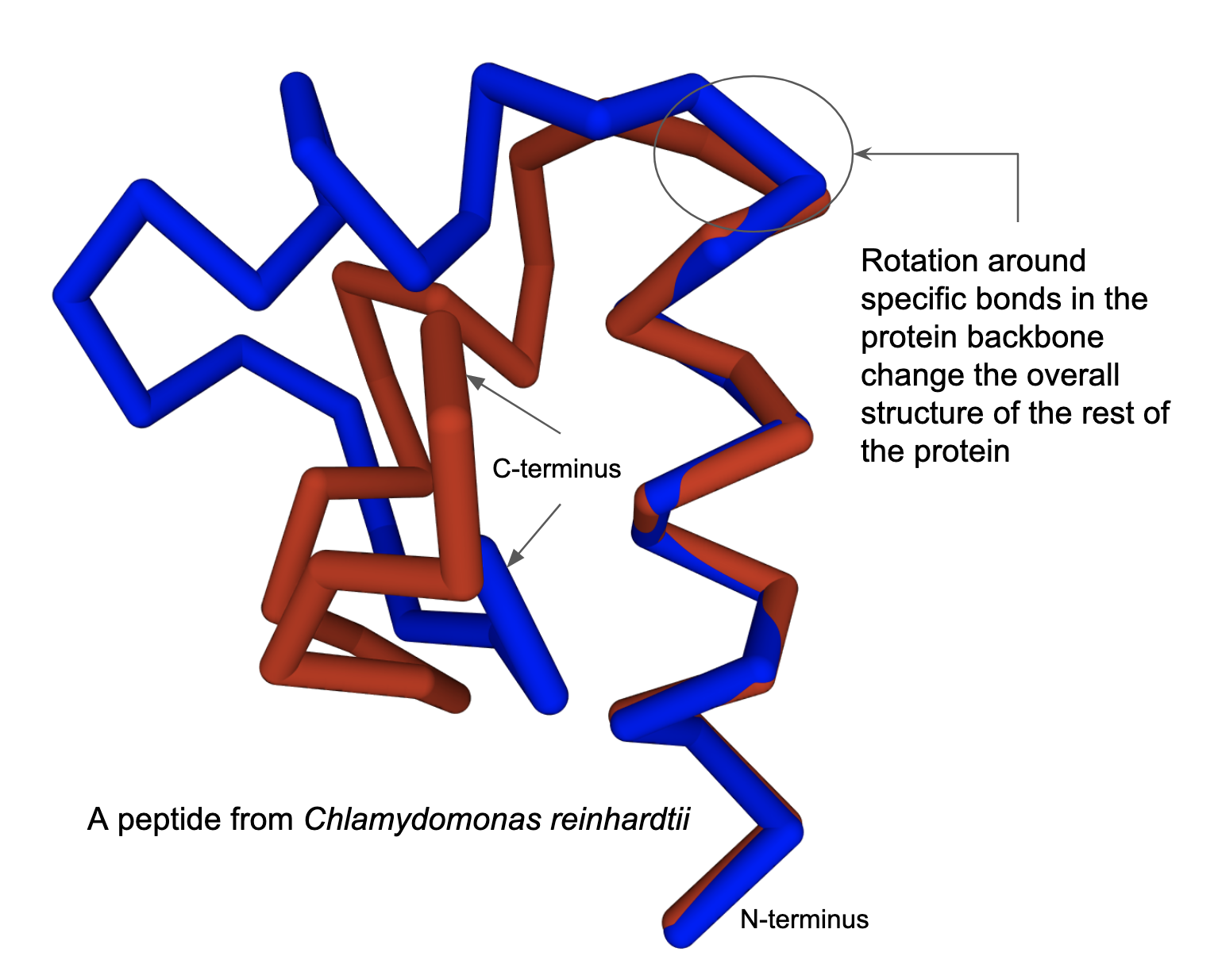
Figure 4: Two different conformations of the same molecule (PDB ID 1fct) shown in red and blue.

- Configuration
  - Spatial arrangement of atoms in a molecule based on how the atoms are bonded to each other – for example a carbon atom with four single bonds bonded to four different atoms/chemical groups shown in Figure 5 has different configurations. Changing configuration requires bond breakage. No amount of rotation will make the left molecule exactly the same as the right molecule.
  - Changing the configuration requires breaking and remaking a bond - where the action of one or more enzymes may be needed to change the relative orientations of atoms bound to an atom.
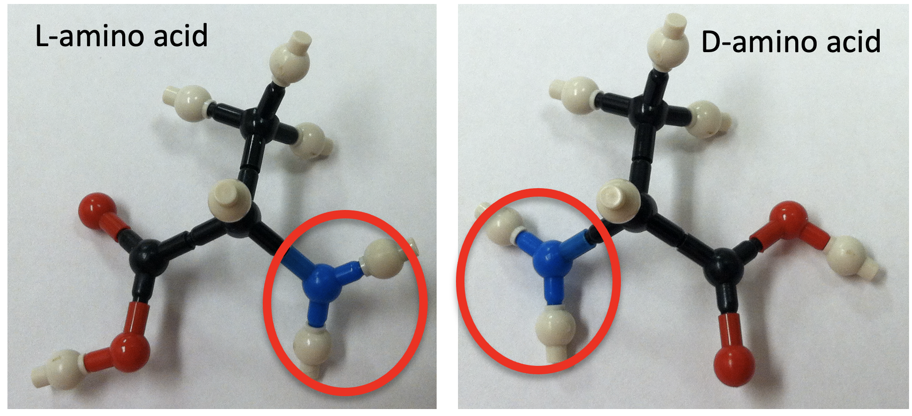
Figure 5: Two different configurations of the amino acid Alanine.

  - Configuration defines the molecule’s chemical reactivity, specificity, and type(s) of bonding it participates in.
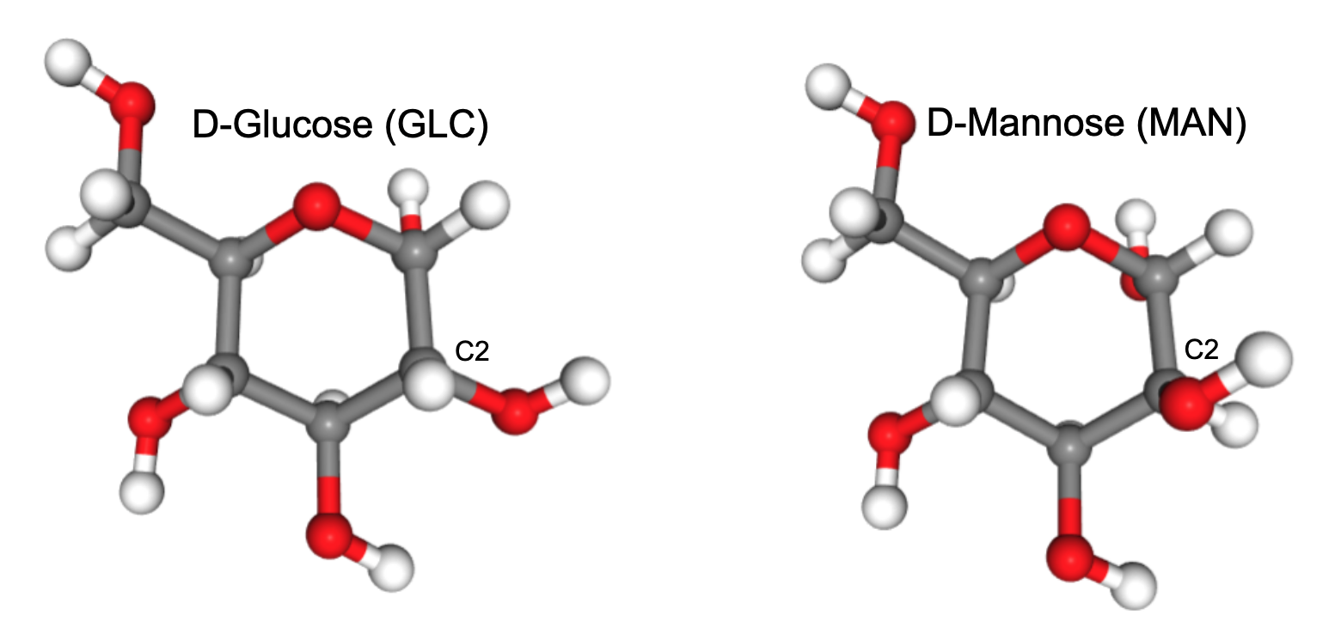
Figure 6: Alternate configurations in GLC and MAN - the relative positions of atoms bound to the carbon atom called C2 are different.
- Why do configuration and conformation matter in biomolecular structures?
  - These properties help determine the overall shape of biological molecules
  - They also play key roles in recognition, binding, and functions of the biomolecule.
  - Note: it is important to keep in mind that changing conformation is possible by changing the rotation about one or more covalent bonds in a molecule, while changing configuration is usually a much bigger deal - it involves breaking and remaking bonds, use of energy, and possibly one or more enzymes etc.

Noncovalent Interactions:

What are they?
- These types of bonds/interaction are based on a variety of properties but do not involve the sharing of electrons.

Where can you find them?
- Various noncovalent interactions are found between atoms in a molecule that help stabilize the molecule and/or facilitate its interactions with other molecules.

Bond Properties:

Table 1: Common noncovalent interactions, their properties and illustrations of examples of the interactions.
Type of Interaction |  | Description | Image
Ionic bonds (video) |  | Occur due to the electrostatic attraction between oppositely charged ions or groups of atoms (i.e., between positive and negative atoms/groups) | 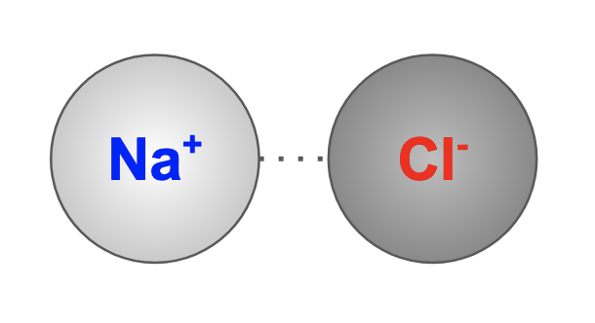
Dipole–Dipole interactions |  | Occur between the partial negative side of one molecule and the partially positive side of another molecule. The partial charges are created as a result of the density of electrons in parts of the molecule. | 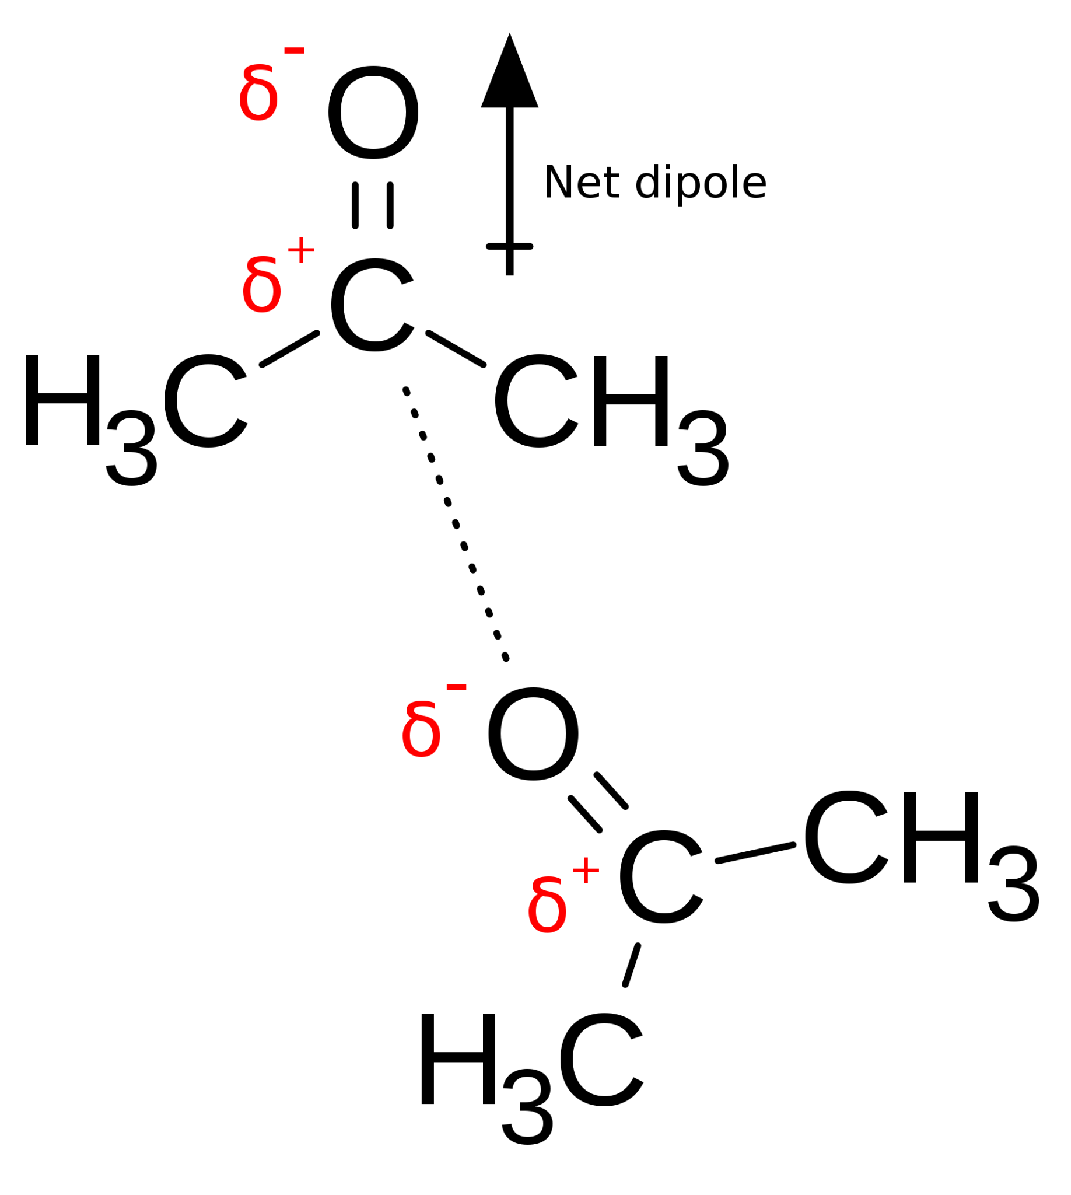
Hydrogen bond  (video) |  | Occur between hydrogen which is covalently bonded to O, N, or F and an O, N, or F, of another molecule. | 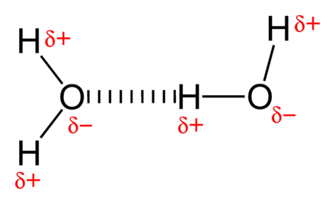
van der Waals interactions |  | Occurs between nonpolar atoms as they are attracted towards each other based on permanent or induced dipole moments. | 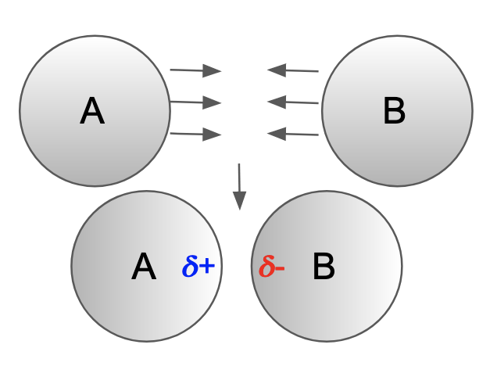
Pi based interactions |  | Occur when pi clouds (e.g., in aromatic rings) interact with each other (pi-pi interactions) or with positively charged groups (pi-cation interactions) | 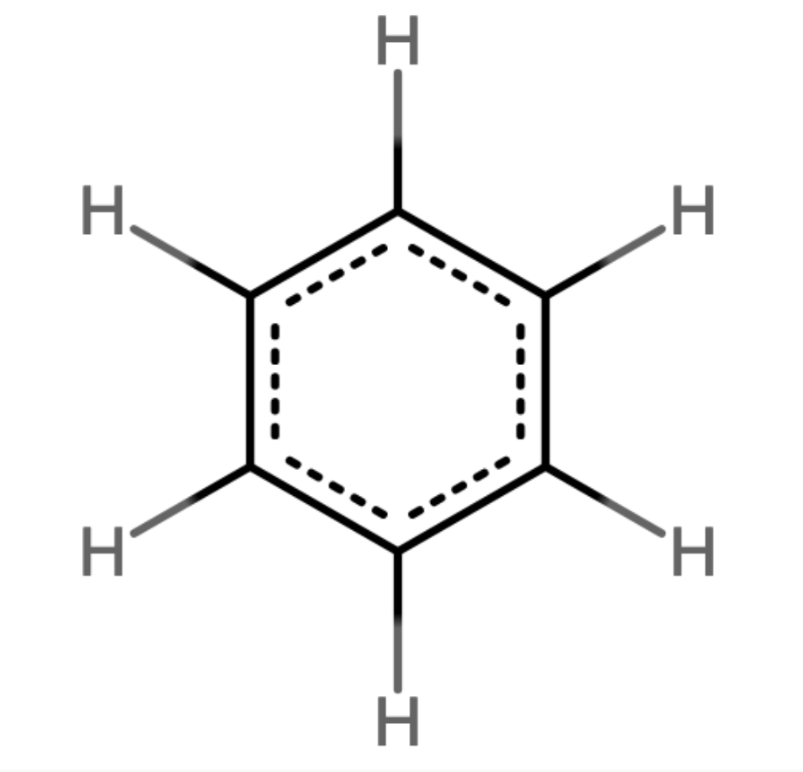
Hydrophobic interactions |  | Is observed as carbon and hydrogen rich molecules (e.g., hydrocarbons) interact with each other and cluster to avoid interactions with surrounding water molecules. | 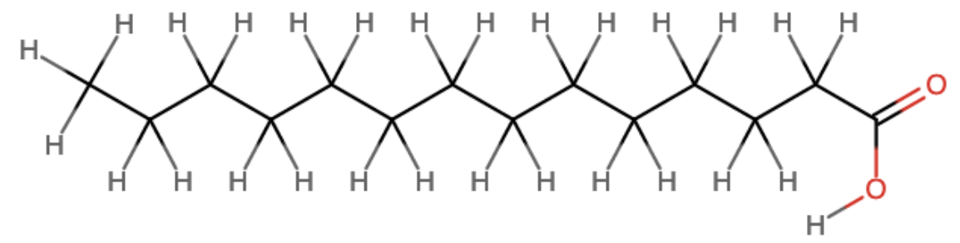

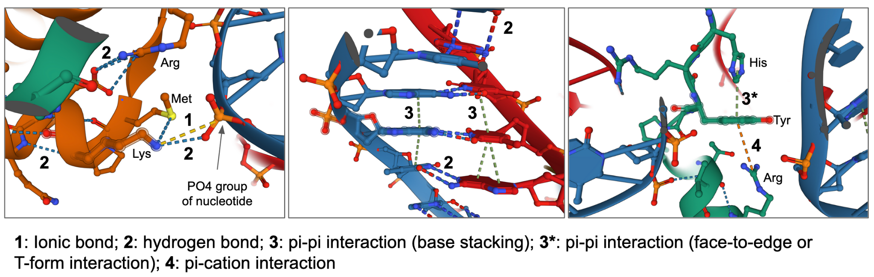
Figure 7: Examples of a few different types of noncovalent interactions as seen in a PDB structure (PDB ID 7xzy).

Molecules
A molecule is the smallest unit of a substance that retains the composition and all of its properties. It is formed by two or more atoms connected by covalent and/or non-covalent bonds. Molecules may range in size and complexity from hydrogen and oxygen like small molecules to large and complex carbon-based organic molecules or biological molecules.

Biologically relevant molecules are either small molecules (including amino acids, nucleotides, saccharides, fatty acids, ions, inhibitors, and drugs), or polymers made of building blocks that linked together in specific ways to form macromolecules - including proteins, nucleic acids, carbohydrates and lipids (see also Table 2).

Polymeric Biomolecules:
Table 2: Summary of the types of atoms, bonds and molecules that make up various types of biological macromolecules
Property | Proteins | Nucleic Acids | Carbohydrates | Lipids
Atoms | C, H, N, O, S | C, H, O, P, N | C, H, O, (P), N, (S) | C, H, O
Building blocks | Amino acids | Nucleotides | Simple sugars | Fatty acids, glycerol
Forms polymers?, bond type | Yes, Peptide bonds | Yes, phosphodiester bonds | Yes, Glycosidic linkages – of various types | No, forms various di-, tri- Glycerides
Common Intra- and Inter-molecular interactions | Covalent (S-S), H-bonds, charge based, van der Waals, pi stacking and more | H-bonds, pi- stacking interactions | H-bonds | van der Waals, hydrophobic interactions
Functional role in cells | Enzymes, structural proteins, sensors, receptors etc. | Storage of genetic information, enzymes, ribosomes | Storage of energy, structural, recognition, interactions | Membranes, signaling, energy storage, small molecule hormones

Proteins
- What are they?
  - They are polymers of amino acids - there are 20 standard amino acids that are genetically coded + selenocysteine and pyrrolysine, which are coded by a stop codon under special circumstances).
  - Proteins are formed by connecting several of them in a specific order to form a shape that can perform key functions
- What do they do?
  - Proteins play countless roles throughout the biological world and make up the structures of all living things.
  - Their functions are diverse ranging from providing structure and support, catalyzing chemical reactions, recognition, regulation and more.
- Composed of:
  - Atoms: They are made up of carbon, hydrogen, oxygen, nitrogen and sulfur
  - Molecules: while amino acids (see Figure 8) are also molecules and have many important roles in biology, these small molecules (components) link together in specific orders to form proteins or polypeptides. Proteins have widely differing structures and functions, but are all made of the same set of amino acids, combined in different ways.
  - Bonds (forming polymers): The amino acids (building blocks of proteins) are linked together through peptide bonds (a covalent bond) between the carbonyl carbon of one amino acid and the amino group of the next one.
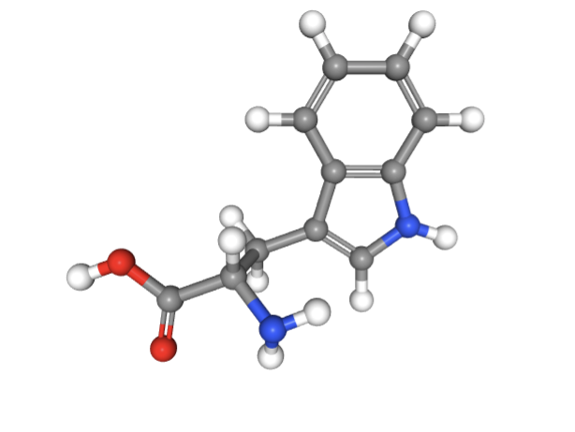
Figure 8: Structure of Tryptophan (TRP) from the chemical component dictionary. Atom colors - N - blue, O - red, H - white, C - gray.

Nucleic acids
- What are they?
  - Nucleic acids, such as DNA and RNA are polymers of building blocks called nucleotides - there are primarily 5 types of nucleotides and many modified versions.
- What do they do?
  - Nucleic acids carry the genetic blueprint of cells.
  - They also play key roles in protein synthesis and regulation.
  - Nucleotides play key roles in energy, metabolism, and signaling pathways.
  - Some RNA molecules are catalysts - i.e., can function as enzymes.
- Composed of:
  - Atoms: They are primarily made up of nitrogen, oxygen, carbon, phosphorous, and hydrogen
  - Molecules: While nucleotides (see Figure 9) are small molecules that have specific functions in biology, they link together to form polynucleotides (DNA or RNA) of varying sizes and structures
  - Bonds forming polymers: The covalent linkages that connect nucleotides to form polynucleotides or nucleic acids are called the phosphodiester linkages. They connect the phosphate groups to the ribose or deoxyribose groups in the nucleotides to form the sugar phosphate backbone of nucleic acids.

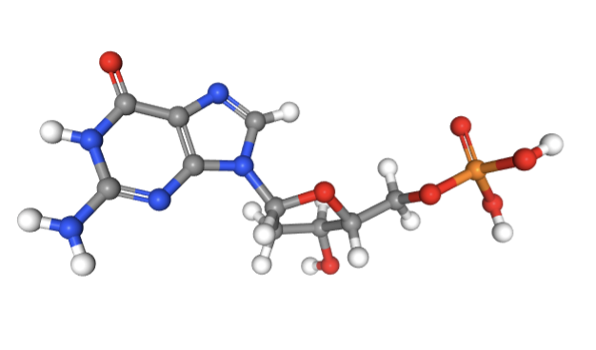
Figure 9: Structure of deoxy Guanosine (DG) from the chemical component dictionary. Atom colors - N - blue, O - red, H - white, C - gray, P - orange.

Carbohydrates
- What are they?
  - Carbohydrates, also known as saccharides, are polymers of monosaccharides that can adopt many different structures and shapes.
- What do they do?
  - Polysaccharides have varying roles in biology - they serve as an energy store (e.g. starch and glycogen) and as structural components (e.g. cellulose in plants and chitin in arthropods) that play important roles in recognition and stability/protection.
  - As monosaccharides they play key roles in metabolism, energy production, signaling and more.
- Composed of:
  - Atoms: Carbohydrates are made up of carbon, hydrogen, oxygen and nitrogen. Phosphorus and Sulfur atoms may also be present in some saccharides.
  - Molecules: The building blocks of carbohydrates and sugars, monosaccharides (see Figure 10) , have a variety of configurations (e.g., epimers, anomers) enabling many different ways of covalently linking them to form polysaccharides or complex sugars.
  - Bonds forming polymers: Since each monosaccharide has multiple hydroxyl groups that may form covalent glycosidic bonds accompanied by dehydration. Monosaccharides can link together to form linear and/or branched chain polysaccharides.
  - Mono- or oligo-saccharide molecules may form covalent glycosidic links to proteins and lipid molecules to form glycoproteins and glycolipids, respectively.
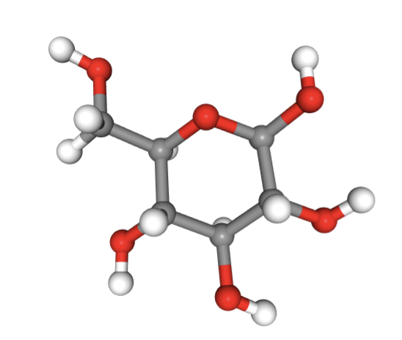
Figure 10: Structure of beta-D-Glucose (BGC) from the chemical component dictionary. Atom colors - O - red, H - white, C - gray.

Lipids
- What are they?
  - Lipids are apolar or nonpolar molecules that are insoluble in water but dissolve in organic solvents.
  - They are found in fats, waxes, oils, some specific hormones, and as components of membranes.
- What do they do?
  - Lipids have many functions - they serve as energy-storage molecules and chemical messengers.
  - As part of membranes, lipids help locate biomolecules in specific regions or compartments of cells.
  - Some lipids (sterols) function as key hormones in plants and animals.
  - They are critical for the absorption and function of specific molecules that are hydrophobic (less or not soluble in water).
- Composed of:
  - Atoms: Lipids are primarily composed of carbon, hydrogen, and oxygen atoms. Some lipids (e.g., phospholipids) may also include phosphorus (as part of phosphate groups)
  - Molecules: Although lipids do not form polymers like proteins, nucleic acids, and carbohydrates the fatty acids (see Figure 11), alcohols, and sterols covalently link to each other and to proteins and carbohydrates to form a variety of complex molecules.
  - Bonds forming complexes: The fatty acids and alcohols form covalent linkages (e.g., esterification) to form fats, phospholipids, glycolipids and more.
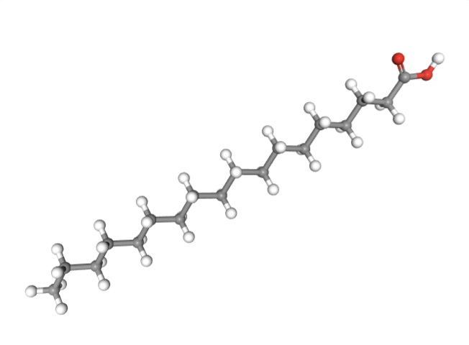
Figure 11: Structure of Stearic acid (STE) from the chemical component dictionary. Atom colors O - red, H - white ,C - gray.

Non Polymeric Biomolecules
These molecules include
- Ions
  - Many proteins, including enzymes, rely on metal ions for their biological activity. The ions themselves are usually alkaline earth metals (e.g., calcium, magnesium) or transition metals (e.g., iron, cobalt, nickel or copper). They enable catalysis due to their electronic structure and the ability to form coordinate bonds.
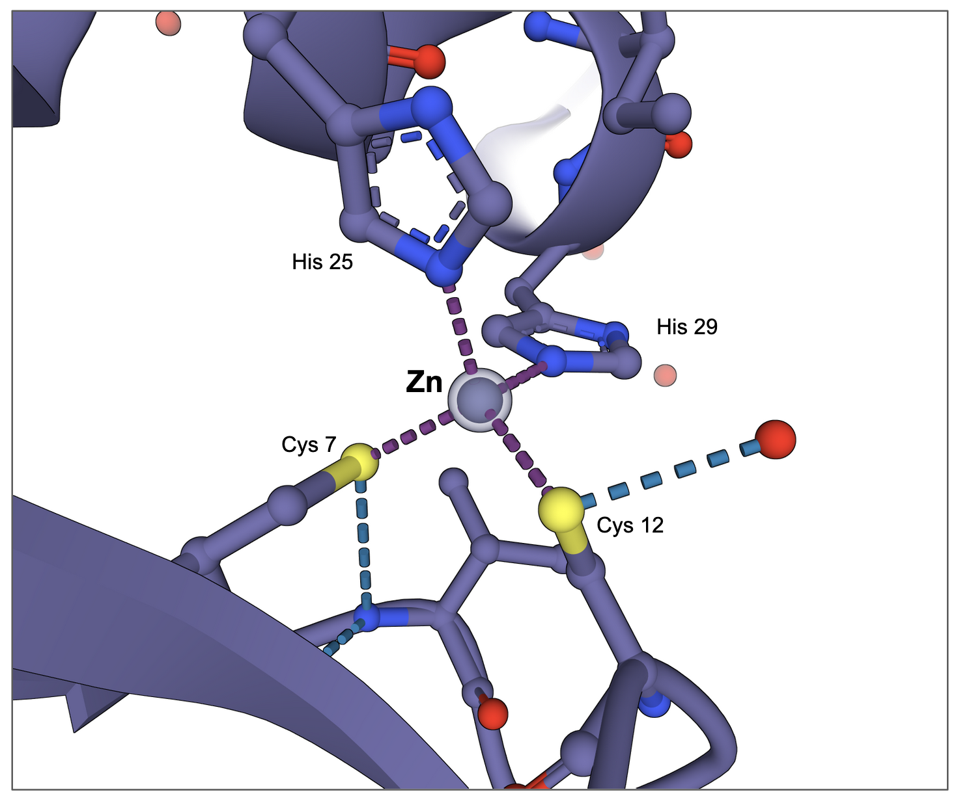
Figure 12: Metal ion Zinc binding to the structure of a zinc finger protein (PDB ID 1zaa)

- Cofactors
  - A cofactor is any non-protein substance required for a protein to be catalytically active. Some cofactors are inorganic, such as the metal atoms zinc, iron, and copper in various oxidation states. Others, such as most vitamins, and molecules like S-adenosylmethionine, FAD, NADH etc. are organic.
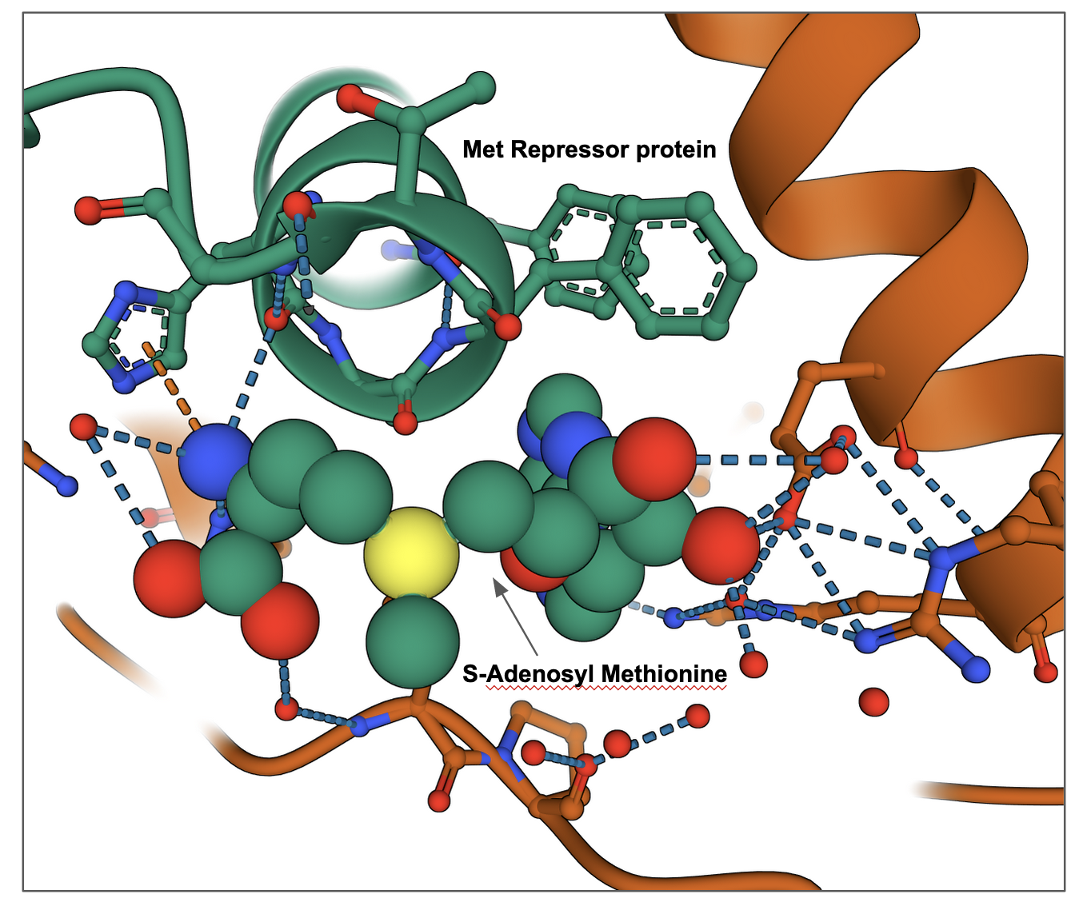
Figure 13: S-AdenosylMethionine (SAM) bound to Met Repressor in PDB entry 1cmc.

- Many other small molecules that function as inhibitors, detergents, drugs, stabilizers, buffer components etc. can be found in PDB structures.

