## Base Pairing

**Authors**: Alexandra Pettit, Carleton University, Ottawa, Ontario, Canada and Shuchismita Dutta, Rutgers University, NJ

**Lesson Overview**:

This lesson reviews base-pairing between nucleotides (seen in nucleic acids, DNA and RNA).

**ASBMB Learning Objectives**

(<https://www.asbmb.org/education/core-concept-teaching-strategies/foundational-concepts/structure-function>)

2. Structure is determined by several factors

* Students should be able to **recognize the repeating units in biological macromolecules** and be able to discuss the structural impacts of the covalent and noncovalent interactions involved *(Introductory)*.
* Students should be able to discuss the **chemical and physical relationships** between **composition and structure** of macromolecules *(Introductory)*.

DNA and RNA form the genetic material for organic life. Base pairing is the basis for replicating genomes in order to make new copies of the genetic code. Here are two fun facts about base pairing seen in nucleic acid structures:

* Most commonly discussed base pairs are the ones described by Watson and Crick - between purines and pyrimidines (e.g., G:C).
* There are other types of non-Watson-Crick base-pairs (e.g., Hoogsteen base pairs) that help stabilize the structures of large RNA molecules and also play roles in recognition, regulation, and catalysis performed by nucleic acids.

1. Explore the base pairing interactions in two DNA structures. In two separate browser windows visualize the PDB entries [1bna](https://www.rcsb.org/3d-view/1BNA) and [417d](https://www.rcsb.org/3d-view/417D).
   1. How many “purine : pyrimidine” base pairs do you see?
      1. In PDB entry 1bna:
      2. In PDB entry 417d:
   2. Are there any non-standard base pairing interactions?
      1. In PDB entry 1bna:
      2. In PDB entry 417d:
   3. If you identified any non-standard base-pairs, list what is unique about the base(s) and/or interaction(s). Support your answer with a suitable figure from the Mol* visualization. *(Hint: to explore the interactions of any specific nucleotide, click on it either in the 3D canvas or in the sequence panel. Save an image using the shutter icon and upload the image to powerpoint or similar tool to add labels.)*

1. Explore the base pairing interactions of the bases in two RNA structures. In two separate browser windows visualize the PDB entries [1csl](https://www.rcsb.org/3d-view/1CSL) and [1etf](https://www.rcsb.org/3d-view/1ETF).

Note: In addition to the RNA, the PDB entry 1etf also includes a short peptide.

* 1. How many unpaired bases do you see?
     1. In PDB entry 1csl:
     2. In PDB entry 1etf:
  2. Examine the base pairing for nucleotide G55 in PDB entry 1etf. Which nucleotide does it base pair with? (Hint: identify the base that forms one or more hydrogen bonds with the base for G55).

1. Examine the following figures and identify the base pairs shown. Feel free to consult the [nucleotide structures](https://www.rcsb.org/search?request=%7B%22query%22%3A%7B%22type%22%3A%22group%22%2C%22nodes%22%3A%5B%7B%22type%22%3A%22group%22%2C%22logical_operator%22%3A%22and%22%2C%22nodes%22%3A%5B%7B%22type%22%3A%22group%22%2C%22nodes%22%3A%5B%7B%22type%22%3A%22terminal%22%2C%22service%22%3A%22text_chem%22%2C%22parameters%22%3A%7B%22attribute%22%3A%22rcsb_chem_comp_container_identifiers.comp_id%22%2C%22operator%22%3A%22in%22%2C%22negation%22%3Afalse%2C%22value%22%3A%5B%22da%22%2C%22dt%22%2C%22dc%22%2C%22dg%22%2C%22a%22%2C%22t%22%2C%22g%22%2C%22c%22%5D%7D%7D%5D%2C%22logical_operator%22%3A%22and%22%7D%5D%2C%22label%22%3A%22text_chem%22%7D%5D%2C%22logical_operator%22%3A%22and%22%7D%2C%22return_type%22%3A%22mol_definition%22%2C%22request_options%22%3A%7B%22paginate%22%3A%7B%22start%22%3A0%2C%22rows%22%3A25%7D%2C%22scoring_strategy%22%3A%22combined%22%2C%22sort%22%3A%5B%7B%22sort_by%22%3A%22score%22%2C%22direction%22%3A%22desc%22%7D%5D%7D%2C%22request_info%22%3A%7B%22query_id%22%3A%227e1373bfc233a4537c5940b4ba0443eb%22%7D%7D) to help with the identification. Complete the blanks in the sentences about the figure written below it. Follow the completed example.
   1. *Figure 1 (from PDB ID 1bna)*

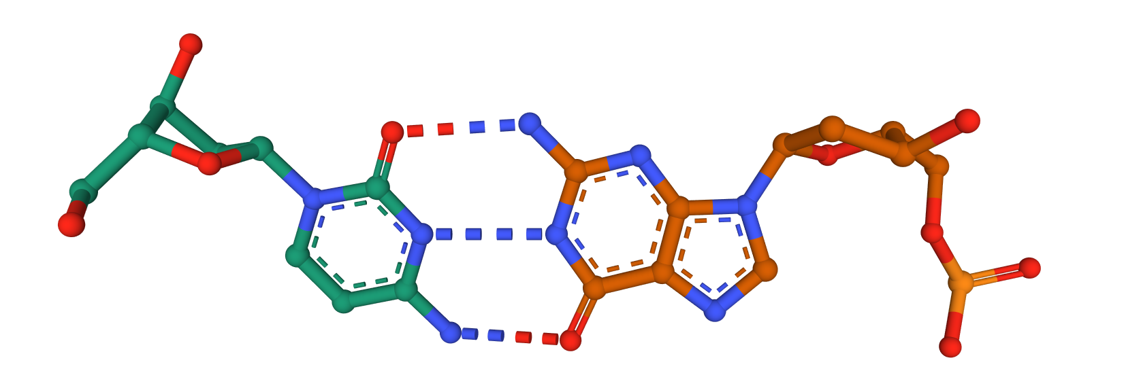

This base pair is between a ___C___: ___G___ with ___3____ hydrogen bonds

* 1. *Figure 2 (from PDB ID 1bna)*

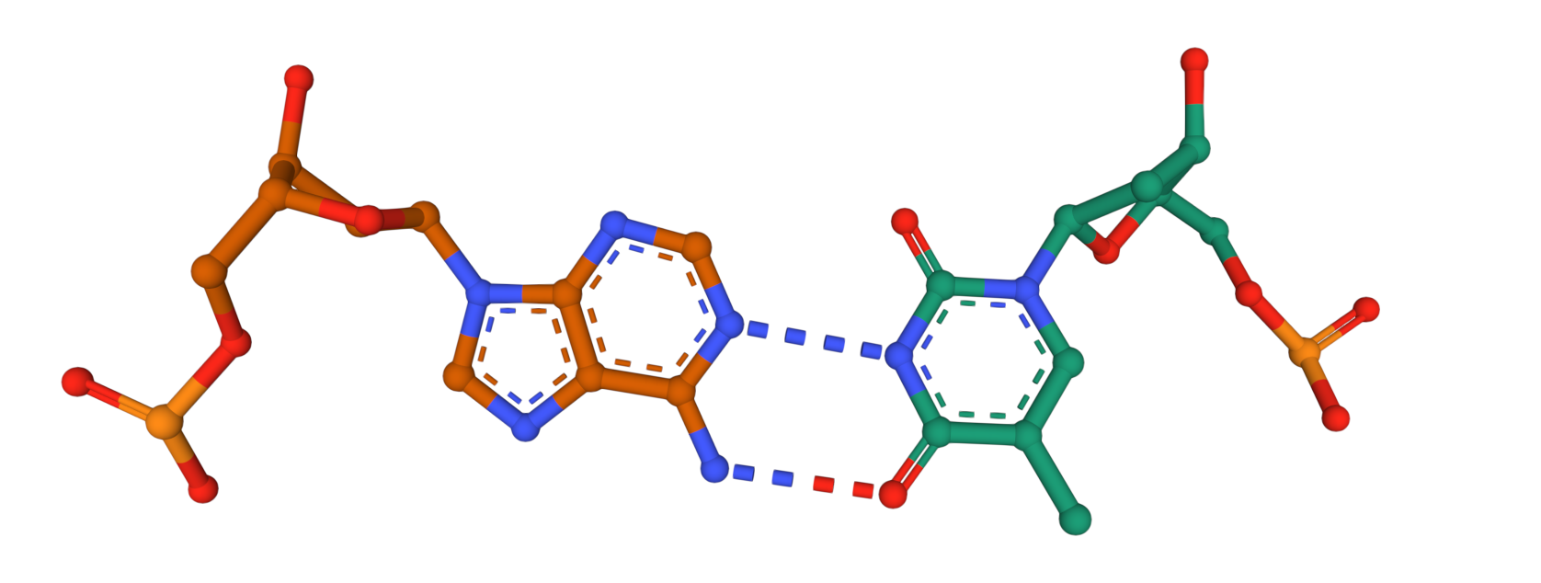

This base pair is between a ______: ______ with ______ hydrogen bonds

* 1. *Figure 3 (from PDB ID 1csl)* 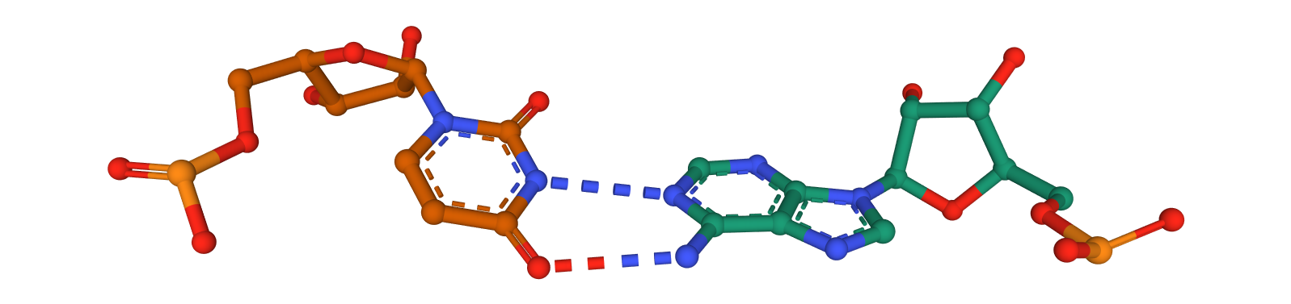

This base pair is between a ______: ______ with _______ hydrogen bonds

* 1. *Figure 4 (from PDB ID 1etf)*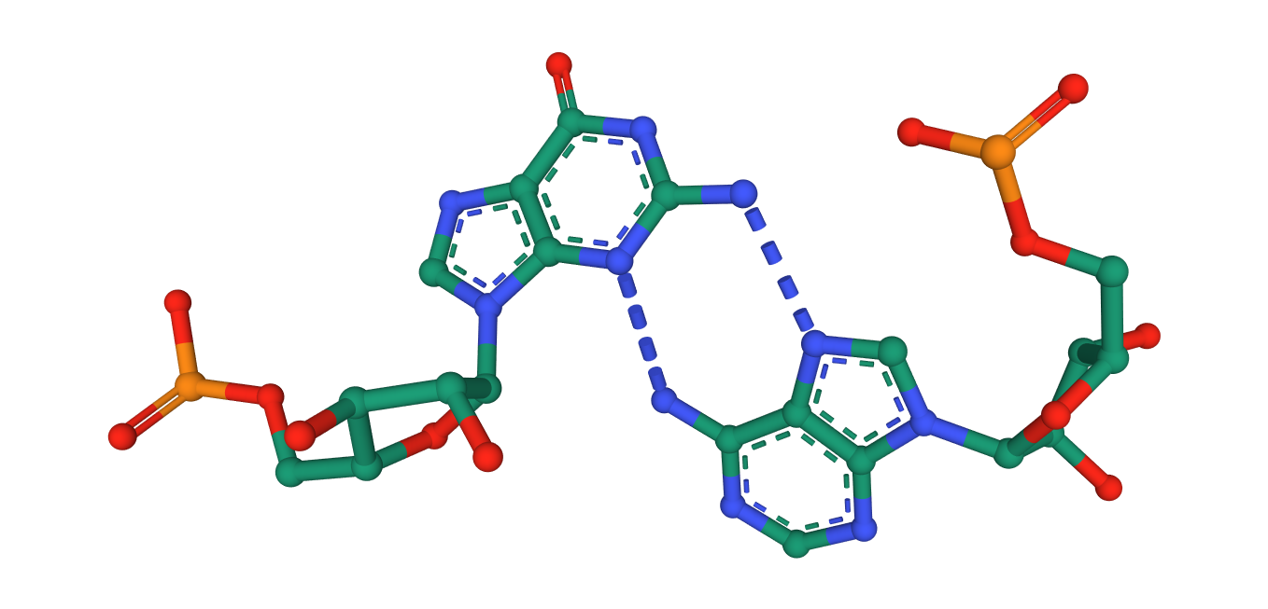

This base pair is between ______: ______ with _______ hydrogen bonds

* 1. *Figure 5 (from PDB ID 1csl)* 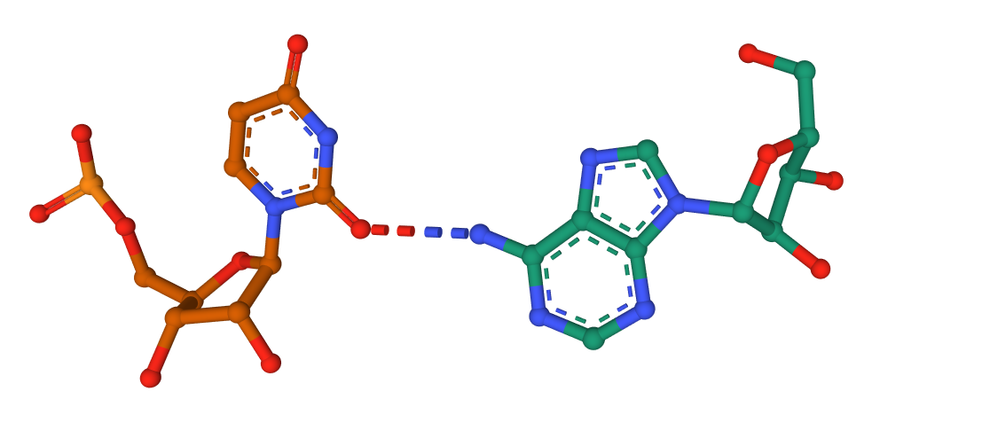

This base pair is between ______: ______ with _______ hydrogen bonds

1. Explore the base pairing interactions of the bases in the RNA structure, [PDB ID 1etf](https://www.rcsb.org/3d-view/1ETF), and answer the following questions.

*(Hint: to explore the interactions of any specific nucleotide, click on it either in the 3D canvas or in the sequence panel)*.

* 1. Examine the base pairing for nucleotide G77 in PDB entry 1etf. Which nucleotide does it base pair with? Support your answer with a suitable figure.

Ans:

* 1. In RNA structures, which nucleotide is commonly seen as the Watson-Crick base pairing partner for A?

Ans:

* 1. Examine the structure and identify which of the A bases in this structure do not form the traditional Watson-Crick base pair. List their names and include a figure to support your answer.

Ans: