Blocking Replication with Remdesivir

Learning Objective: To explore the Structure of RNA dependent RNA Polymerase (RdRP) bound to Remdesivir using RCSB Mol* to understand how it can block replication.

Introduction
The SARS-CoV-2 life cycle has three main phases: (a) Viral attachment and infection; (b) Replication of viral genome and protein synthesis; and (c) Viral assembly and release. Of these phases, replication of the viral genome - i.e., synthesis of RNA from an RNA template is unique to the virus and has no parallel in the host cells. This makes the SARS-CoV-2 RNA dependent RNA polymerase (RdRP) an ideal drug target. Based on this rationale a small molecule called Remdesivir has been tested as an inhibitor of the RNA replication. Here we will learn about the structure and action of Remdesivir.

Tools
- The exercise will use data from the Protein Data Bank (PDB) and DrugBank.
- Students will use the RCSB molecular visualization tool Mol* for the visualization and analysis of SARS-CoV-2 RdRP bound to Remdesivir.
  - To save images, click on the camera (iris) icon , Download and save a *.jpg file. Import the image in any image manipulation software of your choice (e.g., PowerPoint/ Photoshop) to add labels and additional text describing the images.
  - Some key commands and functions of Mol* are included in the Appendix at the end of this document.

Exploration

Explore the structure and action of Remdesivir
In order to understand how Remdesivir works it may be helpful to first learn about its chemical properties. This part of the exercise will introduce you to a resource called DrugBank - a free online data resource with information about drugs, their targets, and many other details.
- Go to the DrugBank home page (https://www.drugbank.ca/) and type the name “Remdesivir” in the top search bar.

A1. Examine information provided on the page and use it to complete the following table:

Name | Remdesivir
Description
Originally developed for
Structure (save a screenshot showing chemical structure)
Target
Mechanism of action

A2. Copy the chemical structure of Remdesivir and mark the region that resembles a nucleotide. Include the image in the box below.

Explore the structure of RNA dependent RNA Polymerase (RdRP) bound to Remdesivir.
- Type the PDB ID “7bv2” in the top search box >> click enter. This should take you to the Structure Summary Page. This page provides a quick glimpse of the contents, quality, and experimental details of the structure.

B1. Examine the contents of the page and complete the table below:

PDB ID
Author(s) of entry
Date (including Year) when the structure was published/released
Structure determination method
Number of protein chains in the entry; protein name, Chain ID
Names and number of copies of ligands (Small Molecules) present in the structure

B2. Do you recognize the Remdesivir in this structure? Is it part of the polymer or listed as a small molecule?
Hint: The picture that you saved in section A is that of the Prodrug. This molecule is processed and only the nucleotide analog remains in this structure.

- Click on the 3D View tab on the top of the page to view the structure in Mol*

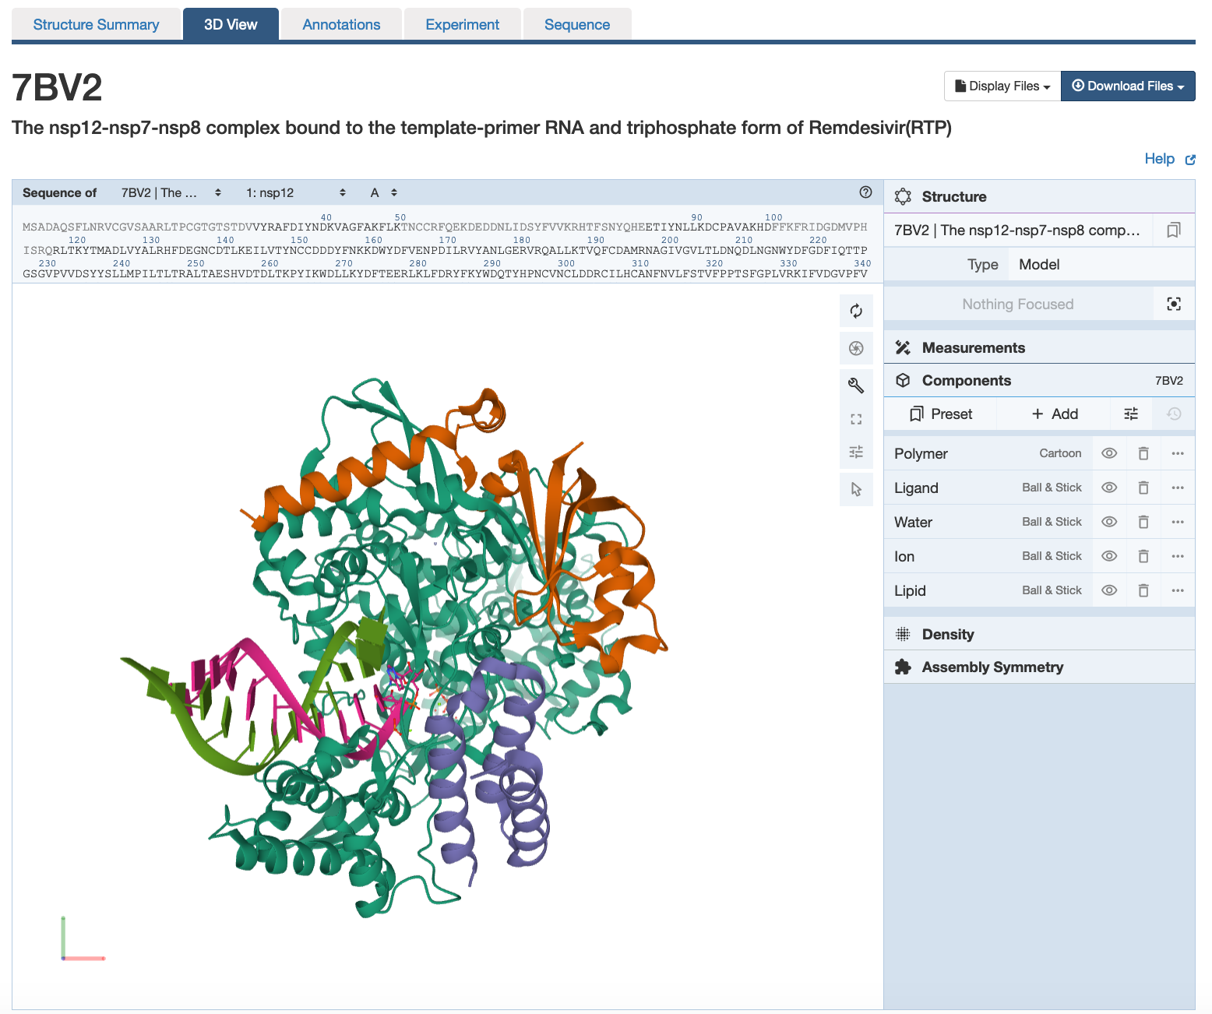 | There are 3 main areas on this screen:  1. Sequence panel (top left)  2. 3D-canvas (white space where the 3D structure is shown). Besides displaying the interactive 3D models, this space also offers  a. Toggle panel (a series of buttons on the right) to enable various functions  b. Log panel (at the bottom of the canvas) records actions taken  3. Control panel (blue column on right) with menus for Structure, Measurements, Components, etc.

- All the protein chains are represented as different colored ribbons with helical regions.
- Use various mouse controls to rotate and translate the molecule you are viewing.
- Note: Hovering the mouse over any object in the 3D canvas will display information about that item in the bottom right corner of the 3D canvas.
- Display the RdRP protein showing its molecular surface to see how the RNA and accessory proteins interact with it. Use the following steps.

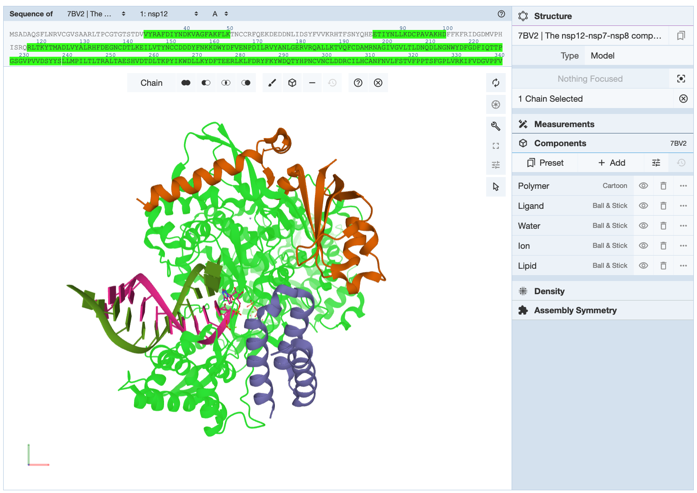 | Activate the selection mode by clicking on the arrow icon 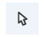in the Toggle panel >> Click on the pull down menu under the word Residue in the Selection options menu (in the top of the 3D canvas). Change the selection level to Chain. >> Click on any atom in the nsp12 (RdRP) protein to select the whole chain. The entire chain will be highlighted with a green halo (see figure)
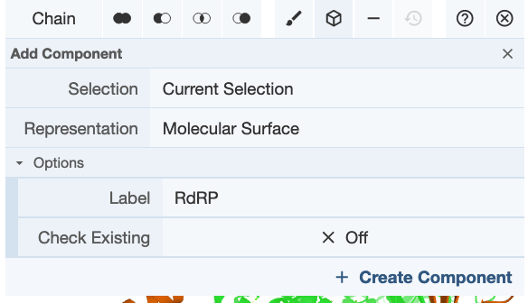 | Create a component with this selection by clicking on the Cube icon 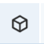 >> Select Representation molecular surface >> Label it “RdRP” >> click on Create Component.

B3. Save an image, label the key polymers (proteins and nucleic acids) in the structure and include it below:

B4: Which of the proteins shown above interact with the RNA? Name it/ them.

- Color the RdRP component according to the rainbow color scheme or by residue sequence id

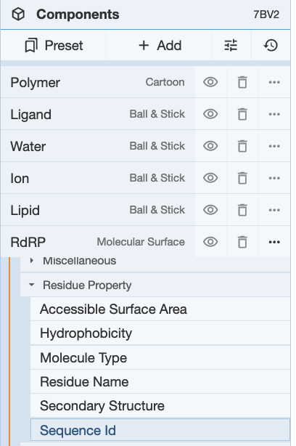 | Click on the 3-dots in the far right for the RdRP component … >> Set Coloring >> Residue property >> Sequence ID.

  - The molecular surface should be colored so that the N-terminal region is colored in various shades of blue, while the C-terminal region is colored in yellow, orange and red.
  - Save an image and include it below:

- Explore this region of the protein to understand how the RNA dependent RNA polymerase functions.
  - Rotate the structure so that you can look down the helix axis of the RNA double helix.
  - The RdRP region is shaped like a right hand with fingers, palm, and thumb subdomains. In the above colored figure, imagine that the RNA double helix is sitting in an open human right-hand palm. The C-terminal, red colored region, forms the thumb of the hand, the yellow/orange regions form the palm and the fingers are colored green.
- Locate the activated Remdesivir and explore its interactions within the RdRP molecule.
  - Reset the selection level to Residue
  - Deactivate the Selection mode by clicking on the arrow icon in the Toggle panel.
  - In the sequence panel, use the pulldown menus to display the entity 9 (F86). Click on it to explore the neighborhood of the drug (activated Remdesivir). Save an image of the region.

B5. Label the saved figure to indicate the nucleotide bases above, below, and/or adjacent to the activated Remdesivir.

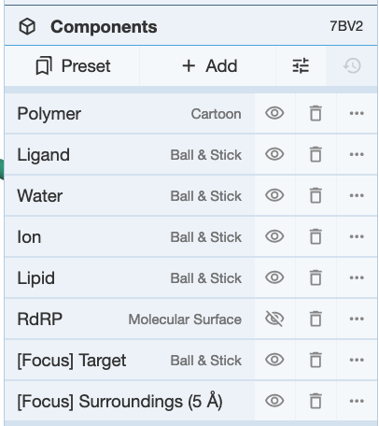 | Hide the molecular surface representation by clicking on the eye icon next to the RdRP component.

  - Orient the molecule to see the neighboring amino acid residues.
  - Examine the non-covalent interactions in the neighborhood. These should be represented as dashed lines of different colors. Mouse over any of these lines to read the type of interaction and residues involved at the bottom right corner of the 3D canvas.
  - Make a note of the residue names (in one letter code) and numbers for all amino acids that are linked to the Remdesivir.

B6. Save an image showing the Remdesivir bound to RdRP in the active site blocking the elongation of the RNA chain. Label any 3 amino acid residues in the RdRP molecule that are close to Remdesivir.

B7. Based on your exploration of the structure above, how do you think Remdesivir blocks RdRP function?

Appendix: Mol* Quick Reference
1. Navigate the 3D Canvas:
a. Rotate
● Press left mouse button and move OR use Shift + left mouse button and drag.
b. Translate
● Press right mouse button and move OR use Control + the left mouse button and move. On a touchscreen device, use a two-finger drag.
c. Zoom
● Use the mouse wheel. On a touchpad, use a two-finger drag. On a touchscreen device, pinch two fingers.
d. Center and zoom
● Use right mouse button to click on the part of the structure you wish to see.
e. Change clipping planes
● Use Shift button + the mouse wheel. On a touchpad, use the Shift button + a two-finger drag.
2. Select: first open Selection Mode and change the Picking Level (if needed)
a. Select Picking Level
● Click on objects in the 3D canvas – such as atoms, residues, chains, etc.
b. Select object in 3D canvas
● Click on residues, chains etc. in the 3D canvas based on picking level
c. Select object from Sequence Panel
● Click on residues, ligands, or entire chain in the Sequence Panel
d. Custom Select combinations
● Use the Set Operations Menu in the Selection Mode toolbar
3. See or Hide:
a. To add representations
- Create a component of the region you wish to see/hide → Go to the Components Panel and press the “eye” icon next to the component you create
b. To hide/remove from view
● Select region you wish to hide → Click on the subtract/hide icon in the Selections toolbar
4. Color:
a. N-terminus to C-terminus (rainbow)
● Components → Polymer → Set Coloring → Residue Property → Sequence Id
b. Heteroatom
● Components → Polymer → Set Coloring → Atom Property → Element Symbol
c. Secondary structure
● Components → Polymer → Set Coloring → Residue Property → Secondary Structure
d. Hydrophobicity
● Components → Polymer → Set Coloring → Residue Property → Hydrophobicity
e. Domain
● Select domain → Selections Menu → Apply Theme to Selection → Color → Apply Theme
5. Compare Structures: first upload two or more structures at rcsb.org/3D-view
a. By chains
● Select 2 or more polymer chains/residues → Superposition → By Chains → Superpose
b. By atoms
● Select 1 or more atoms → Superposition → By Atoms→ Superpose
6. Make Measurements:
a. Distance
● Make 2 or more selections → Measurements → Add → Distance (for first 2 selections)
b. Angle
● Make 3 or more selections → Measurements → Add → Angle (for first 3 selections)
c. Dihedral
● Make 4 or more selections → Measurements → Add → Dihedral (for first 4 selections)

