Bypassing Central Dogma

Learning Objectives: To explore the structure of RNA dependent RNA Polymerase (RdRP) using RCSB Mol*

Introduction
In the early 1950s the double helix model of DNA was used to explain how DNA functions as the genomic material in biology. Following this in the late 1950s Francis Crick proposed the "Central Dogma" of molecular biology - genetic information is transcribed from DNA to messenger RNA and translated to from proteins. While most cells follow this dogma, RNA viruses identified in the 1960s did not have any DNA and yet they were multiplying! This is what led to the discovery of viral RNA dependent RNA polymerases (RdRPs) or RNA replicases. Today we know that RdRPs are found in many different RNA viruses and also in some eukaryotes!

The SARS-CoV-2, a positive strand RNA virus that copies its genome using an RNA dependent RNA polymerase (RdRP). Here we will explore the structure of the enzyme, in complex with RNA and other proteins that help with its function.

Tools
- The exercise will use data from the Protein Data Bank (PDB) and use the RCSB molecular visualization tool Mol* for the visualization and analysis of SARS-CoV-2 RdRP.
- To save images, click on the camera (iris) icon , Download and save a *.jpg file. Import the image in any image manipulation software of your choice (e.g., PowerPoint/ Photoshop) to add labels and additional text describing the images.
- Some key commands and functions of Mol* are included in the Appendix at the end of this document.

Exploration

Find and explore the SARS-CoV-2 RNA dependent RNA Polymerase Model
- Go to RCSB PDB home page (www.rcsb.org) >> in the top search box type “RdRP + SARS-CoV-2” to identify structures to explore. In the list of results returned identify the first released Holoenzyme structure bound to RNA.
Hint: The structure you select for exploration should include the following components
RdRP or Nsp12 + accessory proteins Nsp 7, and Nsp8 + RNA (no drugs e.g., remdesivir)

A1. What is the PDB ID of the entry that you will explore and when was this structure released?

- Type the PDB ID “6yyt” in the top search box >> click enter. This should take you to the Structure Summary Page. This page provides a summary of the components present in the structure and links to the published article describing the structure.

A2. Examine the contents of the page and complete the table below:

PDB ID
Author(s) of entry
Year when the structure was published/released
Structure determination method
Names and numbers of polymer (protein and nucleic acid) chains in the entry
Names of ligands (Small Molecules) present in the structure

- Click on the 3D View tab on the top of the page to view the structure in Mol*

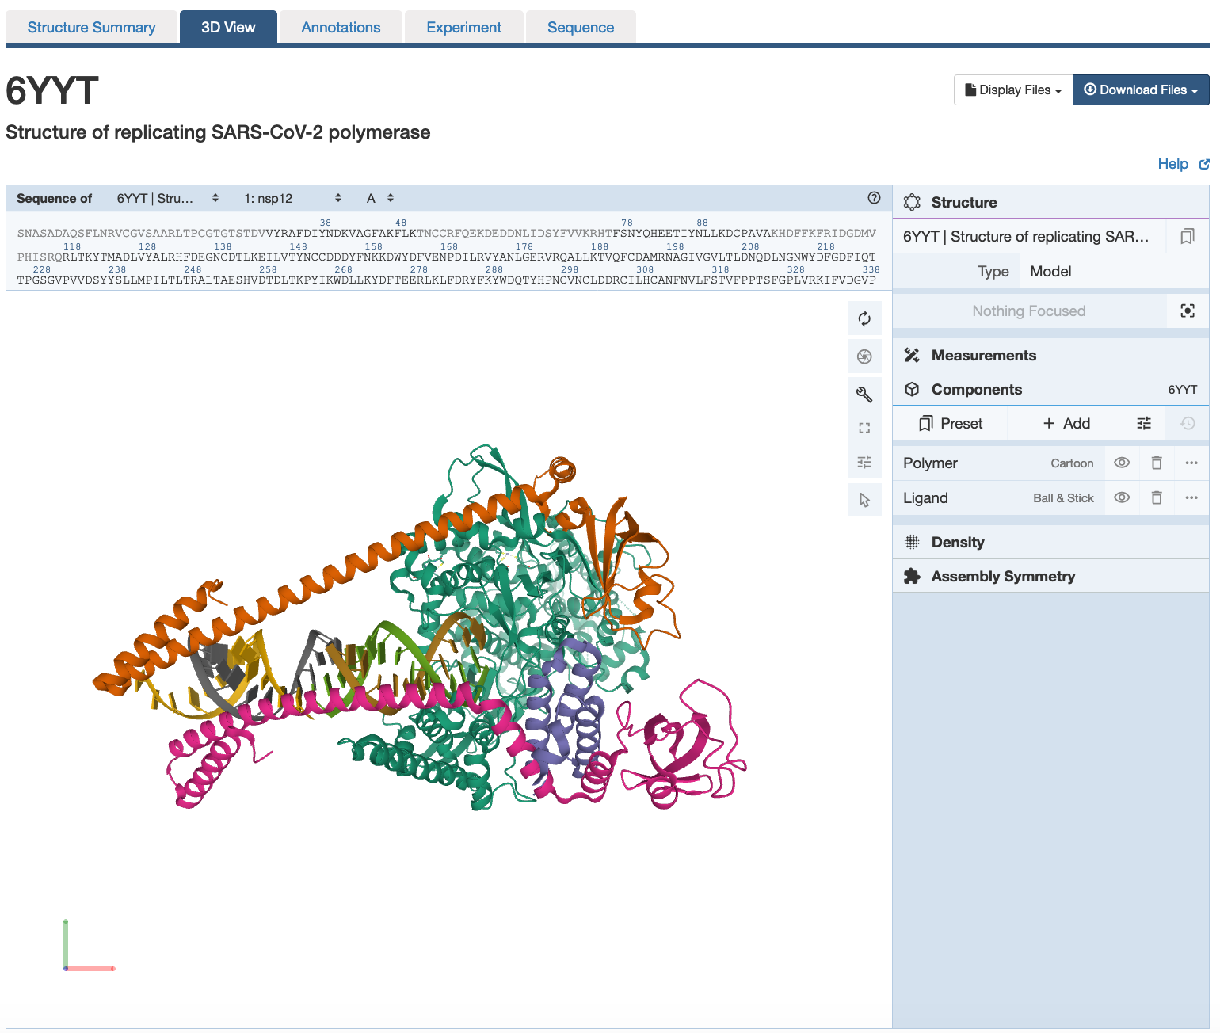 | There are 3 main areas on this screen:  1. Sequence panel (top left)  2. 3D-canvas (white space where the 3D structure is shown). Besides displaying the interactive 3D models, this space also offers  a. Toggle panel (a series of buttons on the right) to enable various functions  b. Log panel (at the bottom of the canvas) records actions taken  3. Control panel (blue column on right) with menus for Structure, Measurements, Components, etc.

- Use various mouse controls to rotate and translate the molecule you are viewing and answer the following questions.
- Note: Hovering the mouse over any object in the 3D canvas will display information about that item in the bottom right corner of the 3D canvas.
- All the protein chains are represented as different colored ribbons with helical regions. The nucleic acids are shown as a spiral ladder.

A3. Are the nucleic acids (RNA) seen in the structure single stranded (unpaired bases) or duplex (base paired)?

A4. What do each of the steps in the ladder represent?

- Explore the structure you are visualizing by showing and hiding its various components*

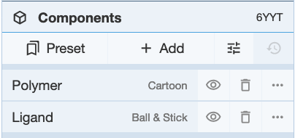 | You can view and hide the polymer (protein chain), ligands, and waters (if any) by clicking on the eye icons in the component panel.  *Note a component is any grouping of atoms/ residues/ ligands/ chains etc. in the structure. In the default settings, all polymers (protein and nucleic acid chains) are grouped under the Polymer component; all ligands are included in the Ligands component and all water molecules are in the Water component. Additional components (groupings) can be made and added to this list (described later).

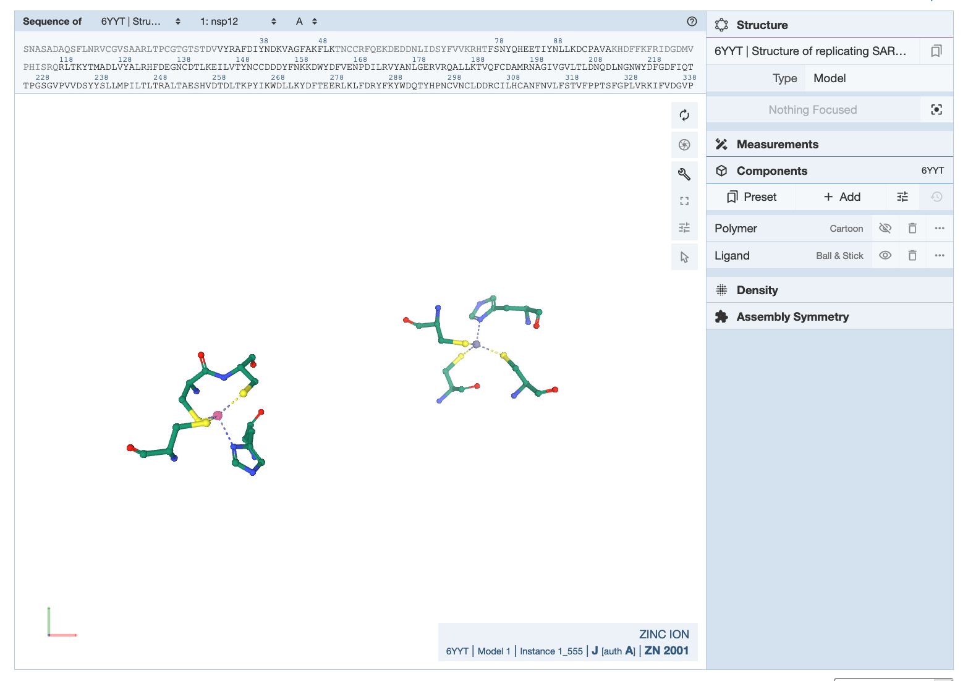 | Hide the polymer component to reveal the ligands present in the structure.  Note: you may have to click on the atoms to zoom in and see a close up of the ligands

A5. Which ligand(s) is/are present in the Ligand component in this structure?

- Display the RdRP protein showing its molecular surface to see how the RNA and accessory proteins interact with it. Use the following steps.

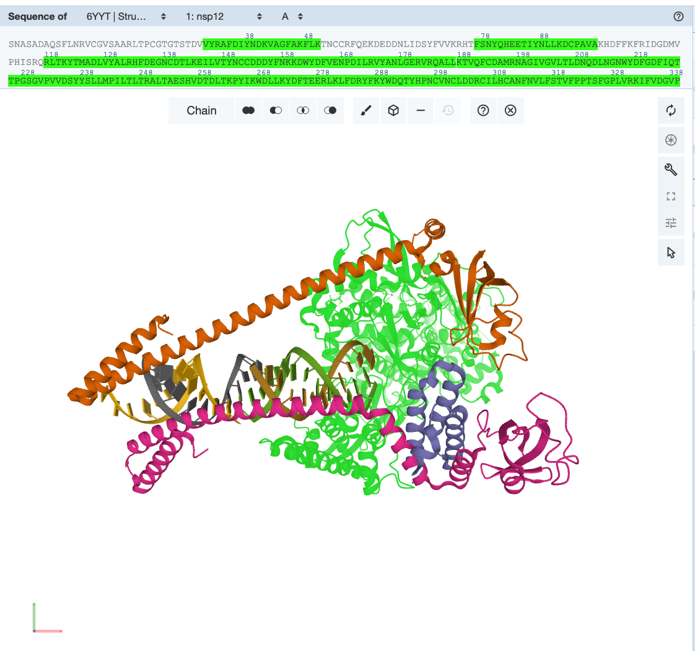 | Activate the selection mode by clicking on the arrow icon 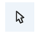in the Toggle panel >> Click on the pull down menu under the word Residue in the Selection options menu (in the top of the 3D canvas). Change the selection level to Chain. >> Click on any atom in the nsp12 (RdRP) protein to select the whole chain. The entire chain will be highlighted with a green halo (see figure)
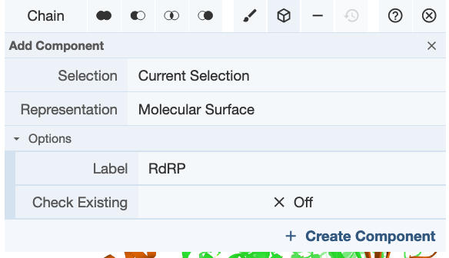 | Create a component with this selection by clicking on the Cube icon 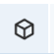 >> Select Representation molecular surface >> Label it “RdRP” >> click on Create Component.

A6. Save an image, label the key polymers in the structure and include it below:

A7: Which protein(s) shown above interact(s) with the RNA? Name it/them

Making new RNA

- The Nsp12 has two functions -
  - the N-terminal portion (amino acids 1-250) is a nucleotidyltransferase, and
  - the C-terminal part (amino acids 398-932) has the RdRP activity (focus of this section).
- Color the RdRP component according to the rainbow color scheme or by residue sequence id

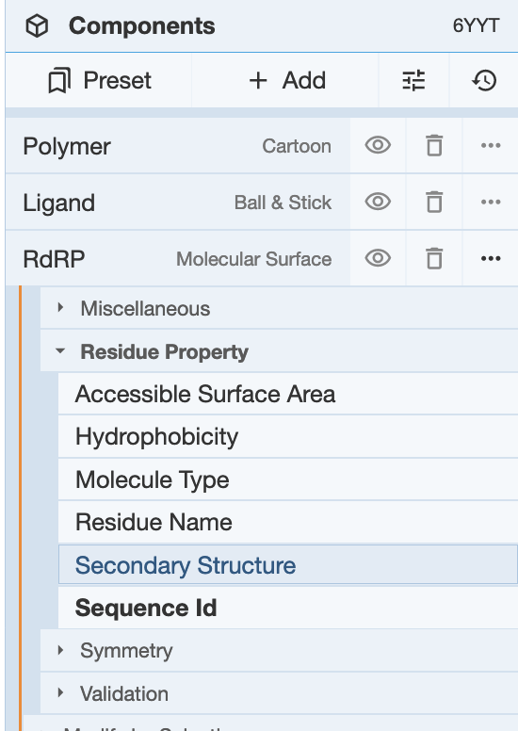 | Click on the 3-dots in the far right for the RdRP component … >> Set Coloring >> Residue property >> Sequence ID.

  - The molecular surface should be colored so that the N-terminal region is colored in various shades of blue, while the C-terminal region is colored in yellow, orange and red.
  - Save an image and include it below:

- Explore this region of the protein to understand how the RNA dependent RNA polymerase functions.
  - Rotate the structure so that you can look down the helix axis of the RNA double helix. Save an image of the structure in this orientation
  - The RdRP region is shaped like a right hand with fingers, palm, and thumb subdomains. In the above colored figure, imagine that the RNA double helix is sitting in an open human right-hand palm. The C-terminal, red colored region, forms the thumb of the hand and the yellow/orange regions form the palm.
  - The ribbon structures of one of the Nsp8 molecules is positioned above the thumb, while the other is on the fingers.

B1. Label the thumb, palm, fingers, RNA, and Nsp 8 and include it below.

- The RNA included in the structure that you are exploring (10.1038/s41586-020-2368-8) was very carefully designed - a single chain with sequence 5′-UUUUCAUGCUACGCGUAG-3′

B2. Fill in the bases in complementary bases for the bolded region and then write the complementary strand sequence starting from the 5’ end.

5’ | C | A | U | G | C | U | A | C | G | C | G | U | A | G | 3’
3’ | G | U | A | C |  |  |  |  |  |  |  |  |  |  | 5’

- New RNA nucleotides are added to the 3’ end of the RNA strand. Locate the 3’ end of the RNA chains that is positioned within the RdRP active site as follows. Deactivate the Selection mode by clicking on the arrow icon in the Toggle panel.
  - Explore the structure of displayed in the 3D Canvas and mouse over the RNA and click on the 3’ end of Chain E
OR
  - In the sequence panel, use the pulldown menus to display the sequence of the RNA chain E. Click on the 3’ end of Chain E.
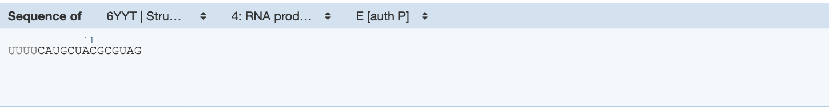

B3. Is the nucleotide that you clicked on, base paired or is it unpaired? If paired list which nucleotide it pairs with.

- Examine the neighborhood of the 3’ end of the RNA to explore the RdRP active site.
  - Save an image of the region

B4. Label the saved figure to indicate the nucleotides listed in Ans B3.
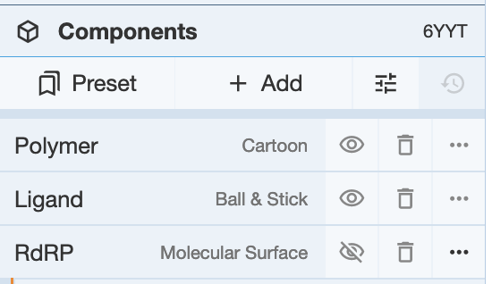 | Hide the molecular surface representation by clicking on the eye icon next to the RdRP component.

  - Orient the molecule to see the neighboring amino acid residues.
  - Examine the non-covalent interactions in the neighborhood. These should be represented as dashed lines of different colors. Mouse over any of these lines to read the type of interaction and residues involved at the bottom right corner of the 3D canvas.
  - Make a note of the residue names (in one letter code) and numbers for all amino acids that are linked to the 3’ end of the RNA chain E for marking in the figure

B5. Save an image showing the RdRP active site with the growing end of the RNA chain. Label any 4 amino acid residues in the RdRP molecule that are close to the 3’ end of the RNA chain.

- One of the conserved sequence motifs in the catalytic site of RdRPs is a sequence of two consecutive Aspartate amino acids.

B6. Based on your exploration of the active site, list the amino acid residues that form part of the catalytic motif.

Appendix: Mol* Quick Reference
1. Navigate the 3D Canvas:
a. Rotate
● Press left mouse button and move OR use Shift + left mouse button and drag.
b. Translate
● Press right mouse button and move OR use Control + the left mouse button and move. On a touchscreen device, use a two-finger drag.
c. Zoom
● Use the mouse wheel. On a touchpad, use a two-finger drag. On a touchscreen device, pinch two fingers.
d. Center and zoom
● Use right mouse button to click on the part of the structure you wish to see.
e. Change clipping planes
● Use Shift button + the mouse wheel. On a touchpad, use the Shift button + a two-finger drag.
2. Select: first open Selection Mode and change the Picking Level (if needed)
a. Select Picking Level
● Click on objects in the 3D canvas – such as atoms, residues, chains, etc.
b. Select object in 3D canvas
● Click on residues, chains etc. in the 3D canvas based on picking level
c. Select object from Sequence Panel
● Click on residues, ligands, or entire chain in the Sequence Panel
d. Custom Select combinations
● Use the Set Operations Menu in the Selection Mode toolbar
3. See or Hide:
a. To add representations
- Create a component of the region you wish to see/hide → Go to the Components Panel and press the “eye” icon next to the component you create
b. To hide/remove from view
● Select region you wish to hide → Click on the subtract/hide icon in the Selections toolbar
4. Color:
a. N-terminus to C-terminus (rainbow)
● Components → Polymer → Set Coloring → Residue Property → Sequence Id
b. Heteroatom
● Components → Polymer → Set Coloring → Atom Property → Element Symbol
c. Secondary structure
● Components → Polymer → Set Coloring → Residue Property → Secondary Structure
d. Hydrophobicity
● Components → Polymer → Set Coloring → Residue Property → Hydrophobicity
e. Domain
● Select domain → Selections Menu → Apply Theme to Selection → Color → Apply Theme
5. Compare Structures: first upload two or more structures at rcsb.org/3D-view
a. By chains
● Select 2 or more polymer chains/residues → Superposition → By Chains → Superpose
b. By atoms
● Select 1 or more atoms → Superposition → By Atoms→ Superpose
6. Make Measurements:
a. Distance
● Make 2 or more selections → Measurements → Add → Distance (for first 2 selections)
b. Angle
● Make 3 or more selections → Measurements → Add → Angle (for first 3 selections)
c. Dihedral
● Make 4 or more selections → Measurements → Add → Dihedral (for first 4 selections)

