# **DNA Conformations: A-, B-, Z-DNA**

**Author**: Alexandra Pettit, Carleton University, Ottawa, Ontario, Canada and Shuchismita Dutta, Rutgers University, NJ

**ASBMB Learning Objectives**

(<https://www.asbmb.org/education/core-concept-teaching-strategies/foundational-concepts/structure-function>)

1. Biological macromolecules are large and complex

* Students should be able to **describe the basic units of the macromolecules** and the types of linkages between them *(Introductory)*.

2. Structure is determined by several factors

* Students should be able to **recognize the repeating units in biological macromolecules** and be able to discuss the structural impacts of the covalent and noncovalent interactions involved *(Introductory)*.

## About DNA

* Deoxyribonucleic acids (or DNA) molecules are made by **covalently linking together a number of nucleotides** in a specific order (the DNA sequence).
* Nucleic acids (NA) are directional molecules that have a beginning (called 5’) and an end (called 3’ end) - see Figure 1A and B.
* The majority of DNA in cells is **double helical**, composed of two **antiparallel strands** (i.e., the two DNA strands are oriented in opposite directions) - see Figure 1.
* The phosphodiester backbone is on the outside, while the nitrogenous bases are on the inside - see Figure 1
* The double helix is stabilized by **hydrogen bonds** between the nitrogenous bases and **stacking interactions** between them.
* In cells **DNA synthesis** occurs both in the nucleus and mitochondria. The DNA polymerase enzyme uses a template strand to create a new strand by adding nucleotides to the growing end of the polymer. The new nucleotide added is selected to be complementary to the template strand of DNA
* Specific enzymes called **Nucleases** can break the phosphodiester bonds in DNA. Some nucleases act at specific sites in the DNA (e.g., Eco RI restriction enzyme) while others remove nucleotides from one end of the nucleic acid (e.g., exonucleases).

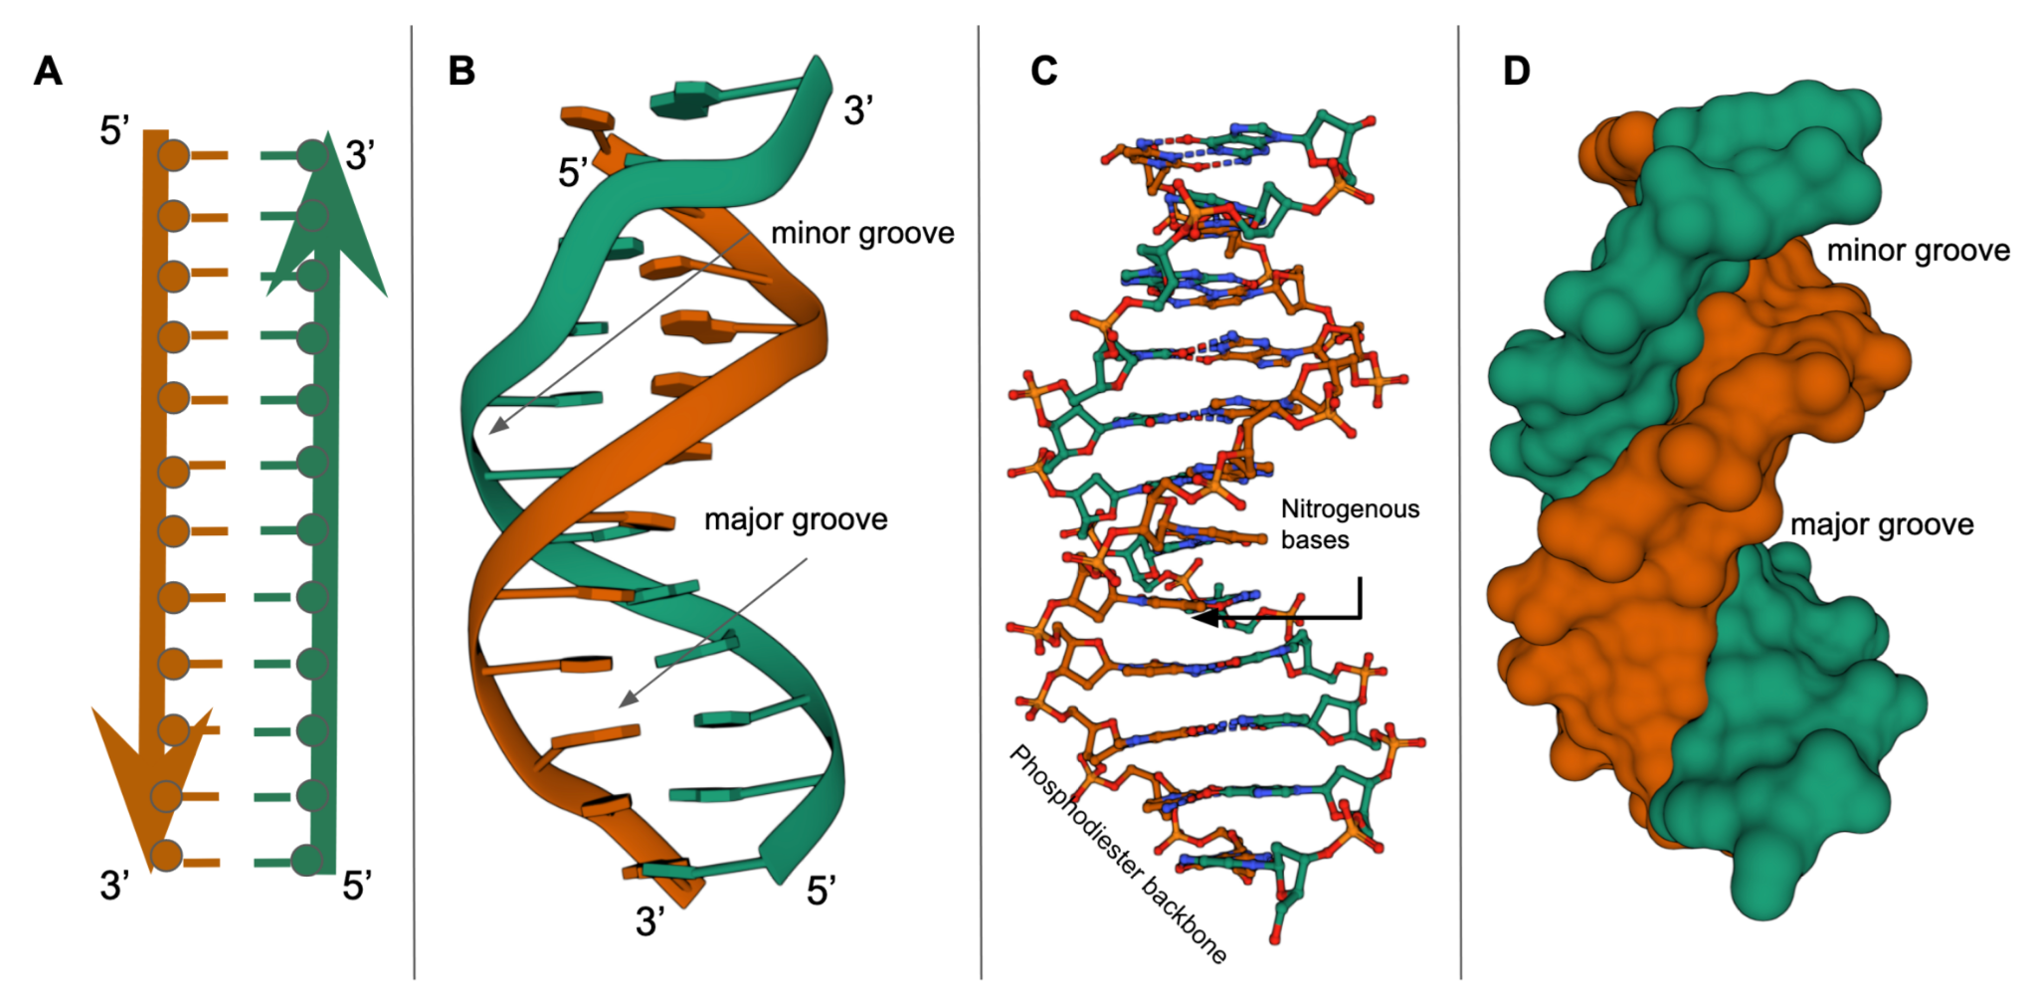

*Figure 1. Double helical DNA: A. a linear representation of 2 strands of DNA showing 5’ to 3’ direction, phosphodiester backbone on the outside and bases on the inside; B Cartoon representation of double helical DNA (PDB ID 1bna) where the phosphodiester backbone is shown as a orange and green ribbons and the bases form a ladder-like structure. The major and minor grooves in the double helix are labeled; C. Ball and stick representation of the same view of double helical DNA as in 1B; D. Surface representation of the same view of double helical DNA as in 1B.*

## Conformations of DNA

There are three conformations commonly adopted by double helical DNA - **A-, B-,** and **Z-DNA**.

* The presence of these conformations can be identified by visualizing the structure to look for specific structural features or determined computationally, using the [DNATCO](https://dnatco.datmos.org/) server. This tool is also available from [Nucleic Acid Knowledgebase (NAKB)](https://beta.nakb.org/).
* Knowledge of nucleic acid conformation can help identify how it interacts with other molecules in the cell (e.g., regulatory proteins, other nucleic acids, ligands, and drugs).

Guidelines for visualizing and recognizing these conformations are included here.

### **A-DNA**

#### What is A-DNA?

This conformation of DNA

* forms a right-handed double helix
* is favored in dehydrated (low water) or high salt conditions (e.g., in DNA fibers)
* is commonly found in most RNA and RNA-DNA hybrid helices

#### Structural Properties: A-DNA helices

* are wider (and shorter) than B-DNA - see Figure 2A and 5
* have bases positioned away from the helix axis - see Figure 2C
* have base pairs that are tilted with reference to the helix axis - see Figure 2A
* have a deep, narrow major groove not easily accessible to proteins and a wide, shallow minor groove accessible to proteins - see Figures 2A, B, and E.

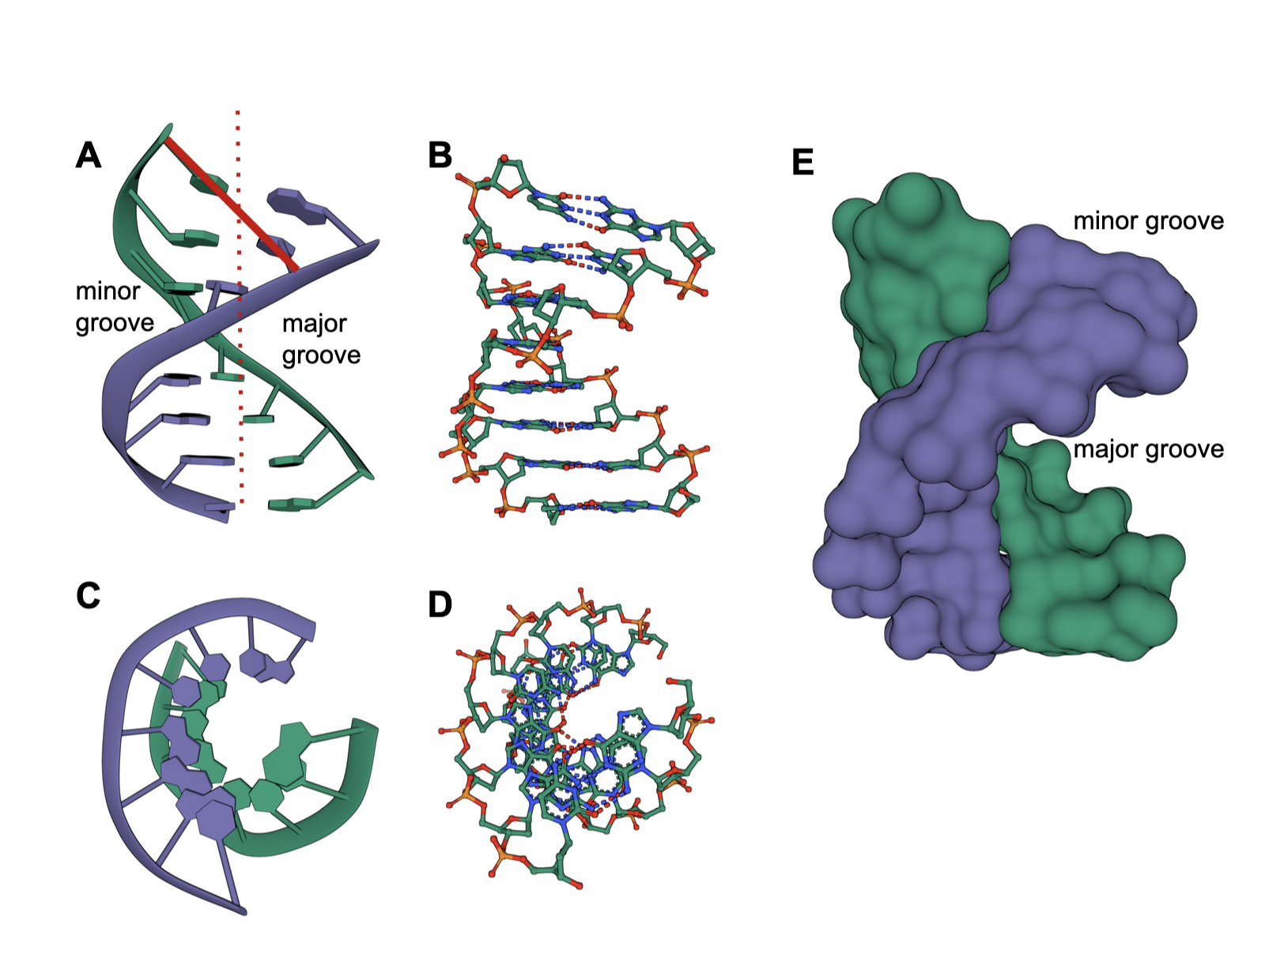

*Figure 2: Various representations of an A-DNA (PDB ID* [*9dna*](https://www.rcsb.org/structure/9DNA)*). A. cartoon representation of the double helix looking from the side, with the helix axis shown in a red dotted line; B. ball and stick representation of the same molecule and view as in 2A; C. cartoon representation of the double helix looking down the helix axis; D. ball and stick representation of the same molecule and view as in 2C ; E. spacefill representation of the same molecule and view as in 2A.*

#### Examples of A-DNA structures

* DNA alone - PDB ID [6l75](https://www.rcsb.org/structure/6L75)
* DNA-RNA hybrid - PDB ID [7nrp](https://www.rcsb.org/structure/7NRP)
* DNA-protein complex - PDB [6nju](https://www.rcsb.org/structure/6NJU)

### **B-DNA**

What is B-DNA?

This conformation of DNA:

* forms a right- handed double helix
* is the most common DNA conformation *in vivo*
* is stable under a variety of conditions but is favored in high water concentrations.

#### Structural Properties: B-DNA helices

* are narrower (more elongated) than A-DNA - see Figure 3A and 5
* have bases positioned towards the center of the helix axis - see Figure 3C
* have base pairs that are perpendicular to the helix axis - see Figure 3A
* have a wide major groove that is easily accessible to proteins and a narrow minor groove - see Figures 3A, B, E

#### 

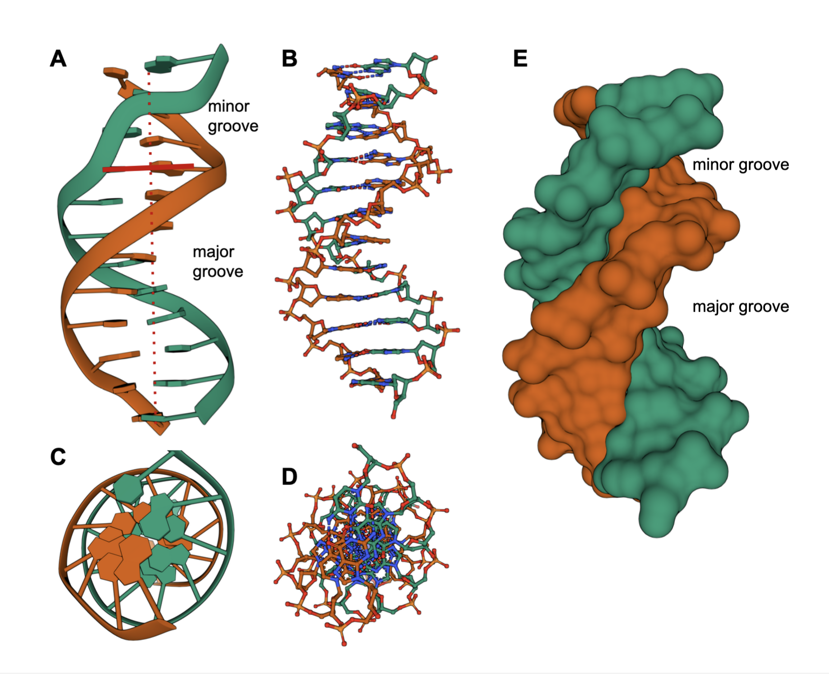

*Figure 3: Various representations of a B-DNA (PDB ID* [*1bna*](https://www.rcsb.org/structure/1BNA)*): A. cartoon representation of the double helix looking from the side, with the helix axis shown in a red dotted line; B. ball and stick representation of the same molecule and view as in 3A; C. cartoon representation of the double helix looking down the helix axis; D. ball and stick representation of the same molecule and view as in 3C ; E. spacefill representation of the same molecule and view as in 3A.*

#### Examples of B-DNA structures

* DNA alone - PDB ID [5ewb](https://www.rcsb.org/structure/5EWB)
* DNA-protein complex - PDB ID [7eds](https://www.rcsb.org/structure/7eds)

### **Z-DNA**

What is Z-DNA?

This conformation of DNA

* forms a left-handed double helix
* can be formed *in vivo* when the DNA has a specific sequence [e.g., alternating purine-pyrimidine - such as (GC)n] and appropriate water/salt conditions

#### Structural Properties: Z-DNA helices

* are narrower (and more elongated) than A or B-DNA - see Figure 4A and 5
* have a zig-zag backbone
* have bases positioned away from the helix axis and close to the periphery of the helix- see Figure 4C
* have base pairs that are nearly perpendicular to the helix axis - see Figure 4A
* have a major groove that is not really a groove and a narrow minor groove - see Figures 4A, B, and E.

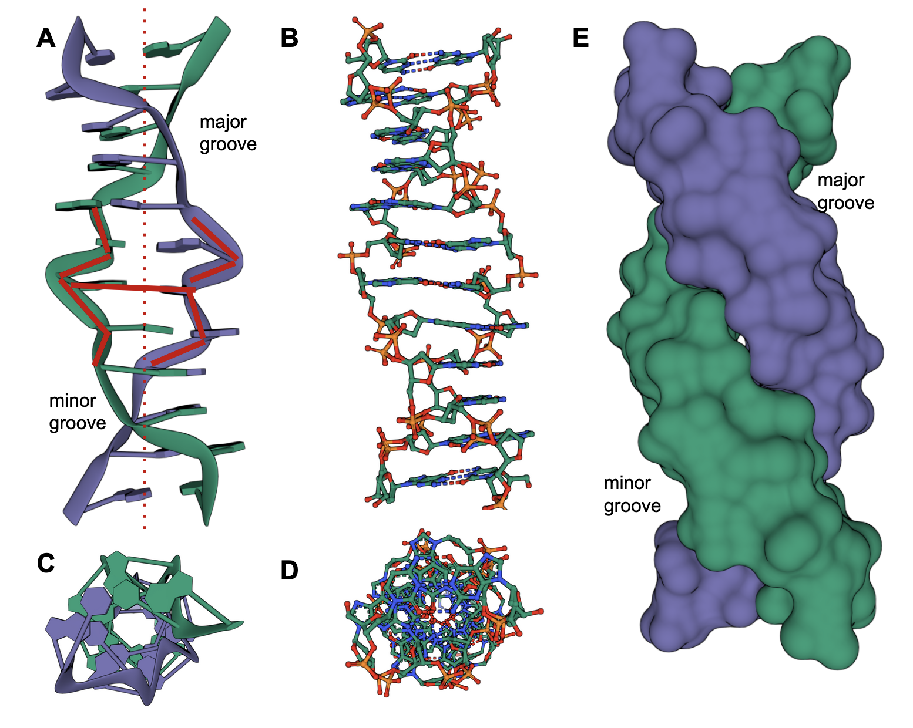

*Figure 4: Various representations of a B-DNA (PDB ID* [*4ocb*](https://www.rcsb.org/structure/4OCB)*): A. cartoon representation of the double helix looking from the side, with the helix axis shown in a red dotted line; B. ball and stick representation of the same molecule and view as in 4A; C. cartoon representation of the double helix looking down the helix axis; D. ball and stick representation of the same molecule and view as in 4C ; E. spacefill representation of the same molecule and view as in 4A.*

#### Examples of Z-DNA structures

* DNA alone - PDB ID [1dn5](https://www.rcsb.org/structure/1DN5)
* DNA-protein complex - PDB ID [1sfu](https://www.rcsb.org/structure/1SFU).

## Summary

The A-, B-, and Z-DNA structures shown below summarize how the first two form a right-handed helix, while the last forms a left-handed helix.

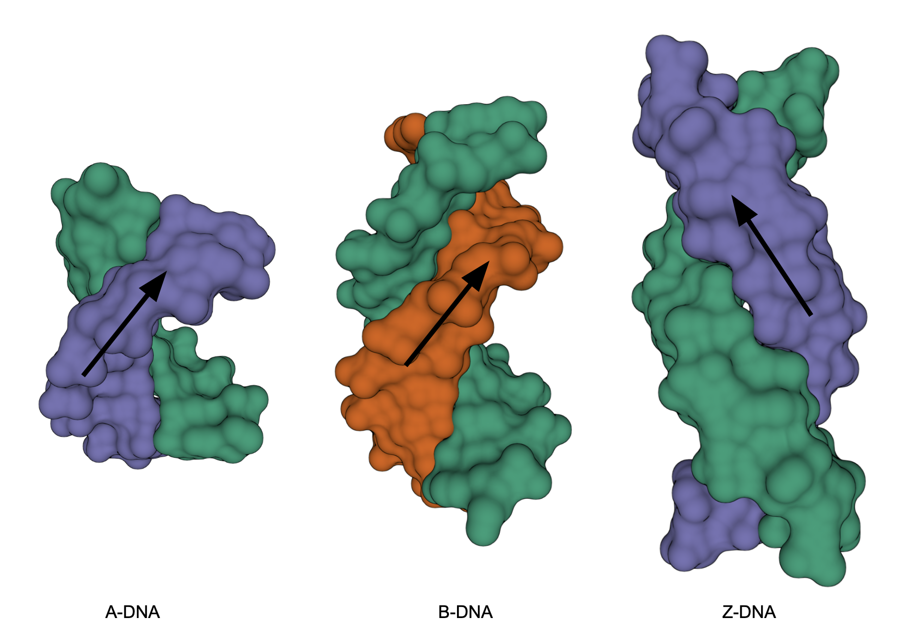

*Figure 5: Comparison of A-, B-, Z-DNA.*