Name _____________________________________________________________ Date ________________

Exploring the Structure and Functions of Catalase

Catalases are enzymes that convert hydrogen peroxide in cells into water and oxygen gas. Read the Molecule of the Month feature on Catalase (http://pdb101.rcsb.org/motm/57). This could be assigned reading, in preparation for the class.

Q1. Complete the following sentences:
- Catalases are very efficient enzymes. They are found in which of the following organisms:
  - Bacteria
  - Plants
  - Animals
  - All of the above
- Catalases use ___________________________ions to assist in their speedy reaction.
- Since the substrates for catalases are reactive molecules, they themselves are very __________________________________ (choose from reactive/stable?) molecules.

Overview:
In this activity you will explore the structure of catalase and attempt to understand its structure-function relationship. You will also explore the conservation catalase structure and function through evolution (compare bacterial and human enzymes).

Learning Goals:
- Visualize the structure of a given molecule using RCSB PDB resources
- Explore the structure to understand its structure-function-evolutionary relationships

Exercise:
The molecular visualization software, UCSF Chimera, is freely available to academic users from http://www.cgl.ucsf.edu/chimera/. Instructions for downloading/installing the software and documentation for using it are also available from this site.
This worksheet provides instructions for visualization of a PDB entry, where you will learn to do the following:
- Fetch/load a PDB coordinate file
- Select specific regions of the coordinates
- Display the atomic coordinates in various formats
- Compare structures or two (or more) PDB entries to learn about their functions and/or evolutionary relationships
To save images that you make, select File… Save Image …, provide a file name. While you can label atoms and residues in Chimera, it may be easier to import the saved image to a document or power point where you can add labels and include additional text to describe the images.

Exploring the Structure of Catalase

Launch the Chimera program and load PDB entry 1dgb. This is the structure of human erythrocyte (red blood cell) catalase enzyme. Assuming your machine is connected to the internet, choose from the “File” menu File… Fetch by ID, type 1dgb in the box, (make sure that the radio button next to “PDB” is selected), and then click “Fetch.” You should see a ribbons view of the structure as follows:
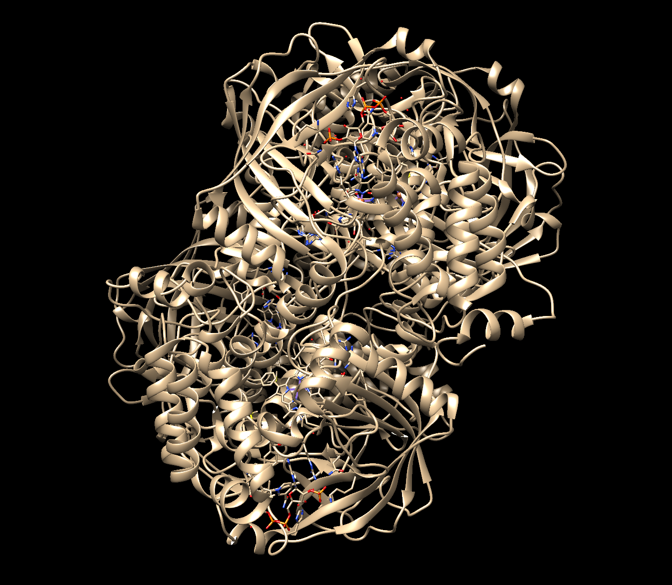
Color the ribbons (seen above) according to secondary structural elements as follows:
Choose Tools… Depiction… Color Secondary Structure from the menu. This should launch a new window with the helix and sheet color code (shown below):
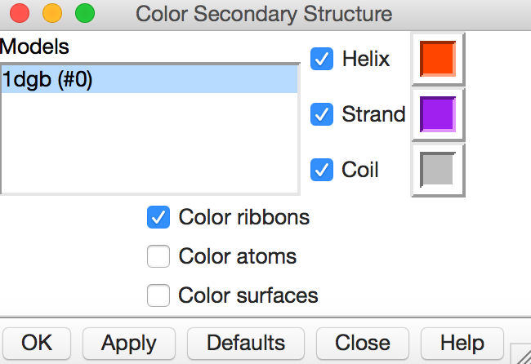
Note that the specific colors may be different in your installation. You can click on the colored box to change it to another color. When you click on Apply you should see the following in your structure display window.
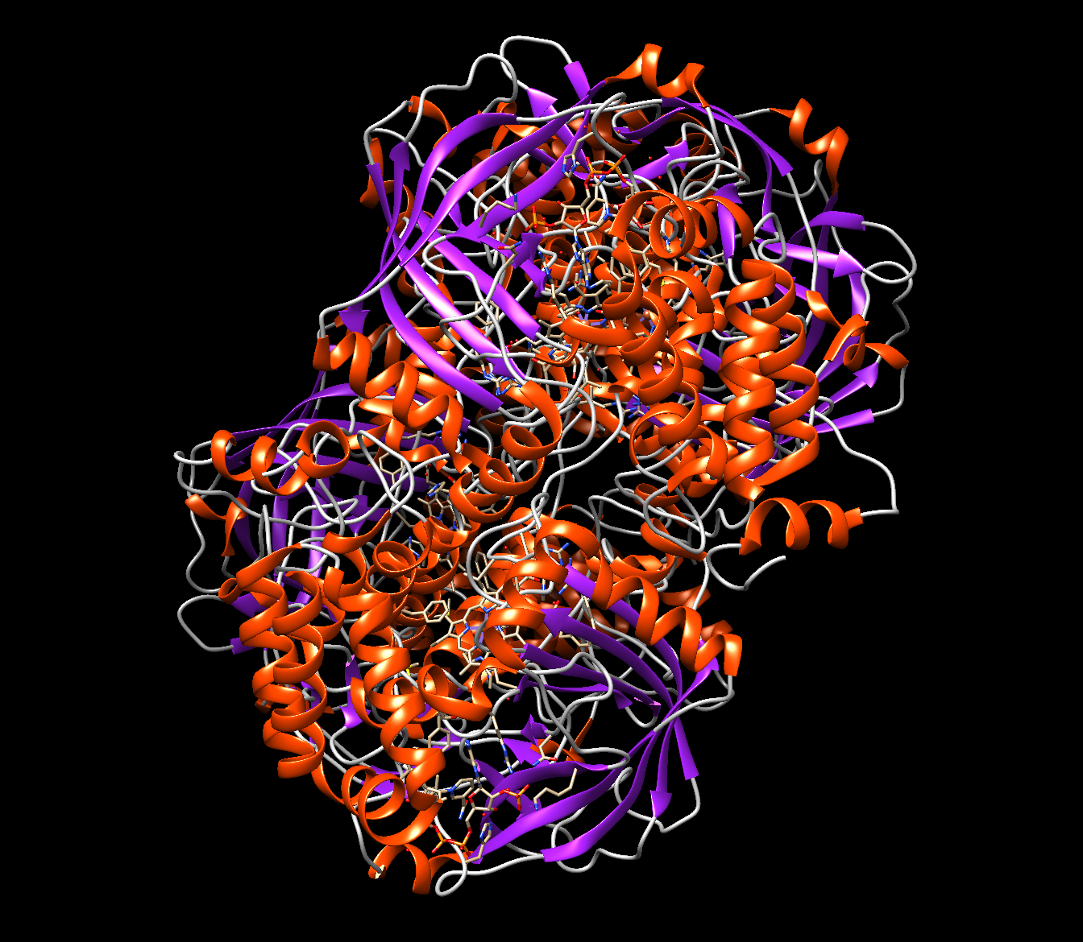
Q2. What is the predominant secondary structural element seen in the human catalase structure?

Color all chains in the structure in a different color. Choose Tools… Depiction… Rainbow from the menu. This should launch a new window with various Rainbow coloring options as shown here.
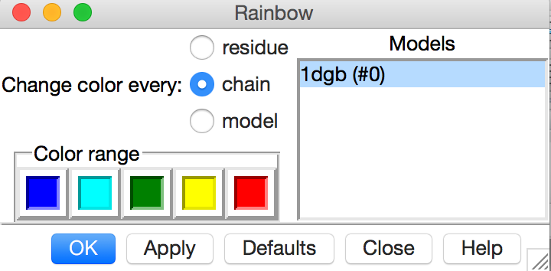
Select the Rainbow color scheme by chain. Click on the Apply button. You should see something like the following:
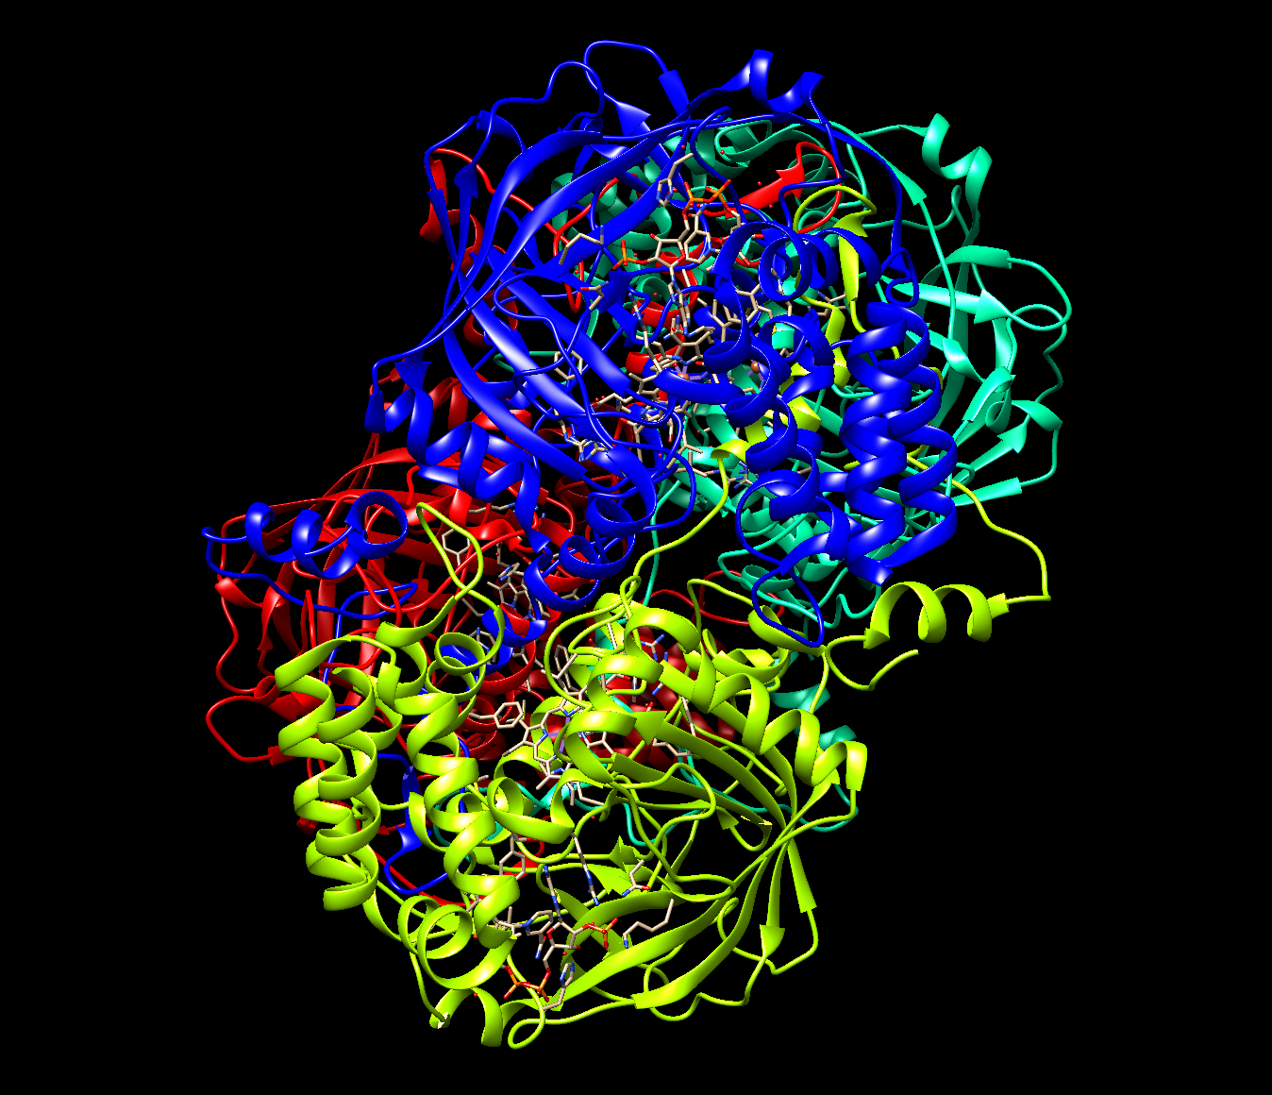

Move the molecule display to see the structure of this molecule as shown below:
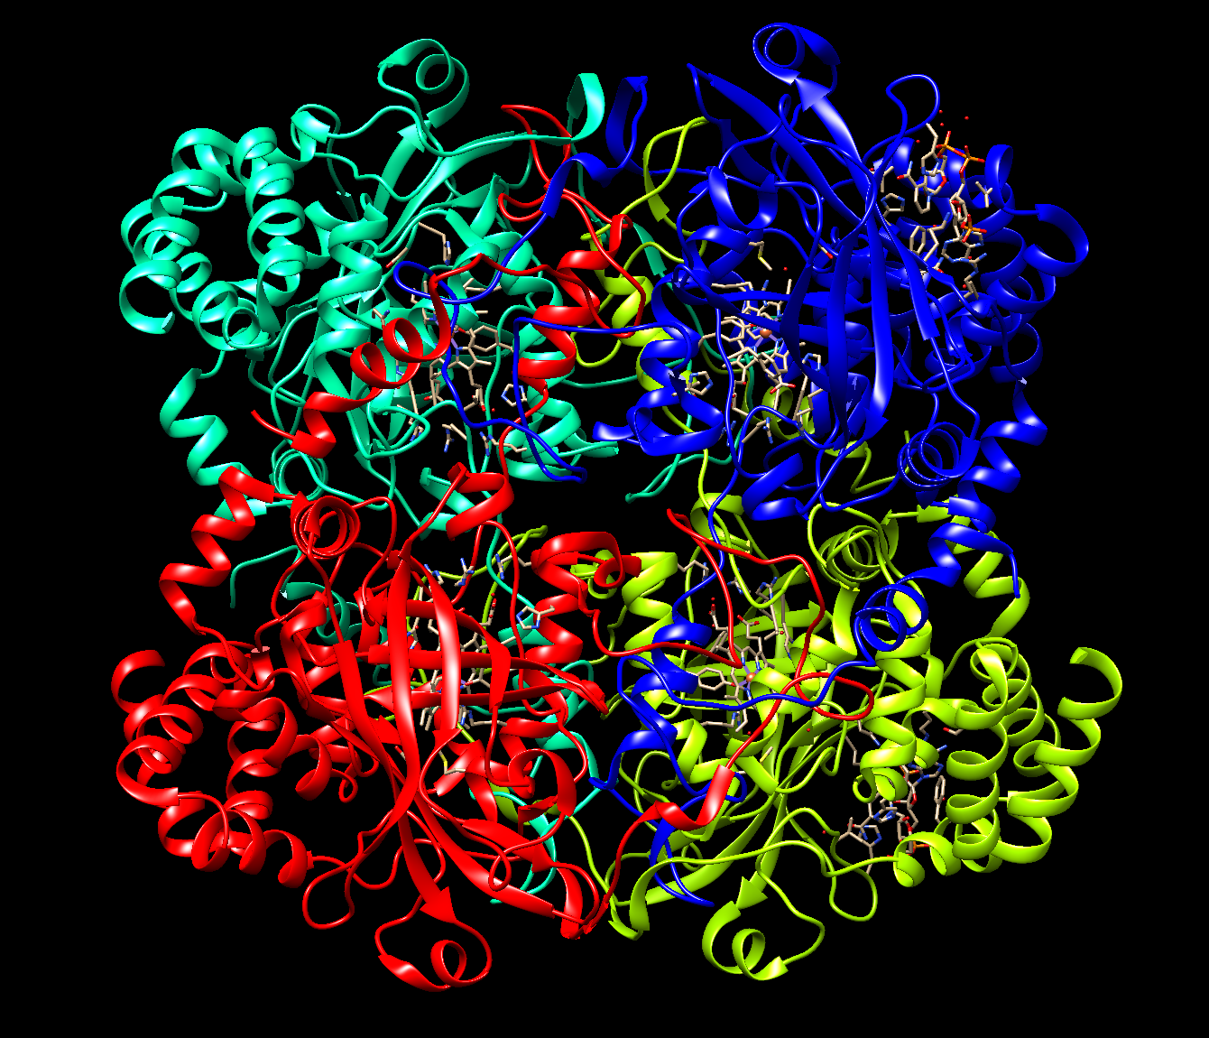

Q3. Describe the composition of Catalase (as seen in this structure) –
- How many protein chains are there?
- Are there any small molecule ligands associated with the enzyme?
- Which ones and how many?
- Save an image of the structure highlighting the above components of the structure – protein chains, and small molecule ligands.
(Hint: In addition to examining the structures, read through the macromolecule and ligands sections of the RCSB PDB structure summary page for the answers).

Based on the “Molecule of the Month” article on Catalase, the Heme group plays a key role in the catalysis. To learn more about how the enzyme works, select the HEM residues in the molecule and focus on the Heme bound to any one of the protein chains (e.g. chain A) –
Menu Select … Residue … HEM;
Menu Select … Selection mode … Intersect;
Menu Select … Chain A

Only 1 heme group should be selected after these steps as shown below:
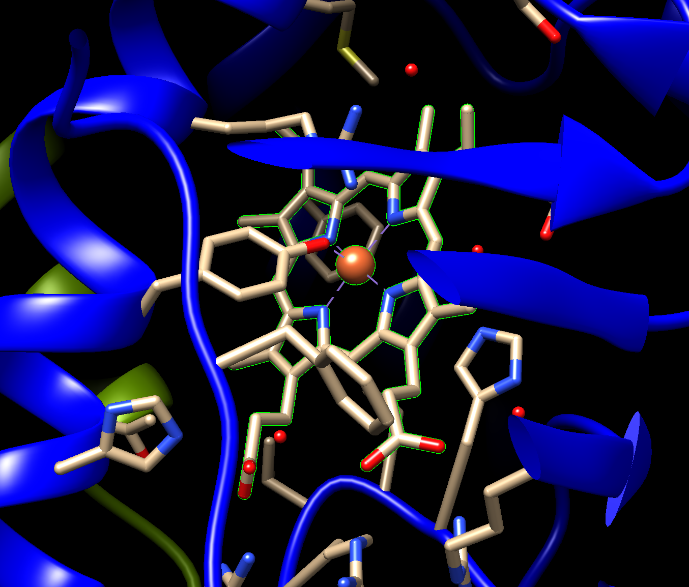

Keep this selection and examine the residues neighboring the Heme group (HEM ligand) -
Menu Select … Selection mode … Replace
Menu Select … Zone … you should see a box with selection options. Set options as follows:
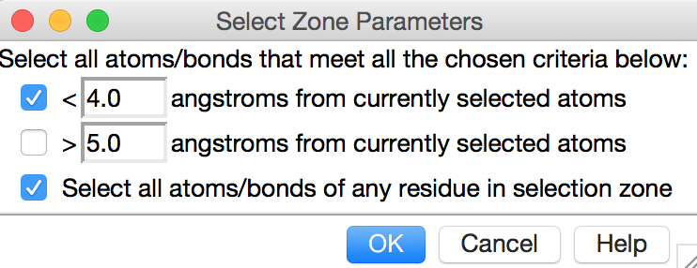
Click on OK to see some residues highlighted with a green halo. Show the side chains of these residues by Menu Actions … Atoms/Bonds … Show

Q4. Name a few amino acid residues that are positioned within 4 angstroms of the heme group (HEM) in Catalase. (Hint: use the visualization tool above to identify these amino acid residues).

Q5. Based on the above visualization, what is the importance of Tyr358 in the Catalase structure? (Hint: locate this residue in the vicinity of the Heme group)

Compare the structures of human erythrocyte Catalase with that from the bacteria, called Proteus mirabilis, (see PDB entry 2cag).

Upload the coordinates of the bacterial enzyme in the same Chimera session as the human protein and superimpose the structures.
Choose File… Fetch by ID… and type 2cag in the box
Choose Tools… Structure Comparison… Matchmaker This brings up the structure alignment window
Under the Chain pairing section click on the option “Specific chain in reference structure with best-aligning chain in match structure” Now the chain options are listed above.
On the left side of the new window, under Reference Structure, highlight 1dgb chain A by clicking it once, then select structure 2cag in the right hand section (structure to match). Now press OK or Apply
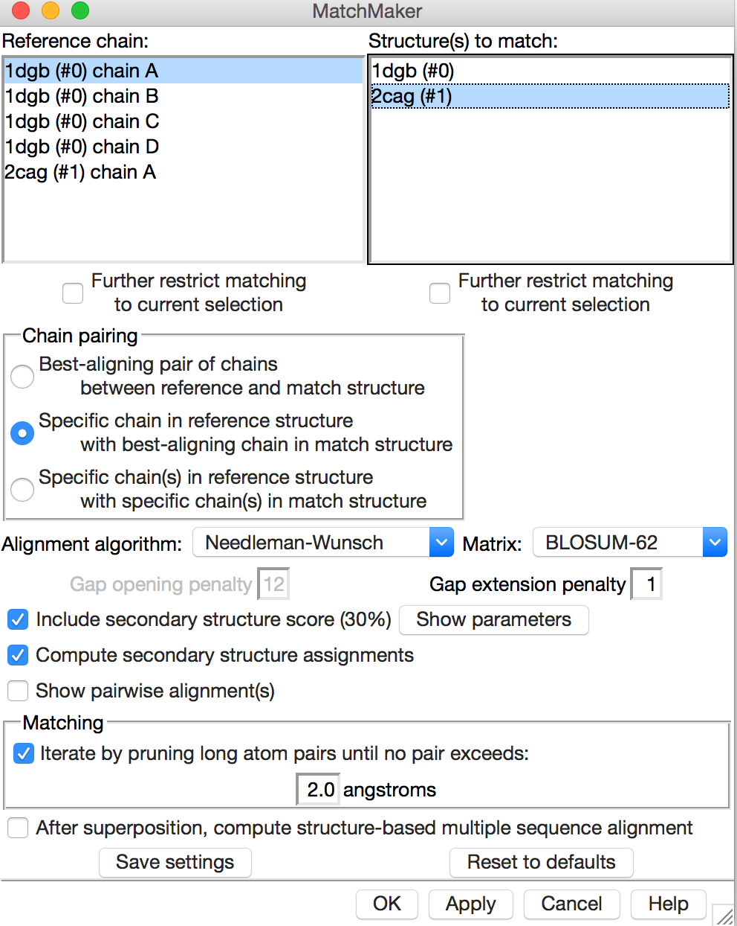
After a few moments, the 2cag ribbons should move on top of the human catalase protein structure ribbons. Look at the superposition and answer the following questions:

Q6. Show an image of the overlapped structures. How well do these structure overlap? (Hint: Zoom back to see the full chain and how all parts of the chain overlap).

Open the sequence comparison window as follows: Tools… Structure Comparison… Match -> Align… This will open the Create Alignments from Superposition window. Select the chains that are superposed (chains A of both structures) and click on OK. The sequence alignment will show up.
Use the Info… Percent Identity… options in this new window to find the percentage identity between these 2 chains.

Note: If you click and drag in the MultiAlignViewer window, the corresponding part of the structure will be highlighted in green. This option can be used to study the sequence comparisons.

Q7. Do you think that the sequences of bacterial and human catalase are very similar? How do the structures compare (i.e. what is the percentage identity between these chains?)

Homework:
Q8. If the structure in PDB entry 2cag represents a reaction intermediate, what do you think the mechanism of action of catalase is? (Hint: Read the Molecule of the Month article to review the reaction mechanism. The oxygen bound to the Heme group of the bacterial enzyme structure provides a clue).

Extension and Enrichment:
Q9. (Challenge question)
Low levels or non-functionality of catalase has been attributed to be a cause of Type 2 Diabetes. What do you think is the connection between Catalase and Diabetes? (Hint: think about Oxidative Stress and metabolic disorders such as Diabetes)

To learn more about manipulating, selecting and analyzing the structures loaded in Chimera explore the UCSF Chimera documentation at http://www.cgl.ucsf.edu/chimera/docindex.html.

