Name _____________________________________________________________ Date ________________

Exploring the Structure and Functions of Catalase

Catalases are enzymes that convert hydrogen peroxide in cells into water and oxygen gas. Read the Molecule of the Month feature on Catalase (http://pdb101.rcsb.org/motm/57). This could be assigned reading, in preparation for the class.

Q1. Complete the following sentences:
- Catalases are very efficient enzymes. They are found in which of the following organisms:
  - Bacteria
  - Plants
  - Animals
  - All of the above
- Catalases use ___________ ions to assist in their speedy reaction.
- Since the substrates for catalases are reactive molecules, they themselves are very _________________ (choose from reactive or stable) molecules.

Overview:
In this activity you will explore the structure of catalase and attempt to understand its structure-function relationship. You will also explore the conservation catalase structure and function through evolution (compare bacterial and human enzymes).

Learning Goals:
- Visualize the structure of a given molecule using RCSB PDB resources
- Explore the structure to understand its structure-function-evolutionary relationships

Exercise:
- The molecular visualization Mol* is freely available to all users from www.rcsb.org.
- This worksheet provides instructions for visualization of a PDB entry, where you will learn to do the following:
  - Visualize the 3D structure of biomolecules using coordinates available from PDB.
  - Display the atomic coordinates in various formats.
  - Examine the structural details and interactions of specific regions of the structure.
  - Compare structures – superpose 2 (or more) structures
- To save images, click on the camera (iris) icon , Download and save a *.jpg file. Import the image in any image manipulation software of your choice (e.g., PowerPoint/ Photoshop) to add labels and additional text describing the images.
- Note: when you hover the cursor over any amino acid residue in the structure, if 2 sets of numbers are displayed, the first number is an internal PDB number and the second set is what matches the numbers assigned by the author (and included in the published literature).
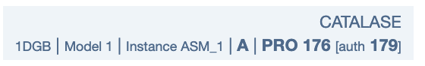
- Some key commands and functions of Mol* are included in the Appendix at the end of this document.

Exploring the Structure of Catalase

Human Catalase, found in red blood cells, is a heme containing enzyme that helps break down hydrogen peroxide (H₂O₂) to water and oxygen. We will explore the structure of this enzyme using the PDB entry 1dgb.

- Open the structure summary page for PDB ID 1dgb by typing the PDB ID in the top search box of (www.rcsb.org) or by directly opening the page https://www.rcsb.org/structure/1DGB
- Open the structure in Mol* by clicking on the 3D view tab at the top of the page or by clicking on the Structure hyperlink below the thumbnail picture of the structure on the structure summary page.
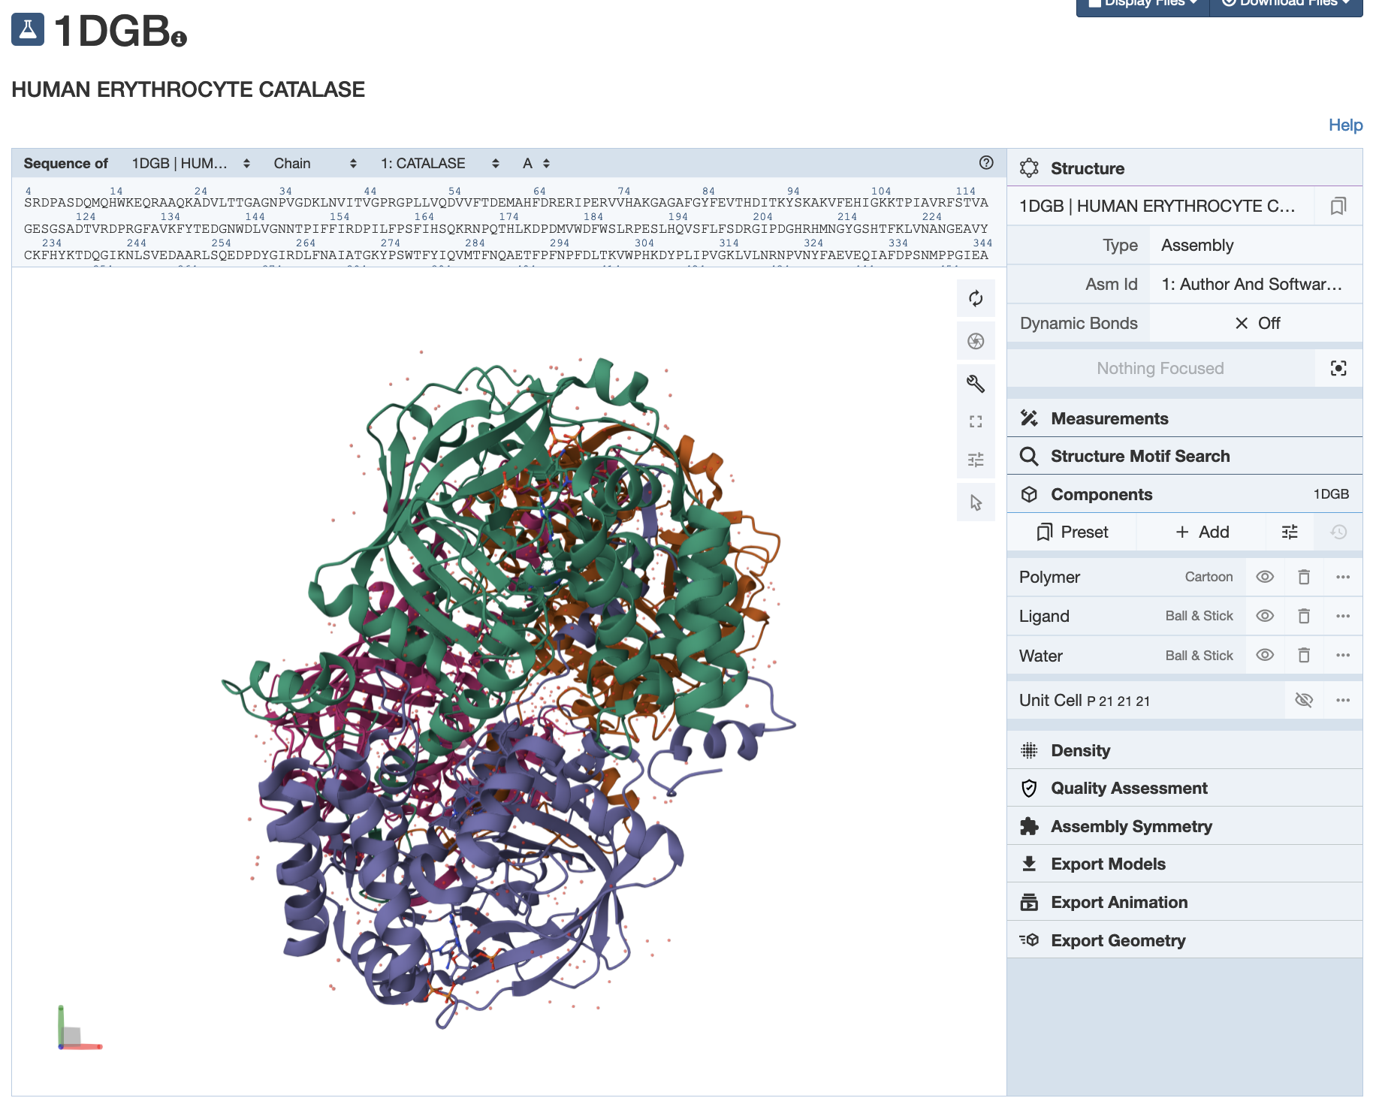
- Assuming that the structure displayed here is colored by protein chains, answer the following questions.

Q2. Describe the composition of Catalase (as seen in this structure) –
- How many protein chains are there?
- Are there any small molecule ligands associated with the enzyme?
- Which ones and how many?
- Save an image of the structure highlighting the above components of the structure – protein chains in cartoon view, and small molecule ligands in spacefill representation. Label each of the components.
(Hint: In addition to examining the structures, read through the macromolecule and ligands sections of the RCSB PDB structure summary page for the answers).

A2.

Q3. What is the predominant secondary structural element seen in the human catalase structure? Support your answer with a suitably labeled figure.

A3:

Examine the interactions of heme (HEM) in the Catalase enzyme.

- Reload the structure PDB ID 1dgb in Mol* in a new window or tab in your browser (or you can just refresh the page).
- Using the Sequence panel at the top of the page click on the HEM ligand bound to any one of the protein chains.
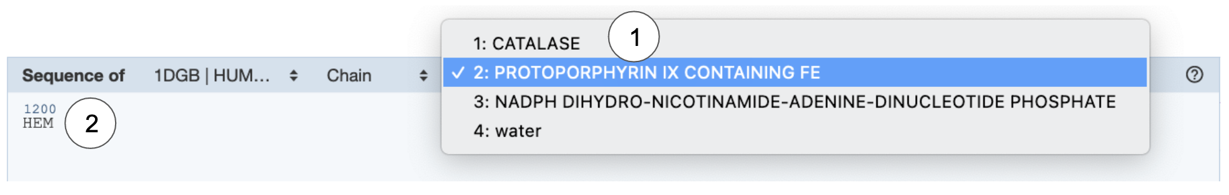
or click on any one of the HEM ligands in the 3D canvas.
- In the default mode, this should focus the display on that ligand and display the non-covalent interactions within its 5Å radius.

Orient the view to view the interactions of the HEM ligand with its neighboring amino acids. Save an image using the camera shutter icon.

Q4. Identify and label amino acid residues that are positioned within 5 angstroms of the heme group (HEM) in Catalase and form each of the following interactions with the HEM:
- hydrogen bond
- pi-stacking interaction
- cation-pi interaction
- coordination bond
- ionic bond
- hydrophobic interaction.
Use the Mol* visualization tool above to identify these amino acid residues. Support your answer with one or more figures.

Note:
- The ionic bond and hydrophobic interactions are not displayed by default. To view these interactions click on the additional options icon in the Components section of the right hand control panel. Click on the Non-covalent Interactions to view all the interaction types. Turn on (or off) the interactions you would like to see.
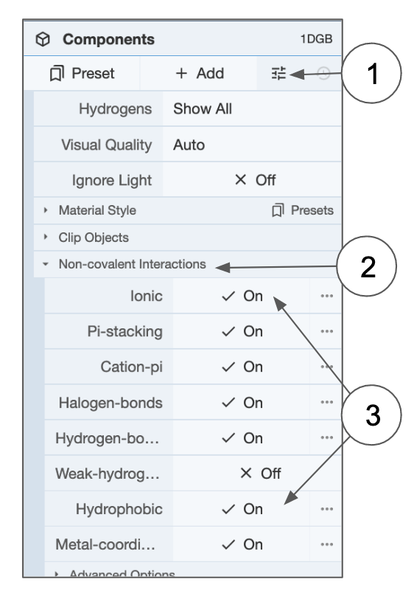
- To make it easier to identify and display these interactions hide the waters
- It may be helpful to color the carbon atoms of the HEM in another color (different from the color used for the polymer chain it is interacting with) using the following steps:
  - click on the arrow icon in the vertical icons menu in the 3D canvas >> this activates the selection mode
  - click on the HEM ligand in the center of the display to select it >> it should be highlighted with a green halo
  - Click on the intersection icon in the selection options in the horizontal menu that opens up in the 3D canvas when the selection mode is activated
  - from the options presented select Elements >> Carbon. This should select only the carbon atoms in the Heme ligand
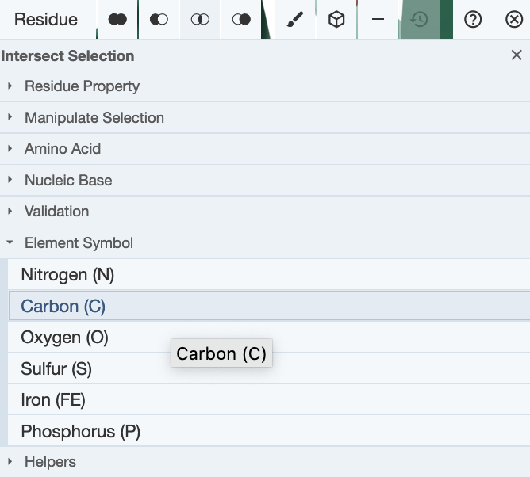
  - Now click on the paint brush icon to select a color of your choice for the carbon atoms selected. Remember to click on the Apply theme button to actually color the selected atoms
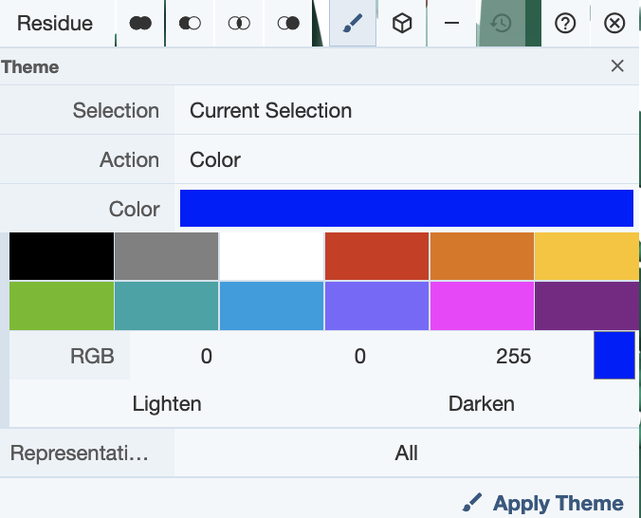

A4:

Q5. Based on the above visualization, what is the importance of Tyr358 in the Catalase structure? (Hint: locate this residue in the vicinity of the Heme group)

A5:

Exploring the active site:
- Go back to the Structure Summary page for PDB ID 1dgb
- Click on the 1D-3D button. Alternatively click on the Sequence tab at the top of page and then they hyperlink View Features.
This should open an interactive page with 1D sequences on the left of the page and the 3D structure on the right.

Q6. What are the active site residues of this enzyme? List their names and describe where they are relative to the Hem and Tyr358. Support your answer with a suitable figure.

A6.

Compare the structures of human erythrocyte Catalase with that from the bacteria, called Proteus mirabilis, (see PDB entry 2cag).

- Open the Pairwise structure alignment tool at https://www.rcsb.org/alignment
- Type in the 2 PDB IDs (1dgb and 2cag)
- Use chain A and default options to run the structure comparison

Q7. Show an image of the overlapped structures. How well do these structures overlap? (Hint: List the RMSD and % identity between the human and bacterial proteins).

A7.

Homework:
Q8. If the structure in PDB entry 2cag represents a reaction intermediate, what do you think the mechanism of action of catalase is? (Hint: Read the Molecule of the Month article to review the reaction mechanism. The oxygen bound to the Heme group of the bacterial enzyme structure provides a clue).

A8:

Extension and Enrichment:
Q9. (Challenge question)
Low levels or non-functionality of catalase has been attributed to be a cause of Type 2 Diabetes. What do you think is the connection between Catalase and Diabetes? (Hint: think about Oxidative Stress and metabolic disorders such as Diabetes)

A9:

Appendix: Mol* Quick Reference
1. Navigate the 3D Canvas:
a. Rotate
● Press left mouse button and move OR use Shift + left mouse button and drag.
b. Translate
● Press right mouse button and move OR use Control + the left mouse button and move. On a touchscreen device, use a two-finger drag.
c. Zoom
● Use the mouse wheel. On a touchpad, use a two-finger drag. On a touchscreen device, pinch two fingers.
d. Center and zoom
● Use right mouse button to click on the part of the structure you wish to see.
e. Change clipping planes
● Use Shift button + the mouse wheel. On a touchpad, use the Shift button + a two-finger drag.
2. Select: first open Selection Mode and change the Picking Level (if needed)
a. Select Picking Level
● Click on objects in the 3D canvas – such as atoms, residues, chains, etc.
b. Select object in 3D canvas
● Click on residues, chains etc. in the 3D canvas based on picking level
c. Select object from Sequence Panel
● Click on residues, ligands, or entire chain in the Sequence Panel
d. Custom Select combinations
● Use the Set Operations Menu in the Selection Mode toolbar
3. See or Hide:
a. To add representations
● Create a component of the region you wish to see/hide → Go to the Components Panel and press the “eye” icon next to the component you create
b. To hide/remove from view
● Select region you wish to hide → Click on the subtract/hide icon in the Selections toolbar
4. Color:
a. N-terminus to C-terminus (rainbow)
● Components → Polymer → Set Coloring → Residue Property → Sequence Id
b. Heteroatom
● Components → Polymer → Set Coloring → Atom Property → Element Symbol
c. Secondary structure
● Components → Polymer → Set Coloring → Residue Property → Secondary Structure
d. Hydrophobicity
● Components → Polymer → Set Coloring → Residue Property → Hydrophobicity
e. Domain
● Select domain → Selections Menu → Apply Theme to Selection → Color → Apply Theme
5. Compare Structures: first upload two or more structures at rcsb.org/3D-view
a. By chains
● Select 2 or more polymer chains/residues → Superposition → By Chains → Superpose
b. By atoms
● Select 1 or more atoms → Superposition → By Atoms→ Superpose
6. Make Measurements:
a. Distance
● Make 2 or more selections → Measurements → Add → Distance (for first 2 selections)
b. Angle
● Make 3 or more selections → Measurements → Add → Angle (for first 3 selections)
c. Dihedral
● Make 4 or more selections → Measurements → Add → Dihedral (for first 4 selections)

