Exploring Atoms, Bonds and Biomolecules
Authors: Thirth Patel, Rutgers University, NJ and Shuchismita Dutta, Rutgers University, NJ

Lesson Overview:
This lesson reviews atoms and bonds in biological molecules (including polymers and small molecules).

ASBMB Learning Objectives
(https://www.asbmb.org/education/core-concept-teaching-strategies/foundational-concepts/structure-function)
2. Structure is determined by several factors
- Students should be able to recognize the repeating units in biological macromolecules and be able to discuss the structural impacts of the covalent and noncovalent interactions involved (Introductory).
__________________________________

Activity:
Exploring three dimensional structures in atomic detail will require you to recognize atoms and the various types of bonds they make to form molecules and interact with other molecules. In Part I of this lesson, we will explore the atoms and bonds in molecules (including a polymer building block and biopolymer) molecules. To appreciate the contents in the archive, we will explore the types of biomolecular building blocks (and small molecules) in Part II, while in Part III we will focus on different types of polymeric biomolecules found in the PDB.

Part I: Exploring Atoms and Bonds
Examine a molecule of Vitamin C or Ascorbic acid, (chemical component ID ASC) at https://www.rcsb.org/ligand/ASC and answer the following questions.
- What type of molecule is it (is it an amino acid, DNA or RNA building block etc.)? (Hint: Review the Chemical Component Summary table for the ligand ASC to answer this question).

- How many atoms are present in this molecule?

- What types of atoms are present in this molecule?

- How many bonds are there in the molecule?

- Are there any chiral atoms in the molecule? If so, list how many.

- Based on your knowledge of bonds and interactions seen in biological molecules, list at least two types of bonds it could form when this molecule is interacting with a protein?

Explore a protein structure with ASC bound to examine how it interacts with the protein.
- Click on the link listing the number of entries that have ASC bound to it - e.g., the link “41 entries” at the time of this writing.
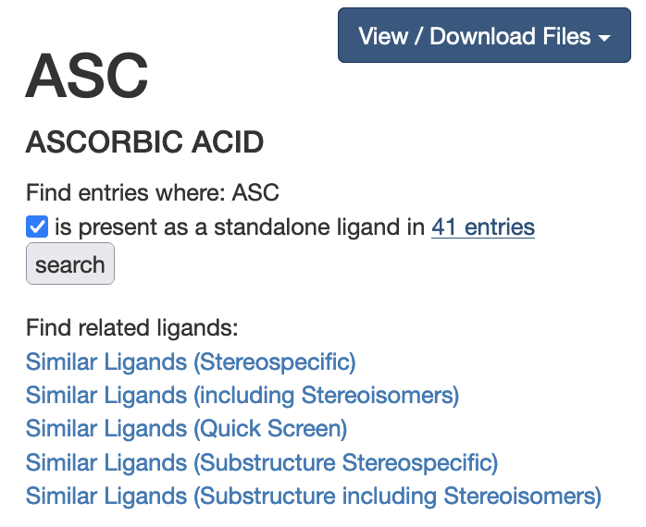
Once the results are listed, sort them by “Release Date: Oldest to Newest”.
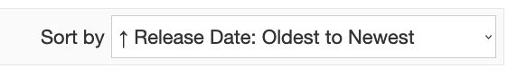
What are the two oldest PDB entries that have ASC in the structure?

Part II: Exploring Biomolecules
Open the structure summary page for PDB entry 1xid and click on the 3D View tab at the top of the page to explore the overall structure.
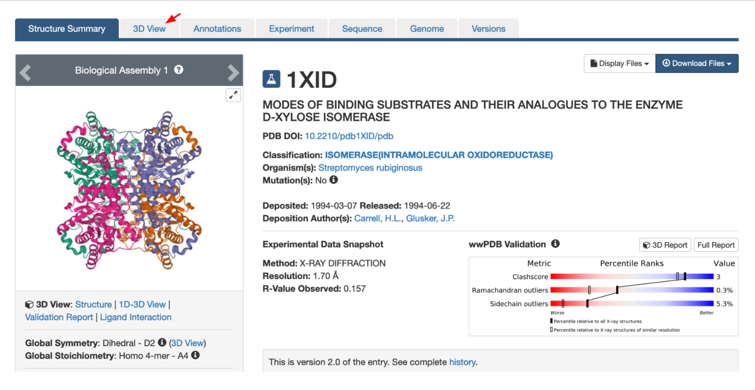
This should open the structure in Mol* (Visualization software). The protein chains are shown in the cartoon (ribbons) representation while the gray pentagonal object.

- Where is the ASC molecule located in the structure? Why do you think it is located there?

To explore the interactions of ASC and the protein, go back to the structure summary page for PDB entry 1xid and scroll down to the small molecules section and click on the blue button titled “Ligand Interactions”.
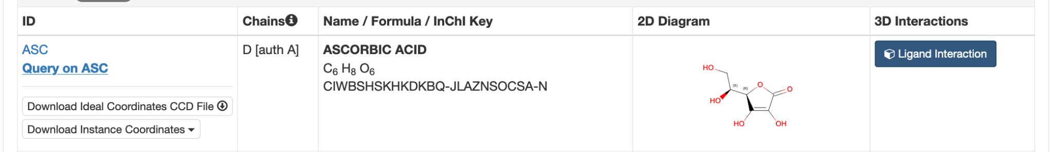
This should open the structure in Mol* (visualization software) with ASC in the center of the view surrounded by amino acids and other ligands interacting with it (as shown below). Alternatively, you can click on this link to see this view.

The ASC molecule is shown as a gray pentagonal object. The various dashed lines represent the interactions it participates in. Find out the identity of the amino acid residues participating in these interactions by hovering over them and reading off the residue name and number at the bottom right corner of the 3D canvas. Examine this structure interactively in Mol* and answer the following questions.
(Hint: mouse over the residues to see their identity at the bottom right corner of the 3D canvas)
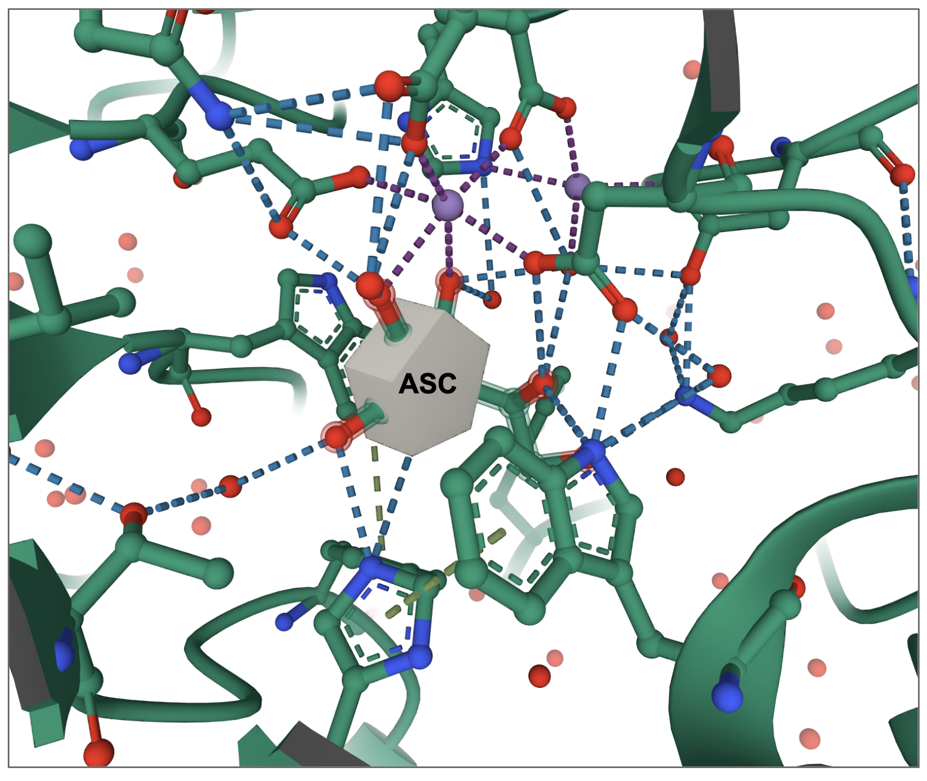
- List which residues participate in making the following types of interactions with ASC:
  - Forms a Hydrogen bond -
  - Forms a metal coordination bond -

- Explore the amino acids in the neighborhood of ASC to see interactions between them.

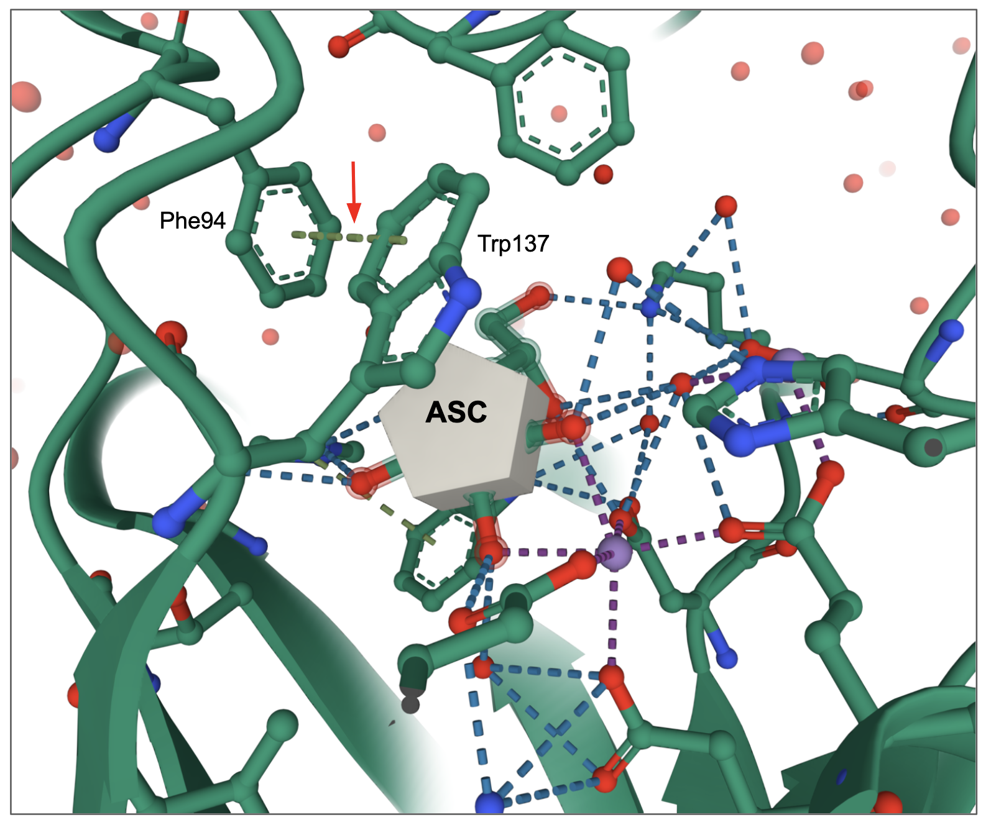
What type of interaction is seen between the amino acids Phe94 and Trp137?

- Complete the table listing the types of bonds these building blocks make to form their respective polymers.

Hint: The hyperlinks in the Ligand ID column open the respective ligand summary pages. Open these pages and explore them to complete the table below. Follow the example completed in the first row.

Ligand ID | Chemical structure | Molecule Type | Bond forming respective polymer | Other possible (noncovalent) bonds formed
AMP | 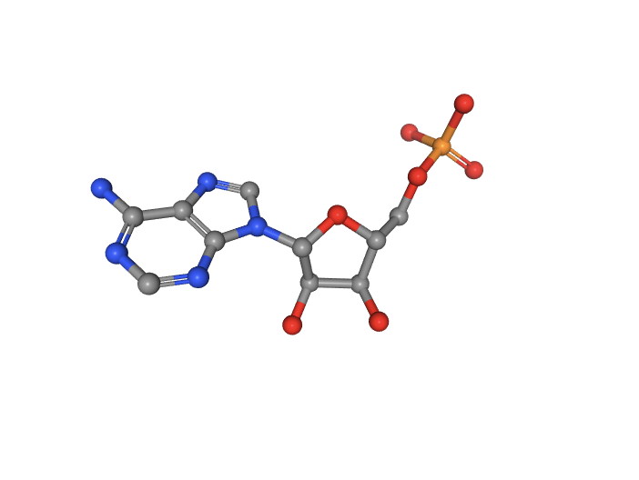 | nucleotide | phosphodiester | Hydrogen bonds, base stacking (pi-stacking)
LEU | 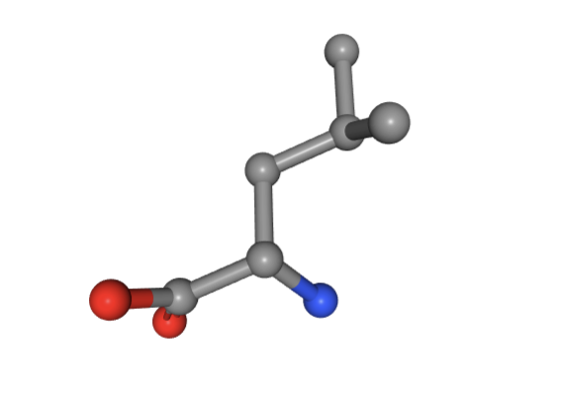 | Amino acid
MAN | 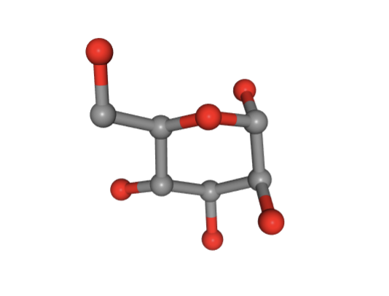 | monosaccharide
FRU | 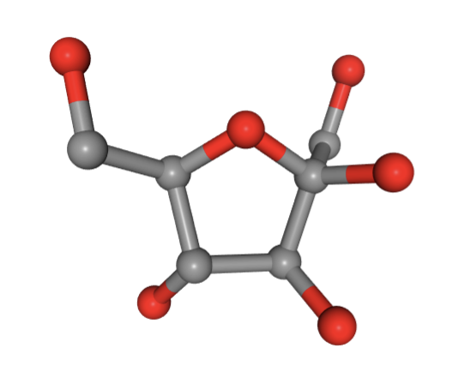 | monosaccharide
LYS | 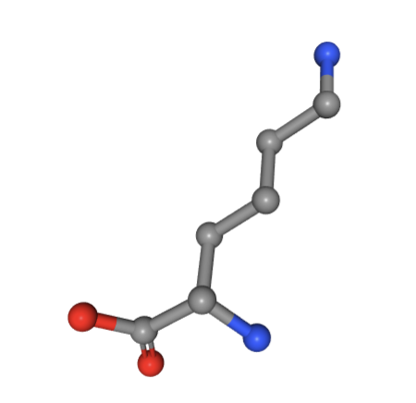 | Amino acid

Part III: Exploring different types of polymeric biomolecules in the PDB

Although the archive is called Protein Data Bank, it also includes structures of nucleic acids, carbohydrates, lipids, inhibitors, drugs, cofactors and much more. This section explores the contents of the archive.

Explore PDB Statistics using the data tables available at https://www.rcsb.org/stats/ and answer the following questions:

- Examine the Protein-only structures statistics - in which year did the number of “Proteins-only” structures submitted annually exceed 1000 for the first time.

- When was the first RNA-only structure submitted to the PDB?

- When was the first DNA-only structure submitted to the PDB?

- When were the first DNA-protein complex structures submitted to the PDB? What were they?

