Exploring a protein structure in the RCSB PDB: Green Fluorescent Protein

Learning Goals:
- Visualize the structure of a given molecule using RCSB PDB resources.
- Explore the structure to understand its structure function relationships

Exercise:
Review the Molecule of the Month feature on Green Fluorescent Protein for background information (http://pdb101.rcsb.org/motm/42). Discuss main ideas of this feature with the students.

Note that there are a few PDB entries listed throughout the feature. For example note the PDB entry 1ema discussed in the “Exploring the structure section”.
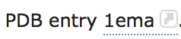
Click on this to open the summary page for the PDB entry 1ema (http://www.rcsb.org/pdb/explore/explore.do?structureId=1ema).

Read/review the page and answer the following questions based on the descriptions provided:
- What is the source of the green fluorescent protein molecule seen in this structure?

- Name the authors who solved the structure of this protein?

- Explore the 3-D structure of this protein by clicking on JSmol (hyperlink) next to 3D View as shown below:
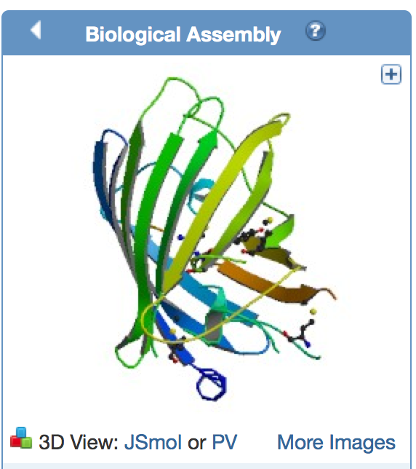
View the polymer chains shown to contain helical ribbons (in magenta), arrows (in golden yellow) and coil-like regions (white/grey).
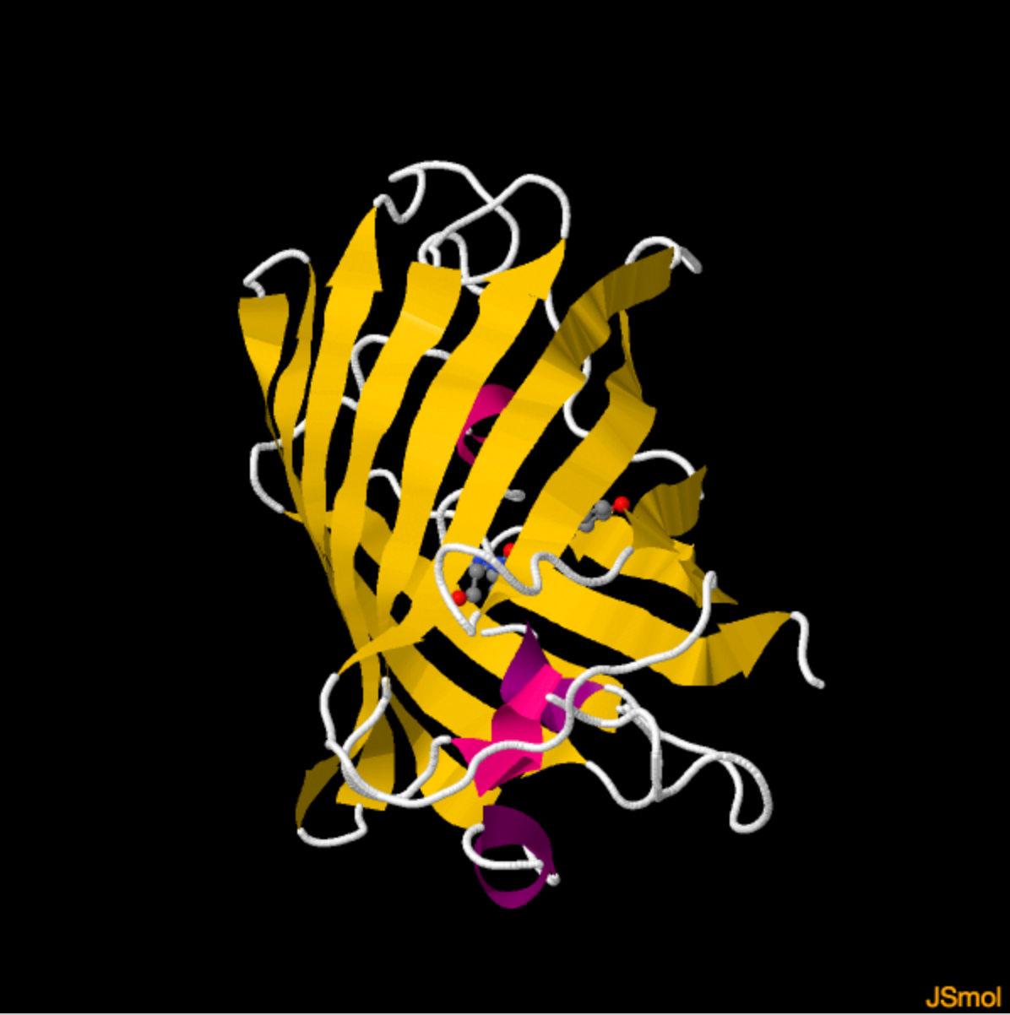
Rotate the molecule and examine it.
How many beta-strands do you see in this structure?

- Explore the atoms shown in ball and stick representation.
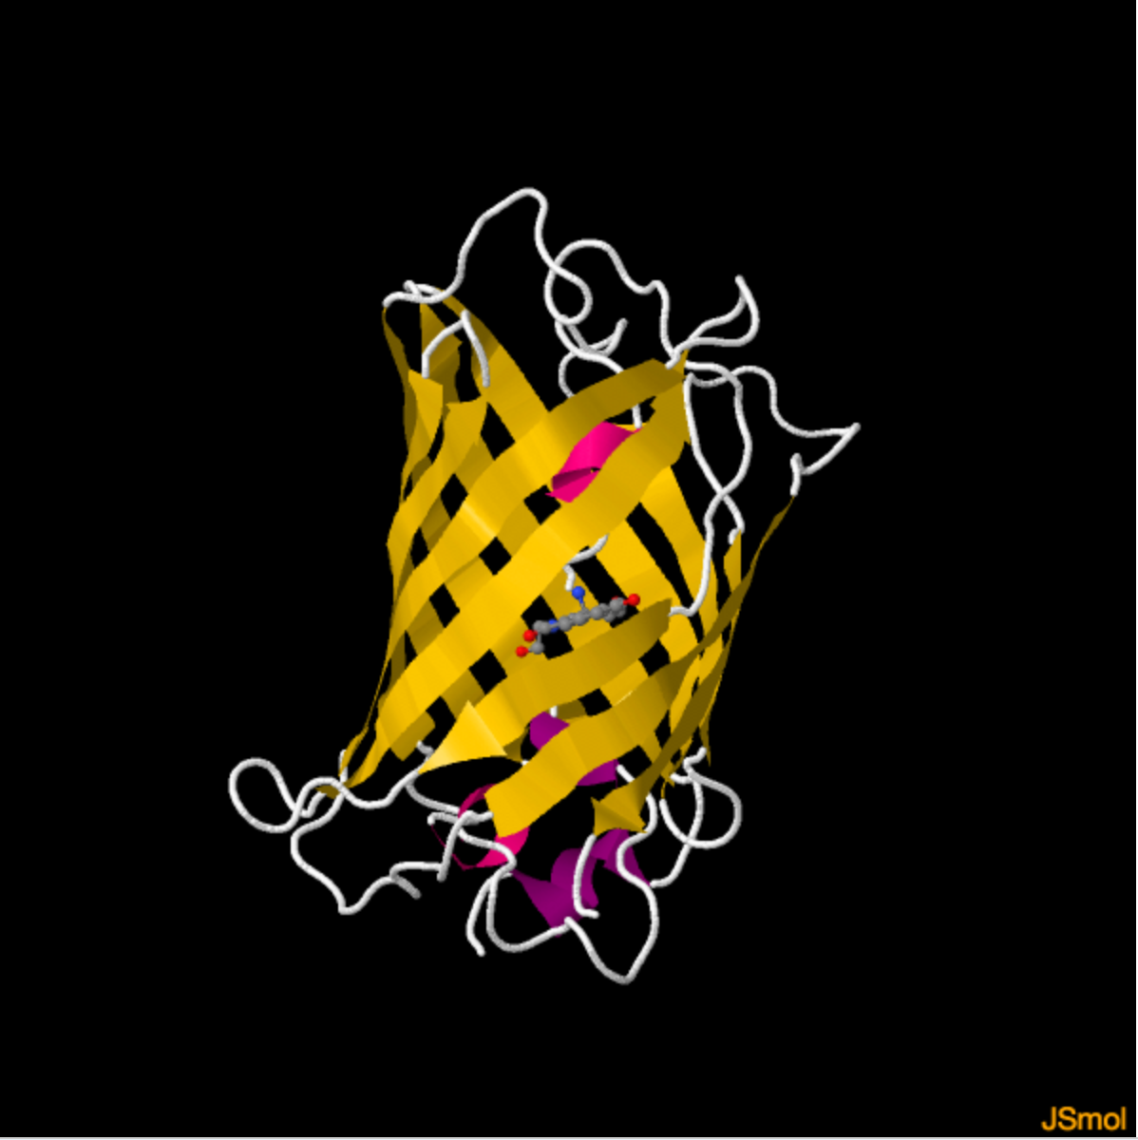
What do they represent?

- In a different tab or browser window, open the JSmol view for the PDB entry 1g7k and explore it.
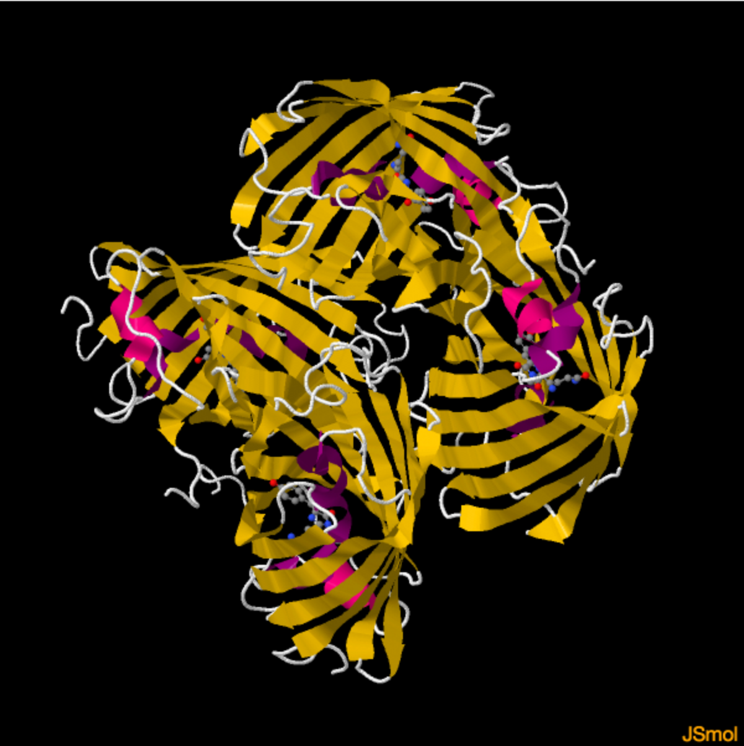
Compare what you see to the structure seen for PDB entry 1ema – note at least two points about how these structures are similar and two points about how they are different.

