Exploring a protein structure in the RCSB PDB: HIV-1 Protease

Learning Goals:
- Visualize the structure of a given molecule using RCSB PDB resources.
- Explore the structure to understand its structure function relationships

Exercise:
Review the Molecule of the Month feature on HIV Protease for background information (http://pdb101.rcsb.org/motm/6). Discuss main ideas of this feature with the students.

Note that there are a few PDB entries listed throughout the feature. For example note the PDB entry 7hvp discussed in the “A Small But Effective Enzyme” section.
Click on this to open the summary page for the PDB entry 7hvp (http://www.rcsb.org/pdb/explore/explore.do?structureId=7hvp).

Read/review the page and answer the following questions based on the descriptions provided:
- How many protein chains are present in this structure? What are they?

- Name the authors who solved the structure of this complex?

- Explore the 3-D structure of this protein by clicking on JSmol (hyperlink) next to View in 3D at the bottom of the image.
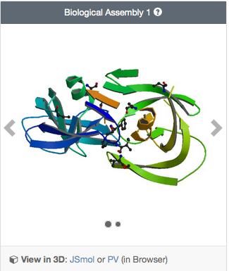
View the polymer chains shown to contain helical ribbons (in magenta), arrows (in golden yellow) and coil-like regions (white/grey).
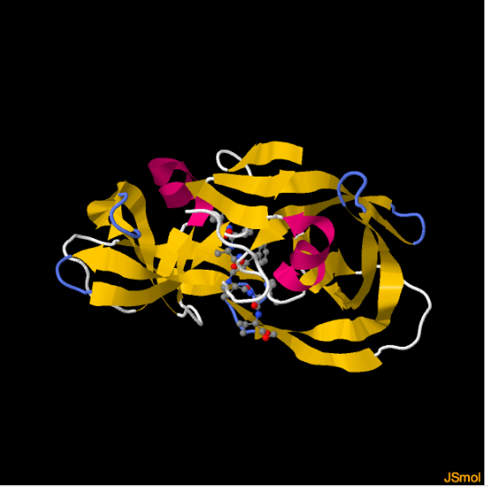
Rotate the molecule and examine it.
Describe the structure of the HIV-1 Protease – including overall shape, symmetry, secondary structural elements and their relative organizations.

- Part of the structure is shown in a ball and stick representation (see image below). What is this part of the structure? What is its function? (Hint: Read the structure title and abstract for the primary citation.)
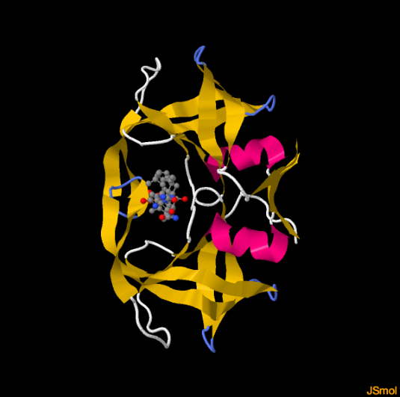

- In a different browser window or tab, open the JSmol view of another PDB entry, 1hxb. Compare what you see in the structures of PDB entry 7hvp and PDB entry 1hxb. Note at least one point each about how these structures are similar and different.

