Exploring a protein structure in the RCSB PDB: HIV-1 Reverse Transcriptase

Learning Goals:
- Visualize the structure of a given molecule using RCSB PDB resources.
- Explore the structure to understand its structure function relationships

Exercise:
Review the Molecule of the Month feature on HIV Reverse Transcriptase for background information (http://pdb101.rcsb.org/motm/33). Discuss main ideas of this feature with the students.

Note that there are a few PDB entries listed throughout the feature. For example note the PDB entry 3hvt discussed in the “Introduction” section.
Click on this to open the summary page for the PDB entry 3hvt (http://www.rcsb.org/pdb/explore/explore.do?structureId=3hvt).

Read/review the page and answer the following questions based on the descriptions provided:
- What protein and non-protein components does this structure contain?

- Name the authors who solved the structure of this complex?

- Explore the 3-D structure of this protein by clicking on JSmol (hyperlink) next to 3D View.
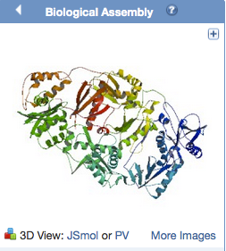
View the polymer chains shown to contain helical ribbons (in magenta), arrows (in golden yellow) and coil-like regions (white/grey).
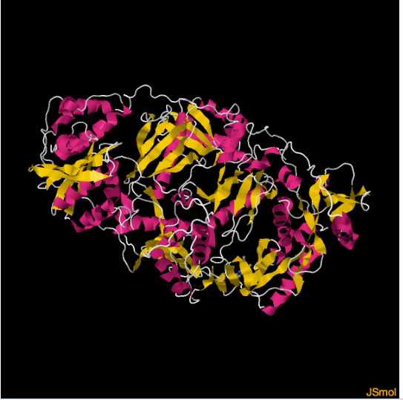
Rotate the molecule and examine it.
Can you identify all the protein and non-protein components you listed above? Describe their relationship to each other. (Hint: try coloring the chains by sequence or subunit)

- In a different tab or browser window, open the JSmol view for the PDB entry 2hmi and explore it.
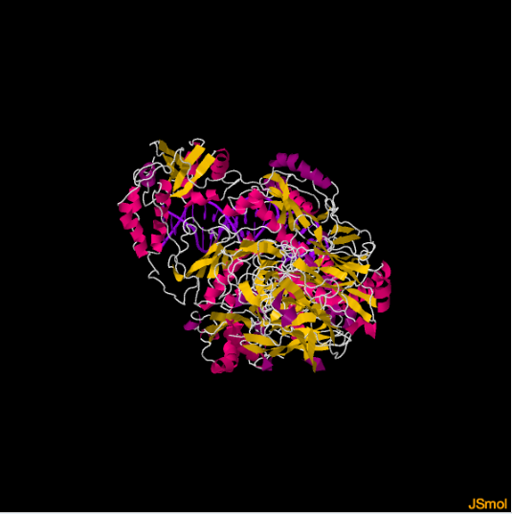
What protein and non-protein components does this structure contain?

- Compare what you see to the structure seen for PDB entry 3hvt – note at least two points about how these structures are similar and two points about how they are different.

