Exploring a Protein Structure in the RCSB PDB: Insulin

Learning Goals:
- Visualize the structure of a given molecule using RCSB PDB resources.
- Explore the structure to understand its structure function relationships

Exercise:
Review the Molecule of the Month feature on Insulin for background information (http://pdb101.rcsb.org/motm/14 ). Discuss main ideas of this feature with the students.

Note that there are a few PDB entries listed throughout the feature. For example, PDB entry 4ins can be linked from
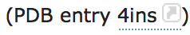
Click on this to open the summary page for the PDB entry 4ins (http://www.rcsb.org/pdb/explore/explore.do?structureId=4ins).

Read/review the page and answer the following questions based on the descriptions provided:
- What is the source (organism) of the insulin molecule in this structure?

- Name the authors who solved the structure of this protein?

- Explore the 3-D structure of this protein by clicking on JSmol (hyperlink) next to 3D View as seen below:
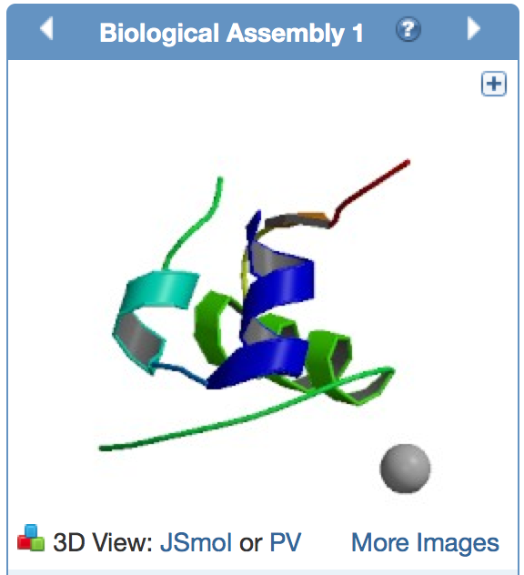
View the polymer chains shown to contain helical ribbons (in magenta), arrows (in golden yellow) and coil-like regions (white/grey).
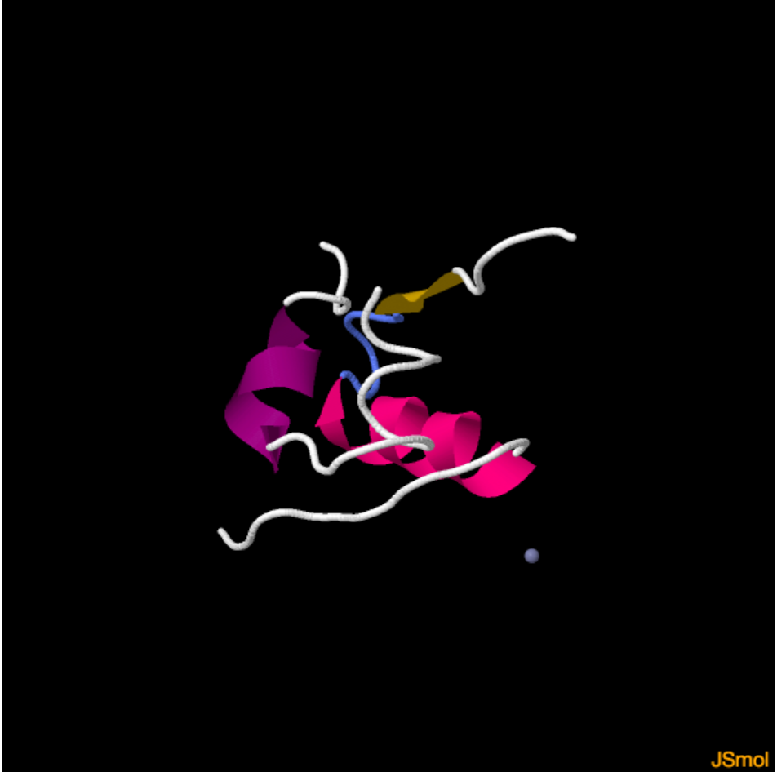
Mouse-over the small grey atom (highlighted by a red arrow, in the above figure). What is it and why do you see this atom in the insulin structure (Hint: read the title and abstract of the structure for clues)

- Change the viewer to PV using the pull-down menu.
The default view is colored by chain (i.e. each protein (polymer) chain in the structure is colored in a different color).

Based on the 3-D model that you see here describe the overall composition of insulin – how many and what chains are present in the structure. Also describe the structure of each insulin molecule in terms of the helical, arrow-like or coiled regions in each chain.

- Go back to the JSmol view of the PDB entry.
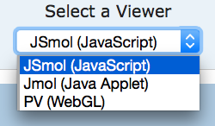
This will re-open the JSmol view of the PDB entry. In the various options click on the box next to S-S bonds to show the disulfide bonds in the structure.
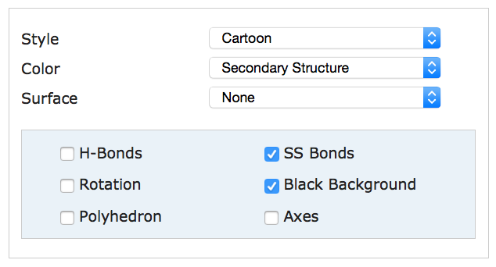
Note yellow SS bond lines appear in the model. These bonds are formed by oxidation of two specific sulfur-containing amino acids. How many such bonds do you see?

- Are these S-S bonds within the same polymer chain or between different chains of insulin? (Hint: Color the ribbons by sequence to see if the S-S bonding is between the same or different polymer chains).

- What do you think is the role of these S-S bonds? Describe in 1-2 sentences.

