Exploring a Protein Structure in the RCSB PDB: Major Histocompatibility Complex

Learning Goals:
- Visualize the structure of a given molecule using RCSB PDB resources.
- Explore the structure to understand its structure function relationships

Exercise:
Review the Molecule of the Month feature on Major Histocompatibility Complex (MHC) for background information (http://pdb101.rcsb.org/motm/62). Discuss main ideas of this feature with the students.

Note that there are a few PDB entries listed throughout the feature. For example, PDB entry 1igt can be linked from
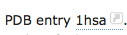
Click on this to open the summary page for the PDB entry 1hsa (http://www.rcsb.org/pdb/explore/explore.do?structureId=1hsa).

Read the provided description here and answer the following questions:
- What is the source (organism) of the Class I Histocompatibility Antigen molecule in this structure?

- Name the authors who solved the structure of this protein?

- Explore the 3-D structure of this protein by clicking on PV (hyperlink) next to 3D View as shown below:
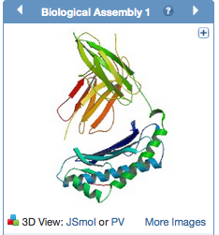
The default view is colored by chain (i.e. each protein (polymer) chain in the structure is colored in a different color).
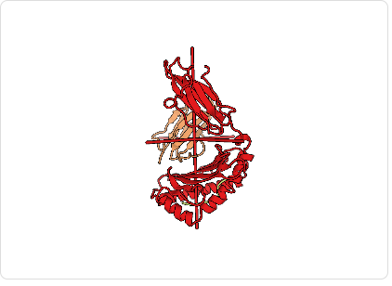
Based on the 3-D model that you see here, describe the overall composition and organization of chains in the MHC structure. How many different protein chains do you see in this structure?

- Change the viewer to JSmol using the pull-down menu.
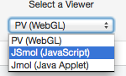
View the polymer chains shown to contain helical ribbons (in magenta), beta strand arrows (in golden yellow) and coil-like regions (white/grey).
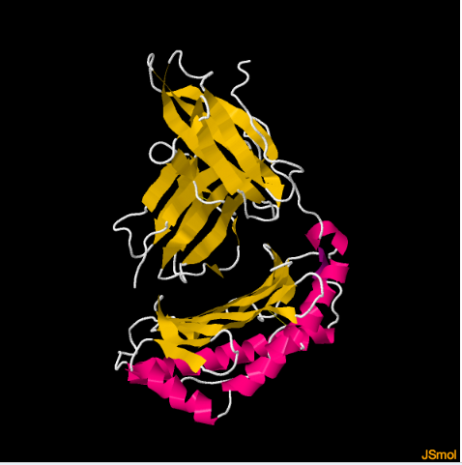
What is the predominant secondary structural element that you see here?

- Click on Custom View to see the options:
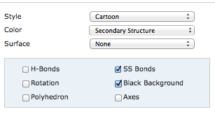
Click on the box next to SS Bonds and notice yellow bond lines appear in the model. These bonds are formed by oxidation of two specific sulfur-containing amino acids. Rotate the model to visualize these bonds closely. Describe what (if any) role these bonds play in holding the MHC structure together.

