## Exploring Monosaccharides

**Authors**: Shuchismita Dutta, Rutgers University, NJ

**Lesson Overview**:

This lesson reviews monosaccharides (the building blocks of oligosaccharides, polysaccharides and other carbohydrates).

**ASBMB Learning Objectives**

(<https://www.asbmb.org/education/core-concept-teaching-strategies/foundational-concepts/structure-function>)

2. Structure is determined by several factors

* Students should be able to **recognize the repeating units in biological macromolecules** and be able to discuss the structural impacts of the covalent and noncovalent interactions involved *(Introductory)*.

__________________________________

Mannose and Glucose have the same chemical formula but the configuration of the carbon C2 is different. It is a key sugar building block used in the glycosylation of proteins.

1. Explore the Mannose molecule [MAN](https://www.rcsb.org/ligand/MAN) and answer the following questions:
   1. What is the complete chemical name of this molecule?
   2. How many chiral atoms are present in this molecule? Save an image of the molecule, label/mark the chiral atoms and include the image here.
   3. Complete the table about MAN’s configuration - explain your answer with suitable figures and include them in the Evidence column. The first row of the table is completed for you.

| Question | Answer | Explanation | Evidence |
| --- | --- | --- | --- |
| Aldose or ketose? | Aldose | The oxygen atom derived from the C=O in the terminal aldehyde group is at C1 - the linear molecule had an aldehyde group here. |  |
| D- or L- sugar? |  |  |  |
| 𝝰 or 𝝱 - sugars? |  |  |  |

*Teaching notes: To learn more about these terms review the accompanying learning materials, titled “Saccharides in the PDB”.*

1. Explore the saccharides in the Chemical Component Dictionary related to MAN.

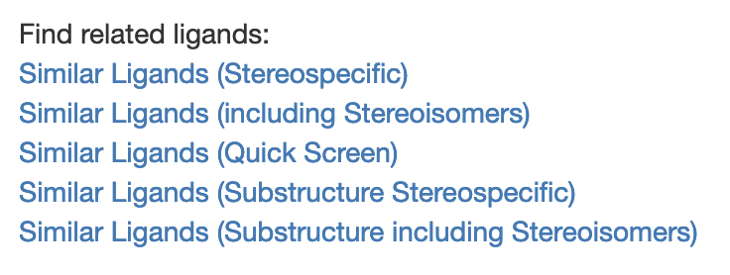

While the Ligand Summary page for the sugar MAN offers several options for finding similar components use the “Similar Ligands (Stereospecific)” option here and answer the following questions:

* 1. Review the list of ligands and identify one that is an Epimer of MAN. Write the chemical component identifier (or code) for this molecule and its complete name. Explain your answer for considering this is an epimer of MAN. Include a suitable figure to support your rationale.

1. Explore the following saccharides in PDB’s Chemical Component Dictionary by clicking on the link included. Complete the following 2 tables by:
   1. Indicating if the monosaccharide is a D- or L- saccharide (Table 1) and 𝝰 or 𝝱 - sugar (Table 2).
   2. Filling in the “Reason” and “Evidence” columns to include the reason for your classification in words and in a figure respectively. Follow the example shown for GLC.

Table 1: D- or L- saccharides

| Ligand ID | Chemical structure | D- or L- saccharide | Evidence | Reason |
| --- | --- | --- | --- | --- |
| [GLC](https://www.rcsb.org/ligand/glc) |  | D-saccharide |  | Has O attached to penultimate stereogenic Carbon on the viewer’s right (in Fischer projection) |
| [BMA](https://www.rcsb.org/ligand/BMA) |  |  |  |  |
| [GAL](https://www.rcsb.org/ligand/GAL) |  |  |  |  |
| [FRU](https://www.rcsb.org/ligand/FRU) |  |  |  |  |
| [SF6](https://www.rcsb.org/ligand/SF6) |  |  |  |  |

Table 2: 𝝰 or 𝝱 Saccharides

| Ligand ID | Chemical structure | 𝝰 or 𝝱 saccharide | Evidence | Reason |
| --- | --- | --- | --- | --- |
| [GLC](https://www.rcsb.org/ligand/glc) |  | 𝝰-saccharide |  | C1 has OH bound on the right in Fischer projection. Configuration of C at C1 and C5 is the same (see also Table 1) → 𝝰-saccharide. |
| [BMA](https://www.rcsb.org/ligand/BMA) |  |  |  |  |
| [GAL](https://www.rcsb.org/ligand/GAL) |  |  |  |  |
| [FRU](https://www.rcsb.org/ligand/FRU) |  |  |  |  |
| [SF6](https://www.rcsb.org/ligand/SF6) |  |  |  |  |