Exploring a Protein Structure in the RCSB PDB: Antibodies

Learning Goals:
- Visualize the structure of a given molecule using RCSB PDB resources.
- Explore the structure to understand its structure function relationships

Exercise:
Review the Molecule of the Month feature on Antibodies for background information (http://pdb101.rcsb.org/motm/21). Discuss main ideas of this feature with the students.

Note that there are a few PDB entries listed throughout the feature. For example, PDB entry 1igt can be linked from
Click on this to open the summary page for the PDB entry 1igt (http://www.rcsb.org/pdb/explore/explore.do?structureId=1igt).

Read the provided description here and answer the following questions:

- What is the source (organism) of the antibody molecule in this structure?
Ans:

- Name the authors who solved the structure of this protein?
Ans:

Explore the 3-D structure of this protein in Mol* by clicking on the Structure hyperlink next to the 3D View written below the structure snapshot or by clicking on the 3D View tab or as shown below
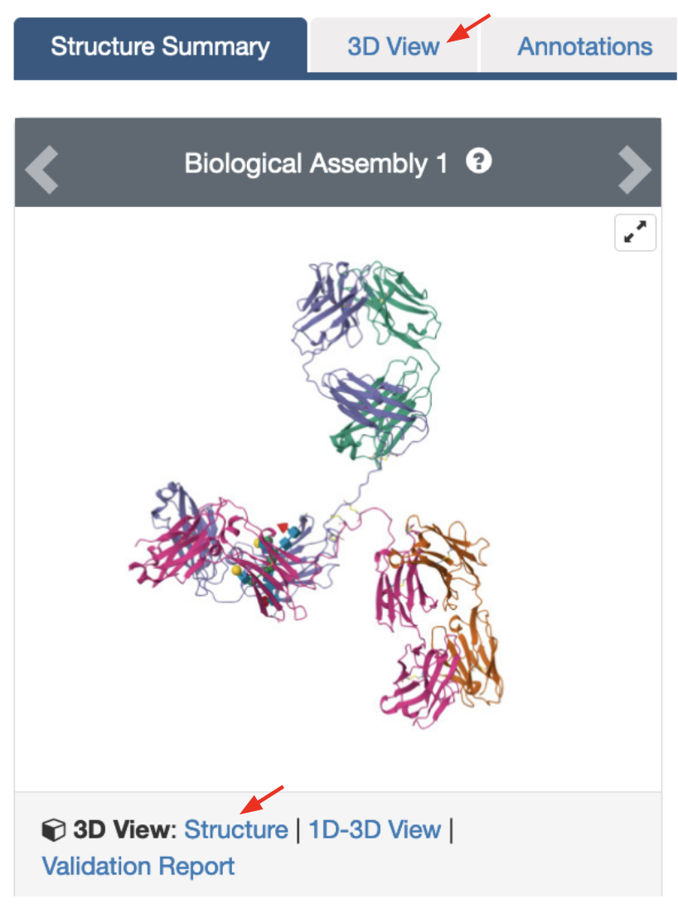

The default view is colored by chain (i.e. each protein (polymer) chain in the structure is colored in a different color).
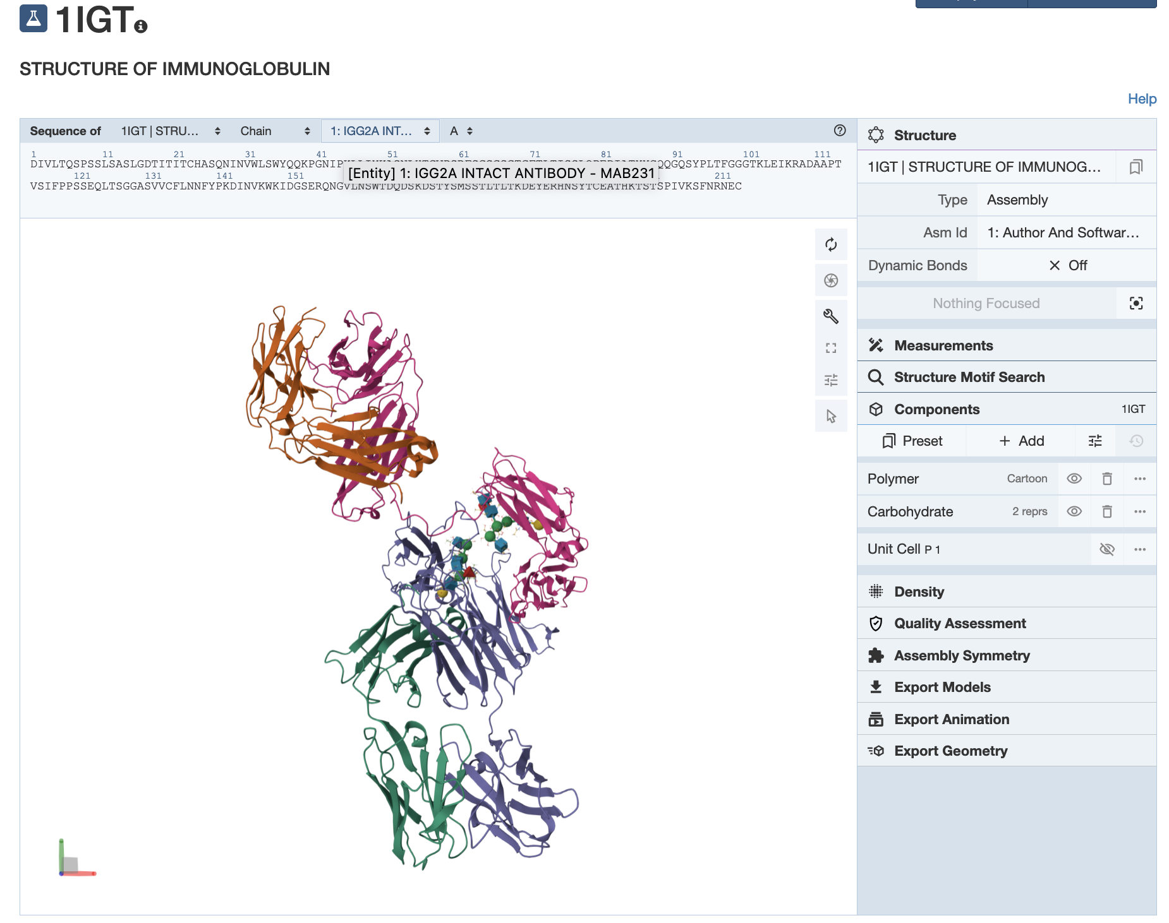
Based on the 3-D model that you see here, describe the overall composition and organization of chains in the antibody structure.

- How many different protein chains do you see in this structure?
Ans:

Teaching Notes:
- Point out that the variable regions of pairs of heavy and light chains form the antigen binding site, while the constant region of the longer/heavy chains interact with each other.

- What is the predominant secondary structural element that you see here?
Ans:

- What are the cubes and spheres that you see in the structure? (Hint: Mouse over them to read their identity at the bottom right corner of the 3D canvas).
Ans:

Display the disulfide bonds in this structure using the following steps:
- Click on the Arrow at the bottom of the vertical menu of buttons in the 3D Canvas (toggle on the selection mode) to display a horizontal menu at the top of the 3D canvas.

- Click on the filled double circle in the horizontal menu to elect Disulfide Bridges as follows:
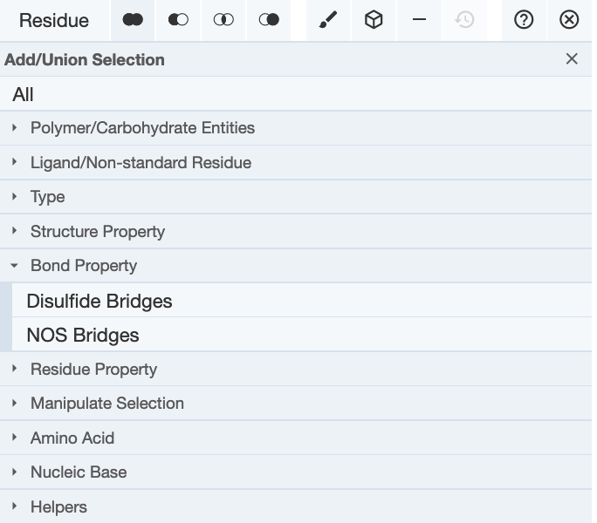

- Once the disulfide bond forming Cys residues are selected (highlighted in green), click on the cube icon in the horizontal menu to create components for the disulfide bonds. Select the option Ball and Stick as follows: Cube icon >> Representation >> select from pulldown “Ball & Stick” >> click on Create component button at the bottom of the box.
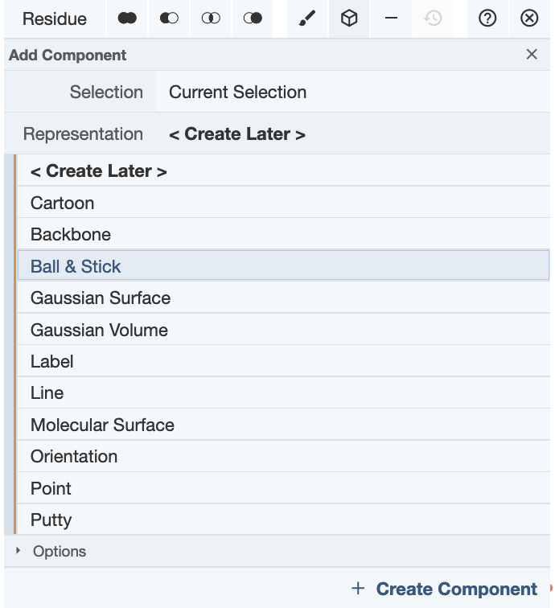
- The Cys side chains are shown in ball and stick format and a new component called Custom Selection is shown on the right-hand components panel.

- Where is/are the disulfide bond(s) located in the structure? Describe what (if any) role these bonds play in holding the antibody structure together.
Ans:

