Exploring Protein Structures in the RCSB PDB: Fluorescent Proteins

Learning Goals:
- Visualize the structure of a given molecule using RCSB PDB resources.
- Explore the structure to understand its structure function relationships

About Green Fluorescent Proteins:
Osamu Shimomura first discovered the Green Fluorescent Protein in the 1960s. After its gene was cloned in the early 1990s Martin Chalfie and Roger Tsien figured out how to fuse this with other genes of interest and use it as a marker for gene expression and protein localization. In 2008 Shimomura, Chalfie and Tsien were awarded the Nobel Prize in Chemistry for their contributions to this field.

Green Fluorescent Protein has been widely used as a tracking reagent in biology and biotechnology. The protein itself is shaped like a barrel made of a single beta sheet. In all GFP and its relative fluorescent proteins a special chemical group, called chromophore, is formed by the fusion of three consecutive amino acid residues. This absorbs and emits light at different wavelengths resulting in fluorescence.

To learn more about this protein and its various other fluorescent cousins, read the following Molecule of the Month features and their references:
http://pdb101.rcsb.org/motm/58
http://pdb101.rcsb.org/motm/174

Exercise:
- The molecular visualization Mol* is freely available to all users from www.rcsb.org.
- This worksheet provides instructions for visualization of a PDB entry, where you will learn to do the following:
  - Visualize the 3D structure of biomolecules using coordinates available from PDB.
  - Display the atomic coordinates in various formats.
  - Examine the structural details and interactions of specific regions of the structure.
  - Compare structures – superpose 2 (or more) structures
- To save images, click on the camera (iris) icon , Download and save a *.jpg file. Import the image in any image manipulation software of your choice (e.g., PowerPoint/ Photoshop) to add labels and additional text describing the images.
- Some key commands and functions of Mol* are included in the Appendix at the end of this document.

Explore the structure of a specific green fluorescent protein structure

Explore the structure of green fluorescent protein that was taken from the jellyfish Aequorea victoria (PDB ID 1ema).
- Type the PDB ID 1ema in the search bar at the top of the page. 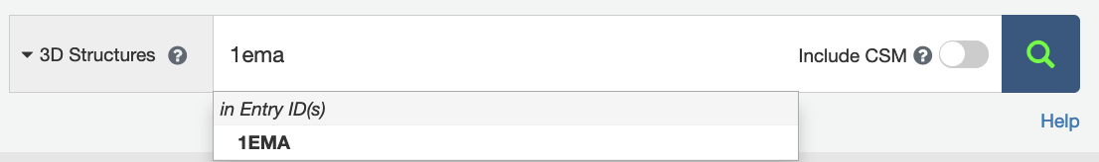

- This will take you to the Structure Summary page for 1ema. Now let’s take a look at the GFP structure in close detail.
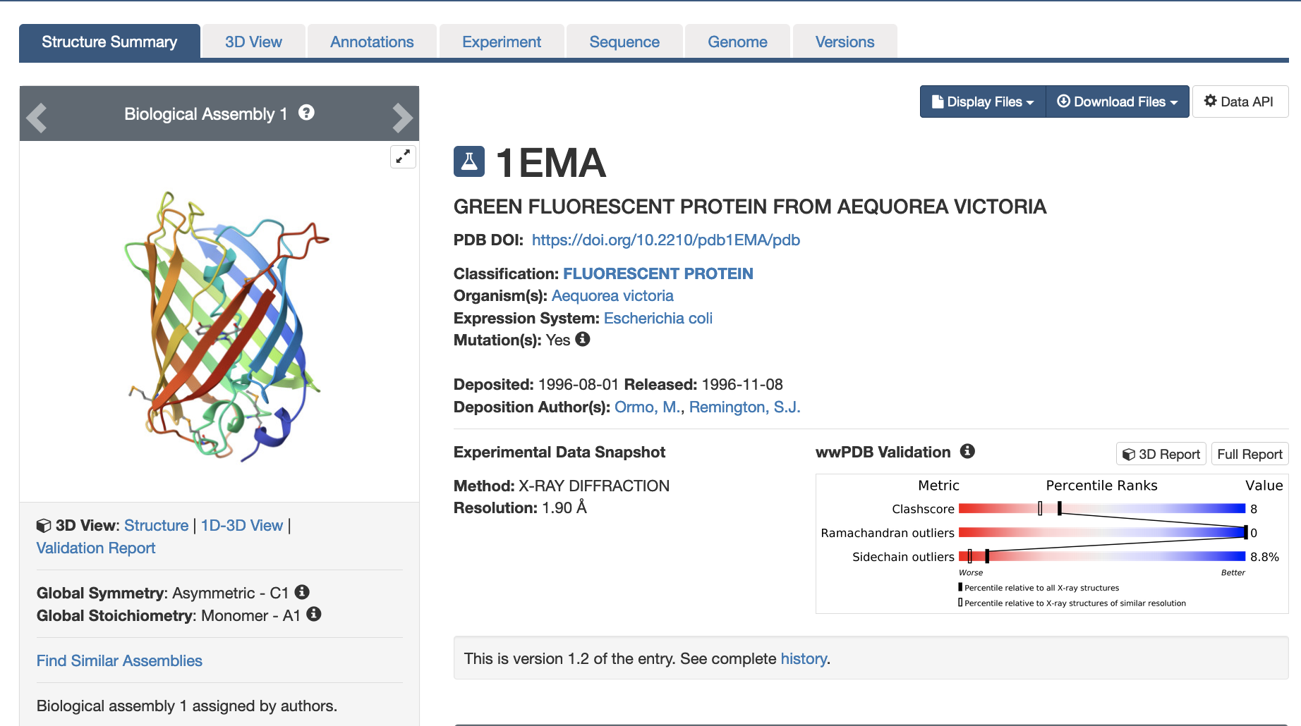

- Click on the 3D Structure tab at the top of the page or on the Structure hyperlink below the snapshot of the structure.
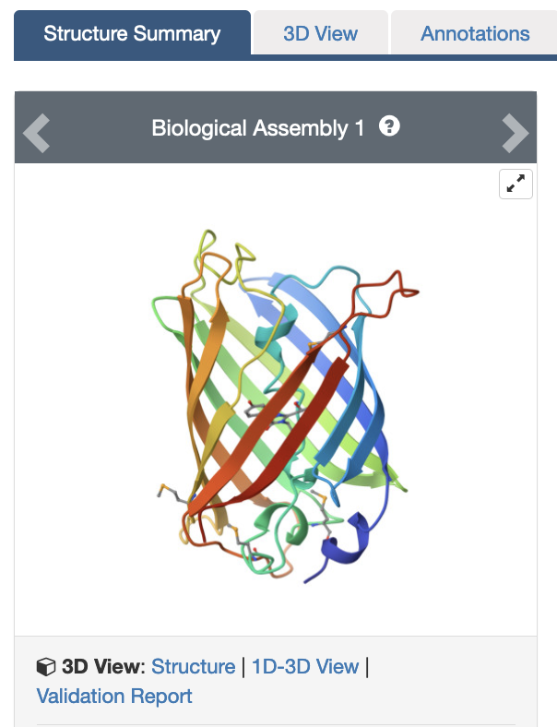

- This opens the structure in Mol*
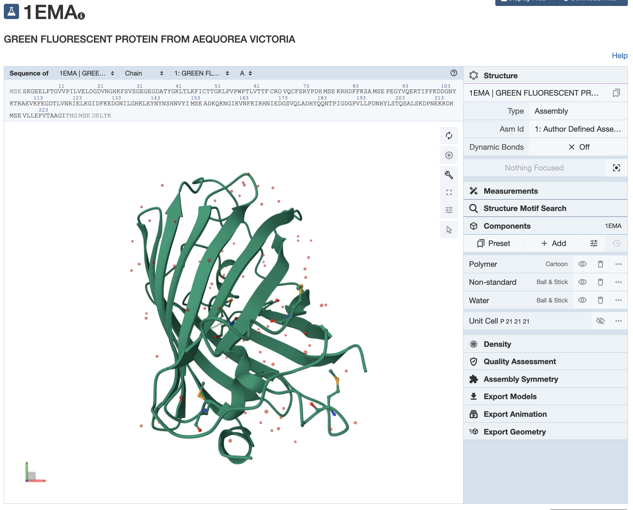
The top of the display shows the sequence of the polymers and is called the sequence panel. The white space showing the 3D structure of the protein is called the 3D canvas and the blue panel on the right is the controls panel for the display.
- Color the structure by secondary structure using the following steps:
  - In the Components section of the Controls panel, click on the 3 dots next to the Polymer to open options
  - Select the options Set coloring >> Residue properties >> secondary structure to color the cartoon representation of the structure.

Q1. What secondary structural elements can you identify in the structure? List how many of these elements you see in each polymer chain. Save an image using the camera lens icon in the vertical menu on the 3D canvas and include it below to support your answer.

Ans:

- Repeat the steps for coloring the cartoon representation of the structure but this time color by Sequence ID (instead of the Secondary structure).
In this color scheme the N-terminal residues are colored in blue while the C-terminal residues are colored in red.
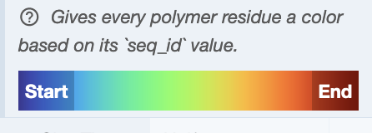

Q2. Identify the N-terminal and C-terminal secondary structural elements. Support your answer with a suitable figure.

Ans.

Explore the business end of the green fluorescent protein (GFP) in atomic detail as follows:

- Click on the ligand (CRO) displayed in ball and stick representation at the center of the GFP protein. This should zoom in on this part of the structure, center on it and display the non-covalent interaction in the neighborhood.

Q3. Identify 3 different amino acid residues that non-covalently interact with CRO. List their name and type of interaction they form. Support your answer with a suitable figure.

Ans.

Explore the structure of a red fluorescent protein from a corallimorpharian, DsRed

Explore the structure of the red fluorescent protein that was taken from the Discosoma sp. (PDB ID 1g7k).

- Use the steps described above to visualize the structure of DsRed in Mol*.

Q4. List one way in which the DsRed structure is similar to that of GFP and one way in which it is different. (Hint: answer at the level of the overall structure). Support your answer with suitable figures.

Ans.

- In the DsRed structure select and display the aromatic amino acid side chains in the spacefill representation as follows:
  - Click on the arrow icon in the vertical menu on the 3D canvas to activate the selection mode.
  - This will open a new horizontal menu at the top of the 3D canvas. Select the Add/Union Selection icon to open options and select the Residue Property >> Aromatic Rings in Residues options. This should select all aromatic residues in the structure.
  - Display these amino acid side chains by clicking on the cube shaped component icon >> Representation >> Spacefill.
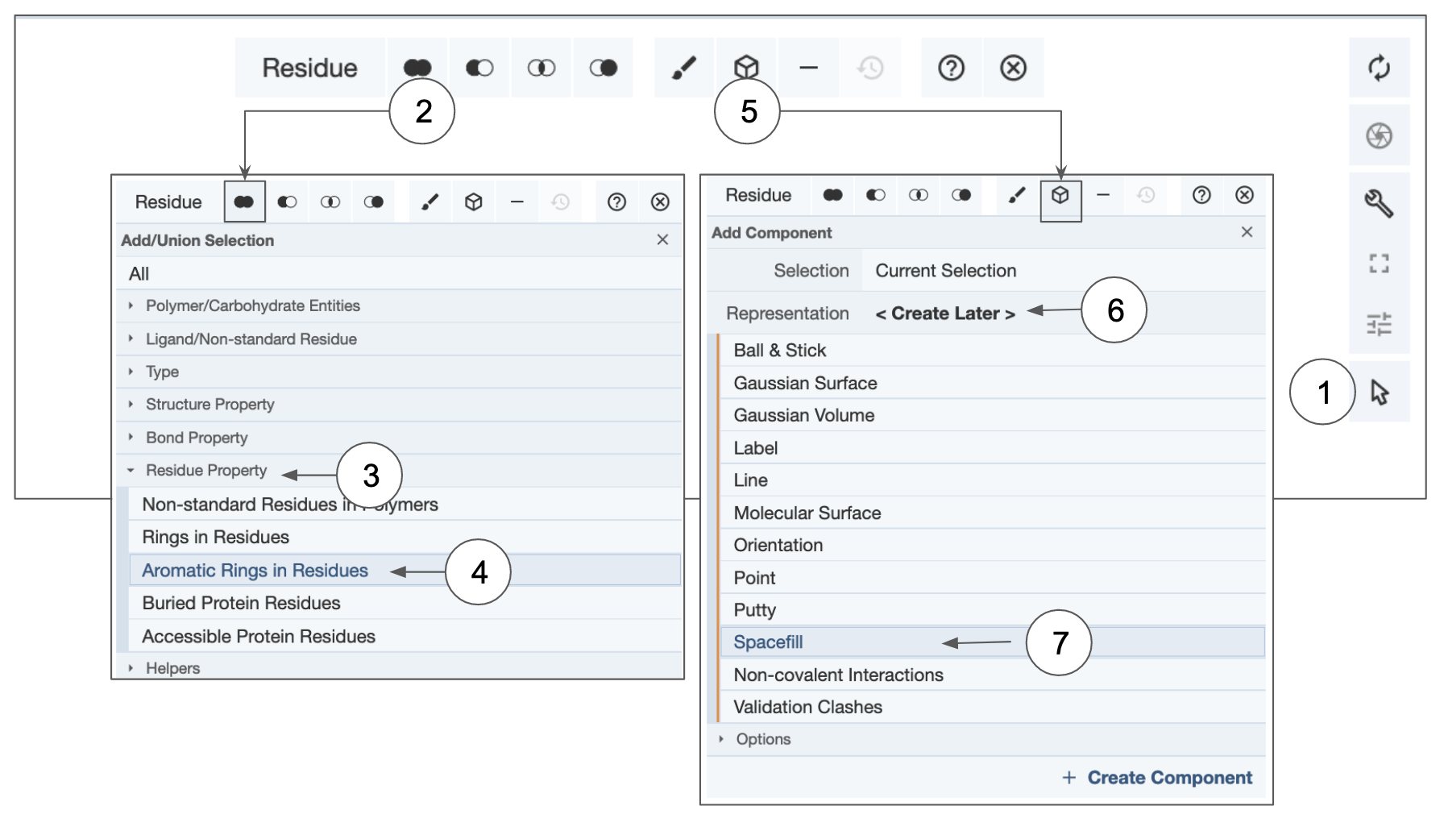
  - Save an image showing the aromatic amino acid side chains in the structure and answer the following question.

Q5. Where are the aromatic amino acid side chains located in the DsRed structure? Do you see any patterns regarding the distribution of these residues? Support your answer with a suitable figure.

Ans.

- Hide the new Custom Selection component by clicking on the eye icon before proceeding to the next step.
- Color the cartoon representation of the polymer chains by clicking on the three dots at the right of the Polymer components in the right hand controls panel.
- From the options that open up click on the Set Coloring >> Residue properties >> Hydrophobicity options. This displays the hydrophobic amino acids as green and hydrophilic amino acids red.

Q6. Which of the interchain interfaces in the DsRed structure has fewer polar amino acid residues? Support your answer with a suitable figure.

Ans.

Compare the structures of GFP and DsRed.

- Open the RCSB Pairwise Structure Alignment tool at https://www.rcsb.org/alignment and set up the structure comparison as follows:
  - In the boxes fill in the PDB IDs 1ema and 1g7k.
  - Select chains A in the boxes provided for the comparison.
  - Use the default search options to launch the comparison by clicking on the Compare button.
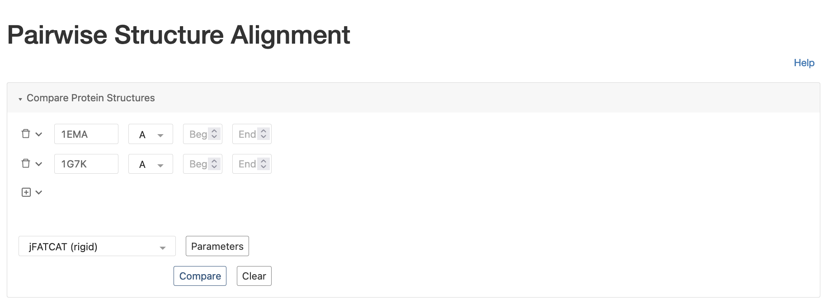

Q7. How well do the Green Fluorescent Protein (GFP) and DsRed structures match? List the root mean squared deviation (rmsd) and the % identity between the two chains. Describe in a sentence what this means. Support your answer with a suitable figure.

Ans.

Appendix: Mol* Quick Reference
1. Navigate the 3D Canvas:
a. Rotate
● Press left mouse button and move OR use Shift + left mouse button and drag.
b. Translate
● Press right mouse button and move OR use Control + the left mouse button and move. On a touchscreen device, use a two-finger drag.
c. Zoom
● Use the mouse wheel. On a touchpad, use a two-finger drag. On a touchscreen device, pinch two fingers.
d. Center and zoom
● Use right mouse button to click on the part of the structure you wish to see.
e. Change clipping planes
● Use Shift button + the mouse wheel. On a touchpad, use the Shift button + a two-finger drag.
2. Select: first open Selection Mode and change the Picking Level (if needed)
a. Select Picking Level
● Click on objects in the 3D canvas – such as atoms, residues, chains, etc.
b. Select object in 3D canvas
● Click on residues, chains etc. in the 3D canvas based on picking level
c. Select object from Sequence Panel
● Click on residues, ligands, or entire chain in the Sequence Panel
d. Custom Select combinations
● Use the Set Operations Menu in the Selection Mode toolbar
3. See or Hide:
a. To add representations
● Create a component of the region you wish to see/hide → Go to the Components Panel and press the “eye” icon next to the component you create
b. To hide/remove from view
● Select region you wish to hide → Click on the subtract/hide icon in the Selections toolbar
4. Color:
a. N-terminus to C-terminus (rainbow)
● Components → Polymer → Set Coloring → Residue Property → Sequence Id
b. Heteroatom
● Components → Polymer → Set Coloring → Atom Property → Element Symbol
c. Secondary structure
● Components → Polymer → Set Coloring → Residue Property → Secondary Structure
d. Hydrophobicity
● Components → Polymer → Set Coloring → Residue Property → Hydrophobicity
e. Domain
● Select domain → Selections Menu → Apply Theme to Selection → Color → Apply Theme
5. Compare Structures: first upload two or more structures at rcsb.org/3D-view
a. By chains
● Select 2 or more polymer chains/residues → Superposition → By Chains → Superpose
b. By atoms
● Select 1 or more atoms → Superposition → By Atoms→ Superpose
6. Make Measurements:
a. Distance
● Make 2 or more selections → Measurements → Add → Distance (for first 2 selections)
b. Angle
● Make 3 or more selections → Measurements → Add → Angle (for first 3 selections)
c. Dihedral
● Make 4 or more selections → Measurements → Add → Dihedral (for first 4 selections)

