## Helices and Sheets (Secondary Structure)

**Authors**: Alexandra Pettit, Carleton University, Ottawa, ON, Canada; Brian Gadd, Los Angeles Mission College, CA; Shuchismita Dutta, Rutgers University, NJ.

**Lesson Overview**:

This lesson reviews the central features of the most common regular secondary structures, α helices and β sheets, found in proteins.

**ASBMB Learning Objectives**

(<https://www.asbmb.org/education/core-concept-teaching-strategies/foundational-concepts/structure-function>)

2. Structure is determined by several factors

* Students should be able to **recognize the repeating units in biological macromolecules** and be able to discuss the structural impacts of the covalent and noncovalent interactions involved *(Introductory)*.
* Students should be able to **discuss the chemical and physical relationships between** **composition and structure** of macromolecules *(Introductory)*.
* Students should be able to **compare and contrast the primary, secondary, tertiary and quaternary structures of proteins** and nucleic acids *(Intermediate)*.

***Note: To complete this lesson you will need to be able to capture an image from your screen. Find a good way to print screen or capture the contents of the screen as an image that can be imported into PowerPoint or other graphics programs to add annotations and labels.***

### Part 1: Recognizing Secondary Structures

This section focuses on examining the polymer sequences and 3D structures of proteins in the PDB to learn about the secondary structural elements present in them.

The PDB entry you will be examining contains the crystal structure for a Src tyrosine kinase SH2 domain solved at 2.50 Å.

Go to the [RCSB PDB home page](https://www.rcsb.org/) and enter the PDB entry code **1spr** in the top search box and click on it to open the “Structure Summary” page for this PDB structure or go to the page (<https://www.rcsb.org/structure/1SPR>).

On the top left corner of the page there is an image showing the structure of the molecule.

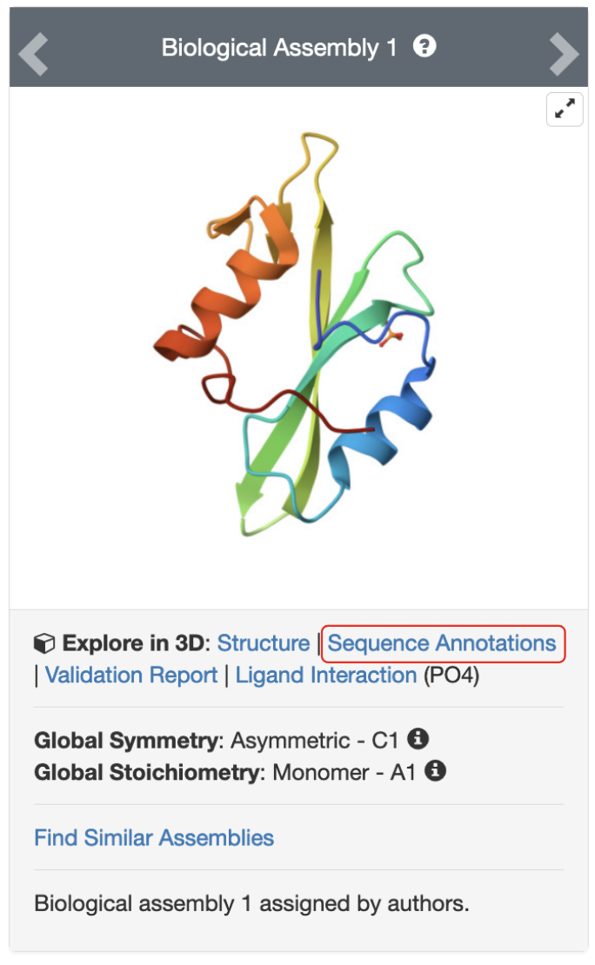

*Figure 1: Structure of Src SH2 tyrosine kinase domain, presented in a cartoon representation of the proteins, with individual amino acid residues colored by the rainbow color code where blue indicates the N terminus and red indicates the C terminus.*

Click on the hyperlink “Sequence Annotations” to launch a view of this molecule.

* In this view, one panel shows the sequence of the protein and the other shows its 3D structure.
* The two panels are connected so that clicking on a specific amino acid in the sequence panel selects and centers the 3D structure view on the same amino acid and displays the interactions around the specific amino acid.
* The sequence panel also displays various annotations about it (e.g., secondary structure, binding sites, hydropathy, …)

Based on the information presented here, answer the following questions.

1. List the names of two secondary structural elements that are present in this structure.

1. How is each secondary structural element represented/indicated in the sequence and 3D structure views? Describe them in words and support your answer with a labeled screenshot from the RCSB PDB website.
2. For each type of secondary structural element described above, list how many of them are present in this structure? List the beginning and end amino acid residue numbers forming these elements.
3. The sequence panel presents the polymer sequence from N- terminus to C-terminus.
   * Can you recognize a β sheet in the sequence panel?
   * How do you recognize a β sheet in the 3D structure panel? What visual cues in the 3D protein view allow you to determine if the sheet is parallel or antiparallel?
   * What type of β sheet is present in this structure. Support your answer with a suitable image and annotate/label it to explain your point(s).

### Part 2: Exploring α helices

This section focuses on examining α helices in a structure - their handedness, interactions stabilizing them, and the nature of amino acids that form them.

Return to the “Structure Summary” page for PDB entry 1spr and then click on the Structure tab at the top of the page (See Figure 2a). Now examine the structure in Mol* (See Figure 2b).

* In this view, you can see the primary sequence of the protein at the top of the screen and the 3D structure below. You can click and drag your mouse over the 3D structure to reorient the protein as desired.
* The sequence and 3D structure presentations are connected so that clicking on a specific amino acid in either panel selects and centers the 3D structure view on the same amino acid and displays the interactions around the specific amino acid.
* The right most panel in this view allows you to manipulate the 3D rendering of the molecule and conduct further analyses (e.g., – take measurements).



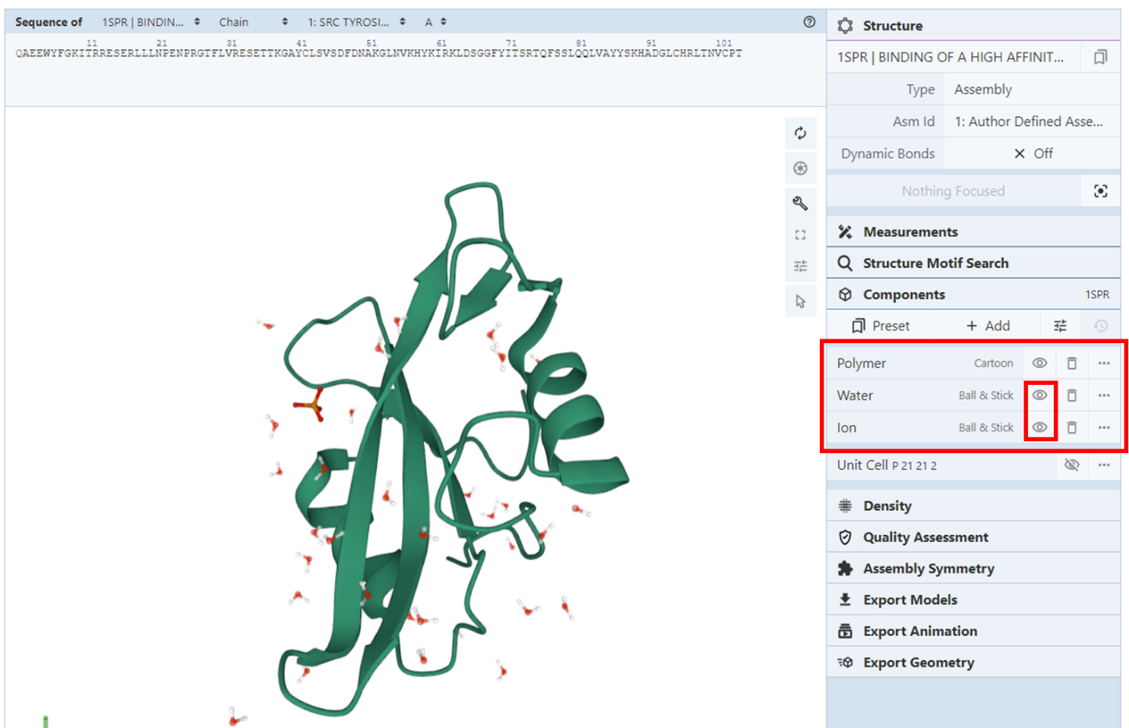

*Figure 2: a. Selecting the tab to visualize the structure; b. Structure of Src SH2 tyrosine kinase visualized in Mol* (when the Structure tab is opened).*

Begin by clicking on the eye icon next to “water” and “ion” in the menu on the right-hand side of the screen (see figure 2 below). Once you have done so, the eye icon will have a line through it and you will no longer see the selected molecules, leaving a simplified representation of the protein alone.

Use your cursor to reorient the protein and explore its structure and answer the following questions.

1. Are the helices in this protein right- or left- handed?

*Hint: You can use your own hands to help you figure this out - if the direction of helix coiling follows the curl of the right hand, when you make a fist and point your thumb upwards, it is a right handed helix.*

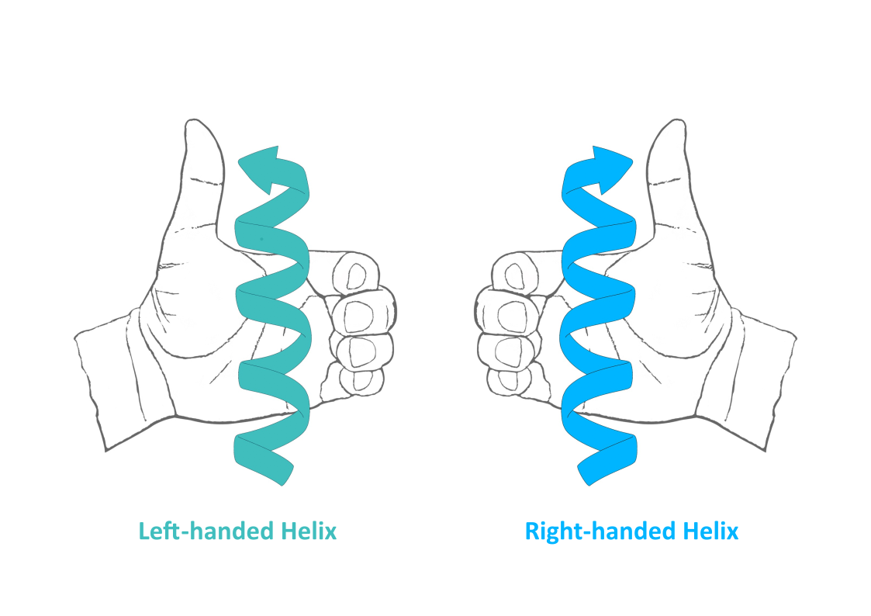

Answer: The helices in the structure are ___________________ handed.

Pick one helix, hover your cursor over the first residue at either end, and begin tracing its back bone by moving your cursor along residue by residue. Count the amino acids as you do so, noting how many make up each turn of the helix.

1. On average how many amino acid residues make up a single turn of the helix? Based on your knowledge of a prototypical α-helix, is this value expected? Why or why not?

Reorient the protein such that you are looking down the center of one of the helices. See figure 3 below for one possible example.

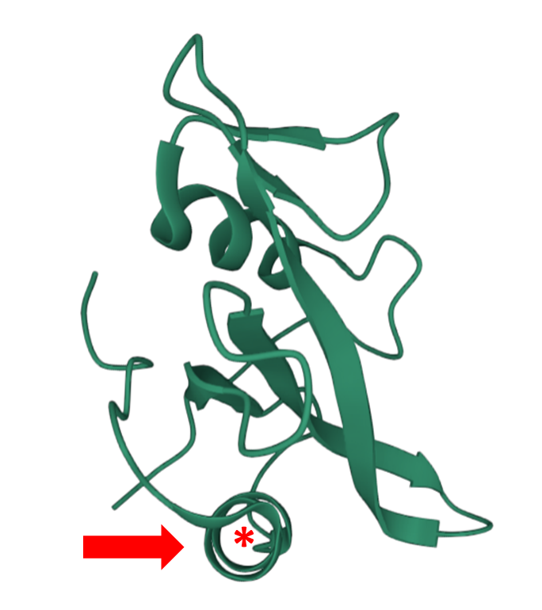

*Figure 3: Structure of Src SH2 tyrosine kinase domain oriented to be looking down the center (annotated with an asterisk) of one of its helices (indicated with an arrow).*

Click on an amino acid residue in this helix, this will center the 3D structure view on that amino acid, displaying all of the amino acids, their side chains, and any non-covalent interactions with 5 Å.

1. Looking at the side chains of the amino acids that make up the helix. Where are they found with respect to the helix axis? Support your answer with a suitable figure.

Click on Thr11 (either on the 3D canvas or in the sequence panel in Mol*) to center the 3D structure on this amino acid. Identify its main chain carbonyl (C=O) group and examine the non-covalent interactions it forms by hovering over the dashed lines extending out from it. As you hover over these dashed lines, the bond type and identity of the interacting partners will be indicated in the lower right-hand corner of the window.

1. What interactions does Thr11’s mainchain C=O form? Save images of the bond(s), label them, and include them in your answer.

1. Based on your knowledge of a prototypical α-helix, which one of these interactions should you have been able to predict and why?
2. If you continue along the helix, does each main chain C=O continue to exhibit the expected interactions necessary for an α-helix to form?

.

1. Which one of Thr11’s interactions you identified in question 7 is not part of its secondary structure?

Explore the nature of the amino acid side chains forming the helices.

Follow these steps to display the side chains in the helices of the structure.

* Click on the Arrow icon in the Toggle menu (marked 1) in Figure 4 to activate the selections menu
* Click on the select icon (marked 2) and from the menu that opens up select options “Structure Property” >> “Helix”. This should select the helices in the structure.
* Click on the create component icon (marked 3, 5) and select the “Representation” to be “Ball and Stick” and click on the “Create Component” button. This should display the side chains of all the amino acids in the helices. Retain the selection of the helices.
* Now click on the intersect icon (marked 4) and from the menu that opens select the option “Residue Property” >> “Buried Protein Residue”. This should select only the amino acids of the helices with buried side chains.
* Click on the create component icon (marked 3, 5), select the “Representation” to be “Spacefill” and click on the “Create Component” button.

Examine the figure that you have created and answer the questions.

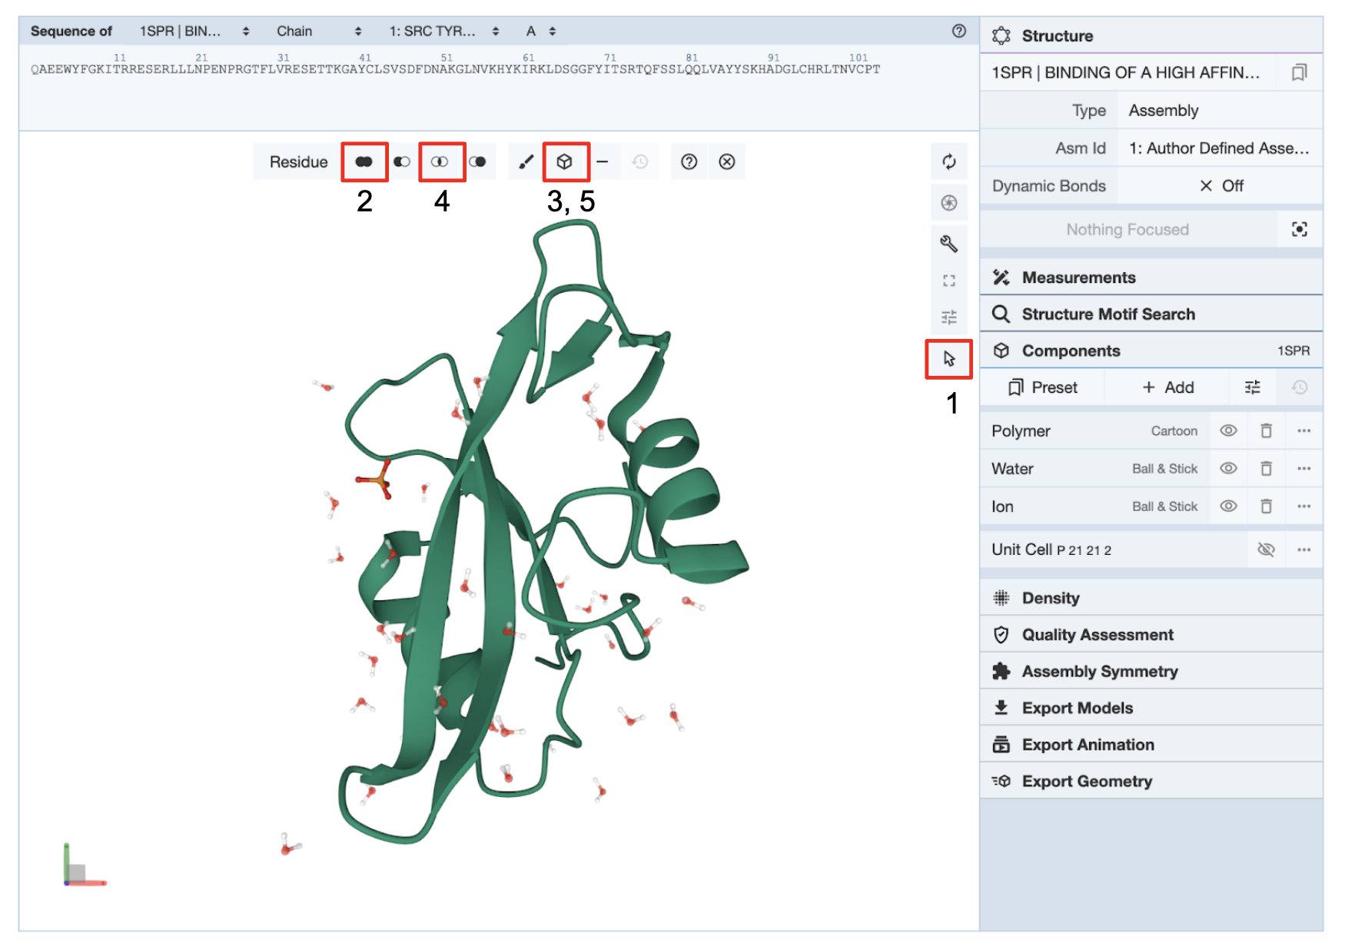

*Figure 4: Examining the nature of amino acids in the helices in PDB entry 1spr. Red boxes with numbers indicate the order of actions to visualize the helices in this part of the activity.*

1. Examine the residues shown in the ball and stick representations - do they have polar or nonpolar side chains?
2. Examine the residues shown in the spacefill representations - do they have polar or nonpolar side chains?
3. What is the distribution of polar and nonpolar amino acids around the helices?

### Part 3: Exploring β strands/sheets

This section focuses on examining β strands/sheets in a structure - their handedness, interactions stabilizing them, and the nature of amino acids that form them.

Click the double circular arrow symbol (🔃) at the top right-hand corner of the 3D canvas to zoom back out to the whole structure and click in the white space around the structure to deselect any previously highlighted residues. Alternatively, you can also reload the page to see the full structure, just as it is loaded in Mol* for the first time.

Examine the overall shape of the β sheet

Orient the structure in the 3D canvas so that the two helices are located on the sides and the β sheet is in the middle (see Figure 5 below)

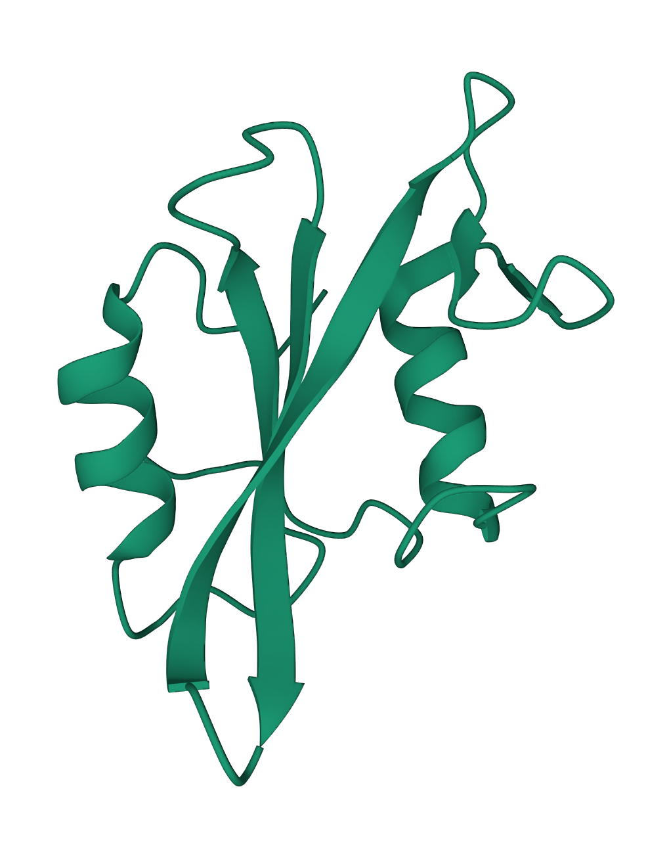

*Figure 5: Secondary structural elements shown in cartoon representation in the PDB entry 1spr*

1. Describe the twist in the β sheet - is it right handed or left handed?

Examine the overall shape of the β strands

In the sequence panel select a beta strand [e.g., amino acids 41-49 (YCLSDVSDFD)] as follows:

* Click on the Arrow icon in the Toggle menu (marked 1) in Figure 6 to activate the selections menu
* Click on the sequence panel to select the amino acids 41-49 (marked 2) and note that the same amino acids should be highlighted in the 3D canvas (marked with a red arrow).
* Click on the create component icon (marked 3, 4) and select the “Representation” to be “Backbone”, open the Options menu in this box and label the component “Backbone”, now click on the “Create Component” button. This should create a new component that displays these residues as the C-α backbone. Retain the selection of the helices.
* Now click on the create component icon again (marked 3, 4), and select the “Representation” to be “Ball and Stick”, open the Options menu in this box and label the component “Ball and Stick”, now click on the “Create Component” button. This should create a new component that displays the side chains of all the amino acids in the strand.
* Hide the Polymer, Water, and Ions by clicking on the eye icon. Only the components that you just created should be visible.

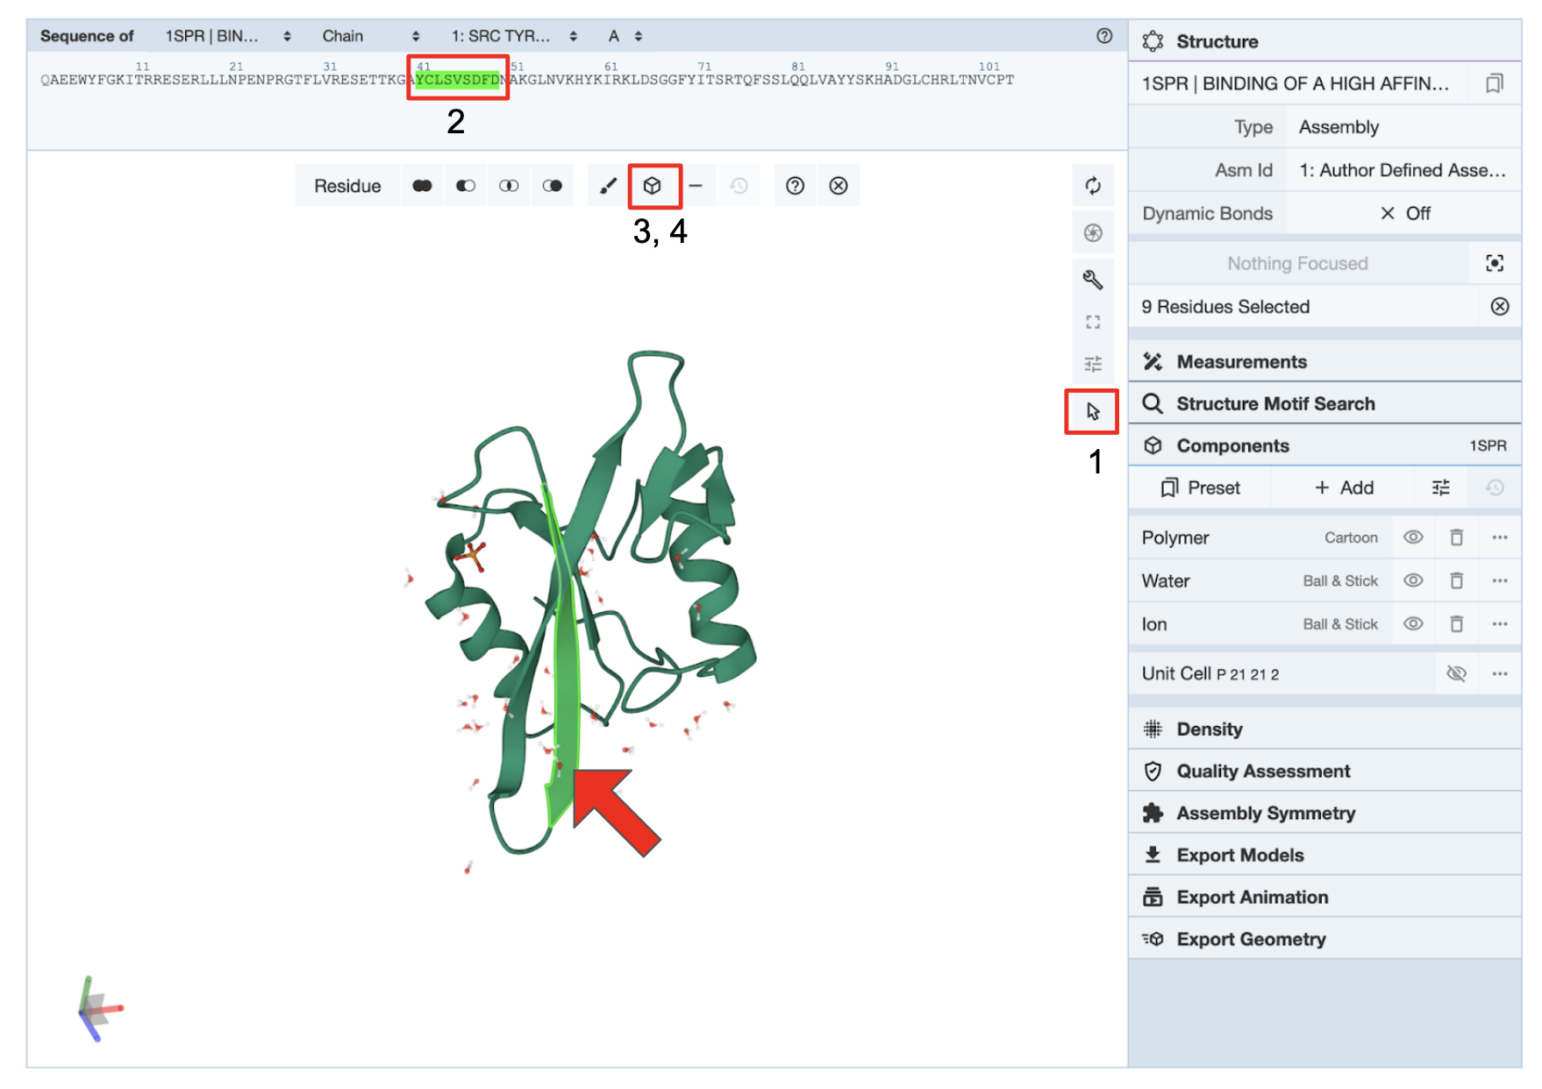

*Figure 6: Examining the nature of amino acid interactions in the β strands in PDB entry 1spr. Red boxes with numbers indicate the order of actions to visualize the β strands in this part of the activity.*

Examine the figure that you have created and answer the questions.

1. View the “Backbone” component alone and describe the appearance of the peptide backbone of this β strand. Support your answer with suitable figures.
2. Now view the “Ball and Stick” component alone and describe the location of the amino acid side chains. Also describe the relative locations of the backbone amino (NH) and carbonyl (C=O) groups in the β strand. Support your answer with suitable figures.

Examine the hydrogen bonding interactions stabilizing the β strand

Select and color one amino acid in the strand and examine the interactions in its neighborhood as follows:

* While the selection mode is on (i.e., the selection options are still displayed in the horizontal menu on the 3D canvas) click on the amino acid 45 (V or Val) in the sequence panel.
* Click on the Paintbrush icon in the same menu to display options for coloring the selected atoms/residues. Select a color (e.g., magenta) and then click on the “Apply Theme” to color the selected residue with that color.
* Now turn off the selection menu by clicking on the arrow icon (marked 1 in Figure 6).
* Click on the residue V 45 again to zoom in and explore the interactions in its neighborhood.

1. Within this view, examine the interactions of the C=O and NH groups of Val45 and Ser44. Examine and list their interacting partners and the non-covalent interactions they form. Save images of the bond(s), label them, and include them in your answer.

In this same view click on the Cartoons representation of the Polymer component by clicking on the eye icon next to Polymers in the Controls Panel.

1. As you continue along the adjacent β strands, can you identify a pattern of interactions (remember we are talking about secondary structure here so look at interactions between the peptide backbones) that allow for the formation of this beta sheet?
2. Are your findings about the organization and interactions of amino acids in the β strands what you would expect to find in a prototypical β sheet?