# Hemoglobin Structure and Function

**Authors**: Shuchismita Dutta, Rutgers University, NJ

**Lesson Overview**:

This lesson introduces the structure and function of a molecule (hemoglobin). It begins by reviewing the RCSB Molecule of the Month article on the molecule, and explores the ready-made static and interactive models of the structure. Subsequent parts of the lesson uses RCSB PDB tools and resources to visualize and analyze the molecular structure to learn more about the structure and function of the protein.

***Note: There are several sections in this activity. Feel free to select and use parts of the exercise that are aligned with your curricular/course learning goals.***

**ASBMB Learning Objectives** (<https://www.asbmb.org/education/core-concept-teaching-strategies/foundational-concepts/structure-function>)

2. Structure is determined by several factors

* Students should be able to **recognize the repeating units** in biological macromolecules and be able to discuss the **structural impacts of the covalent and noncovalent interactions involved** *(Introductory)*.
* Students should be able to compare and contrast the **primary, secondary, tertiary and quaternary structures** of proteins *(Intermediate)*.
* Students should be able to **use various bioinformatics approaches to analyze** macromolecular primary **sequence and structure** *(Intermediate)*.

4. Macromolecular interactions

* Students should be able to discuss the **impact of specificity or affinity changes** on **biological function** and any potential **evolutionary impact** *(Introductory)*.
* Students should be able to discuss the **interactions between a variety of biological molecules** (including proteins, nucleic acids, lipids, carbohydrates and small organics, etc.) and describe how these interactions **impact specificity or affinity** leading to **changes in biological function** *(Intermediate).*

6. The biological activity of macromolecules is often regulated

* Students should be able to **compare and contrast various mechanisms for regulating the function of a macromolecule** or an enzymatic reaction or pathway *(Introductory)*.
* Students should be able to discuss the **advantages and disadvantages of regulating a reaction allosterically** *(Intermediate).*
* Students should be able to discuss **examples of allosteric regulation, covalent regulation and gene level alterations of** macromolecular **structure-function** *(Intermediate).*

***Note: To complete this lesson you will need to be able to capture an image from your screen. Find a good way to print screen or capture the contents of the screen as an image that can be imported into PowerPoint or other graphics programs to add annotations and labels.***

### Part I: Begin with the RCSB PDB Molecule of the Month

The focus in this part is to learn about Hemoglobin’s function, what the molecule looks like and where its active site is.

Read the RCSB PDB Molecule of the Month Article on Hemoglobin (<https://pdb101.rcsb.org/motm/41>) and answer the following questions.

1. About the Featured Molecule(s)

*Function*:

* 1. What is the main biological function discussed in the article?

*Players*:

* 1. Name the key molecule(s) (proteins, nucleic acid, etc.) performing the function(s) listed above. Are there any other molecules mentioned in the article that interact with the molecule being studied – either facilitating or regulating the discussed function? Name the molecule(s).

*Big picture*:

* 1. In a few sentences describe how reading this article helps you understand the function of hemoglobin in the human body.

1. Explore the structure-function relationship of the molecule(s) discussed in the article

*Overview*:

* 1. Describe how the shape, size and interaction of relevant molecules discussed in the article help in performing the function

*Details*:

Go to the “Exploring the Structure” section in the article and analyze the structures shown in detail. Examine the static images, and JSmol interactive views, where available.

* 1. Take screenshots of two different views of the entire hemoglobin protein (in JSmol) - oxy and deoxy states and include them in your answer. Describe any one structural feature that is different in these images.

* 1. Create two images showing a closeup of the heme groups in the oxy and deoxy states. Describe the interactions stabilizing the heme group and also the oxygen binding (in the oxy state). *Note that the CPK colors used for the heme group shows carbon in gray; nitrogen in blue; oxygen in red; and sulfur in yellow.*

### Part II: Exploring Hemoglobin Structure using Mol*

The focus in this part is to learn more about Hemoglobin’s

1. Structure and assembly - primary, secondary, tertiary, and quaternary structures
2. Function - oxygen binding and release
3. Regulation - by low pH (H+), carbon dioxide (CO2), 2,3-Bisphosphoglyceric acid (BPG), Gene expression
4. Evolution - myoglobin, neuroglobin and more

The PDB structures used in this exercise are listed in the table below:

| PDB ID | Entry Title | Comments |
| --- | --- | --- |
| 1b86 | Human deoxyhemoglobin - 2,3-diphosphoglycerate complex | BPG bound hemoglobin (deoxy form) |
| 1fdh | Structure of human fetal deoxyhaemoglobin | hemoglobin with 2 alpha and 2 gamma chains (deoxy form) |
| 2dn1 | 1.25A resolution crystal structure of human hemoglobin in the oxy form | oxy form of Hb |
| 2dn2 | 1.25A resolution crystal structure of human hemoglobin in the deoxy form | deoxy form of Hb |
| 2dn3 | 1.25A resolution crystal structure of human hemoglobin in the carbonmonoxy form | carbon monoxy form of Hb |
| 2hhb | The crystal structure of human deoxyhemoglobin at 1.74A resolution | Older oxy form of Hb referenced in the Molecule of the Month Article |

Go to the [RCSB PDB home page](https://www.rcsb.org/) and enter the hemoglobin PDB code 2hhb in the top search box and click on it to open the Structure summary page for a deoxy human hemoglobin or go to the page (<https://www.rcsb.org/structure/2hhb>).

On the top left corner of the page there is an image showing the structure of the molecule.

|  | *Figure 2: Structure of the deoxy-hemoglobin molecule (PDB ID 2hhb) - composed of four subunits - two copies each of the Hemoglobin alpha protein (colored in green and orange), and two copies of the Hemoglobin beta protein (colored in pink and violet). The four subunits interact with each other through non-covalent interactions.* |
| --- | --- |

Click on the hyperlink “Sequence Annotations” to launch a view of this molecule.

* In this view, one panel shows the sequence of the protein chains in hemoglobin and the other shows its 3D structure.
* The two panels are connected so that clicking on a specific amino acid in the sequence panel selects and centers the 3D structure view on the same amino acid and displays the interactions around the specific amino acid.
* The sequence panel also displays various annotations about it (e.g., secondary structure, hydropathy, metal binding)

Based on the information presented here, answer the following questions.

#### A. Exploring Structure and Assembly

1. What secondary structural elements are present in Chains A and B in the structure? Name these secondary structural elements by alphabets A, B, C, D, etc., starting from the N- to the C-terminal end. List the amino acid residue numbers forming these elements.
2. Of the secondary structural element(s) listed above which one(s) has/have a His that forms coordinate bonds with the heme iron? List the alphabetical name of that secondary structural element and its primary structure (or sequence) (in both chains).
3. Tertiary structure:
   1. Identify the amino acid #7 in Chain A (Hemoglobin alpha) - what is it?
   2. Click on this amino acid to focus (zoom in and center) on it, display the amino acids within 5Å, and show non-covalent interactions amongst these amino acids. List the amino acid(s) forming non-covalent interactions with the side chain of the amino acid #7. List the type of non-covalent interaction. Support your answer with an image of the interaction.
4. Quaternary Structure:
   1. Examine the interactions of the amino acid R141 in chain A and list any non-covalent interaction involving this residue’s backbone atoms and side chains that stabilizes the quaternary structure of this molecule. Save an image to support your answer and list the type of interaction(s) shown.

#### B. Exploring Hemoglobin Function

Oxygen molecules bind to the heme groups in hemoglobin. Oxygen binding introduces structural changes - locally near the heme, and also at the level of the hemoglobin molecule’s tertiary and quaternary structure. This section focuses on examining these changes and comparing the PDB structures of oxygen bound hemoglobin (PDB ID 2dn1) and the deoxy form of hemoglobin (PDB ID 2dn2).

1. Getting Oriented:

In two different tabs of your browser, open the Structure Summary Page for the PDB IDs 2dn1 and 2dn2.

PDB entry 2dn2

Scroll down to the Macromolecules section of this page to see what is included in these structures. There are two hemoglobin alpha chains (Chain A, C) and two hemoglobin beta chains (Chain B, D). Click on the Structure tab on the top of the page to visualize the structure in Mol*. It should look like this:

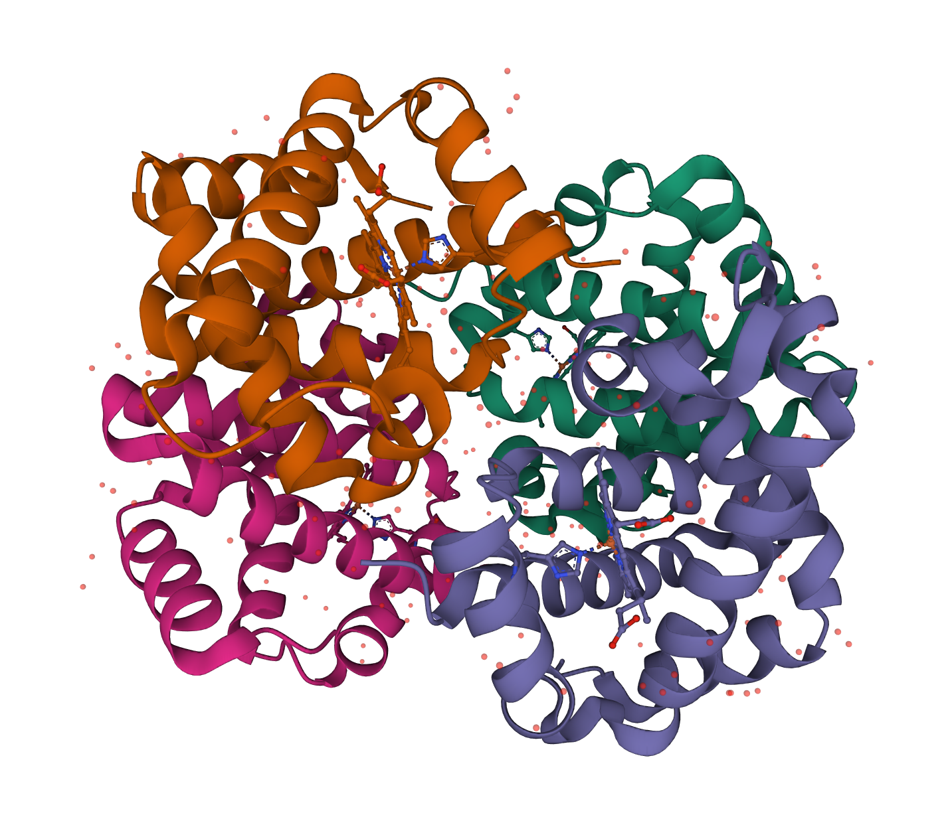

* 1. Save an image of the complete molecule (shown above). Import the image into PowerPoint or similar software and label the two alpha chains as alpha1 (chain A) and alpha2. Also label the two beta chains as beta1 and beta2. Mark the locations of the heme groups.

PDB entry 2dn1

* 1. Scroll down to the Macromolecules section on the Structure Summary Page for this entry. Based on the information listed here which and how many proteins are included in the structure?
  2. Open the structure of this PDB entry in Mol* (using the same steps as used in part a. of this question). Save an image of the molecule and label the hemoglobin subunits with alpha1, alpha2, beta1, and beta2.

[Hint: You may have to color the polymer chains by instance to see an image similar to that seen in Answer a. Use the following steps,

In the right hand control panel

* Click on the Actions (...) button for Polymers →
* Click to expand Set Coloring options →
* Select Polymer Chain Instance]
  1. Do you see any difference in the central water cavity (between the 4 protein chains forming hemoglobin) in the oxy vs deoxy version of the proteins? Explain your observation in a sentence or two.

1. Heme and Oxygen Binding:

In each of the PDB structures, select the heme group bound to Chain A (Hemoglobin alpha) to examine the interactions around it. Use the following steps to focus on the ligand and show all interactions in its neighborhood:

* Click on the heme group in Mol*’s 3D Canvas (graphics window)**OR**
* In the sequence panel, click on the name of the molecules to select the ligand PROTOPORPHYRIN IX CONTAINING FE.
* Click on the Chain A HEM ligand shown in the sequence panel \
  1. Save an image of the heme group and its neighborhood in both the oxy (PDB ID 2dn1) and deoxy (PDB ID 2dn2) molecules. Label the proximal and distal histidines, helices E and F, and where the oxygen molecule is bound.
  2. In deoxyhemoglobin, what molecule occupies the oxygen binding site?
  3. Do you see any difference in the heme iron position in the deoxy and oxy hemoglobin structures?

Measure the distance between the His87 NE2 and the heme iron (in both PDB entries 2dn2 and 2dn1). Use the following steps

* Click on the arrow icon () to activate the Toggle Menu for selections and changing representations
* Change the level of selection to Atoms/Coarse Element.
* In the 3D canvas click to **select two atoms** that you want to measure thedistance between. The selected atom(s) will have a green halo around it/them.
* Go to the Measurements Panel, and select Add → Select Distance.
* The distance will be labeled in the 3D canvas and have a new menu under Controls.

d. What is the distance between His87 NE2 and Heme iron in both the structures (PDB ID 2dn1 and 2dn2)?

1. Changes in Quaternary Structure upon Oxygen Binding:

Explore the non-covalent interactions stabilizing Arg141 in the hemoglobin alpha chain in both the deoxy (PDB ID 2dn2) and oxy (PDB ID 2dn1) hemoglobin.

* If the Toggle Menu for Selections and changing representations (on the top of the 3D Canvas) is active, inactivate it by clicking on the arrow icon ().
* In the sequence panel at the top of the Mol* page click on the residue R141 (Chain A).
* Examine the neighborhood of this amino acid and save an image for each of the PDB entries.
* Label the images to describe the interactions.
  1. Are the interactions of this amino acid similar in the oxygenated and deoxygenated forms of hemoglobin? Describe any changes that you see. Support your answer with suitable, and labeled illustrations.
  2. In the complete hemoglobin molecule, where are the Arg141 interactions located (in terms of the alpha1, alpha2, beta1, beta2 proteins)?

1. Carbon Monoxide poisoning

Carbon monoxide or CO (PDB Ligand ID CMO) is an odorless and colorless gas that binds to hemoglobin and can lead to death. Examine the binding of CMO in the PDB entry 2dn3 and answer the following questions.

1. Where in the hemoglobin molecule does carbon monoxide bind? Illustrate your answer with a suitable image.
2. Why is carbon monoxide a poisonous gas? Explain your answer with a suitable figure of the CMO bound to hemoglobin to explain your answer. (Hint: you may measure the length of the bond holding the carbon monoxide in place. Follow the same steps for measurements as in Question 2 d above).

#### C. Exploring Regulation of Hemoglobin Function

Oxygen binding to hemoglobin is regulated by changes in pH, organic regulators (e.g., 2,3-di-phospho-glycerate, 2,3-DPG), and changes in the expression of specific genes during different developmental stages. Here we will explore examples of the molecular mechanisms that facilitate these regulations. Note that all these regulations act at locations other than the oxygen binding site, so are examples of allosteric regulations.

1. Carbon dioxide, pH, and Bohr effect

In the tissues where there is a higher concentration of carbon dioxide, the pH is expected to be lower (e.g., 7.2) than the physiological pH (e.g., 7.4-7.6). Histidine is unique in that the pKa for the side chain is ~6 and its isoelectric pH (pI) is ~7.6. However, the effective pKa for each of the His residues may vary depending on the neighboring environment.

* 1. Examine the Hemoglobin beta chains terminal His (His146) in the oxyhemoglobin (PDB ID 2dn1) and deoxy hemoglobin (PDB ID 2dn2) structures. List the interactions stabilizing this residue and support your answer with suitable images.
  2. Compare the structures of chain B in PDB entries 2dn1 and 2dn2 using the structure alignment tool. What are the Root Mean Square Deviation (RMSD) and percentage of sequence identity (SI%) for this alignment? [Learn more about the tool](https://www.rcsb.org/docs/tools/pairwise-structure-alignment) and the implications of the RMSD and SI% values.
  3. Select the option to display the whole structure. Click on the His146 location in chain B and comment on its location in the two structures. Support your answer with a suitable image.
  4. What would happen if the His residue loses its charge as the pH reduces (due to high concentration of carbon dioxide)? (Hint: List which interactions would break and how that would affect the overall tertiary structure of hemoglobin).

1. 2,3-BPG (or DPG)

2,3-bisphosphoglycerate (BPG) is a glycolytic intermediate that is found in high concentrations in the red blood cells. In addition to its role in regulating several metabolic enzymes, BPG also binds to hemoglobin to impact oxygen binding. Examine the structure of BPG bound to hemoglobin (PDB ID 1b86) to answer the following questions.

* 1. On the structure summary page scroll down to the Small Molecules section and click on the “Ligand Interactions” button to view the binding environment of BPG (Ligand DG2 in the PDB structure). Where does this molecule bond in the hemoglobin molecule? List its interactions and support your answer with a suitable image.
  2. The binding of BPG promotes oxygen release - use the BPG bound hemoglobin structure to explain this phenomenon at a molecular level.

1. Fetal Hemoglobin

In the fetus the hemoglobin molecule is composed of two alpha and two gamma chains. The gamma chains are similar to the beta chains (seen in adult hemoglobin) but have some differences. Read the Molecule of the Month feature on Fetal Hemoglobin to learn more about this molecule (<https://pdb101.rcsb.org/motm/257>).

* 1. Does fetal hemoglobin have a higher or lower affinity for oxygen (compared to adult hemoglobin). Why? Explain your answer in molecular terms.
  2. Examine the structure of fetal hemoglobin (PDB ID 1fdh), especially the location corresponding to where BPG binds to adult hemoglobin. Would BPG bind to the fetal hemoglobin? Support your answer with a suitable image. (Hint: you may measure the distance between the closest points of interaction between the hemoglobin chains around the DG2 ligand in the BPG bound structure (PDB ID 1b86) and compare that with the same atoms in this structure to support your claim.
  3. Advanced level (optional): Examine the structure of fetal hemoglobin bound to carbon monoxide and oxygen (PDB ID 4mqj). How many chains have these ligands bound? Where do each of these ligands bind (list the name of the hemoglobin chain it binds to)? What does this suggest about the binding of carbon monoxide to fetal hemoglobin?

#### D. Exploring Hemoglobin Evolution

Return to the Structure Summary page for the PDB entry 2dn2 (<https://www.rcsb.org/structure/2DN2>) and scroll down to the Macromolecules section.

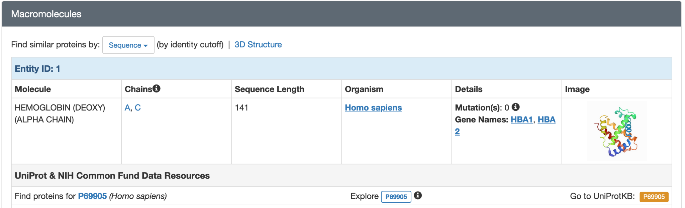

Click on the “Sequence” pulldown options and the hyperlinked “3D Structure” to explore the PDB archive and find other structures that have similar amino acid sequence and shape (3D structure).

1. Using the Sequence pulldown menu, explore proteins in the PDB archive that have similar sequences. Try different sequence identity matches (from 90% to 30%) to answer this question. List the names of 2 organisms that have proteins similar to human hemoglobin alpha. What is the sequence identity of the proteins for the organisms you selected?

1. Using the structure similarity search options (shown above), explore proteins in the PDB that have similar structures. From the search results, list the names of 1 organism, which belongs to a different phylum (from humans). Also list the name of the protein that is structurally similar to human hemoglobin (alpha chain) and the PDB ID in which the matched polymer is present.
2. Comparing hemoglobin alpha and beta chains (in PDB entry 2dn2).

Use the following steps to compare these protein chains:

* From the top bar on the RCSB website (rcsb.org) click on the Analyze Menu
* Select Protein Structure Alignment and in the page that opens, select the “protein structure alignment tool”
* Enter the PDB ID and Chain ID in the boxes presented - one should have 2hhb Chain A and the other should be 2hhb Chain B.
* Click on the Compare button and review the results presented.
  1. What is the root mean square deviation (RMSD) and the Sequence Identity (SI%) of the superimposed structure? Save an image of the structure comparison and include it in your answer.
  2. Are these proteins related more closely by sequence or structure?