# Insulin Structure and Function

**Authors**: Keith Johnson, Bradley University, IL; Brian Gadd, Los Angeles Mission College, CA ; Alexandra Pettit, Carleton University, Ottawa, ON, Canada; Thirth Patel, Rutgers University NJ, and Shuchismita Dutta, Rutgers University, NJ

**Lesson Overview**:

This lesson introduces the structure and function of a molecule (Insulin). It begins by reviewing the RCSB Molecule of the Month article on the molecule, and explores the ready-made static and interactive models of the structure. Subsequent parts of the lesson introduce other websites that can be used to visualize and analyze the molecular structure to learn more about the structure and function of the protein.

**ASBMB Learning Objectives** (<https://www.asbmb.org/education/core-concept-teaching-strategies/foundational-concepts/structure-function>)

2. Structure is determined by several factors

* Students should be able to **recognize the repeating units** in biological macromolecules and be able to discuss the **structural impacts of the covalent and noncovalent interactions involved**.
* Students should be able to compare and contrast the **primary, secondary, tertiary and quaternary structures** of proteins
* Students should be able to **use various bioinformatics approaches to analyze** macromolecular primary **sequence and structure**.

***Note: To complete this lesson you will need to be able to capture an image from your screen. Find a good way to print screen or capture the contents of the screen as an image that can be imported into PowerPoint or other graphics programs to add annotations and labels.***

### Part I: Begin with the RCSB PDB Molecule of the Month

The focus in this part is to learn about Insulin’s function and what the molecule looks like.

Read the RCSB PDB Molecule of the Month Article on Insulin (<https://pdb101.rcsb.org/motm/14>) and answer the following questions.

1. About the Featured Molecule(s)
   1. *Function*: Insulin plays a role in what biological function or process?

* 1. *Players*: Are there any other molecules mentioned in the article that interact with insulin – either facilitating or regulating the discussed function? Name the molecule(s).
  2. *Molecules:* What type of molecule is insulin? What type(s) of molecule does it interact with?

* 1. *Big picture*: Describe a few sentences how reading this article helps you understand the function of insulin in the human body.

1. Explore the structure-function relationship of the molecule(s) discussed in the article

*Overview*:

* 1. Describe how the shape, size and interaction of relevant molecules discussed in the article help in performing the function

*Details*: Go to the “Exploring the Structure” section of the article and analyze the structures shown in detail. Examine the static images, and JSmol interactive views, where available. Take screenshots of different views (in JSmol) as instructed and include them in your answer.

* 1. Create one image ‘color by chains’ and ‘show bonds’ (default). Describe any one structural feature highlighted in this image.
  2. Create two images of ‘color by properties’, in one use the ‘show bonds’ and in the other use the ‘show atoms’ option. Describe any one physical or chemical property of the molecule that you can learn from these images. *Note that the residue colors used here show hydrophobic (non-polar) amino acids in white; hydrophilic (polar) amino acids in green; positively charged amino acids in blue; negatively charged amino acids in red.*
  3. What can you learn about the structure in the “Show bonds” option that you cannot learn from the “Show atoms” representation of the structure.
  4. Create two images with ‘color by atom type’, in one use the ‘show bonds’ and in the other use the ‘show atoms’ option. Describe any one physical or chemical property of the molecule that you can learn from these images. *Note that the CPK colors used here show carbon in gray; nitrogen in blue; oxygen in red; and sulfur in yellow.*

* 1. What can you learn about the structure in the “Show atoms” option that you cannot learn from the “bonds” representation of the structure.

### Part II: Exploring Insulin Structure using FirstGlance

The focus in this part is to see if we can learn something more about the insulin molecule using another visualization tool.

Go to [FirstGlance](https://proteopedia.org/wiki/fgij/) and enter the insulin PDB code 1trz and click on ‘Submit’.

* + - 1. You should see a rotating version of insulin in the right-hand window. The two windows on the left provide some information about the structure.

*Note: You might have to ‘Accept Cookies’ to continue.*

* + - 1. In the top left window, click on the ‘Views’ tab. The default view is the ‘Cartoon’. Click on the ‘Secondary Structure’ button to view secondary structures in insulin.

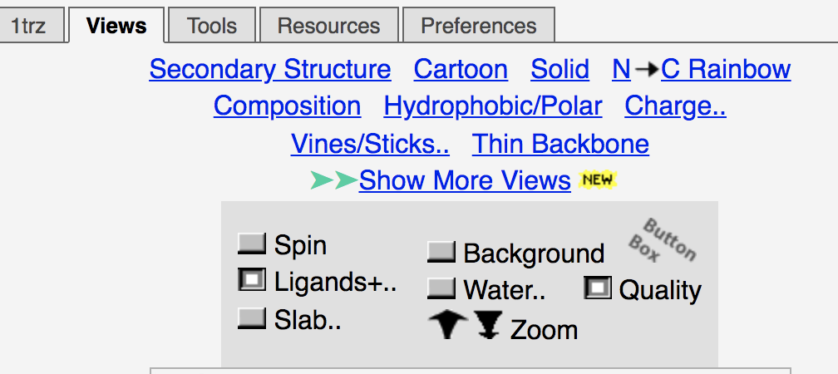

*Figure 1: Screenshot of the Views options in FirstGlance.*

* + - 1. Using your favorite screen grab program, capture a screen view of this image and paste that image below. *Click on ‘Spin’ in the top left window to stop the automatic rotation. You can use your mouse to rotate the image to a view that you wish to capture.*
      2. Looking at the ‘Secondary Structure’ window in the bottom left of your screen, how much (percent) of the insulin protein is in an alpha helical conformation according to the authors? How are they represented in the structure visualized here?
      3. What do you think are shown as the gray and green spheres?
      4. In the top left window, now click on ‘Charge’ to view the surface charge of insulin. Capture an image of the surface charge and paste that image below. What can you learn about the charged surface of the molecule? Does this agree with what you learned in the explorations in the Molecule of the Month.

### Part III: Exploring Insulin Structure using Mol*

The focus in this part is to learn more about

1. Insulin’s structure and assembly
2. Insulin sequence and structural homologs.

Go to the [RCSB PDB home page](https://www.rcsb.org/) and enter the insulin PDB code 1trz in the top search box and click on it to open the Structure summary page for this PDB structure or go to the page (<https://www.rcsb.org/structure/1TRZ>).

On the top left corner of the page there is an image showing the structure of the molecule.

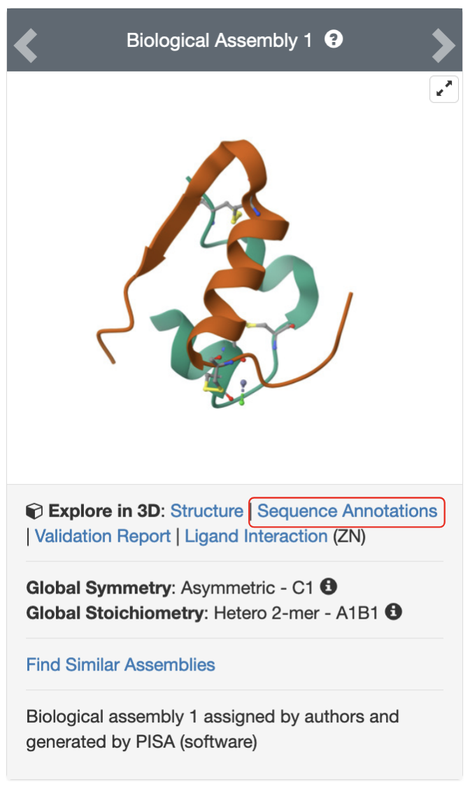

*Figure 2: Structure of one insulin molecule - composed of two protein chains (subunits) colored in green and orange, that interact with each other through disulfide bonds and various non-covalent interactions.*

Click on the hyperlink “Sequence Annotations” to launch a view of this molecule.

* In this view, one panel shows the sequence of the protein chains in Insulin and the other shows its 3D structure.
* The two panels are connected so that clicking on a specific amino acid in the sequence panel selects and centers the 3D structure view on the same amino acid and displays the interactions around the specific amino acid.
* The sequence panel also displays various annotations about it (e.g., secondary structure, disulfide bridge)

Based on the information presented here, answer the following questions.

1. What secondary structural elements are present in Chain B in the structure? List the amino acid residue numbers forming these elements.
2. What is the primary structure (sequence) of the beta strand identified in your answer to question 1 above?
3. Identify the amino acids in chain B that form disulfide bonds. Click on these amino acids in the sequence panel and examine the 3D structure to determine the amino acids forming the disulfide bonds. Save images of the bond(s) and include them in your answer.
4. Examine the interactions of the amino acid R22 in chain B and list any non-covalent interaction involving this residue that stabilizes the quaternary structure of this molecule. Save an image to support your answer and list the type of interaction(s) shown. (Hint: list any H-bonds direct or water mediated that this amino acid participates in)

Return to the Structure Summary page for the PDB entry 1trz (<https://www.rcsb.org/structure/1TRZ>) and scroll down to the Macromolecules section.

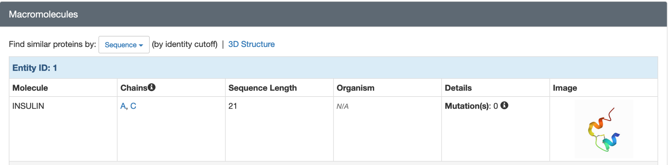

Click on the “Sequence” pulldown options and the hyperlinked “3D Structure” to explore the PDB archive and find other structures that have similar amino acid sequence and shape (3D structure).

1. Using the Sequence pulldown menu, explore proteins in the PDB archive that have similar sequences. Try different sequence identity matches (from 80% to 30%) to answer this question. List the names of 2 organisms that have proteins similar to human insulin. What is the sequence identity of the proteins for the organisms you selected?
2. Search for proteins with similar structures in the PDB: In the Macromolecules section of the Structure Summary page, click on "3D Structure" next to "Find similar proteins by:.

From the search results, list the names of 1 organism, which is not a mammal (e.g., human, porcine, bovine). Also list the name of the protein that is structurally similar to human insulin.