Exploring a Protein Structure in the RCSB PDB: Insulin

Learning Goals:
- Visualize the structure of a given molecule using RCSB PDB resources.
- Explore the structure to understand its structure function relationships

Educational Standards
- Common Core
  - Craft and Structure
    - RI.9-10.4
    - RI.11-12.4
  - Integration of Knowledge and Ideas
    - RI.9-10.7
    - RI.11-12.7
- Next Generation Science Standards
  - Practices
    - 8. Obtaining, Evaluating and Communicating Information
  - Crosscutting Concepts
    - 3. Scale, proportion and quantity
    - 4. Systems and system models
    - 6. Structure and function
  - Disciplinary Core Ideas
    - LS1.A: Structure and Function
    - PS2.B: Types of Interactions
- Advanced Placement Biology - Essential Knowledge (EK), Learning Objectives (LO), Science Practices (SP)
  - EK 4.A.1
    - LO 4.2, SP 1.3
    - LO 4.3, SP 6.1, 6.4

Teaching Notes:

About Insulin Biosynthesis:
The insulin protein is composed of 2 protein polymer chains. Although synthesized as a single large protein polymer, the central region of the polymer is cleaved off (see figure below) while the two terminal portions (Chain A, 21 residues long and Chain B, 30 residues long) form the insulin molecule and are held together by disulfide bonds.
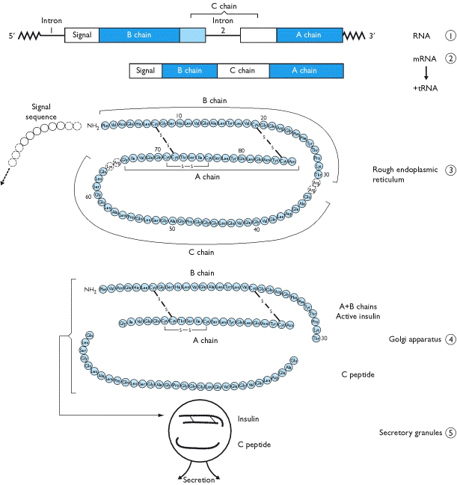
Insulin Biosynthesis from http://www.ncbi.nlm.nih.gov/books/NBK30/bin/ch2fb15.jpg

The function of the C-peptide is not known but it is used as a diagnostic to determine if an individual is producing insulin.

Exercise:
- The molecular visualization Mol* is freely available to all users from www.rcsb.org.
- This worksheet provides instructions for visualization of a PDB entry, where you will learn to do the following:
  - Visualize the 3D structure of biomolecules using coordinates available from PDB.
  - Display the atomic coordinates in various formats.
  - Examine the structural details and interactions of specific regions of the structure.
  - Compare structures – superpose 2 (or more) structures
- To save images, click on the camera (iris) icon , Download and save a *.jpg file. Import the image in any image manipulation software of your choice (e.g., PowerPoint/ Photoshop) to add labels and additional text describing the images.
- Some key commands and functions of Mol* are included in the Appendix at the end of this document.

Insulin
Review the Molecule of the Month feature on Insulin for background information.
(http://pdb101.rcsb.org/motm/14)

- On the structure summary page for the PDB entry 4ins (https://www.rcsb.org/3d-view/4INS), click on the 3D view tab on the top of the page to open the structure in the visualization program - Mol*
- The top of the display shows the sequence of the polymers and is called the sequence panel. The white space showing the 3D structure of the protein is called the 3D canvas and the blue panel on the right is the controls panel for the display.
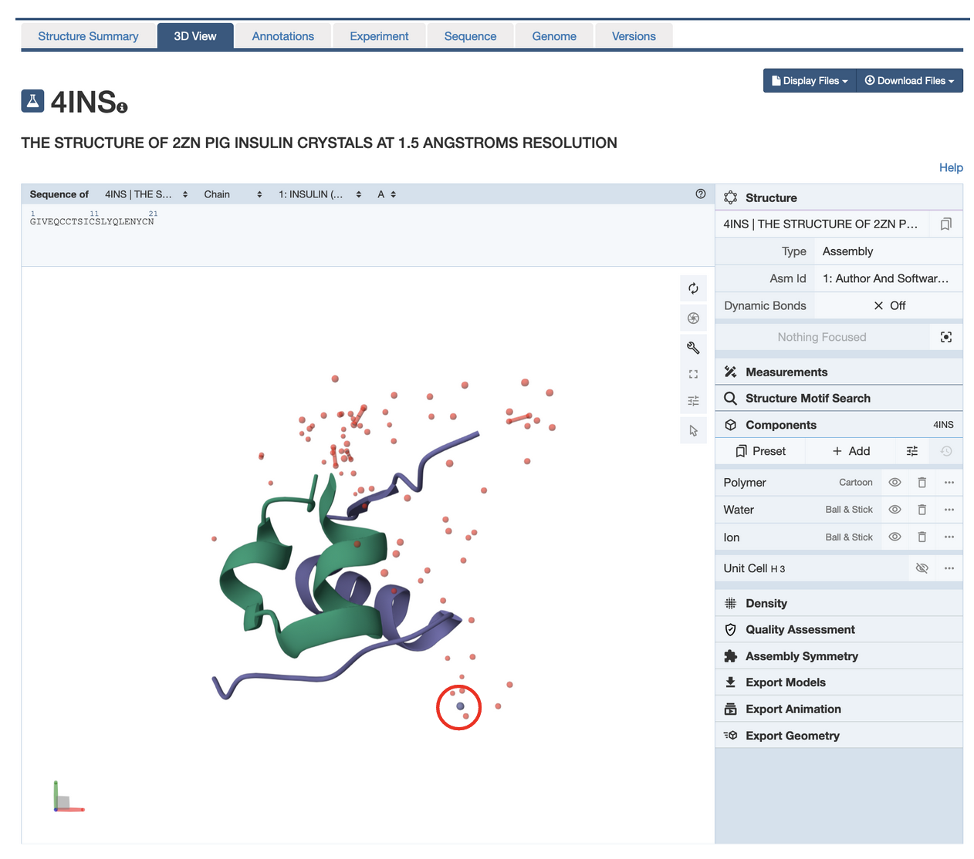

- Read/review the page and answer the following questions based on the descriptions provided:

Q1. What is the predominant secondary structural element seen in the insulin structure?
A1: Alpha helix. Both chains A and B have alpha helices while chain B has a single beta strand.

Q2. What is the little purple/gray atom highlighted in the structure (circled in red above) and why do you see this atom in the insulin structure?
A2: The atom is that of Zn which is present in the insulin structure to help make it more stable for storage.

- In the sequence panel (top of the display), click on the amino acid Glu 4 or E4 in chain A. View interactions of this amino acid with other amino acids in the same and/or different polymer chain and answer the following question.

Q3. List any three interactions of this amino acid (E4 in chain A) that help stabilize its tertiary and quaternary and structure. Support your answer with a labeled figure showing the interactions.
A3: The side chain of the amino acid forms a H-bond with the amino group of G1 in chain A and the backbone amino group of Val3 of chain A; a direct and a water mediated H-bond with the backbone atoms of K29 in Chain B; and with another water molecule. The interactions with atoms in the same polymer chain (chain A) are examples of tertiary structure while those between atoms of two different polymers are examples of quaternary structures.

Teaching Note:
- Tertiary interactions are those that are formed between amino acids that are distant in their primary sequence but close to each other in 3D space.
- Quaternary interactions are those that are formed between amino acids that are distant in their primary sequence but close to each other in 3D space.

- Click on the Arrow at the bottom of the vertical menu of buttons in the 3D Canvas (toggle on the selection mode) to display a horizontal menu at the top of the 3D canvas.

- Click on the filled double circle in the horizontal menu to elect Disulfide Bridges as follows:
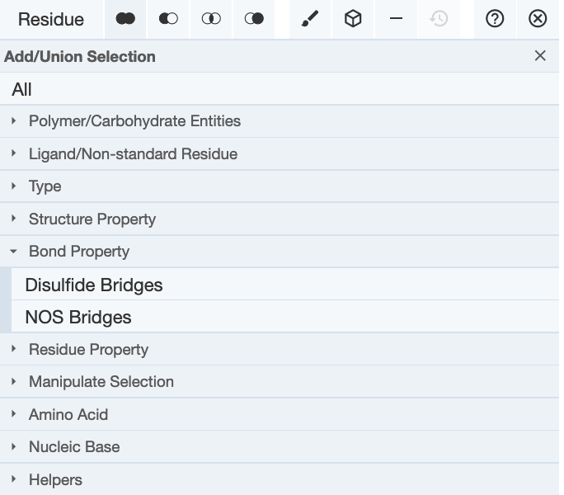

- Once the disulfide bond forming Cys residues are selected (highlighted in green), click on the cube icon in the horizontal menu to create components for the disulfide bonds. Select the option Ball and Stick as follows: Cube icon >> Representation >> select from pulldown “Ball & Stick” >> click on Create component button at the bottom of the box.
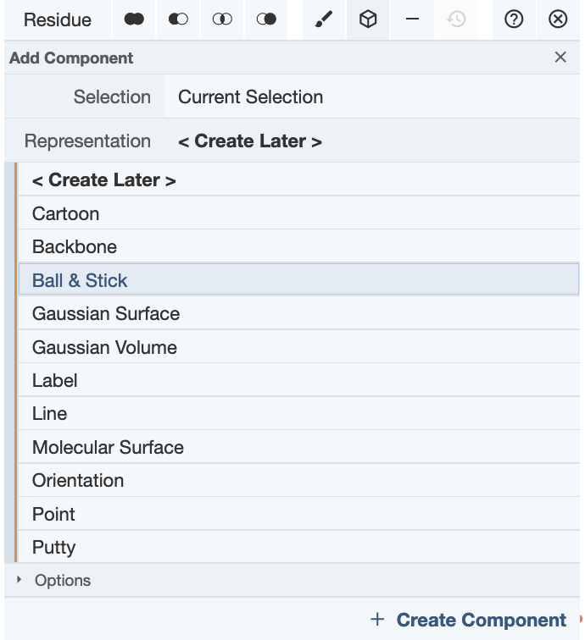

- The Cys side chains are shown in ball and stick format and a new component called Custom Selection is shown on the right-hand components panel.

Q4. Where are these (Cys) residues located? Can you explain the role that these residues play in the stability of the insulin structure?
A4: There are 3 Cys residues on chain A and 2 on chain B. These Cys residues form 3 disulfide bridges – two inter-chain and 1 intra-chain. All these help stabilize the structure of insulin and hold the two protein chains of insulin together.

- In its storage form insulin has been shown to form hexameric assemblies. In the top section of the Controls panel, open the pulldown options for Asym id and select the Biological Assembly “3. Software defined Assembly”
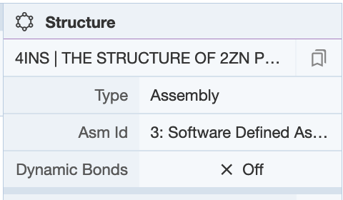

- Hide the waters by clicking on the eye icon as shown below
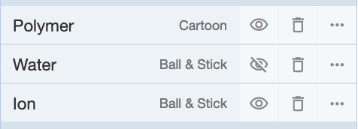
Q5. How many insulin molecules are shown in the above image? What does this structure tell you about a functional assembly of insulin?
A5: There are 6 insulin molecules – each with two protein chains. This structure shows that insulin can form a large oligomeric assembly such as the hexamer structure seen here – perhaps for storage and transport.

Q6. Based on the structure seen here, what do you think the role of Zinc is?
A6: Zinc facilitates the storage of insulin molecules by forming a stable complex.

- Click on the gray sphere in the center of the structures to zoom in, center on it and view its interactions.

Q7. How are these gray atoms interacting with the insulin protein? Support your answer with a suitable figure.
A7: His residues 10 from the insulin B chain forms covalent coordinate bonds with the Zinc atoms/ions through the NE2 atoms in the residue. The zinc atoms also bind a few water molecules.
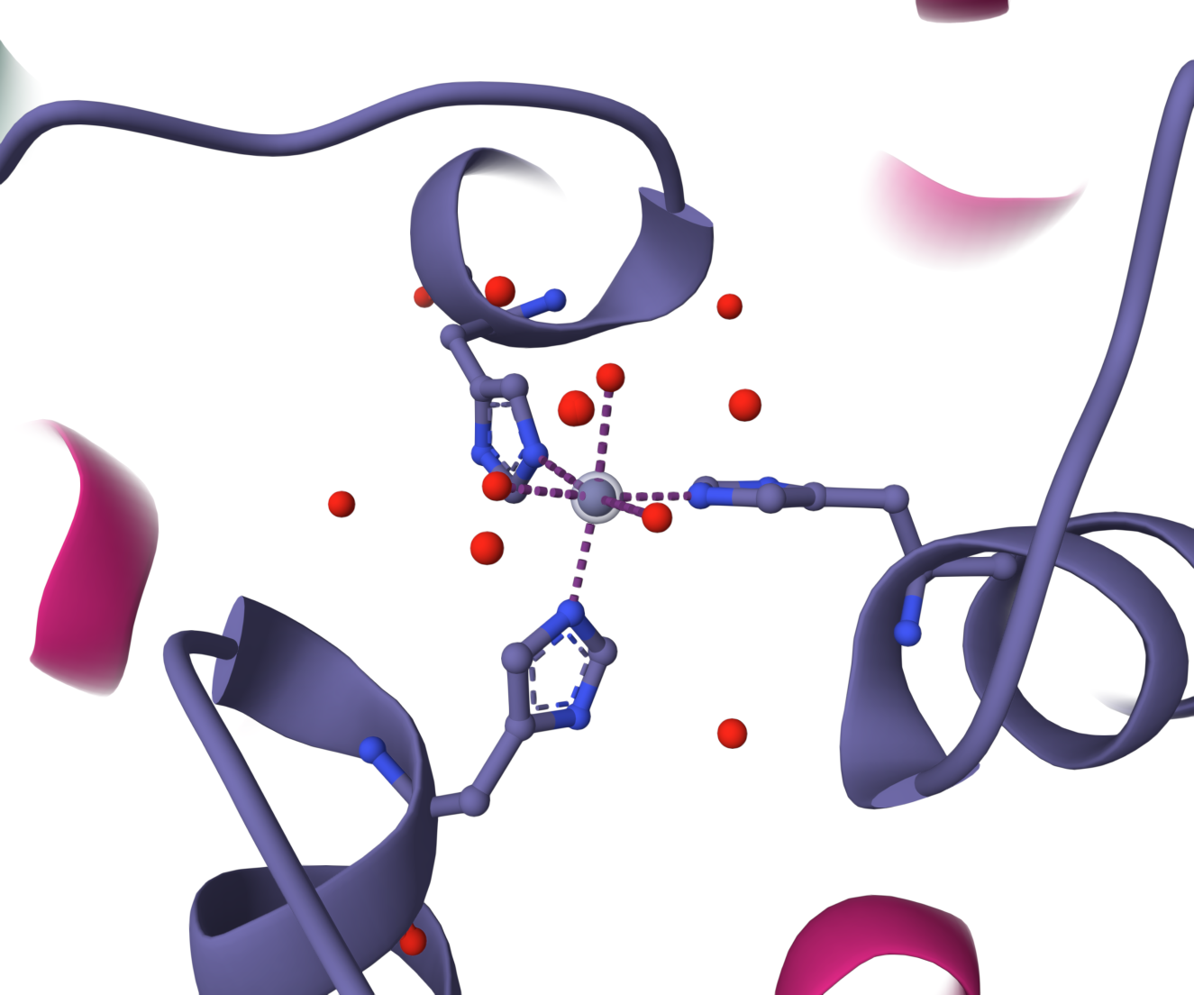

Appendix: Mol* Quick Reference
1. Navigate the 3D Canvas:
a. Rotate
● Press left mouse button and move OR use Shift + left mouse button and drag.
b. Translate
● Press right mouse button and move OR use Control + the left mouse button and move. On a touchscreen device, use a two-finger drag.
c. Zoom
● Use the mouse wheel. On a touchpad, use a two-finger drag. On a touchscreen device, pinch two fingers.
d. Center and zoom
● Use right mouse button to click on the part of the structure you wish to see.
e. Change clipping planes
● Use Shift button + the mouse wheel. On a touchpad, use the Shift button + a two-finger drag.
2. Select: first open Selection Mode and change the Picking Level (if needed)
a. Select Picking Level
● Click on objects in the 3D canvas – such as atoms, residues, chains, etc.
b. Select object in 3D canvas
● Click on residues, chains etc. in the 3D canvas based on picking level
c. Select object from Sequence Panel
● Click on residues, ligands, or entire chain in the Sequence Panel
d. Custom Select combinations
● Use the Set Operations Menu in the Selection Mode toolbar
3. See or Hide:
a. To add representations
● Create a component of the region you wish to see/hide → Go to the Components Panel and press the “eye” icon next to the component you create
b. To hide/remove from view
● Select region you wish to hide → Click on the subtract/hide icon in the Selections toolbar
4. Color:
a. N-terminus to C-terminus (rainbow)
● Components → Polymer → Set Coloring → Residue Property → Sequence Id
b. Heteroatom
● Components → Polymer → Set Coloring → Atom Property → Element Symbol
c. Secondary structure
● Components → Polymer → Set Coloring → Residue Property → Secondary Structure
d. Hydrophobicity
● Components → Polymer → Set Coloring → Residue Property → Hydrophobicity
e. Domain
● Select domain → Selections Menu → Apply Theme to Selection → Color → Apply Theme
5. Compare Structures: first upload two or more structures at rcsb.org/3D-view
a. By chains
● Select 2 or more polymer chains/residues → Superposition → By Chains → Superpose
b. By atoms
● Select 1 or more atoms → Superposition → By Atoms→ Superpose
6. Make Measurements:
a. Distance
● Make 2 or more selections → Measurements → Add → Distance (for first 2 selections)
b. Angle
● Make 3 or more selections → Measurements → Add → Angle (for first 3 selections)
c. Dihedral
● Make 4 or more selections → Measurements → Add → Dihedral (for first 4 selections)

