Name _____________________________________________________________ Date ________________

Mutant Insulin: Wakayama

Read the Molecule of the Month feature on Insulin (http://pdb101.rcsb.org/motm/14).

Q1. Use the following words to complete the sentences written below:

Muscle
Arginine
Hydrophobic
Liver
Valine
Glutamate
Fat
Disulfide
Leucine
Pancreas

- Insulin is synthesized by beta cells of __________________________________and act on ___________________, ___________________________, and _______________________________ cells.
- Each monomer of insulin is composed of one A-chain and one B-chain linked by 3 _____________________________________ bonds.
- Just like in other globular proteins, carbon rich __________________________ amino acids, such as ____________________________ and _____________________________ are clustered in the core of the insulin protein. The surface is covered with charged amino acids like __________________________and ____________________________ that interact favorably with the surrounding water molecules.

Q2. Draw the amino acids Leucine and Valine showing all atoms in their side chains.

This activity will follow the following steps in order to answer a question and tell a molecular story.
- Ask a question – this is the theme for the molecular storytelling
- Build model based on literature review – what will you explore in the PDB
- Investigate - Query/Browse PDB; Select PDB entries; Visualize
- Analyze - Explore interactions; Compare Structures
- Construct molecular explanations for original question
- Develop argument - relate structure to bioinformatics information (go back to the literature to see if the molecular explanation makes sense)
- Communicate - Tell a Molecular Story with Illustrations

Overview:
This activity focuses on a familial mutant of insulin reported in Wakayama, Japan I the late 1980s. It provides an opportunity to explore and understand a molecular basis for this disease and its symptoms.

Learning Goals:
- Define a question/topic for exploration at a molecular level
- Explore the literature to find out about the topic
- Query the RCSB PDB website to find specific structure(s) for exploration.
- Explore relevant molecular structures to develop a molecular story explaining the topic.

Guided Molecular Storytelling:
In 1987, an article published in the journal Diabetologia, reports the familial syndrome in Japan related to a mutant insulin called Insulin Wakayama (Nanjo, K., Miyano, M., Kondo, M. et al. Diabetologia (1987) 30: 87. doi:10.1007/BF00274577). The article summary is included below:
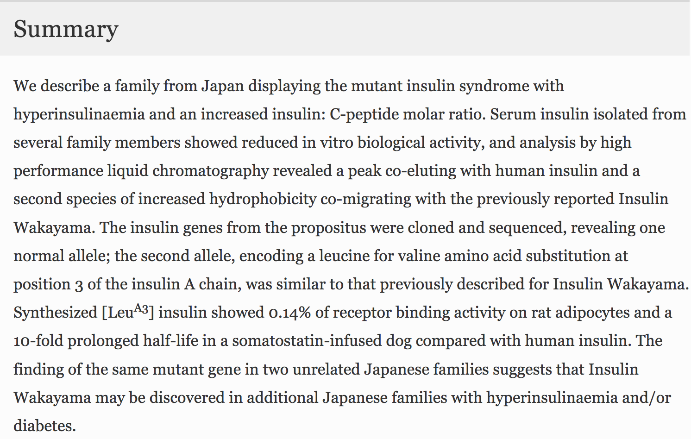

- Ask a question:
The question: Why does the insulin Wakayama have a 0.14% of receptor binding activity. Explain this observation (reported in the abstract included above) at a molecular level.

- Build a model:
Search for information about insulin Wakayama. For your initial explorations you may search:
- Online – using your favorite search engine (Google, Bing etc.)
- In text books – that you or your library owns; or check the NCBI bookshelf (online) at http://www.ncbi.nlm.nih.gov/books
- Review articles – you can search for these using the NCBI PubMed (online) at http://www.ncbi.nlm.nih.gov/pubmed

Q3. Based on your knowledge of insulin Wakayama, what molecule(s) would you like to explore in the PDB? Name at least 2. (Hint: Native and mutant proteins)

- Investigate:
Search for your molecule(s) of interest in the PDB using known properties – e.g. molecule name, mutation, presence of ligand etc.

Q4. List the PDB ID and Structure titles for at least 1 structure in the PDB for each of the two molecules that you have identified in Ans 3.

Q5. How did you perform the search on the RCSB PDB website? List your search options and any logic that you used to refine your search results.

Visualize the PDB entries that you identified – independently. If necessary and appropriate, superpose the structures to explore the structure-function relationships. Save suitable images and include them in your answers below.

Q6. What do your molecule(s) of interest look like? Is there anything unusual in the structure of the molecule(s) you are exploring?

- Analyze:
Insulin Wakayama was shown to have a mutation a Proinsulin Tokyo is caused by a specific mutation of valine to leucine (V92L or ValA3Leu). In the structure(s) that you have selected, focus on the areas in the vicinity of the mutation to explore the significance of the residue V92 or Val A3.

Q7. What is special about the residues involved in the molecular interactions involving Val A3 and Leu A3. Illustrate your answer with 1-2 illustrations based on your structural explorations.

- Molecular explanations:
Based on the images included above and your explorations of the molecular structures and interactions think about the Val to Leu mutation at the A3 position.

Q8. What are the main differences between the insulin molecule(s) that you are exploring – native vs mutated at A3?

- Argument:
Q9. What changes at the molecular level lead to poor binding of insulin Wakayama to the insulin receptors? Does comparing the structures of these proteins provide an explanation for why their functions (ability to bind to insulin receptor) are so different? If yes, explain your answer with 1-2 images supporting your explanation. If no, how would you explore this question further and develop a molecular explanation for the reduced function of insulin Wakayama. Can you explain why individuals with insulin Wakayama develop hyperinsulinemia and/or diabetes?

Complete the following questions for HW:
- Communicate:
Q10. Summarize all that you have learned about insulin Wakayama and explain the differences between the native and mutant insulin proteins.

Extension and Enrichment:
Q11. Compare the structure of insulin Wakayama with that of native insulin bound to the insulin receptor. Can you figure out why the mutant insulin binds so poorly to insulin receptors. Explain your answer with suitable evidence(s) at a molecular level. Can you explain why individuals with insulin Wakayama develop hyperinsulinemia and/or diabetes?

