Exploring a Protein Structure in the RCSB PDB: Insulin

Learning Goals:
- Visualize the structure of a given molecule using RCSB PDB resources.
- Explore the structure to understand its structure function relationships

Exercise:
Review the Molecule of the Month feature on Insulin for background information (http://pdb101.rcsb.org/motm/14 ). Discuss main ideas of this feature with the students.

Note that there are a few PDB entries listed throughout the feature. For example, PDB entry 4ins can be linked from
Click on this to open the summary page for the PDB entry 4ins (http://www.rcsb.org/pdb/explore/explore.do?structureId=4ins).

Read/review the page and answer the following questions based on the descriptions provided:

Q1. What is the source of the insulin molecule in this structure?
A1.

Q2. Name the authors who solved the structure of this protein?
A2.

- On the structure summary page for the PDB entry 1trz, click on the 3D view tab on the top of the page to open the structure in the visualization program - Mol*
- The top of the display shows the sequence of the polymers and is called the sequence panel. The white space showing the 3D structure of the protein is called the 3D canvas and the blue panel on the right is the controls panel for the display.
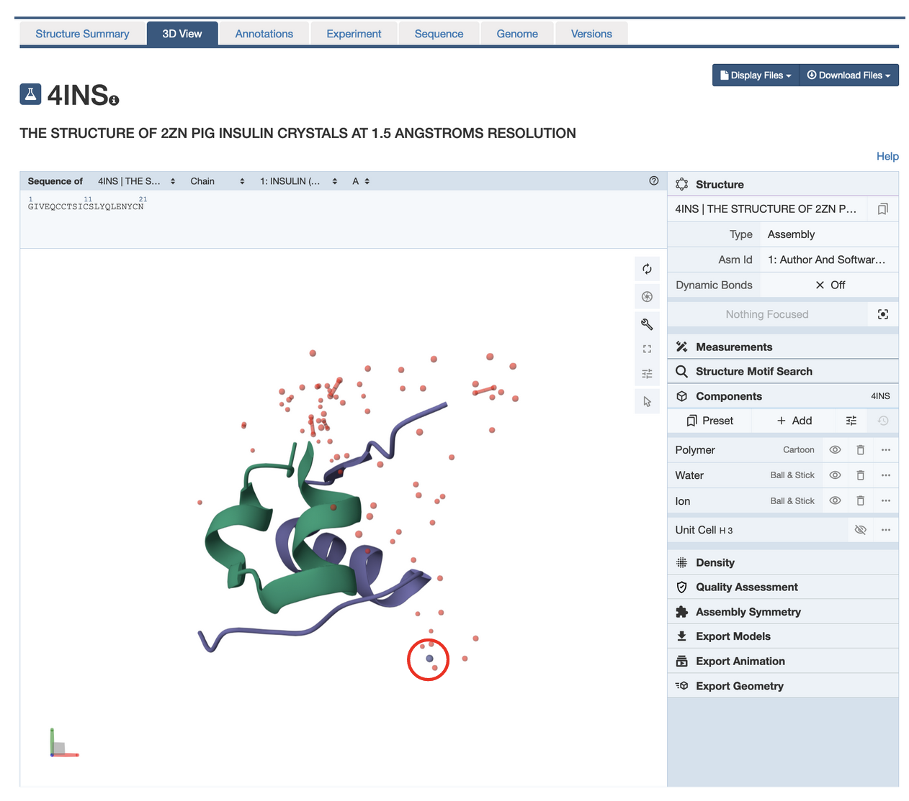

Q3. What is the little purple/gray atom highlighted in the structure (circled in red above) and why do you see this atom in the insulin structure?
A3.

Q4. Describe the overall composition of insulin – how many and what chains are present in the structure. Also describe the structure of each insulin molecule in terms of the helical, arrow-like or coiled regions in each chain. Support your answer with a suitable figure.
A4.

- Click on the Arrow at the bottom of the vertical menu of buttons in the 3D Canvas (toggle on the selection mode) to display a horizontal menu at the top of the 3D canvas.

- Click on the filled double circle in the horizontal menu to elect Disulfide Bridges as follows:
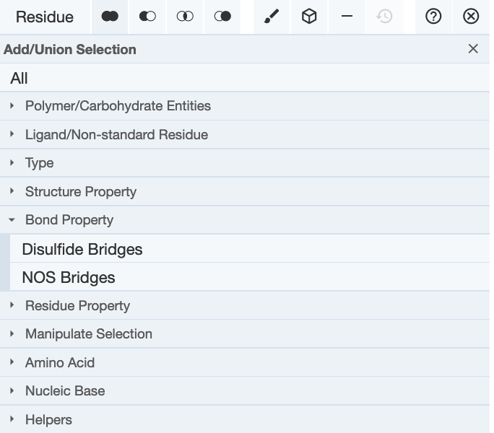

- Once the disulfide bond forming Cys residues are selected (highlighted in green), click on the cube icon in the horizontal menu to create components for the disulfide bonds. Select the option Ball and Stick as follows: Cube icon >> Representation >> select from pulldown “Ball & Stick” >> click on Create component button at the bottom of the box.
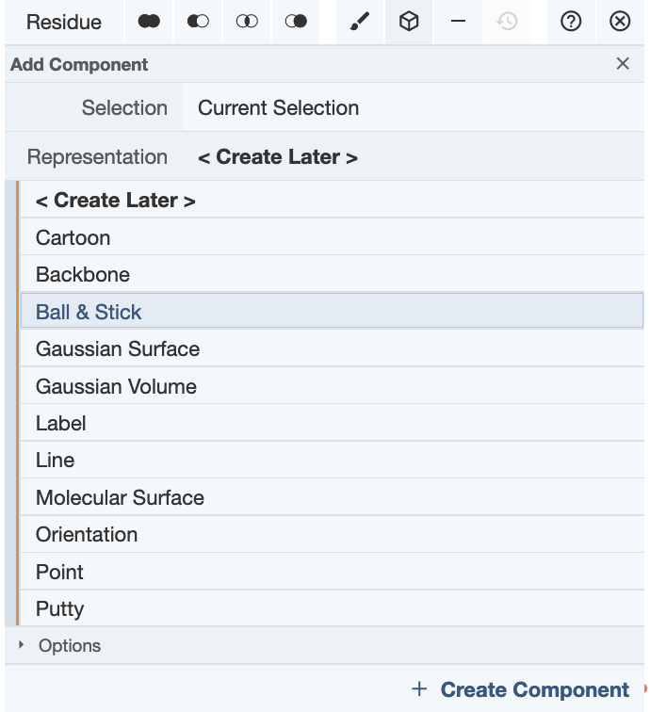

- The Cys side chains are shown in ball and stick format and a new component called Custom Selection is shown on the right-hand components panel.

Q5. How many disulfide bonds do you see?
A5.

Q6. Are these S-S bonds within the same polymer chain or between different chains of insulin.
A6.

Q7. What do you think is the role of these S-S bonds? Describe in 1-2 sentences.
A7.

