Managing the Cytokine Storm

Learning Objectives: To explore the structure and interactions of interleukin-6 (IL-6) to its receptor and to a humanized antibody that binds to it Using RCSB Mol* and figure out if the antibodies can help manage the cytokine storm.

Introduction
In advanced stages of COVID-19, the immune response is dysregulated and many cytokines and Interleukins are produced that signal responses leading to cell/tissue damage and severe complications. This overproduction and activation of various cytokines is called the Cytokine Storm. Interleukin-6 (IL-6) is a critical regulator of the immune system and has been widely implicated in autoimmune disease. Blocking the interaction between IL-6 and its receptor can help manage the cytokine storm. This has been accomplished in a few different ways.

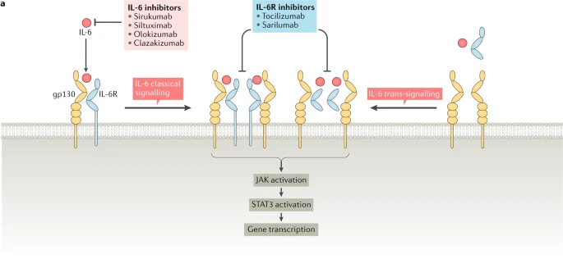  https://www.nature.com/articles/s41584-020-0419-z/figures/2 | Bind a specific antibody to the IL6 receptor so that IL-6 can not bind to it - example Tocilizumab
 | Bind a specific antibody to IL-6 so that it can not bind to its receptor - example Olokizumab
 | Inhibit the kinases that are part of the signaling pathways activated by the binding of IL-6 to its receptor - example JAK inhibitor

In this exercise we will explore the structures of IL-6 bound to its receptor and also to the humanized antibody Olokizumab.

- We will begin with an introduction to the shape and functions of antibodies and learn a few vocabulary words/phrases. This knowledge will help understand the structures explored in this exercise.

- What is an Antibody?
Antibodies are immune molecules that our body makes in response to specific pieces of foreign materials (including pathogens like viruses, bacteria, and other natural or synthetic material that may enter our body). While there are many types of antibodies, the one most commonly discussed are the Y-shaped Immunoglobulin G or IgG molecules. They are made of four protein chains - 2 heavy (orange and magenta) and 2 light chains (green and purple) in the figure below from PDB ID 1igt.
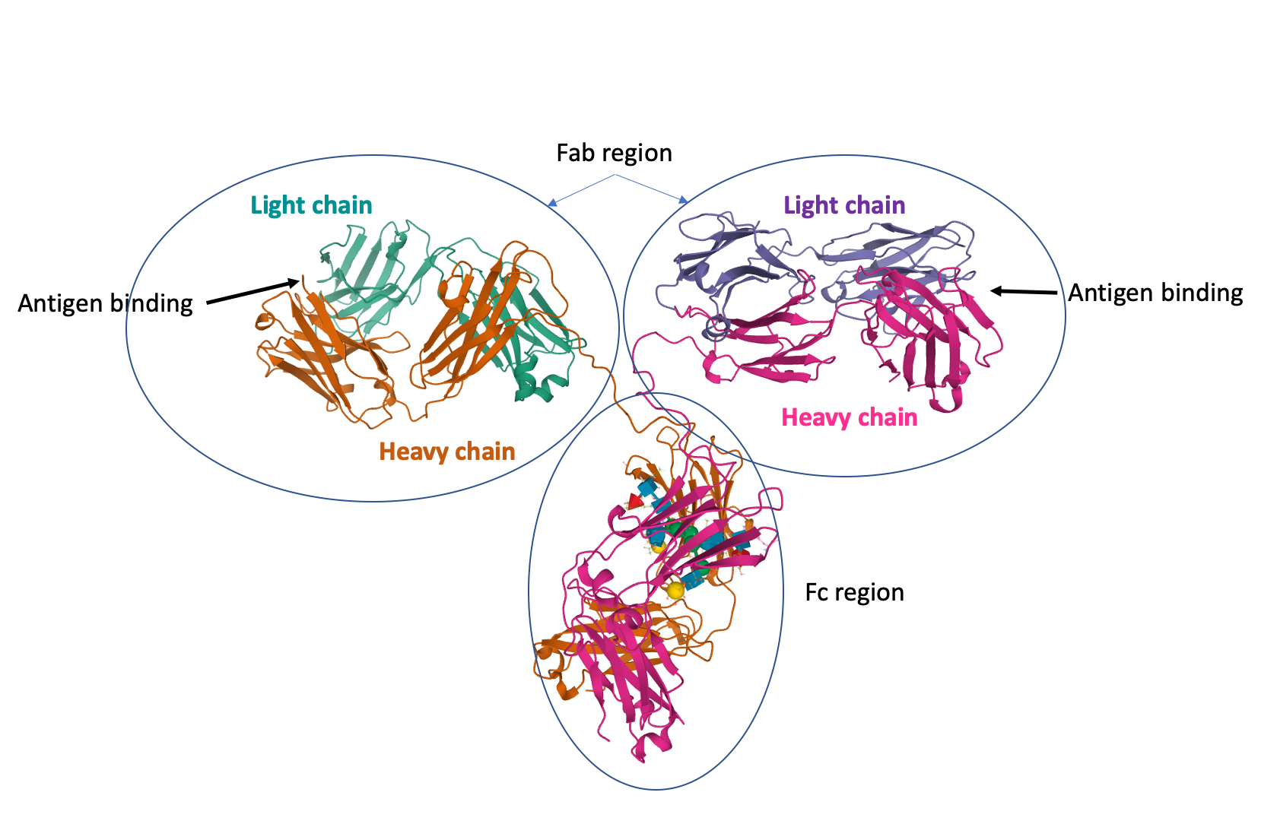
The junction of the arms and stem in the Y shaped molecule can be cut by proteases producing 2 arms that can bind the antigen (also called fragment antigen binding or Fab) and a stem that can bind to specific receptors on immune cells to activate them (called fragment crystallizable or Fc). To learn more about antibodies and make paper antibodies visit http://pdb101.rcsb.org/learn/paper-models/antibody

Most structures of proteins bound to their specific antibodies only the Fab fragments are seen. The Fab fragment is made up of 2 chains, each with 2 immunoglobulin domains. One end of the Fab fragment has regions that specifically interact with and bind to the antigen.

- What is a humanized Antibody?
These antibodies are derived from non-human sources (mice, rats, etc.) and are intended for some therapeutic application. To prevent the host (who will receive these antibodies) from mounting an immune response to these antibodies parts of the antibody are changed to make it “look” more like a human antibody. The ability to specifically bind to a target antigen is retained. The names of these types of therapeutic antibodies end in -zumab e.g., Olokizumab.

Tools
- The exercise will use data from the Protein Data Bank (PDB) and use the RCSB molecular visualization tool Mol* for the visualization and analysis of human IL-6 bound to its Receptor and to a specific antibody.
- To save images, click on the camera (iris) icon , Download and save a *.jpg file. Import the image in any image manipulation software of your choice (e.g., PowerPoint/ Photoshop) to add labels and additional text describing the images.
- Some key commands and functions of Mol* are included in the Appendix at the end of this document.

Exploration

Explore the binding of IL-6 to its Receptor
- Type the PDB ID “1p9m” in the top search box >> click enter. This should take you to the Structure Summary Page. This page provides a quick glimpse of the contents, quality, and experimental details of the structure.

A1. Examine the contents of the page and complete the table below:

PDB ID
Author(s) of entry
Date (including Year) when the structure was published/released
Structure determination method
Number of protein chains in the entry; protein name, Chain ID
Names and number of copies of ligands (Small Molecules) present in the structure

- Click on the 3D View tab on the top of the page to view the structure in Mol*

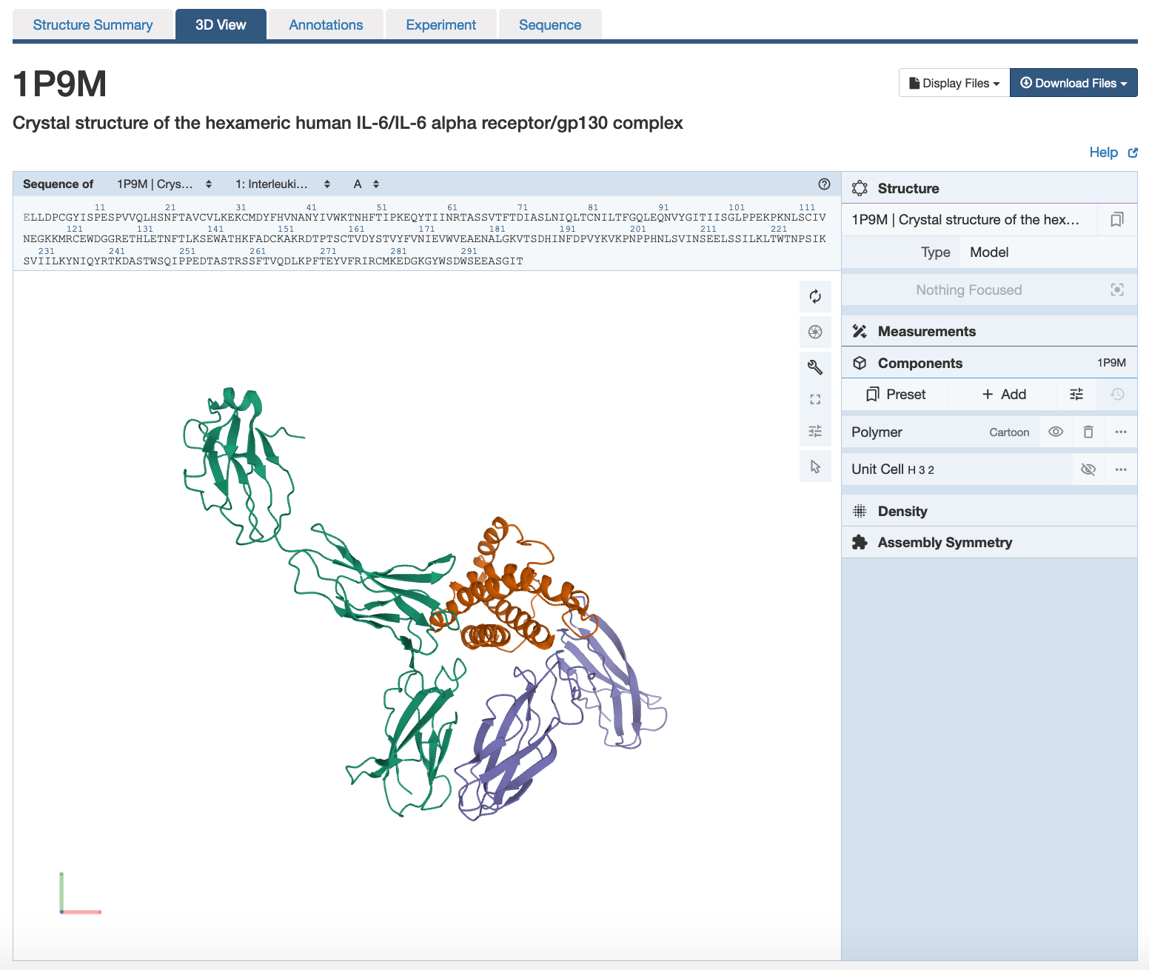 | There are 3 main areas on this screen:  1. Sequence panel (top left)  2. 3D-canvas (white space where the 3D structure is shown). Besides displaying the interactive 3D models, this space also offers  a. Toggle panel (a series of buttons on the right) to enable various functions  b. Log panel (at the bottom of the canvas) records actions taken  3. Control panel (blue column on right) with menus for Structure, Measurements, Components, etc.

- All the protein chains are represented as different colored ribbons with helical regions.
- Use various mouse controls to rotate and translate the molecule you are viewing.
- Note: Hovering the mouse over any object in the 3D canvas will display information about that item in the bottom right corner of the 3D canvas.

A2. Save an image of the structure you see and label the proteins in the structure - IL-6, IL-6 Receptor Alpha Chain, IL-6 Receptor Beta Chain (or gp130). Include the labeled image below.

- What is seen here is only part of the assembly. The other part can be seen by applying symmetry operations as follows:

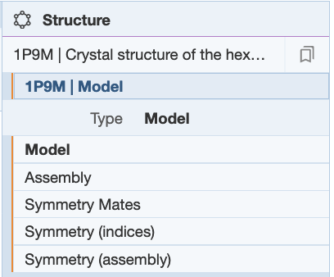 | In the right hand panel click on Structure >> Type >> select Assembly

- Display the molecular surface of IL-6 and color the protein using the rainbow color scheme. This will help determine which parts of the IL-6 chain are bound by the Receptor proteins.

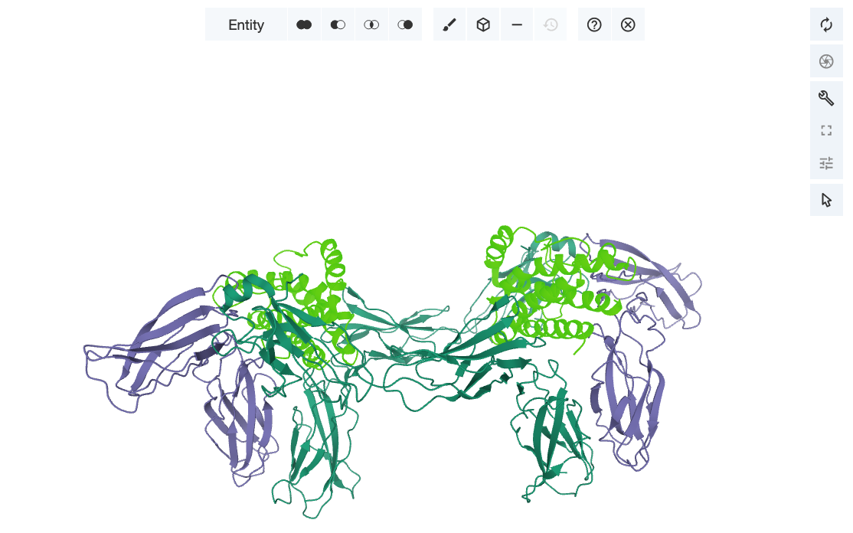 | Activate the selection mode by clicking on the arrow icon 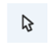in the Toggle panel >> Change the picking level to Entity by clicking on the word residue and selection from the pull-down options. Now the 3D canvas, click on any atom of the IL-6 molecules. This should select both the molecules that are highlighted in green.
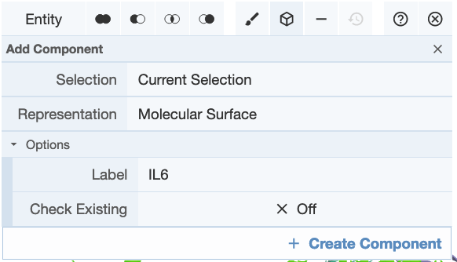 | Create a component with this selection by clicking on the Cube icon 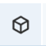 >> Select Representation molecular surface >> Label it “IL6” >> click on Create Component.
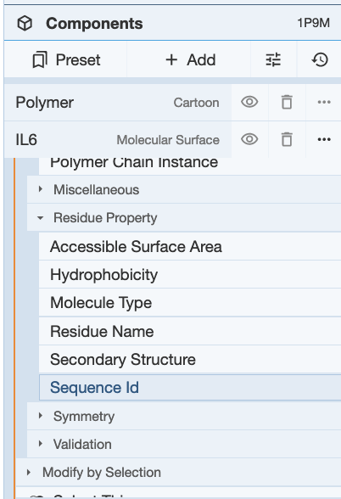 | Click on the 3-dots in the far right for the component IL6 … >> Set Coloring >> Residue property >> Sequence ID.  Note the N-terminal ends of these chains is colored blue while the C-terminal ends are colored red.

A3. Save an image of the structure you see and label the proteins in the structure - IL-6, IL-6 Receptor Alpha Chain, IL-6 Receptor Beta Chain (or gp130). Include the labeled image below.

- Note all the surfaces of IL-6 that are covered by the binding of IL-6 receptor proteins (alpha and beta chains).

Explore the binding of IL-6 with the Fab fragment of humanized antibody Olokizumab
Olokizumab is a humanized monoclonal antibody that binds to IL-6 has shown promise in treating inflammatory conditions such as Rheumatoid Arthritis. Since IL-6 is a key player in the Cytokine Storm, it may be a candidate for managing COVID-19 induced cytokine storm.

- Type the PDB ID “4cni” in the top search box >> click enter. This should take you to the Structure Summary Page.

B1. Examine the contents of the page and complete the table below:

PDB ID
Author(s) of entry
Date (including Year) when the structure was published/released
Structure determination method
Number of protein chains in the entry; protein name, Chain ID
Names and number of copies of ligands (Small Molecules) present in the structure

- Click on the 3D View tab on the top of the page to view the structure in Mol*
- Using the same steps as in Section A, create a separate component for the IL-6 molecules, show their molecular surfaces, and color them by sequence ID (rainbow color scheme).

B2. Save an image of the structure you see and label the proteins in the structure - IL-6, and Olokizumab Fab fragments. Include the labeled image below.

B3. Based on the structures you examined, does Olokizumab binding to IL-6 interfere with its receptor binding? Do you think that this can help manage the cytokine storm? Explain your answer in words and with a figure.

Appendix: Mol* Quick Reference
1. Navigate the 3D Canvas:
a. Rotate
● Press left mouse button and move OR use Shift + left mouse button and drag.
b. Translate
● Press right mouse button and move OR use Control + the left mouse button and move. On a touchscreen device, use a two-finger drag.
c. Zoom
● Use the mouse wheel. On a touchpad, use a two-finger drag. On a touchscreen device, pinch two fingers.
d. Center and zoom
● Use right mouse button to click on the part of the structure you wish to see.
e. Change clipping planes
● Use Shift button + the mouse wheel. On a touchpad, use the Shift button + a two-finger drag.
2. Select: first open Selection Mode and change the Picking Level (if needed)
a. Select Picking Level
● Click on objects in the 3D canvas – such as atoms, residues, chains, etc.
b. Select object in 3D canvas
● Click on residues, chains etc. in the 3D canvas based on picking level
c. Select object from Sequence Panel
● Click on residues, ligands, or entire chain in the Sequence Panel
d. Custom Select combinations
● Use the Set Operations Menu in the Selection Mode toolbar
3. See or Hide:
a. To add representations
- Create a component of the region you wish to see/hide → Go to the Components Panel and press the “eye” icon next to the component you create
b. To hide/remove from view
● Select region you wish to hide → Click on the subtract/hide icon in the Selections toolbar
4. Color:
a. N-terminus to C-terminus (rainbow)
● Components → Polymer → Set Coloring → Residue Property → Sequence Id
b. Heteroatom
● Components → Polymer → Set Coloring → Atom Property → Element Symbol
c. Secondary structure
● Components → Polymer → Set Coloring → Residue Property → Secondary Structure
d. Hydrophobicity
● Components → Polymer → Set Coloring → Residue Property → Hydrophobicity
e. Domain
● Select domain → Selections Menu → Apply Theme to Selection → Color → Apply Theme
5. Compare Structures: first upload two or more structures at rcsb.org/3D-view
a. By chains
● Select 2 or more polymer chains/residues → Superposition → By Chains → Superpose
b. By atoms
● Select 1 or more atoms → Superposition → By Atoms→ Superpose
6. Make Measurements:
a. Distance
● Make 2 or more selections → Measurements → Add → Distance (for first 2 selections)
b. Angle
● Make 3 or more selections → Measurements → Add → Angle (for first 3 selections)
c. Dihedral
● Make 4 or more selections → Measurements → Add → Dihedral (for first 4 selections)

