Exploring a Topic of Interest at a Molecular Level
Learning Objectives:
- To broadly understand/learn more about the topic of interest
- To identify name(s) (and where possible sequence) of key players relevant to the topic of interest

Background Research:
- WHAT is the topic of interest?
Asthma

- What do you know about the research topic?
  - Get overview of topic
  - Learn about key players
  - Learn about important functions and interactions of key players
  - Learn about conditions for the interactions and functions
Key Resources: Wikipedia, Google Scholar, NCBI (http://www.ncbi.nlm.nih.gov/; includes PubMed, PubMed Central, NCBI Books, GenBank, OMIM, Mesh); UniProt (http://www.uniprot.org/); PDB 101(http://pdb101.rcsb.org/) to look for relevant Molecule of the Month features.

A. Type Asthma in a search engine of choice (e.g. Google, Bing etc.) >>

Open links from search results >> Look for information from various sources (e.g. Wikipedia; Mayo Clinic; WebMD; National Heart, Lung, and Blood Institute; American Academy of Allergy, Asthma, and Immunology; American Lung Association etc.). Note that many of these are national professional societies and are likely to have reliable sources of information. Examining the above links teach us about Asthma.

Wikipedia:
- Asthma (from the Greek ἅσθμα, ásthma, "panting") is a common chronic inflammatory disease of the airways
- 25 genes had been associated with asthma in six or more separate populations, including GSTM1, IL10, CTLA-4, SPINK5, LTC4S, IL4R and ADAM33, among others
- Treatment: Short-acting beta2-adrenoceptor agonists (Albuterol)
- Look up some of the list of references included at the end of the article (~200). Select reputable resources, primary and review articles that are relevant to your specific interest to read and learn more.

http://www.nhlbi.nih.gov/health/health-topics/topics/asthma
- Asthma (AZ-ma) is a chronic (long-term) lung disease that inflames and narrows the airways
- Treatment:
  - Cromolyn. This medicine is taken using a device called a nebulizer. As you breathe in, the nebulizer sends a fine mist of medicine to your lungs. Cromolyn helps prevent airway inflammation.
  - Omalizumab (anti-IgE). This medicine is given as a shot (injection) one or two times a month. It helps prevent your body from reacting to asthma triggers, such as pollen and dust mites. Anti-IgE might be used if other asthma medicines have not worked well.
  - Inhaled long-acting beta2-agonists. These medicines open the airways. They might be added to inhaled corticosteroids to improve asthma control. Inhaled long-acting beta2-agonists should never be used on their own for long-term asthma control. They must used with inhaled corticosteroids.
  - Leukotriene modifiers. These medicines are taken by mouth. They help block the chain reaction that increases inflammation in your airways.
  - Theophylline. This medicine is taken by mouth. Theophylline helps open the airways.

http://www.aaaai.org/conditions-and-treatments/asthma.aspx
- See similar information as above
http://www.lung.org/lung-health-and-diseases/lung-disease-lookup/asthma/
- See similar information as above

http://www.cdc.gov/asthma/
- See similar information as above

B. In the web search results for “Asthma and mechanism” or “Asthma and treatment” look at images.

Find images that provide a summary of how Asthma occurs or how it can be treated, such as shown below. Click on any of the images that are meaningful to your quest and read the original article where the image was published.

You may find images from a presentation in slideshare – Note that depending on who made the slides these images may or may not be reliable. Look for images in published articles or reputable resource.

http://www.nejm.org/na101/home/literatum/publisher/mms/journals/content/nejm/2006/nejm_2006.354.issue-25/nejmct055184/production/images/medium/nejmct055184_f1.gif
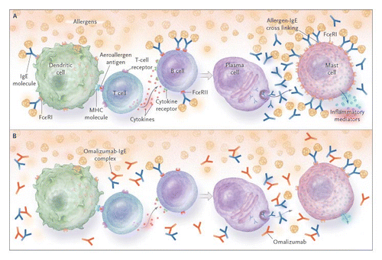
Note: action of Omalizumab in treating Asthma

http://www.nature.com/nrd/journal/v11/n12/images/nrd3792-f2.jpg
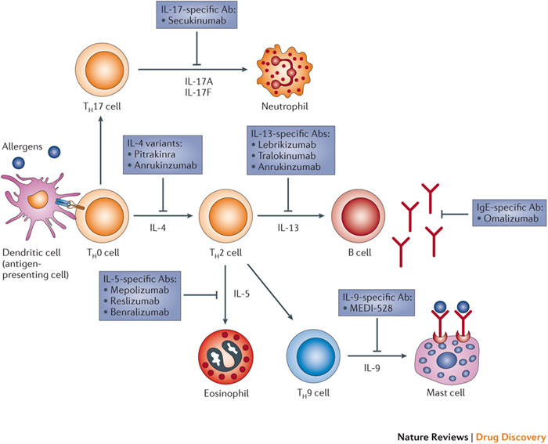
Key players, their interactions and treatment options
Note: action of Omalizumab and various other treatment options
Also see association of various Immune cells and Interleukins in Asthma – IL-4, IL-5, IL-9, IL-13, IL-17, IgE

http://www.nature.com/nrd/journal/v3/n10/images/nrd1524-f2.jpg
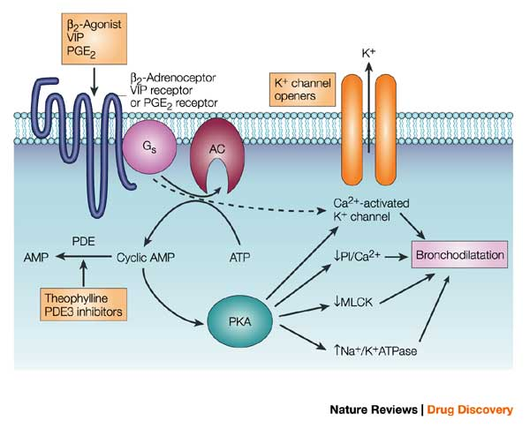
Note: how Beta 2- agonists, Theophyline, K+ channel openers work

C. Type “Asthma and Review” or “Asthma and mechanism” in the NCBI’s top search box.

Try “Asthma and Review”; “Asthma and mechanism” or “Asthma and Treatment”
See various current research and review articles >> read titles, abstracts and papers as appropriate
Also look for Book chapters on NCBI Bookshelf

Search also for articles related to any of the above molecule names identified above.

- WHO are the key players?
- HOW do these molecules relate to the topic of interest?
Identify the name(s) of the molecule(s) and domains related to topic of interest

The names of key players and relevant interactions are highlighted in yellow above.
Add to this any information that you can add from reading various articles.

