Neutralizing or Not?

Learning Objectives: To explore the structures of Spike Protein Receptor Binding Domain (RBD) bound to ACE2 and Antibodies Using RCSB PDB Mol* and figure out if the antibodies are neutralizing.

Introduction
One of the hallmarks of a successful vaccine is its ability to induce the immune system to produce neutralizing antibodies. These antibodies bind to the antigen (in this case, part of the viral Spike protein) in a manner that the infection is blocked. In other words, the antibody binding must interfere with the Spike protein’s ability to bind the host cell receptors (ACE2). In this way neutralizing antibodies provide an individual protection against the infection.

Before exploring neutralizing antibodies, we will learn a little about the shape and functions of antibodies in general and learn a few vocabulary words/phrases. This knowledge will help understand the structures explored in this exercise.

- What is an Antibody?
Antibodies are immune molecules that our body makes in response to specific pieces of foreign materials (including pathogens like viruses, bacteria, and other natural or synthetic material that may enter our body). While there are many types of antibodies, the one most commonly discussed are the Y-shaped Immunoglobulin G or IgG molecules. They are made of four protein chains - 2 heavy (orange and magenta) and 2 light chains (green and purple) in the figure below from PDB ID 1igt.
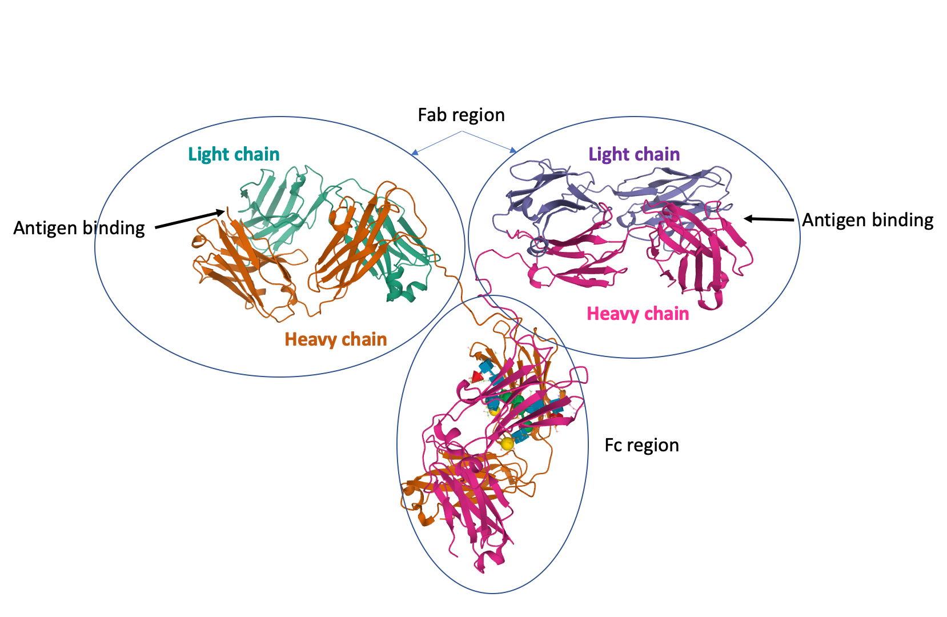
The junction of the arms and stem in the Y shaped molecule can be cut by proteases producing 2 arms that can bind the antigen (also called fragment antigen binding or Fab) and a stem that can bind to specific receptors on immune cells to activate them (called fragment crystallizable or Fc).

Most structures of proteins bound to their specific antibodies only the Fab fragments are seen. The Fab fragment is made up of 2 chains, each with 2 immunoglobulin domains. One end of the Fab fragment has regions that specifically interact with and bind to the antigen.

To learn more about antibodies and make paper antibodies visit http://pdb101.rcsb.org/learn/paper-models/antibody

Tools
- The exercise will use data from the Protein Data Bank (PDB) and use the RCSB molecular visualization tool Mol* for the visualization and analysis of SARS-CoV-2 Spike protein Receptor Binding Domain (RBD) when bound to the ACE2 receptor and two different antibodies.
- To save images, click on the camera (iris) icon , Download and save a *.jpg file. Import the image in any image manipulation software of your choice (e.g., PowerPoint/ Photoshop) to add labels and additional text describing the images.
- Some key commands and functions of Mol* are included in the Appendix at the end of this document.

Exploration

Explore the binding of SARS-CoV-2 Spike Receptor Binding Domain (RBD) to ACE2
- Type the PDB ID “6m0j” in the top search box >> click enter. This should take you to the Structure Summary Page. This page provides a quick glimpse of the contents, quality, and experimental details of the structure.

A1. Examine the contents of the page and complete the table below:

PDB ID
Author(s) of entry
Date (including Year) when the structure was published/released
Structure determination method
Number of protein chains in the entry; protein name, Chain ID
Names and number of copies of ligands (Small Molecules) present in the structure

- Click on the 3D View tab on the top of the page to view the structure in Mol*

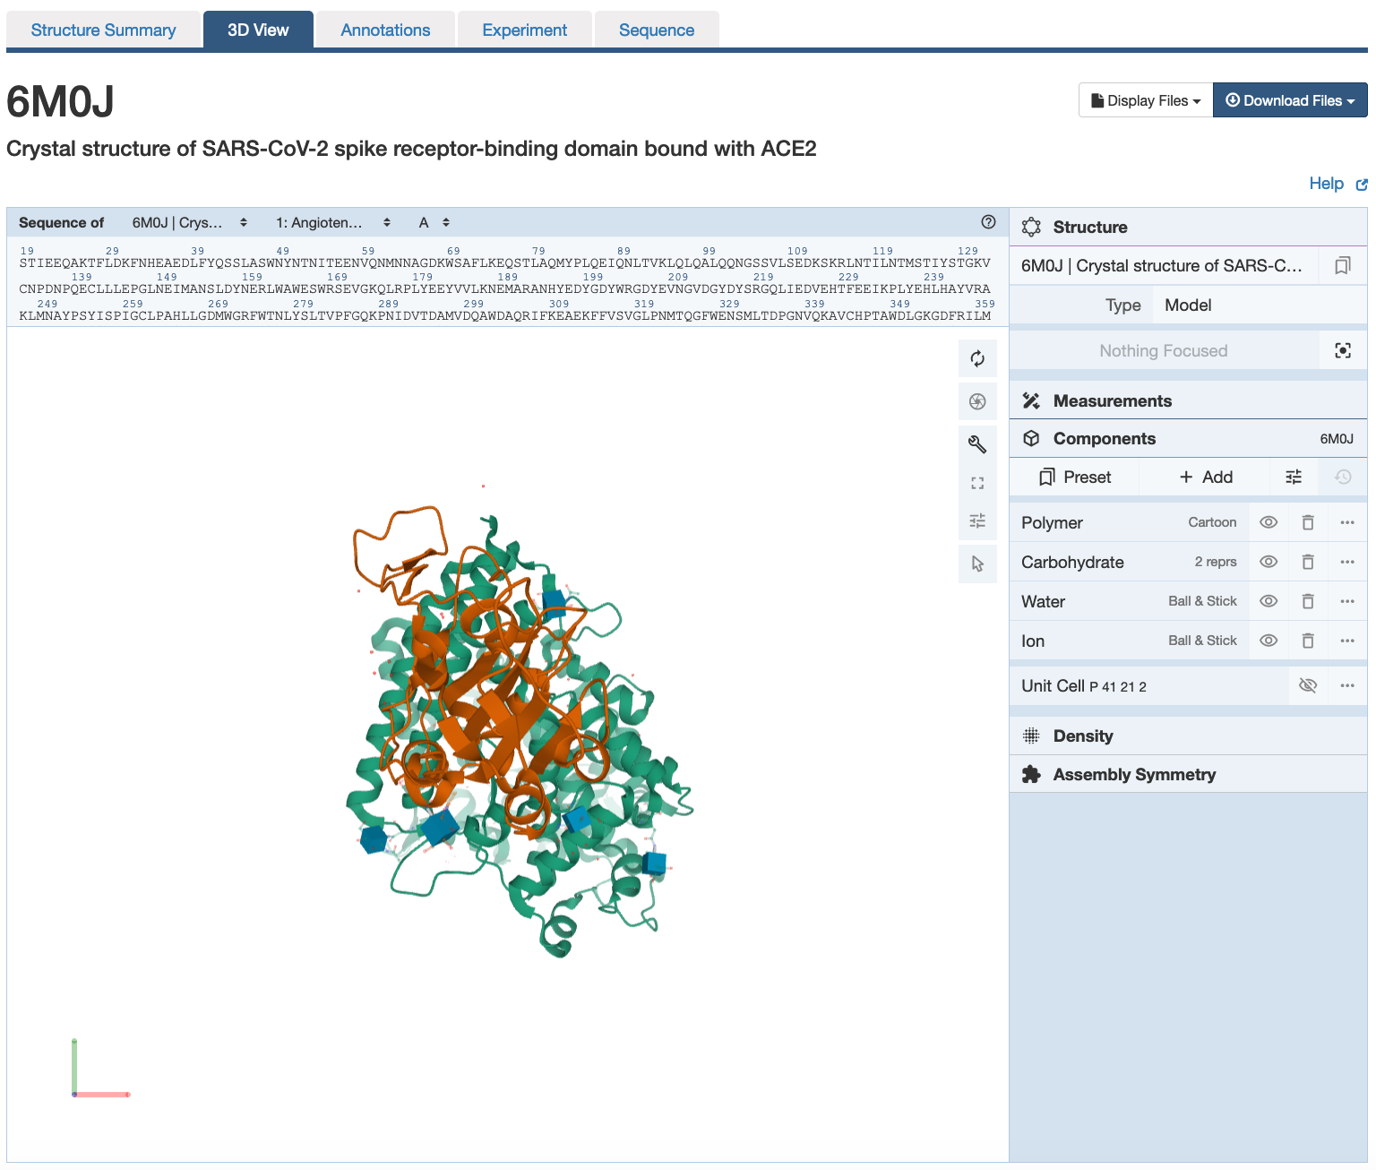 | There are 3 main areas on this screen:  1. Sequence panel (top left)  2. 3D-canvas (white space where the 3D structure is shown). Besides displaying the interactive 3D models, this space also offers  a. Toggle panel (a series of buttons on the right) to enable various functions  b. Log panel (at the bottom of the canvas) records actions taken  3. Control panel (blue column on right) with menus for Structure, Measurements, Components, etc.

- All the protein chains are represented as different colored ribbons with helical regions.
- Use various mouse controls to rotate and translate the molecule you are viewing.
- Note: Hovering the mouse over any object in the 3D canvas will display information about that item in the bottom right corner of the 3D canvas.
- Orient the structure so that the ACE2 protein is positioned on the top and the Spike protein is shown below.

A2. Save an image of the structure you see and label the two proteins in the structure - Spike protein and ACE2. Include the labeled image below.

- One specific amino acid (K417) in the Spike RBD is known to form a salt bridge with an amino acid in ACE2.
- Explore this residue and its interacting partners.

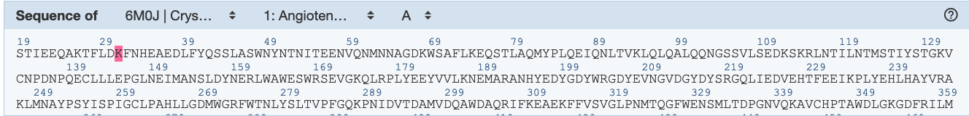 | Make sure that the selection mode is not activated.  In the sequence panel select the Spike receptor binding domain protein (from the pulldown menus). Identify the amino acid residue Lysine or Lys or K 417 in this chain and click on it.  In the 3D canvas this amino acid should be highlighted and all interactions in its neighborhood should be displayed.
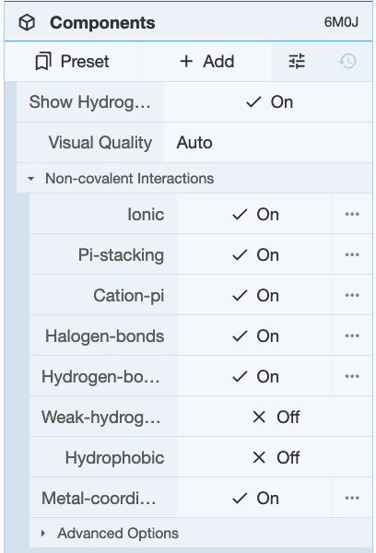 | To make sure that you are seeing all the non-covalent interactions in this region >> click on the options icon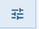 in the Components Panel to select the types of non-covalent interactions to view:  Make sure that the types of non-covalent interactions shown include the figure (left).

A3. Save an image of the non-covalent interactions around Spike RBD’s K417. Label any amino acids that form non-covalent bonds with this residue. Include the labeled image in the box below.

- Display the residue K417 in the Spike protein RBD in spacefill representation.

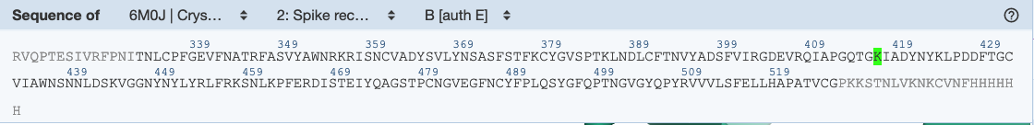 | Activate the selection mode by clicking on the arrow icon 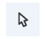in the Toggle panel >> Select the residues K417 in the Spike RBD
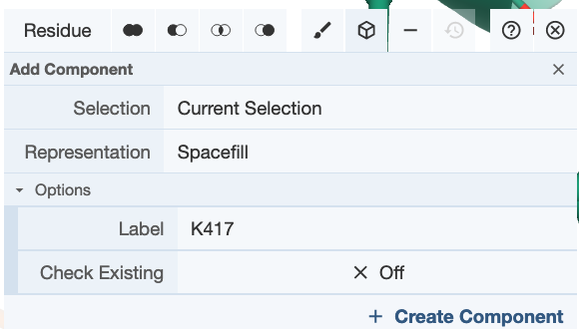 | Create a component with this selection by clicking on the Cube icon 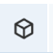 >> Select Representation Spacefill >> Label it “K417” >> click on Create Component.
.
- Click on the Reset Camera icon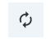 to zoom out. Orient the structure so that the Spike RBD is shown in the bottom of the figure with K417 pointing upwards. Save this image.

A4. Label the 2 proteins in the structure and K417. Include the labeled figure in the box below.

Explore the binding of SARS-CoV-2 Spike Receptor Binding Domain (RBD) to a Cross-reacting SARS-CoV Antibody
In the past two decades, two other coronaviruses have led to epidemics - SARS-CoV (2002–2003) and Middle East respiratory syndrome coronavirus (MERS-CoV) (2012–present). The SARS-CoV and SARS-CoV-2 Spike protein RBDs have over 70% sequence identity. They both bind to the same host receptor protein ACE2. Scientists asked if SARS-CoV antibodies would cross-react with SARS-CoV-2 and would they be neutralizing. Ian Wilson and his collaborators solved the structure of SARS-CoV-2 RBD bound to the Fab region of a human antibody CR3022, that was isolated as a neutralizing antibody from a patient who recovered from SARS (Yuan et al., 2020; DOI: 10.1126/science.abb7269).

- Type the PDB ID “6w41” in the top search box >> click enter. This should take you to the Structure Summary Page.

B1. Examine the contents of the page and complete the table below:

PDB ID
Author(s) of entry
Date (including Year) when the structure was published/released
Structure determination method
Number of protein chains in the entry; protein name, Chain ID
Names and number of copies of ligands (Small Molecules) present in the structure

- Click on the 3D View tab on the top of the page to view the structure in Mol*
- Display the residue K417 in the Spike protein RBD in spacefill representation.

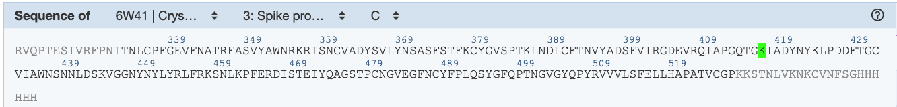 | Activate the selection mode by clicking on the arrow icon in the Toggle panel >> Select the residues K417 in the Spike RBD
 | Create a component with this selection by clicking on the Cube icon >> Select Representation Spacefill >> Label it “K417” >> click on Create Component.
.
- Click on the Reset Camera icon to zoom out. Orient the structure so that the Spike RBD is shown in the bottom of the figure with K417 pointing upwards. Orient the molecule in the same or similar orientation as in answer A4. Save this image.

B2. Label the 2 proteins in the structure and K417. Include the labeled figure in the box below.

B3. Does the CR3022 antibody bind in the same region as the ACE2 or different region? How do you know?

Explore the binding of SARS-CoV-2 Spike Receptor Binding Domain (RBD) to a human-origin monoclonal antibody from a convalescent patient.
Scientists have been searching for antibodies in individuals who have recovered from a SARS-CoV-2 infection to identify ones that specifically bind to SARS-CoV-3 Spike protein and prevent infection (i.e., neutralizing antibodies). They can be used to passively immunize and even treat individuals with SARS-CoV-2 infection. Learning about specific regions of the Spike protein where these antibodies bind may also help in designing vaccines that can prime individuals to produce these antibodies.
Several structures of Fab fragments of human origin antibodies bound to SARS-CoV-2 Spike were solved. Here, we explore one such structure of Spike Protein bound to the Fab fragment of antibody B38, solved by Wu et al., 2020 (10.1126/science.abc2241).

- Type the PDB ID “7bz5” in the top search box >> click enter. This should take you to the Structure Summary Page.

C1. Examine the contents of the page and complete the table below:

PDB ID
Author(s) of entry
Date (including Year) when the structure was published/released
Structure determination method
Number of protein chains in the entry; protein name, Chain ID
Names and number of copies of ligands (Small Molecules) present in the structure

- Click on the 3D View tab on the top of the page to view the structure in Mol*
- Display the residue K417 in the Spike protein RBD in spacefill representation.

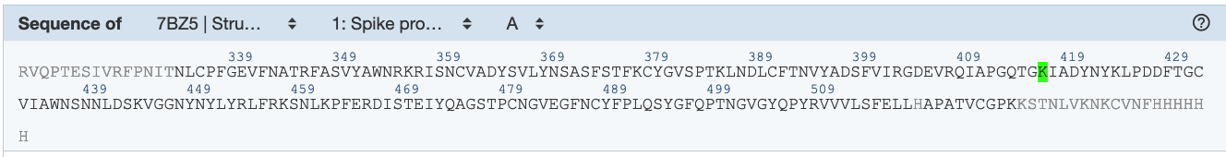 | Activate the selection mode by clicking on the arrow icon in the Toggle panel >> Select the residues K417 in the Spike RBD
 | Create a component with this selection by clicking on the Cube icon >> Select Representation Spacefill >> Label it “K417” >> click on Create Component.
.
- Click on the Reset Camera icon to zoom out. Orient the structure so that the Spike RBD is shown in the bottom of the figure with K417 pointing upwards. Orient the molecule in the same or similar orientation as in answer A4. Save this image.

C2. Label the 2 proteins in the structure and K417. Include the labeled figure in the box below.

C3. Does the B38 antibody bind in the same region as the ACE2 or different region? How do you know?

C4. From your structural explorations would you say if B38 is a neutralizing antibody or not?

Appendix: Mol* Quick Reference
1. Navigate the 3D Canvas:
a. Rotate
● Press left mouse button and move OR use Shift + left mouse button and drag.
b. Translate
● Press right mouse button and move OR use Control + the left mouse button and move. On a touchscreen device, use a two-finger drag.
c. Zoom
● Use the mouse wheel. On a touchpad, use a two-finger drag. On a touchscreen device, pinch two fingers.
d. Center and zoom
● Use right mouse button to click on the part of the structure you wish to see.
e. Change clipping planes
● Use Shift button + the mouse wheel. On a touchpad, use the Shift button + a two-finger drag.
2. Select: first open Selection Mode and change the Picking Level (if needed)
a. Select Picking Level
● Click on objects in the 3D canvas – such as atoms, residues, chains, etc.
b. Select object in 3D canvas
● Click on residues, chains etc. in the 3D canvas based on picking level
c. Select object from Sequence Panel
● Click on residues, ligands, or entire chain in the Sequence Panel
d. Custom Select combinations
● Use the Set Operations Menu in the Selection Mode toolbar
3. See or Hide:
a. To add representations
- Create a component of the region you wish to see/hide → Go to the Components Panel and press the “eye” icon next to the component you create
b. To hide/remove from view
● Select region you wish to hide → Click on the subtract/hide icon in the Selections toolbar
4. Color:
a. N-terminus to C-terminus (rainbow)
● Components → Polymer → Set Coloring → Residue Property → Sequence Id
b. Heteroatom
● Components → Polymer → Set Coloring → Atom Property → Element Symbol
c. Secondary structure
● Components → Polymer → Set Coloring → Residue Property → Secondary Structure
d. Hydrophobicity
● Components → Polymer → Set Coloring → Residue Property → Hydrophobicity
e. Domain
● Select domain → Selections Menu → Apply Theme to Selection → Color → Apply Theme
5. Compare Structures: first upload two or more structures at rcsb.org/3D-view
a. By chains
● Select 2 or more polymer chains/residues → Superposition → By Chains → Superpose
b. By atoms
● Select 1 or more atoms → Superposition → By Atoms→ Superpose
6. Make Measurements:
a. Distance
● Make 2 or more selections → Measurements → Add → Distance (for first 2 selections)
b. Angle
● Make 3 or more selections → Measurements → Add → Angle (for first 3 selections)
c. Dihedral
● Make 4 or more selections → Measurements → Add → Dihedral (for first 4 selections)

