Name _____________________________________________________________ Date ________________

Proinsulin Tokyo

Review the biosynthesis of insulin by reading the “About Insulin” section on the Insulin activity page (http://pdb101.rcsb.org/learn/resource/insulin-activity-page).

Q1. Use the following words to complete the sentences written below:

Preproinsulin
Proinsulin
Chain A
Chain B

C-peptide
Disulfide linkages
Rough Endoplasmic Reticulum
Golgi

- The 24 amino acid signal peptide present in ___________________ targets it to the _____________.
- After cleavage of the signal peptide the __________________ molecule forms three ____________.
- In the ___________, proinsulin is cleaved into three fragments by the action of the Prohormone convertases and Carboxypeptidase E. The resulting peptides are also called _________, ________________, and ________________.

Q2. Draw a schematic of insulin biosynthesis showing the relationship between preproinsulin, proinsulin and insulin.

Ans 2.
This activity will follow the following steps in order to answer a question and tell a molecular story.
- Ask a question – this is the theme for the molecular storytelling
- Build model based on literature review – what will you explore in the PDB
- Investigate - Query/Browse PDB; Select PDB entries; Visualize
- Analyze - Explore interactions; Compare Structures
- Construct molecular explanations for original question
- Develop argument - relate structure to bioinformatics information (go back to the literature to see if the molecular explanation makes sense)
- Communicate - Tell a Molecular Story with Illustrations

Overview:
This activity focuses on a familial case of Diabetes, called Proinsulin Tokyo. It provides an opportunity to explore and understand a molecular basis for this disease and its symptoms.

Learning Goals:
- Define a question/topic for exploration at a molecular level
- Explore the literature to find out about the topic
- Query the RCSB PDB website to find specific structure(s) for exploration.
- Explore relevant molecular structures to develop a molecular story explaining the topic.

Guided Molecular Storytelling:
In 1981, an article published in the Nature magazine, reported two patient families with Diabetes resulting from defective biosynthesis and function of insulin (Robbins et al., Nature. 1981 Jun 25; 291(5817): 679-81; doi:10.1172/JCI111973.). The article abstract is included below:
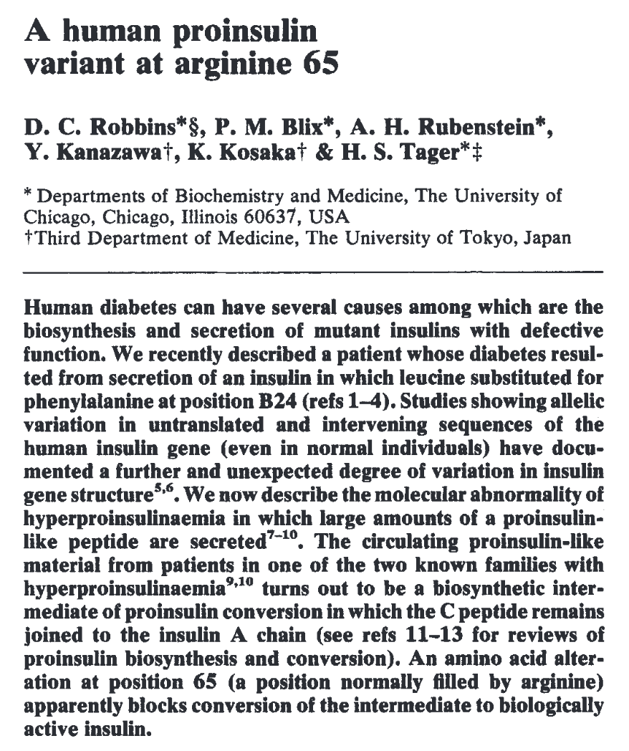
- Ask a question:
The question: Why does the mutation R65 lead to Hyperproinsulinemia? Explain this observation at a molecular level.

- Build a model:
Search for information about proinsulin, insulin, and the mutant reported as Proinsulin Tokyo. Try to learn about the process of insulin synthesis, its key steps, and players. For your initial explorations you may search:
- Online – using your favorite search engine (Google, Bing etc.)
- In text books – that you or your library owns; or check the NCBI bookshelf (online) at http://www.ncbi.nlm.nih.gov/books
- Review articles – you can search for these using the NCBI PubMed (online) at http://www.ncbi.nlm.nih.gov/pubmed

Literature research reveals that the Proinsulin Tokyo mutation in the case discussed here is changing an Arg to His. The article titled “Posttranslational Cleavage of Proinsulin Is Blocked by a Point Mutation in Familial Hyperproinsulinemia” by Shibasaki et. Al., 1985 (http://dx.doi.org/10.1172/JCI111973). A key result reported in this paper shows the changes at the gene and protein level in this mutation – see below:
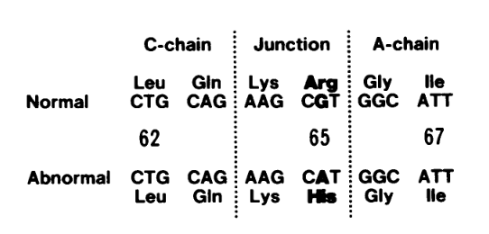

Q3. Based on your knowledge of insulin biosynthesis, which molecule(s) would you like to explore in the PDB? Name at least 2.

Ans 3:

- Investigate:
Search for your molecule(s) of interest in the PDB using known properties – e.g., molecule name, mutation, presence of ligand etc.

Q4. List the PDB ID and Structure titles for at least 1 structure in the PDB for the larger of the two molecules that you have identified in Ans 3. (Hint: You may begin your search from the native human insulin PDB ID 1trz.
Ans 4:

Q5. How did you perform the search on the RCSB PDB website? List your search options and any logic that you used to refine your search results.

Ans 5:

Visualize the PDB entry that you identified and the PDB ID 1trz. Save suitable images and include them in your answers below.

- Open the structure summary page for PDB ID 1trz.
- Click on the 3D structure tab at the top of the page to open the structure in the visualization tool Mol*.
- To save images, click on the camera (iris) icon , Download and save a *.jpg file.
- Repeat the steps for the PDB entry for Proinsulin that you identified above.
- Import the images in any image manipulation software of your choice (e.g., PowerPoint/ Photoshop) to add labels and additional text describing the images.

Q6. Show the images of the insulin and proinsulin proteins. List two differences between the structures you see.

Ans 6:

Compare the structures of insulin and proinsulin as follows.
- Open the Pairwise Structure Comparison tool at https://www.rcsb.org/alignment
- In the boxes fill in the PDB IDs 1trz and the proinsulin PDB ID
- Select chains D in the boxes provided for the comparison.
- Use the default search options to launch the comparison by clicking on the Compare button.

Q7. Which parts of the insulin and proinsulin structures match and which do not? Include a suitably labeled figure of the superposed structures here.

Ans 7.

- Analyze:
Reviewing the literature will show that the Prohormone convertase 1/3 prefers to cleave the protein chain immediately after two consecutive basic amino acids (i.e. Lys and Arg)

Proinsulin Tokyo is caused by a specific mutation of Arginine 65 being replaced by Histidine (R65H). In the proinsulin structure that you have selected, focus on the areas in the vicinity of the mutation to explore the significance of the residue Arg65.
- Open the proinsulin structure in Mol*
- Activate the selection mode by clicking on the arrow icon in the vertical icons menu on the 3D canvas.
- Use the sequence panel at the top of the page to select consecutive RR or KR residues in the sequence.
- Once the residues are highlighted, click on the cube like components icon at the top of the page to select Representation >> Ball and Stick.
- To change the color of carbons in a specific residue - select the residue.
- Now click on the intersect selection options in the horizontal icons menu on the 3D canvas displayed when the selection model is active.
- Select Element >> Carbon (C) and then click on the paintbrush icon to select the magenta color and click on the Apply theme button.
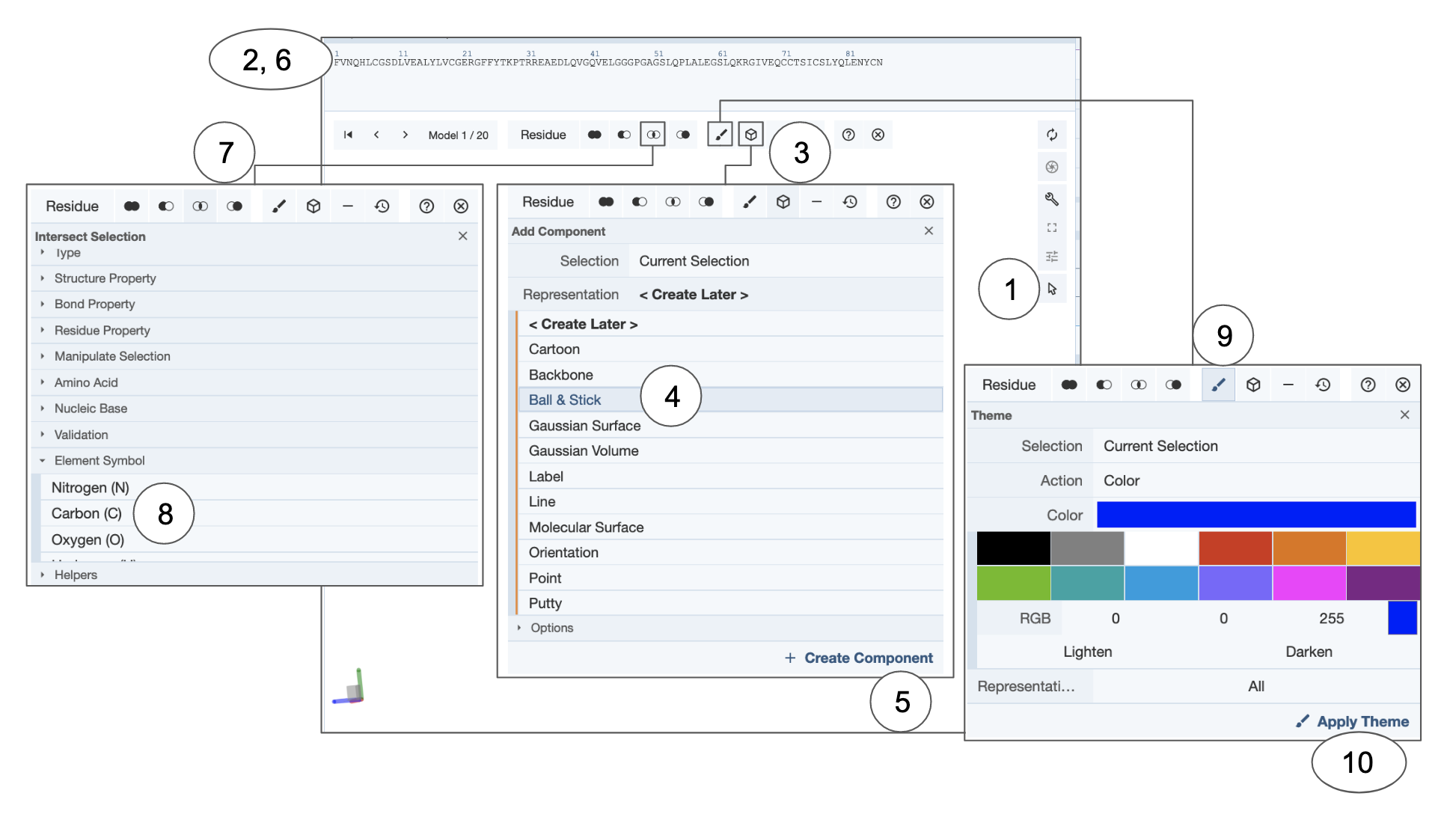

Q8. Show the side chains of all basic amino acids (Lys and Arg) in the Proinsulin protein. What is special about the residues involved in the molecular interactions involving R65. Color this Arg (R65) so that the carbons are colored magenta. Include a suitable illustration here.

Ans 8:

- Molecular explanations:
Based on the images included above and your explorations of the molecular structures and interactions think about the R65H mutant.

Q9. What are the main differences between the molecule(s) that you are exploring in healthy individuals compared to those in individuals with hyperproinsulinemia related to the R65H mutation?

Ans 9:

- Argument:
Q10. What changes at the molecular level lead to hyperproinsulinemia? Substantiate your answer with at least one additional fact or observation about this condition.

Ans 10.

Extension and Enrichment:
Q11. Based on your understanding of the molecular basis of Proinsulin Tokyo – propose a treatment strategy for individuals with the R65H mutation.

Ans 11.

