Name _____________________________________________________________ Date ________________

Proinsulin Tokyo

Review the biosynthesis of insulin by reading the “About Insulin” section on the Insulin activity page (http://pdb101.rcsb.org/learn/resource/insulin-activity-page).

Q1. Use the following words to complete the sentences written below:

Preproinsulin
Proinsulin
Chain A
Chain B

C-peptide
Disulfide linkages
Rough Endoplasmic Reticulum
Golgi

- The 24 amino acid signal peptide present in ______________________________________ targets it to the ____________________________________________________________.
- After cleavage of the signal peptide the _____________________________________ molecule forms three _______________________________________________.
- In the _______________________________________________, proinsulin is cleaved into three fragments by the action of the Prohormone convertases and Carboxypeptidase E. The resulting peptides are also called _________________________________, _____________________________________, and ____________________________________________.

Q2. Draw a schematic of insulin biosynthesis showing the relationship between preproinsulin, proinsulin and insulin.

This activity will follow the following steps in order to answer a question and tell a molecular story.
- Ask a question – this is the theme for the molecular storytelling
- Build model based on literature review – what will you explore in the PDB
- Investigate - Query/Browse PDB; Select PDB entries; Visualize
- Analyze - Explore interactions; Compare Structures
- Construct molecular explanations for original question
- Develop argument - relate structure to bioinformatics information (go back to the literature to see if the molecular explanation makes sense)
- Communicate - Tell a Molecular Story with Illustrations

Overview:
This activity focuses on a familial case of Diabetes, called Proinsulin Tokyo. It provides an opportunity to explore and understand a molecular basis for this disease and its symptoms.

Learning Goals:
- Define a question/topic for exploration at a molecular level
- Explore the literature to find out about the topic
- Query the RCSB PDB website to find specific structure(s) for exploration.
- Explore relevant molecular structures to develop a molecular story explaining the topic.

Guided Molecular Storytelling:
In 1981, an article published in the Nature magazine, reported two patient families with Diabetes resulting from defective biosynthesis and function of insulin (Robbins et al., Nature. 1981 Jun 25; 291(5817): 679-81; doi:10.1172/JCI111973.). The article abstract is included below:
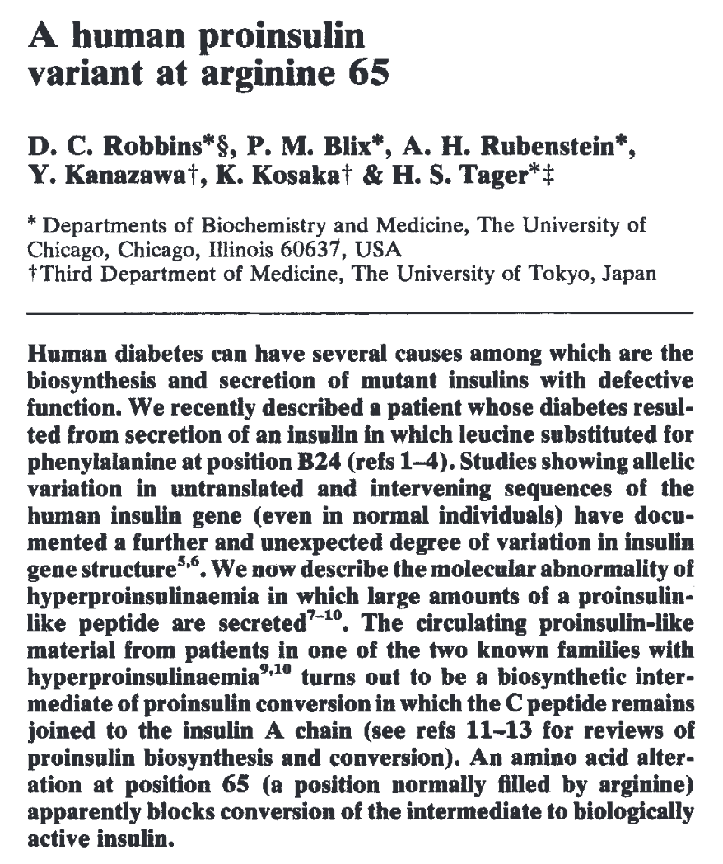
- Ask a question:
The question: Why does the mutation R65, lead to Hyperproinsulinemia? Explain this observation at a molecular level.

- Build a model:
Search for information about proinsulin, insulin, and the mutant reported as Proinsulin Tokyo. Try to learn about the process of insulin synthesis and key steps and players in the biosynthesis. For your initial explorations you may search:
- Online – using your favorite search engine (Google, Bing etc.)
- In text books – that you or your library owns; or check the NCBI bookshelf (online) at http://www.ncbi.nlm.nih.gov/books
- Review articles – you can search for these using the NCBI PubMed (online) at http://www.ncbi.nlm.nih.gov/pubmed

Q3. Based on your knowledge of insulin biosynthesis, what molecule(s) would you like to explore in the PDB? Name at least 2.

- Investigate:
Search for your molecule(s) of interest in the PDB using known properties – e.g. molecule name, mutation, presence of ligand etc.

Q4. List the PDB ID and Structure titles for at least 1 structure in the PDB for each of the two molecules that you have identified in Ans 3. (Hint: such as insulin, proinsulin etc.).

Q5. How did you perform the search on the RCSB PDB website? List your search options and any logic that you used to refine your search results.

Visualize the PDB entries that you identified – independently. If necessary and appropriate, superpose the structures to explore the structure-function relationships. Save suitable images and include them in your answers below.

Q6. What do your molecule(s) of interest look like? Is there anything unusual in the structure of the molecule(s) you are exploring?

- Analyze:
Proinsulin Tokyo is caused by a specific mutation of Arginine 65 being replaced by Histidine (R65H). In the structure(s) that you have selected, focus on the areas in the vicinity of the mutation to explore the significance of the residue Arg65.

Q7. What is special about the residues involved in the molecular interactions involving R65. Illustrate your answer with 1-2 illustrations based on your structural explorations.

- Molecular explanations:
Based on the images included above and your explorations of the molecular structures and interactions think about the R65H mutant.
Q8. What are the main differences between the molecule(s) that you are exploring in healthy individuals compared to that in individuals with hyperproinsulinemia related with the R65H mutation?

- Argument:
Q9. What changes at the molecular level lead to hyperproinsulinemia? Substantiate your answer with at least one additional fact or observation about this condition.

Complete the following questions for HW:
- Communicate:
Q10. Describe the molecular basis for hyperproinsulinemia caused by Proinsulin Tokyo - the mutation R65H. Include an introduction, molecular explanation for symptoms of the disease and a few sentences about treatments and future directions, based on your explorations (molecular and literature). Include some discussion about why this same mutation is also referred to as R89H.

Extension and Enrichment:
Q11. Based on your understanding of the molecular basis of Proinsulin Tokyo – propose a treatment strategy for individuals with the R65H mutation.

