# Hemagglutinin: Protein Carbohydrate Binding

**Authors**: Shuchismita Dutta, Rutgers University, NJ

**Lesson Overview**:

This lesson explores the structure and function of Hemagglutinin, a glycoprotein found on the envelope of influenza viruses that plays a key role in viral infection. The activity begins by reviewing the RCSB Molecule of the Month article on this molecule. Through the lesson students are introduced to the RCSB PDB websites and various tools and resources it offers (including the visualization software Mol*).

**ASBMB Learning Objectives** (<https://www.asbmb.org/education/core-concept-teaching-strategies/foundational-concepts/structure-function>)

2. Structure is determined by several factors

* Students should be able to **recognize the repeating units** in biological macromolecules and be able to discuss the **structural impacts of the covalent and noncovalent interactions involved** *(Introductory)*.
* Students should be able to **use various bioinformatics approaches to analyze** macromolecular primary **sequence and structure** *(Intermediate)*.

3. Structure and function are related

* Students should be able to use **mechanistic reasoning to explain how an enzyme** or ribozyme **catalyzes a particular reaction** *(Introductory)*.

4. Macromolecular interactions

* Students should be able to discuss the **interactions between a variety of biological molecules** (including proteins, nucleic acids, lipids, carbohydrates and small organics, etc.) and **describe how these interactions impact specificity or affinity** leading to changes in biological function *(Intermediate)*.
* Students should be able to **predict the effects of either mutation or ligand structural change on the affinity of binding** and design appropriate experiments to test their predictions *(Upper)*.

***Note: To complete this lesson you will need to be able to capture an image from your screen. Find a good way to print screen or capture the contents of the screen as an image that can be imported into PowerPoint or other graphics programs to add annotations and labels.***

### **Part I: Begin with the RCSB PDB Molecule of the Month**

The focus in this part is to learn about Hemagglutinin’s function and what the molecule looks like.

Read the RCSB PDB Molecule of the Month Article on Hemagglutinin (<https://pdb101.rcsb.org/motm/76>) and answer the following questions.

1. About the Featured Molecule(s)
   1. *Function*: What biological function or process is discussed in this article?
   2. *Molecules*: What type of biological macromolecules is Hemagglutinin (as described in this article)? (Hint: proteins, lipids, nucleic acids, carbohydrates)
   3. *Location:* Where are hemagglutinin molecules found?
   4. *Diseases*: How does the function of hemagglutinin cause the disease (flu)?

1. Explore the structure-function relationship of the molecule(s) discussed in the article

*Overview*:

* 1. Describe the functions of each of the two parts of hemagglutinin (protein) in binding host cells.

*Details*: The figures included in the “Exploring the Structure” section of the article shows antibody fragments bound to the hemagglutinin.

* 1. How does antibody binding impact the function of hemagglutinin?

### **Part II: Exploring the Hemagglutinin’s Structure and Function using Mol\***

The focus in this part is to learn more about

1. Structure of Hemagglutinin
2. Sugar binding in and by Hemagglutinin.

Go to the [RCSB PDB home page](https://www.rcsb.org/) and enter in the top search box the hemagglutinin PDB code 1qfu (discussed in the Molecular of the Month feature). Click on the PDB ID in the results page to open the Structure summary page for this PDB structure or go to the page (<https://www.rcsb.org/structure/1qfu>).

On the top left corner of the page there is an image showing the structure of the molecule.

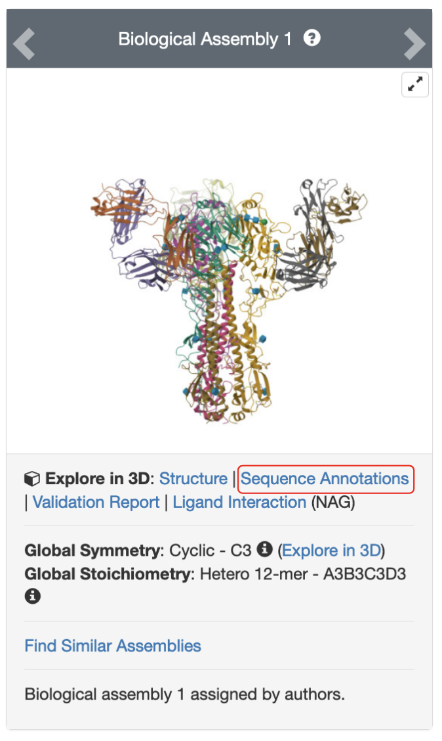

*Figure 1: Structure of influenza hemagglutinin with a neutralizing antibody (PDB ID 1qfu).*

Click on the hyperlink “Sequence Annotations” to launch a view of this molecule.

* In this view, one panel shows the sequence of the protein and nucleic acid chains in the structure while the other shows its 3D structure.
* The two panels are connected so that clicking on a specific amino acid in the sequence panel selects and centers the 3D structure view on the same amino acid and displays the interactions around the specific amino acid.
* The sequence panel also displays various annotations about it (e.g., secondary structure, active site, mutagenesis etc.)

Based on the information presented here, answer the following questions.

1. How many intra-chain disulfide bonds are present in Chain A of the hemagglutinin structure?
2. What is the length of the longest helix (secondary structural element) in chain B of the hemagglutinin structure? List the first and last amino acids forming it

Go back to viewing the sequence of Chain A. Click on the Glycosylation sites in chain A in the sequence panel and examine their 3D structure. Examine the glycosylation sites at amino acids Asn38 (N38) and Asn165 (N165) and answer the following questions:

1. What sugars are attached to each of these glycosylation sites (N38 and N165).
2. Identify at least one non-covalent interaction that the sugars linked to N38 and N165 participate in. Make note of whether the interactions involve protein backbone or side chain atoms. Support your answer with a labeled figure in your answer.
3. Based on the above structural exploration, describe the types of non-covalent interactions between sugars and proteins. Support your answer with a suitable image.