# Restriction Enzymes: Protein DNA Binding

**Authors**: Brian Gadd, Los Angeles Mission College, CA and Shuchismita Dutta, Rutgers University, NJ

**Lesson Overview**:

This lesson explores the structure and function of the restriction enzyme EcoRI. The activity begins by reviewing the RCSB Molecule of the Month article on this class of enzymes and examines interactions of DNA and protein (the enzyme) in order to accomplish a specific function (cutting the DNA molecule at a specific sequence). Through the lesson students are introduced to the RCSB PDB websites and various tools and resources it offers (including the visualization software Mol*).

**ASBMB Learning Objectives** (<https://www.asbmb.org/education/core-concept-teaching-strategies/foundational-concepts/structure-function>)

2. Structure is determined by several factors

* Students should be able to **recognize the repeating units** in biological macromolecules and be able to discuss the **structural impacts of the covalent and noncovalent interactions involved** *(Introductory)*.
* Students should be able to **use various bioinformatics approaches to analyze** macromolecular primary **sequence and structure** *(Intermediate)*.

3. Structure and function are related

* Students should be able to use **mechanistic reasoning to explain how an enzyme** or ribozyme **catalyzes a particular reaction** *(Introductory)*.

4. Macromolecular interactions

* Students should be able to discuss the **interactions between a variety of biological molecules** (including proteins, nucleic acids, lipids, carbohydrates and small organics, etc.) and **describe how these interactions impact specificity or affinity** leading to changes in biological function *(Intermediate)*.
* Students should be able to **predict the effects of either mutation or ligand structural change on the affinity of binding** and design appropriate experiments to test their predictions *(Upper)*.

***Note: To complete this lesson you will need to be able to capture an image from your screen. Find a good way to print screen or capture the contents of the screen as an image that can be imported into PowerPoint or other graphics programs to add annotations and labels.***

### **Part I: Begin with the RCSB PDB Molecule of the Month**

The focus in this part is to learn about the Restriction enzyme’s function and what the molecule looks like.

Read the RCSB PDB Molecule of the Month Article on Restriction Enzymes (<https://pdb101.rcsb.org/motm/8>) and answer the following questions.

1. About the Featured Molecule(s)
   1. *Function*: What biological function or process is discussed in this article?

* 1. *Molecules*: Which types of biological macromolecules are described in this article? (Hint: proteins, lipids, nucleic acids, carbohydrates)

* 1. *Role in Biology:* What is the biological role of these enzymes in bacteria?

* 1. *Role in Biotechnology*: What are some of the biotechnological uses of these enzymes?

1. Explore the structure-function relationship of the molecule(s) discussed in the article

*Overview*:

* 1. Describe how the restriction enzyme (protein) interacts with its substrate to perform its function.

*Details*: The figures included in the “Exploring the Structure” section of the article shows a few arrows.

* 1. What do these arrows represent? What is the relationship between the two figures shown?

### **Part II: Exploring the Restriction Enzymes’ Structure and Function using Mol\***

The focus in this part is to learn more about

1. Specific binding of the restrictions enzyme to its substrate
2. Molecular mechanisms of cutting the substrate.

Go to the [RCSB PDB home page](https://www.rcsb.org/) and enter the Restriction Enzyme PDB code 1rva in the top search box and click on it to open the Structure summary page for this PDB structure or go to the page (<https://www.rcsb.org/structure/1RVA>).

On the top left corner of the page there is an image showing the structure of the molecule.

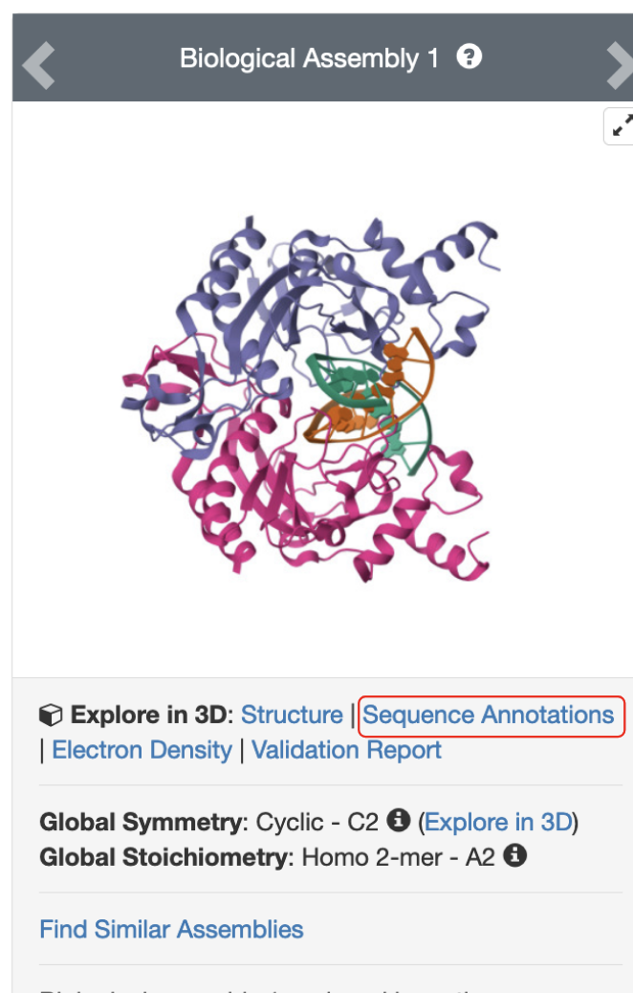

*Figure 1: Structure of EcoRV endonuclease bound to the target substrate (PDB ID 1rva).*

Click on the hyperlink “Sequence Annotations” to launch a view of this molecule.

* In this view, one panel shows the sequence of the protein and nucleic acid chains in the structure while the other shows its 3D structure.
* The two panels are connected so that clicking on a specific amino acid in the sequence panel selects and centers the 3D structure view on the same amino acid and displays the interactions around the specific amino acid.
* The sequence panel also displays various annotations about it (e.g., secondary structure, active site, mutagenesis etc.)
* In the top left corner click on the pull-down menu under the Chains to select the polymer chain whose sequence and annotations you wish to explore.
* Note that there are two different sets of Chain IDs and residue numbers listed. The one that is listed as auth:## is the chain ID and residue number used in the coordinate file deposited by the author. The other one is a numbering assigned by the PDB during curation of the structure.

Based on the information presented here, answer the following questions.

1. What is the longest stretch of secondary structural element in Chain C [Auth A] of the structure? List the type of secondary structure and amino acid residue numbers forming these elements.
2. Identify and list the amino acids in chain C [auth A] that form the active site.

(Hint: zoom into the sequence panel by scrolling the mouse to read out the marked amino acids)

Click on these active site amino acids in the sequence panel and examine their 3D structure.

1. For each of these active site amino acids, identify at least one non-covalent interaction that it participates in. Support your answer with a labeled figure in your answer.

The amino acids discussed above facilitate DNA cutting but not in the recognition of the specific nucleotide sequence at which to cut the DNA.

1. Which of the following types of interactions do you think will be important for recognition of the specific DNA sequence?
   1. Hydrogen bonding interaction with the bases of the target sequence
   2. Ionic interactions with the bases of the target sequence
   3. Hydrogen bonding interactions with the phosphodiester backbone of the target sequence.
   4. Ionic interactions with the bases of the target sequence.
   5. Base stacking interactions between the bases of the target sequence.

Go back to the structure summary page for the PDB entry 1rva (<https://www.rcsb.org/structure/1RVA>). Click on the orange button in the Macromolecules section to access the UniProt page for Type II restriction enzyme EcoRV.

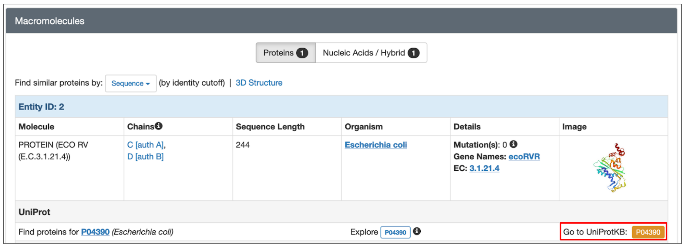

Based on the information available in that page, answer the following questions?

1. What is the target sequence that is recognized by this enzyme?

Explore the Phenotypes and Variants section of the page (<https://www.uniprot.org/uniprotkb/P04390/entry#phenotypes_variants>) to note description of mutagenesis where residues 183-188 are deleted.

Go back to PDB entry 1rva (<https://www.rcsb.org/structure/1RVA>). Click on the link called Structure or the Structure tab to visualize the structure in Mol*

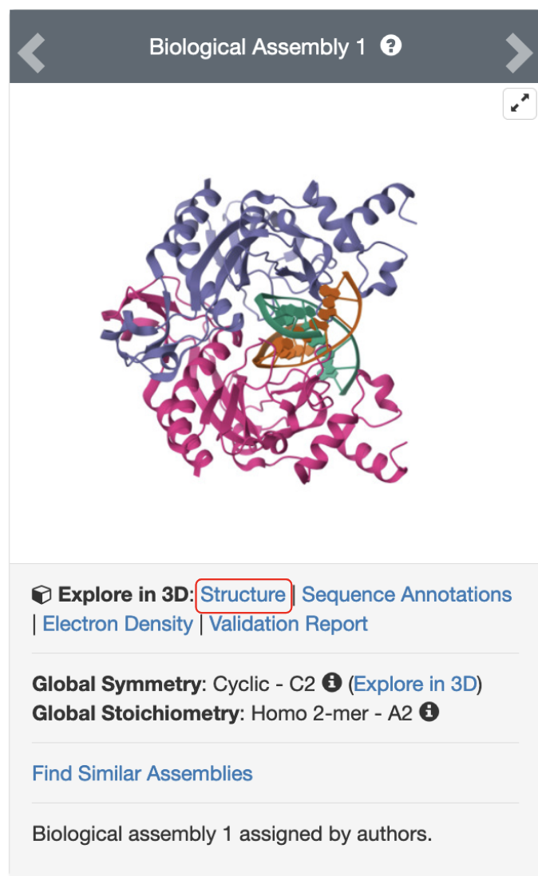

*Figure 2: Structure of EcoRV endonuclease bound to the target substrate (PDB ID 1rva). The hyperlink to view the structure in Mol* is marked with a red-outlined box.*

Once the structure is displayed in Mol*, change the Entity from "1:DNA..." to "2:PROTEIN…" and then click on the residues [auth 183-188] one at a time In the sequence panel and examine the non-covalent interactions it is involved in.

1. For the residues [auth 183-188] list at any two non-covalent interactions that can help explain the mutagenesis behavior (i.e., deletion of residues results in Weak, non-specific phosphodiesterase activity.). Support your answer with a suitable labeled figure.
2. Based on these explorations, list the types of non-covalent interactions commonly seen in protein-DNA interactions?