# Phospholipase A2: Protein Lipid Binding

**Authors**: Alexandra Pettit, Carleton University, Ottawa, ON, Canada, and Shuchismita Dutta, Rutgers University, NJ

**Lesson Overview**:

This lesson explores the structure and function of Phospholipase A2, an enzyme that can cleave fatty acids from phospholipid molecules, breaking up cell membranes. The activity begins by reviewing the RCSB Molecule of the Month article on this molecule. Through the lesson students are introduced to the RCSB PDB websites and various tools and resources it offers (including the visualization software Mol*).

**ASBMB Learning Objectives** (<https://www.asbmb.org/education/core-concept-teaching-strategies/foundational-concepts/structure-function>)

2. Structure is determined by several factors

* Students should be able to **recognize the repeating units** in biological macromolecules and be able to discuss the **structural impacts of the covalent and noncovalent interactions involved** *(Introductory)*.
* Students should be able to **use various bioinformatics approaches to analyze** macromolecular primary **sequence and structure** *(Intermediate)*.

3. Structure and function are related

* Students should be able to use **mechanistic reasoning to explain how an enzyme** or ribozyme **catalyzes a particular reaction** *(Introductory)*.

4. Macromolecular interactions

* Students should be able to discuss the **interactions between a variety of biological molecules** (including proteins, nucleic acids, lipids, carbohydrates and small organics, etc.) and **describe how these interactions impact specificity or affinity** leading to changes in biological function *(Intermediate)*.
* Students should be able to **predict the effects of either mutation or ligand structural change on the affinity of binding** and design appropriate experiments to test their predictions *(Upper)*.

***Note: To complete this lesson you will need to be able to capture an image from your screen. Find a good way to print screen or capture the contents of the screen as an image that can be imported into PowerPoint or other graphics programs to add annotations and labels.***

### **Part I: Begin with the RCSB PDB Molecule of the Month**

The focus in this part is to learn about Phospholipase A2’s function and what the molecule looks like.

Read the RCSB PDB Molecule of the Month Article on Phospholipase A2 (<https://pdb101.rcsb.org/motm/239>) and answer the following questions.

1. About the Featured Molecule(s)
   1. *Function*: What biological function or process is discussed in this article?
   2. *Molecules*: Which types of biological macromolecules are described in this article? (Hint: proteins, lipids, nucleic acids, carbohydrates)
   3. *Location:* Where are these enzymes in human cells?
   4. *Diseases*: What are some diseases caused by the improper function of these

1. Explore the structure-function relationship of the molecule(s) discussed in the article

*Overview*:

* 1. Describe what the venom phospholipase A2 (protein) does to its substrate.

*Details*: The figures included in the “Exploring the Structure” section of the article shows a few specific amino acids that play key roles in the enzyme function.

* 1. What are these amino acids? What roles do they play in the enzyme action?

### **Part II: Exploring the Phospholipase A2’s Structure and Function using Mol\***

The focus in this part is to learn more about

1. Structure of Phospholipase A2
2. Substrate binding and cleavage by Phospholipase A2.

Go to the [RCSB PDB home page](https://www.rcsb.org/) and enter the phospholipase A2 PDB code 1pob (discussed in the Molecule of the Month article) in the top search box and click on it to open the Structure summary page for this PDB structure or go to the page (<https://www.rcsb.org/structure/1pob>).

On the top left corner of the page there is an image showing the structure of the molecule.

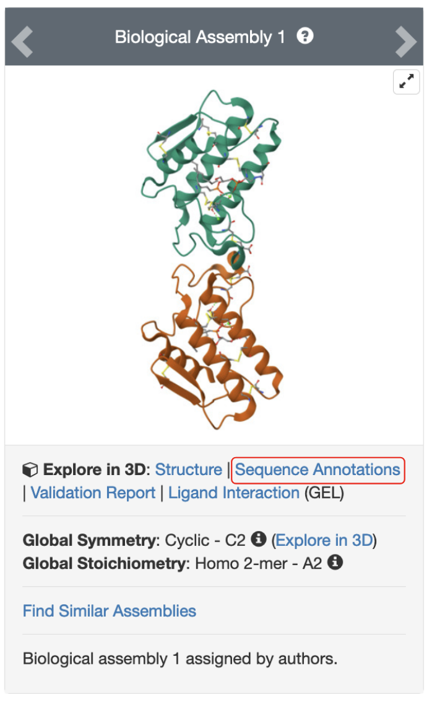

*Figure 1: Structure of Cobra Venom Phospholipase A2 from bound to a transition state analog (PDB ID 1pob).*

Click on the hyperlink “Sequence Annotations” to launch a view of this molecule.

* In this view, one panel shows the sequence of the protein and nucleic acid chains in the structure while the other shows its 3D structure.
* The two panels are connected so that clicking on a specific amino acid in the sequence panel selects and centers the 3D structure view on the same amino acid and displays the interactions around the specific amino acid.
* The 1D sequence panel also displays various annotations about it (e.g., secondary structure, active site, mutagenesis etc.)

Based on the information presented here, answer the following questions.

1. How many disulfide bonds are present in this structure?
2. What are the amino acid numbers for the active site His and Asp residues?
3. What is the length of the secondary structural element in which the active site His is located? List the type of secondary structural element and the first and last amino acids forming it.

Click on these active site amino acids in the sequence panel and examine their 3D structure.

1. For each of these active site amino acids, identify at least one non-covalent interaction that it participates in. Support your answer with a labeled figure in your answer.

Go back to the structure summary page for PDB entry 1pob (<https://www.rcsb.org/structure/1pob>) and scroll down to the small molecule section of the page. Under the 3D Interactions column, click on the Interactions button for GEL, then select Focus on Chain E [auth A] to examine the binding environment for this molecule. Examine the binding of the phospholipid transition state analog and answer the following questions.

1. List 3 amino acid side chains that interact with the hydrophobic fatty acyl groups in the phospholipid. Support your answer with a suitable image.