Name \_\_\_\_\_\_\_\_\_\_\_\_\_\_\_\_\_\_\_\_\_\_\_\_\_\_\_\_\_\_\_\_\_\_\_\_\_\_\_\_\_\_\_\_\_\_\_\_\_\_\_\_\_\_\_\_\_\_\_\_\_\_\_\_\_ Date \_\_\_\_\_\_\_\_\_\_\_\_\_\_\_\_

Protein Modeling Using Toobers (or Pipe Cleaners)

Draw two amino acids forming the peptide bond in the space below. You can denote the side chains of these amino acids as R1 and R2.

In this activity we will explore how the structure of the protein that is indicated by its sequence of amino acid is related to its function. Answer the following review questions before the modeling activity

1. Each protein is made up of building blocks called \_\_\_\_\_\_\_\_\_\_\_\_\_\_\_\_\_\_\_\_\_\_\_\_\_\_\_\_\_\_\_\_\_\_\_\_\_\_\_.
2. Each amino acid is made up of four parts. List them below

\_\_\_\_\_\_\_\_\_\_\_\_\_\_\_\_\_\_\_\_\_\_ \_\_\_\_\_\_\_\_\_\_\_\_\_\_\_\_\_\_\_\_\_\_\_

\_\_\_\_\_\_\_\_\_\_\_\_\_\_\_\_\_\_\_\_\_\_\_\_ \_\_\_\_\_\_\_\_\_\_\_\_\_\_\_\_\_\_\_\_\_\_\_

1. Which of the above listed part(s) is/are common to all amino acids?

\_\_\_\_\_\_\_\_\_\_\_\_\_\_\_\_\_\_\_\_\_\_\_\_\_\_\_\_\_\_\_\_\_\_\_\_\_\_\_\_\_\_\_\_\_\_\_\_\_\_\_\_\_\_\_\_\_\_\_\_\_\_\_\_\_\_\_\_\_\_\_\_\_\_\_\_\_\_\_\_\_\_\_\_\_\_\_\_\_\_\_\_\_\_\_\_\_

1. Which of the above listed part(s) is/are unique to each amino acid? \_\_\_\_\_\_\_\_\_\_\_\_\_\_\_\_\_\_\_\_\_\_\_\_\_\_\_\_\_\_\_\_\_\_\_\_\_\_\_\_\_\_\_\_\_\_\_\_\_\_\_\_\_\_\_\_\_\_\_\_\_\_\_\_\_\_\_\_\_\_\_\_\_\_\_\_\_\_\_\_\_\_\_\_\_\_\_\_\_\_\_\_\_\_\_\_\_
2. How many kinds of amino acids are there? \_\_\_\_\_\_\_\_\_\_\_\_\_\_\_\_\_\_\_\_\_\_\_\_\_

Based on the properties of the R groups or side chains, amino acids could be **hydrophobic, hydrophilic, positively charged or negatively charged.**

Examine the amino acid chart provided below and review properties of the different amino acids.

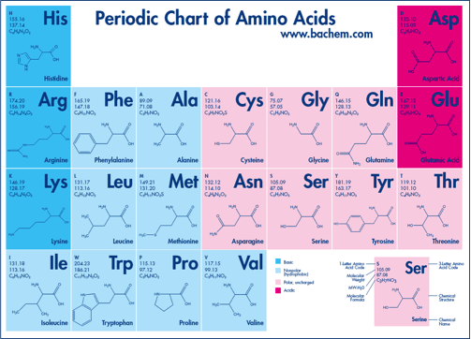

1. Hydrophobic side chains (R) primarily contain \_\_\_\_\_\_\_\_\_\_\_\_\_\_\_\_\_ atoms.
2. Hydrophilic side chains have various combinations of \_\_\_\_\_\_\_\_\_\_\_\_\_\_\_\_\_\_\_\_\_\_\_\_\_\_\_\_\_\_\_\_\_\_\_\_\_ atoms
3. Acidic side chains contain two \_\_\_\_\_\_\_\_\_\_\_\_\_\_\_\_\_ atoms. This looks like a carboxylic functional group.
4. Basic side chains contain \_\_\_\_\_\_\_\_\_\_\_\_\_\_\_\_\_\_\_\_\_\_\_\_\_ atoms. This is called the amino functional group.
5. An exception to the above is \_\_\_\_\_\_\_\_\_\_\_\_\_\_\_\_\_\_\_\_\_\_\_\_\_\_\_. What makes this side chain different?

**Learning Goals:**

1. Build a protein model following interaction guidelines
2. Explore the modeled structure(s) and relate to known protein structures

**Exercise:**

The modeling exercise here is written using a “Toober” and thumbtacks. In case a toober is not available, a pipecleaner (commonly available in craft stores) may also be used for this modeling activity. In the latter case, short pieces of pipecleaners may be used instead of the thumbtacks.

|  |  |
| --- | --- |
| Macintosh HD:Users:SDutta:Desktop:IMG_2353.jpg | Macintosh HD:Users:SDutta:Desktop:IMG_2362.jpg |
| Toober for modeling | Pipecleaner for modeling |

The toober model will require the following:

1. 1 Toober (~30 inches long)
2. 10 thumb tacks
   1. 1 Blue (representing Basic amino acids, positively charged)
   2. 1 Red (representing Acidic amino acids, negatively charged)
   3. 4 Yellow (representing Hydrophobic amino acids)
   4. 2 White (representing Hydrophilic amino acids)
   5. 2 Green (Cysteine)
3. A ruler to measure the distance between the thumbtacks
4. Modeling steps:
5. Start by placing the thumb tacks on the toober, ~3inches apart and in any order that you wish. As you push the tacks into the mini-toober they may hit the wire in the middle and not go in all the way. Reposition the tack so it goes slightly above or below the wire.

**Be careful not to push the tack through to the other side of the mini-toober where it could poke your finger. Also, be careful and do not tear the foam with the tack. 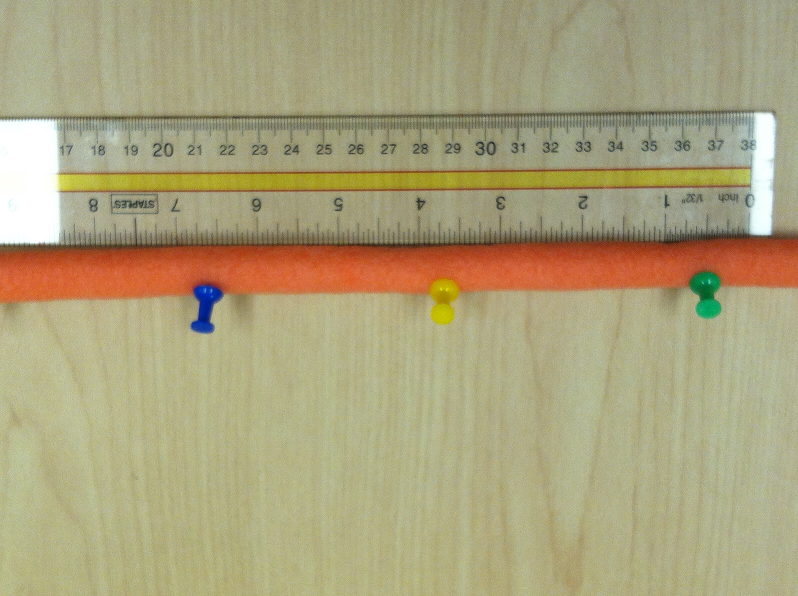**

1. Record the sequence of thumb tacks or amino acids (primary sequence) in the space below. You can use any hydrophobic, polar, acidic and basic amino acids to represent the yellow, white, red and blue thumb tacks.

\_\_\_\_\_\_\_\_\_\_\_\_\_\_\_\_\_\_\_\_\_\_\_\_\_\_\_\_\_\_\_\_\_\_\_\_\_\_\_\_\_\_\_\_\_\_\_\_\_\_\_\_\_\_\_\_\_\_\_\_\_\_\_\_\_\_\_\_\_\_\_\_\_\_\_\_\_\_\_\_\_\_\_\_\_\_\_\_\_\_\_\_\_\_\_\_\_\_\_\_\_\_\_\_\_

1. Assume that the model protein is folding in an aqueous environment. The side chain (thumb tack) interactions should conform to the following rules:

|  |  |
| --- | --- |
| a. Hydrophobic interactions (yellows should be away from water, white near water) |  |
| b. Charge based interactions (red and blue should pair up) |  |
| c. Disulphide bonds (the greens should pair up to form a bond) |  |

The built model should be stable (like a folded 3D structure of a protein)

1. What does the tertiary structure of your protein look like? Make a rough sketch of your protein model. Use colored pencils to indicate the different colors of the tacks.

1. Were you able to fold your protein so that all of the chemical properties were in effect at the same time? Explain.
2. Compare your structure with structures made by others in the class. List 2 similarities and 2 differences you see? How do you explain the differences you observed?
3. Now take your acidic amino acid (red in color) and switch it with a hydrophobic amino acid (yellow thumb tack). This models a mutation in the protein. Refold your protein again to satisfy the chemical interaction rules. Make a rough sketch of your new protein model. Use colored pencils to indicate the different colors of the tacks.
4. Compare this structure in G. with the original structure you drew in D. above. What are the similarities and differences?
5. One difference in amino acid could result in a protein folding so differently that it is not able to perform its function. Do you think that the function of your protein is preserved?

**Complete the following questions for HW:**

1. How many different proteins 10 amino acids long can you make, given an unlimited amount of all 20 amino acids that exist in nature?
2. Assuming most real proteins are actually around 300 amino acids long. How many different proteins, 300 amino acids in length, could exist?
3. **Research** – how many proteins are found in the human body?
4. Why do you think that there are fewer actual proteins than possible ones?
5. As you know, proteins are critical to your growth and well-being. In fact, life cannot exist without proteins. List some important proteins and the functions it performs in your body.

**Extension and Enrichment:**

In this section of the exercise you will fold a “real” protein using toobers.

Zinc finger proteins regulate the transcription of DNA by binding to it and signaling RNA polymerase to bind there. A zinc finger protein contains a zinc atom that is coordinated (note: this is special chemistry term – referring to metal coordination) by 4 amino acid side chains. In various zinc finger proteins the amino acids binding the Zinc is either cysteines or histidines in various combinations.

The protein Zif268 has 3 zinc finger domains. The PDB entry 1zaa shows the structure of the protein.

|  |  |
| --- | --- |
|  |  |
| Top view of Zif268 in complex with DNA | Side view of Zif 268 in complex with DNA |

The Zi268 protein has 3 zinc finger domains marked with circles. You will fold a toober model of the first of these three.

* The primary structure of the first domain is shown below:

**R P Y A C P V E S C D R R F S R S D E L T R H I R I H T G Q K**

* Consult the amino acid periodic table included earlier to identify the underlined amino acids.
* Place 4 yellow thumb tacks to map the C and H residues and a blue thumb tack for R. Map the positions of these residues on the ~30” toober. (Hint: each amino acid occupies ~1 inches on the toober). Use a ruler and pencil to measure and mark the distances. Please do not use a pen to mark the distances.
* Model the secondary structure - the first 13 amino acids will fold into a 2 stranded beta sheet. Create this by making a zigzag structure that is bent in the middle. Hydrogen bonds will keep this structure intact. The last 13-14 amino acids exist as a compact right-handed alpha helix and can be made by wrapping the toober around your index finger or a pencil.
* Fold the beta sheet and the alpha helix to form the compact tertiary fold of the protein. Consult the following figure to see if your structure was built correctly.



Single domain of zinc finger domain with the N-terminal end at the top right and C-terminus at the bottom right.

* In its final tertiary structure, the five underlined amino acids shown above will be positioned such that :
  + The two cysteines and the two histidines will be oriented to simultaneously bind to the zinc atom in the center of the structure.
  + The positively charged arginine side chain will be exposed to the top of the alpha helix where it is available to bind with the negatively charged phosphate backbone of the DNA

Reflection:

1. Both alpha helices and beta sheets are stabilized by hydrogen bonds. Which atoms share the hydrogen in these H bonds?

1. Are these backbone atoms or side chain atoms?
2. Describe the secondary structure of the zinc finger protein.
3. How is the zinc atom involved in the stabilization of the zinc finger protein?
4. Zinc fingers often bind to DNA. How might the Arginine side chain shown in your model be involved in the DNA binding. Hint: What is the property of the Arginine side chain?