# Aminoacyl-tRNA Synthetases: Protein RNA Binding

**Authors**: Brian Gadd, Los Angeles Mission College, CA, Alexandra Pettit, Carleton University, Ottawa, Ontario, Canada, and Shuchismita Dutta, Rutgers University, NJ

**Lesson Overview**:

This lesson explores the structure and function of Aminoacyl-tRNA Synthetases that recognize the specific anticodon loop in a tRNA molecule and charges it with (i.e., attaches) the amino acid that corresponds to it. The activity begins by reviewing the RCSB Molecule of the Month article on this class of enzymes and examines interactions of RNA and protein (the enzyme) in order to recognize and charge the tRNA molecule. Through the lesson students are introduced to the RCSB PDB websites and various tools and resources it offers (including the visualization software Mol*).

**ASBMB Learning Objectives** (<https://www.asbmb.org/education/core-concept-teaching-strategies/foundational-concepts/structure-function>)

2. Structure is determined by several factors

* Students should be able to **recognize the repeating units** in biological macromolecules and be able to discuss the **structural impacts of the covalent and noncovalent interactions involved** *(Introductory)*.
* Students should be able to **use various bioinformatics approaches to analyze** macromolecular primary **sequence and structure** *(Intermediate)*.

3. Structure and function are related

* Students should be able to use **mechanistic reasoning to explain how an enzyme** or ribozyme **catalyzes a particular reaction** *(Introductory)*.

4. Macromolecular interactions

* Students should be able to discuss the **interactions between a variety of biological molecules** (including proteins, nucleic acids, lipids, carbohydrates and small organics, etc.) and **describe how these interactions impact specificity or affinity** leading to changes in biological function *(Intermediate)*.
* Students should be able to **predict the effects of either mutation or ligand structural change on the affinity of binding** and design appropriate experiments to test their predictions *(Upper)*.

***Note: To complete this lesson you will need to be able to capture an image from your screen. Find a good way to print screen or capture the contents of the screen as an image that can be imported into PowerPoint or other graphics programs to add annotations and labels.***

### **Part I: Begin with the RCSB PDB Molecule of the Month**

The focus in this part is to learn about Aminoacyl tRNA Synthetase’s function and what the molecule looks like.

Read the RCSB PDB Molecule of the Month Article on Aminoacyl-tRNA Synthetases (<https://pdb101.rcsb.org/motm/16>) and answer the following questions.

1. About the Featured Molecule(s)
   1. *Function*: What biological function or process is discussed in this article?

* 1. *Molecules*: Which types of biological macromolecules are described in this article? (Hint: proteins, lipids, nucleic acids, carbohydrates)

* 1. *Role in Biology:* What is the biological role of these enzymes?

* 1. *Substrate*: Examine the following table showing the genetic code.

|  |  |
| --- | --- |

*Figure 1: Genetic Code showing the start, stop and other codons (left), and three letter abbreviations for amino acids (right).*

Are there amino acids that have codon sequences that may vary at all three positions? List the amino acid name and the possible codons.

* 1. *Specificity*: List three ways in which the aminoacyl tRNA synthetase ensures that the appropriate amino acid is attached to the tRNA molecule.

1. Explore the structure-function relationship of the molecule(s) discussed in the article and the figure in the “Exploring the Structure” section.

*Overview*:

* 1. Describe how the aminoacyl tRNA (protein) interacts with its substrate to perform its function.

*Details*: The figure shows an ATP bound to the structure (shown with an arrow).

* 1. What do you think is the function of this ATP?

### **Part II: Exploring the Aminoacyl tRNA Synthetase Structure and Function using Mol\***

The focus in this part is to learn more about

1. Specific binding of the aminoacyl tRNA synthetase enzyme to its substrate tRNA
2. Molecular mechanisms of ligating an amino acid to its specific tRNA substrate.

Go to the [RCSB PDB home page](https://www.rcsb.org/) and enter the aminoacyl tRNA synthetase PDB code 1gtr in the top search box and click on it to open the Structure summary page for this PDB structure or go to the page (<https://www.rcsb.org/structure/1gtr>). Based on the information presented here, answer the following questions.

1. Biological function: What is the specific amino acid tRNA that is made by the enzyme in this structure?

1. Using the genetic code table included above (Q 1e), what is/are the expected anticodon sequence(s) for this tRNA?

On the top left corner of the structure summary page there is an image showing the structure of the molecule.

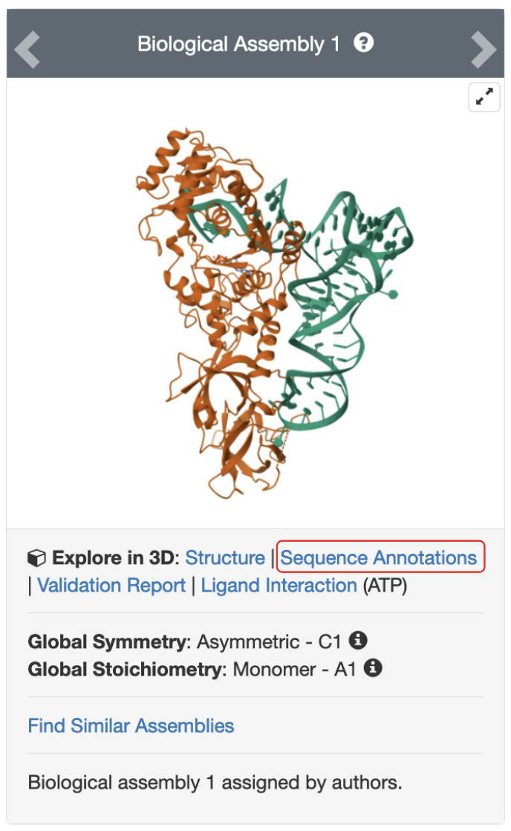

*Figure 2: Structure of glutaminyl-tRNA synthetase bound to tRNA and ATP (PDB ID 1gtr).*

Click on the hyperlink “Sequence Annotations” to launch a view of this molecule.

* In this view, one panel shows the sequence of the protein and nucleic acid chains in the structure while the other shows its 3D structure.
* The two panels are connected so that clicking on a specific amino acid in the sequence panel selects and centers the 3D structure view on the same amino acid and displays the interactions around the specific amino acid.
* The sequence panel also displays various annotations about the specific polymer being viewed (e.g., secondary structure, active site, mutagenesis etc.)
* Start with the nucleic acid sequence (chain A [Auth B])

1. Look for the anticodon sequence identified in question 2 of Part II and write down the sequence of 5 bases - one base 5’ to the anticodon, the tree anticodon residues, and one base 3’ to the anticodon.

1. In the row labeled Binding Chain B [Auth A] click on the nucleotides 33 [Auth 35]; and 72 [Auth 74]. Examine the neighboring amino acids and save images to explain - a. Where in the tRNA structure are these nucleotides located; and b. What specific interactions do these nucleotide bases participate in? Support your answer with labeled figures (one for each of the nucleotides).

Go back to the structure summary page for the PDB entry 1gtr. (<https://www.rcsb.org/structure/1gtr>). Scroll down to the small molecules section of the page. Under the 3D Interactions column, click on the Interactions button for ATP, then select Focus Chain C [auth A] to explore the interactions stabilizing the ATP in 3D.

Note: By default, only common types of non-covalent interactions are shown (e.g., 𝜋-stacking interactions, 𝜋-cation interactions, Halogen bonds, Hydrogen bonds, and Metal coordination). Additional types of interactions (e.g., Ionic interactions, Weak hydrogen bonds and Hydrophobic interactions) can be shown using the steps shown in Figure 3. Expand the global representation options (1) and Non-covalent Interactions Section (2), toggle the types of non-covalent interactions as desired, such as turn on ionic interactions (3).

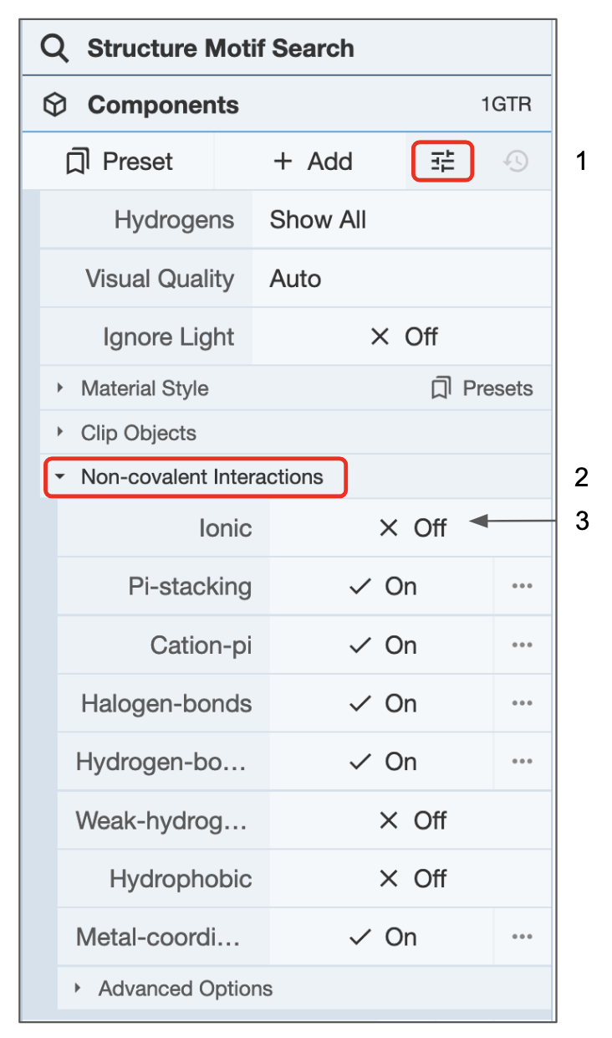

*Figure 3: Global representation options for selectively displaying or hiding non-covalent interactions in Mol\**

* Turn on the ionic and hydrophobic interactions
* Mouse over a residue of interest to see its identity listed at the bottom right corner of the 3D canvas.
* You can mouse over any interaction (represented as differently colored dashed lines) to learn about its identity at the bottom right corner of the 3D canvas.
* You can turn on the selection mode and click on a specific amino acid residue in the sequence panel to locate it in the 3D Canvas
* Use the non-covalent interactions of ATP in PDB entry 1gtr visualized above to answer the following questions.

1. Which of the following residues participate in specific interactions with the ATP molecule bound in this structure? (Select all that apply)
   1. Ionic interactions with R260
   2. Hydrogen bonds with T230
   3. Pi stacking interactions with F233
   4. Ionic interactions with K45
   5. Cation-pi interaction with His43
   6. Hydrogen bonds with N36