Protein Reagents for Testing

Learning Objectives: To explore the structures and properties of key proteins that play vital roles in the COVID-19 tests. Learning about this may help better understand the tests and its results.

Introduction
The tests for identifying both viral RNA and host immune response were well established many years ago. This exercise discusses key steps of the tests and reviews some proteins that play important roles in these processes. Understanding the structures and functions of these proteins will help students appreciate how the tests are conducted.

Tools
- The exercise will use data from the Protein Data Bank (PDB) and UniProt for the visualization and learning about specific proteins.

Exploration

RT-PCR
SARS-CoV-2 is a +ive stranded RNA virus. When it infects an individual it enters specific cells in the body and rapidly multiplies. One obvious sign of infection is presence of viral RNA in the patient sample.
- The patient sample is commonly either nasal swabs or saliva.
- RNA is extracted from these samples and converted into DNA, using a Reverse Transcriptase (RT) enzyme.

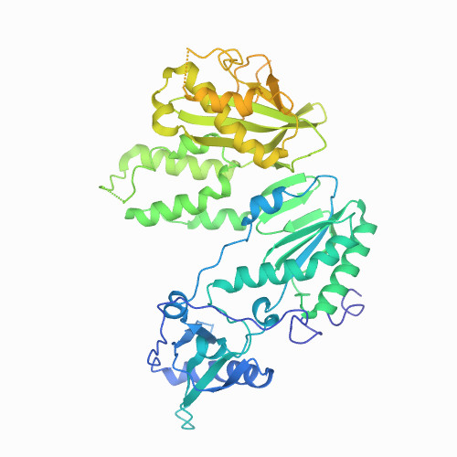 | The RT for the tests is commonly derived from Moloney murine leukemia virus or MoMLV. Structure of the MoMLV RT from PDB ID 4mh8 is shown here.  The enzyme has 2 domains, - RT and ribonuclease H.

A1. Which of the following is correct about the function of MoMLV RT
- It can make DNA based on an RNA template
- It can made DNA based on a DNA template
- It can make RNA based on a DNA template
- It can make DNA based on both RNA and DNA templates.

A2. What does the ribonuclease H domain do?
Hint: you can find out more from the abstract describing the structure (PDB ID 4mh8, https://www.rcsb.org/structure/4mh8) or from UniProt (https://www.uniprot.org/uniprot/P03355#function)

- Short primers corresponding to genes of the SARS-CoV-2 proteins are used to bind to the reverse transcribed viral DNA. Using a Polymerase Chain Reaction (PCR) the primers are extended and the viral signatures are amplified by the Taq polymerase.
- The amplified DNA signal is read off using fluorescent probes.

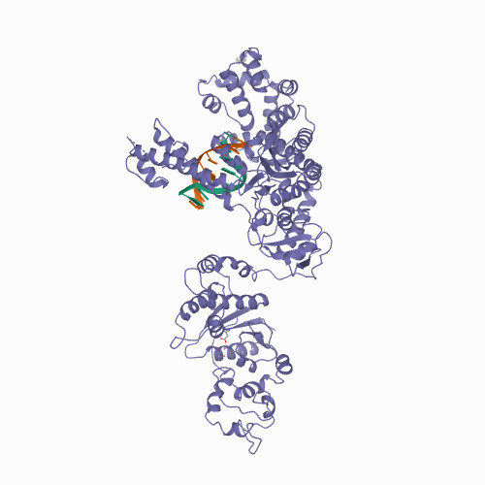 | The structure of Taq polymerase from PDB ID 1tau is shown here bound to DNA.  This enzyme also has two domains - N-terminal 5’-3’ exonuclease and C-terminal polymerase.

A3. Which of the following is correct about the function of Taq polymerase
- It can make DNA based on an RNA template
- It can made DNA based on a DNA template
- It can make RNA based on a DNA template
- It can make DNA based on both RNA and DNA templates.

A4. What does the 5’-3’ exonuclease domain do?
Hint: you can find out more from the abstract describing the structure (PDB ID 1tau, https://www.rcsb.org/structure/1tau) or from UniProt (https://www.uniprot.org/uniprot/P19821).

A5. Taq polymerase is specially suited for use in the PCR cycles. Why are other DNA polymerases such as the E.coli Klenow fragment not used?

B. ELISA
Individuals who have been exposed to or infected with SARS-CoV-2 usually mount an immune response. In the initial stages it is mostly innate immune response but over time the adaptive immune response will also occur - i.e., the individuals will make immunoglobulin M (or IgM) and then over time immunoglobulin G or (IgG).

- The assay begins with drawing blood from patients.
- Antigens from SARS-CoV-2 are fixed on to the experimental set up - e.g., plastic well/plate.
- The patient’s plasma which may have IgM, IgG, or both is allowed to bind to this antigen.

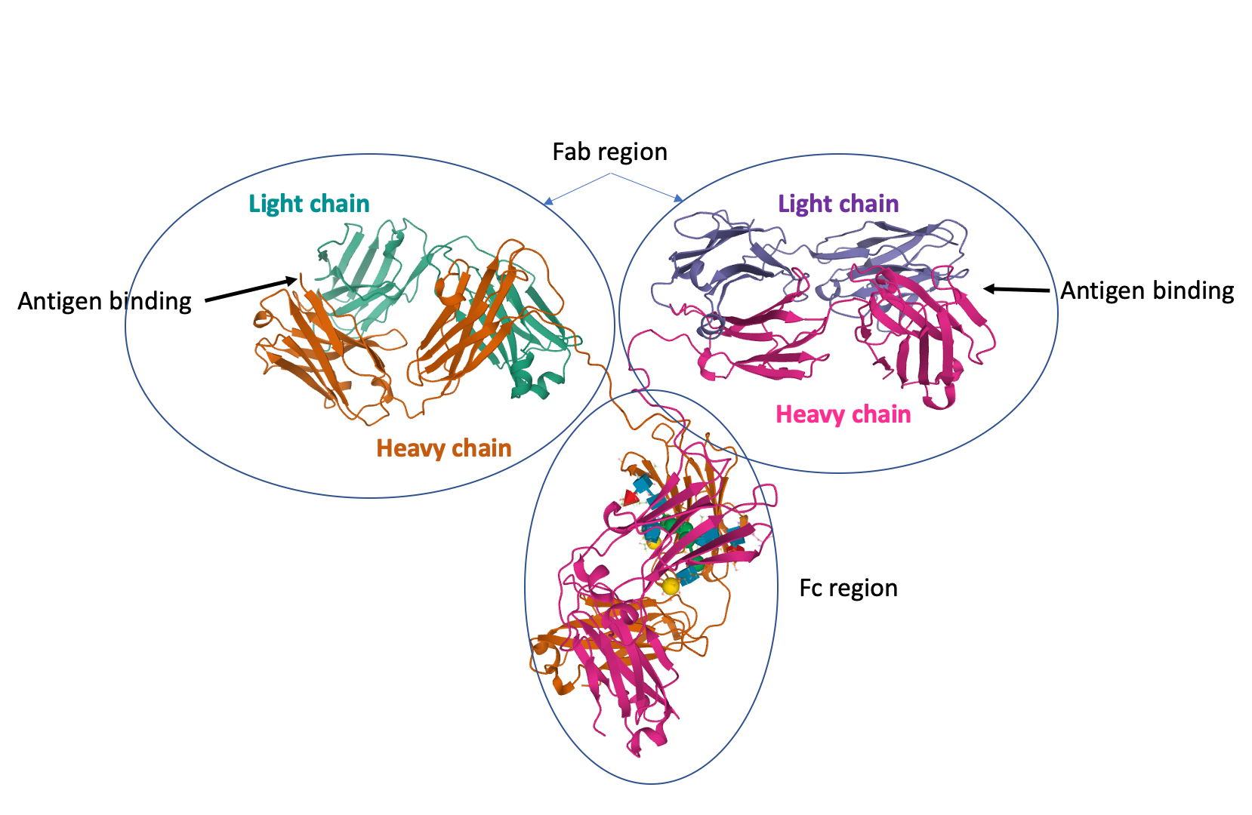 | IgGs are made of four protein chains - 2 heavy (orange and magenta) and 2 light chains (green and purple) in the figure below from PDB ID 1igt.  The antigen binding region is variable, while Fc region is considered very
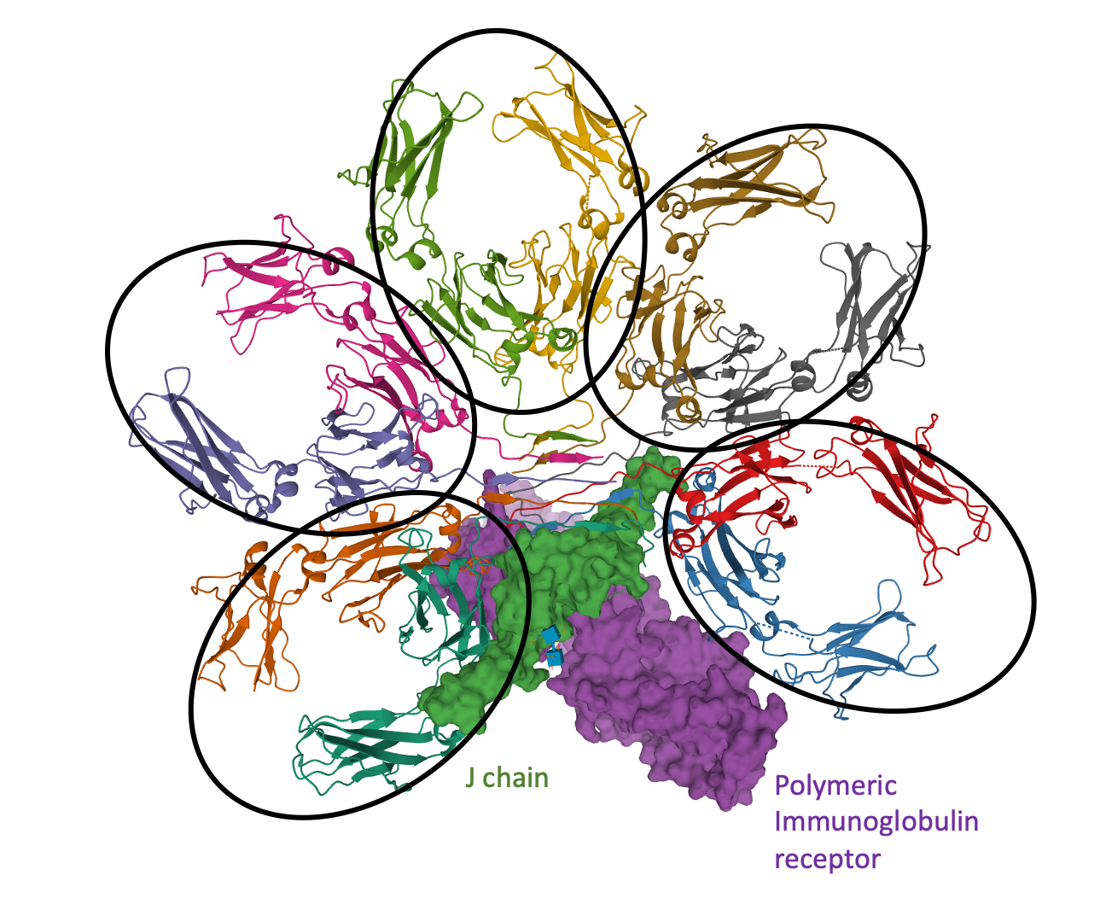 | IgMs have a more complex structure than IgG - they are pentameric, and the Y shaped structures are joined together by another protein called the J protein. The structure of IgM heavy chains from the PDB ID 6kxs is shown here.  The antigen binding sites are at the periphery. The J chain and an Ig receptor protein are shown with molecular surfaces.

- Secondary antibodies (anti-Immunoglobulin antibodies) are used to bind and recognize any antibodies in the patient plasma that bind to the Antigen.
- The secondary antibodies are bound to enzymes such as horseradish peroxidase. A positive signal is detected by this enzyme’s color reaction.

B1. What would the secondary antibodies look like? What would they recognize?

B2. How many kinds of secondary antibodies are needed for the COVID-19 ELISAs? Explain your answer.

