## **RNA Structure and Function**

**Authors**: Shuchismita Dutta, Rutgers University, NJ

**Lesson Overview**:

This lesson reviews RNA structure and function in the context of a ribozyme. Although this is a single RNA molecule it has both secondary and tertiary structure that allows it to perform its specific function.

**ASBMB Learning Objectives**

(<https://www.asbmb.org/education/core-concept-teaching-strategies/foundational-concepts/structure-function>)

2. Structure is determined by several factors

* Students should be able to **recognize the repeating units in biological macromolecules** and be able to discuss the **structural impacts of the covalent and noncovalent interactions** involved *(Introductory).*
* Students should be able to discuss the **chemical and physical relationships between composition and structure of macromolecules** *(Introductory).*
* Students should be able to compare and contrast the **primary, secondary, tertiary and quaternary structures** of proteins and nucleic acids *(Intermediate)*.

3. Structure and function are related

* Students should be able to use **mechanistic reasoning to explain how** an enzyme or **ribozyme catalyzes a particular reaction** *(Introductory).*

### **Part I: Begin with the RCSB PDB Molecule of the Month**

The focus in this part is to learn about RNA structure and function as an enzyme.

Read the RCSB PDB Molecule of the Month Article on Self-splicing RNA (<https://pdb101.rcsb.org/motm/65>) and answer the following questions.

1. About the Featured Molecule(s)
   1. *Function:* What unique function of RNAs did Thomas Cech and his coworkers discover in the 1980s?
   2. *Examples*: List two different contexts in which RNA molecules are known to catalyze the cleavage of other RNA molecules.
2. Go to the “Exploring the Structure” section of the article, analyze the structure shown in detail, and answer the following question.
3. *Mechanism of Enzyme Action*: Copy the image shown in this section and include it here with a label on it the part described as the “guide sequence”.
4. Explain in words how the guide sequence facilitates the splicing function.

### **Part II: Exploring the structure of a Hammerhead Ribozyme using Mol\***

The focus in this part is to learn about a specific type of ribozyme - the hammerhead ribozyme.

1. Composition and interactions (Primary and Secondary structure)
2. Function - Catalysis (Quaternary structure)

Go to the [RCSB PDB home page](https://www.rcsb.org/) and enter the PDB code 1mme in the top search box and click on it to open the Structure summary page for this PDB structure or go to the page (<https://www.rcsb.org/structure/1MME>).

On the top left corner of the page there is an image showing the structure of the molecule.

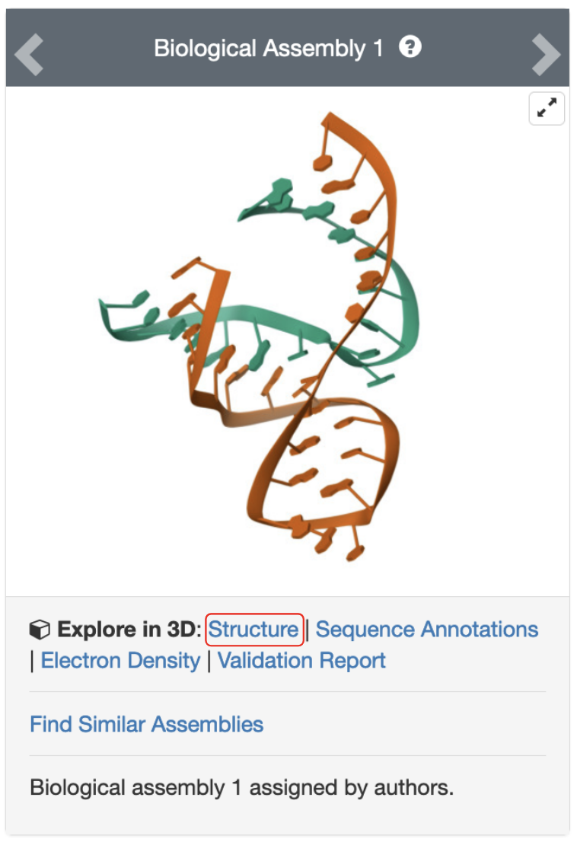

*Figure 1: Structure of a hammerhead ribozyme, PDB ID 1mme. The link to view the structure in Mol* is marked with a red-outlined box.*

Click on the hyperlinked word Structure to visualize the structure in Mol*

* 1. *Composition:* How many types of RNA polymers (strands) does this structure have?

The secondary structure for each pair of ribozyme and substrate chains is shown below:

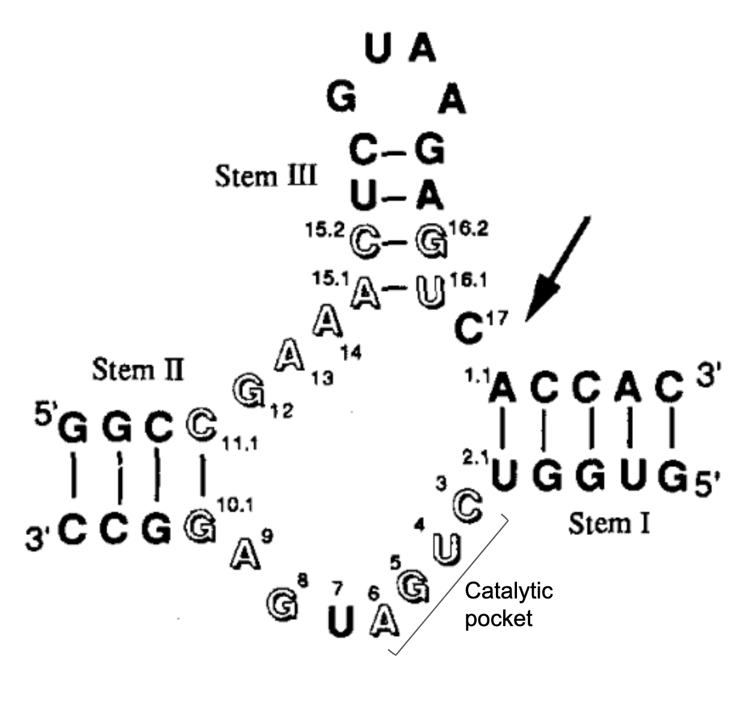

*Figure 2: SecondaryStructure of the Hammerhead Ribozyme (adapted from Scott et al., 1995, DOI: 10.1016/s0092-8674(05)80004-2)*

Examine the 3 RNA stems (I, II, and III), identify them in the 3D structure displayed in Mol* (<https://www.rcsb.org/3d-view/1MME>).

* 1. Save an image of the 3D structure showing the 3 stems, the catalytic loop, and the cleavage sites. Label these parts and save the image below.
  2. *Interactions*: click on the U in the catalytic pocket and explore the interactions of this nucleotide. Which of the following statement(s) is/are correct?
     1. The base of this nucleotide forms hydrogen bonds with C in the other RNA strand
     2. The base of this nucleotide forms a hydrogen bond with the phosphodiester backbone of the other RNA strand
     3. The base of this nucleotide forms stacking interactions with a neighboring base on the same strand
     4. The sugar hydroxyl forms a hydrogen bond with a base in the other RNA strand

### **Part III: Finding structures of other hammerhead ribozymes in the PDB**

Go back to the structure summary page for the PDB code 1mme (<https://www.rcsb.org/structure/1MME>).

Below the image in the top left corner of the page there is a hyperlink “Find Similar Assemblies”.

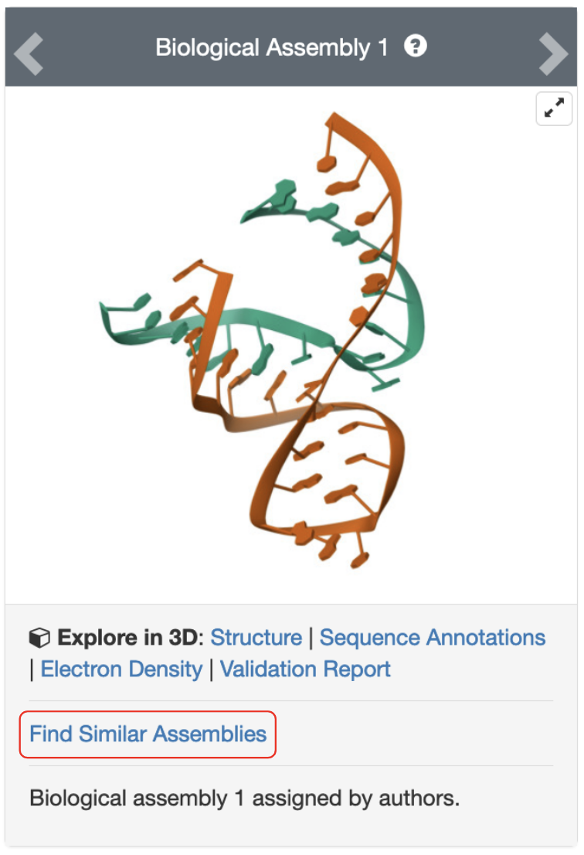

*Figure 3: Structure of a hammerhead ribozyme, PDB ID 1mme. The link to launch a search in the archive for structures with the same assembly is highlighted in a red box.*

* 1. List the PDB identifiers of any 3 assemblies from the results of this search, for which the structure match score is greater than 60. and complete the following table.

Answer:

| PDB ID | Structure title | Year of structure release | Authors |
| --- | --- | --- | --- |
| 1mme | The Crystal Structure Of An All-RNA Hammerhead Ribozyme: A Proposed Mechanism For RNA Catalytic Cleavage | 1995 | Scott, W.G., Finch, J.T., Klug, A. |
|  |  |  |  |
|  |  |  |  |
|  |  |  |  |