SARS-CoV-2 and Hand Washing

Learning Objectives: To learn about the molecular basis of how handwashing can protect from SARS-CoV-2 infection

Introduction:
Since the beginning of the COVID-19 pandemic, health experts have consistently recommended washing hands thoroughly with soap for at least 20 seconds.

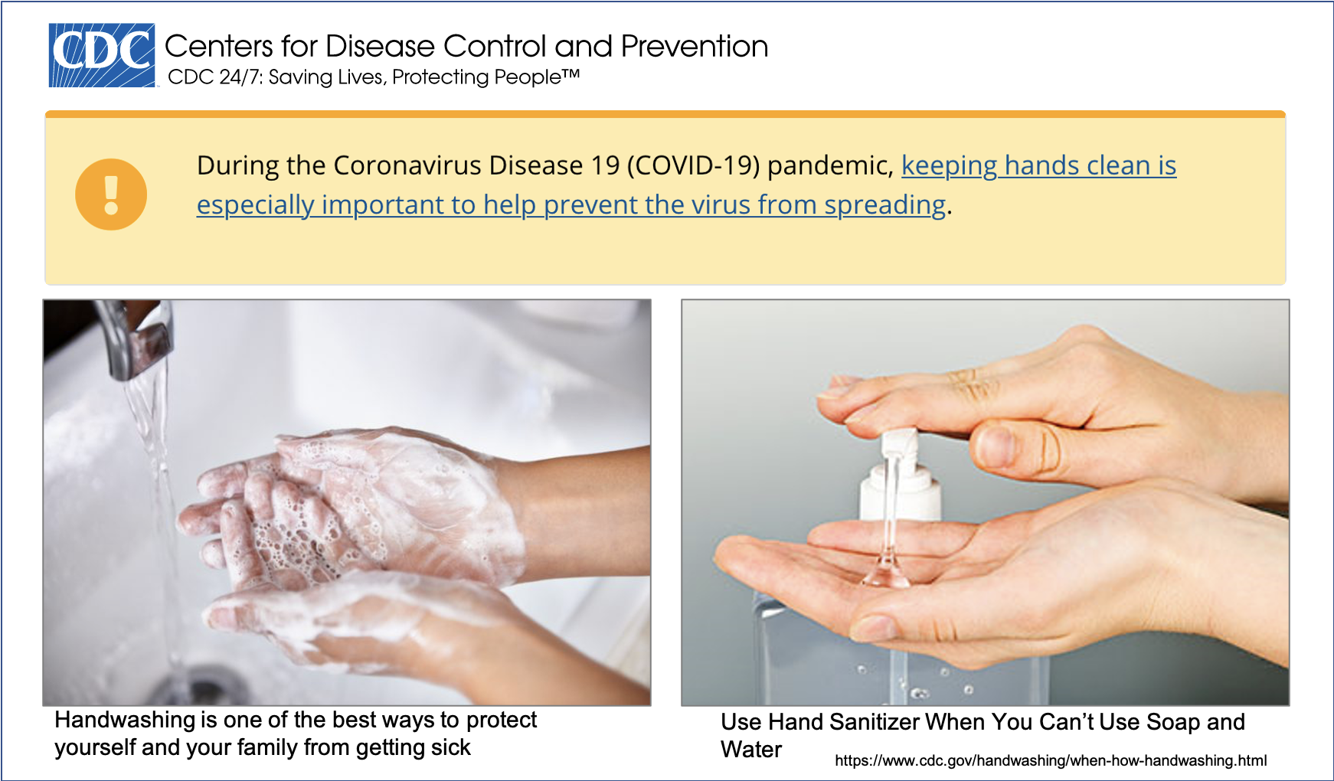

We all know that washing our hands with soap and water can get rid of dirt and grime. Here we will discuss how it can also protect us from SARS-CoV-2.

What is Soap?
Soap is a water soluble salt of fatty acids. The chemical structure of a soap molecule (Sodium octadecanoate) is shown below:
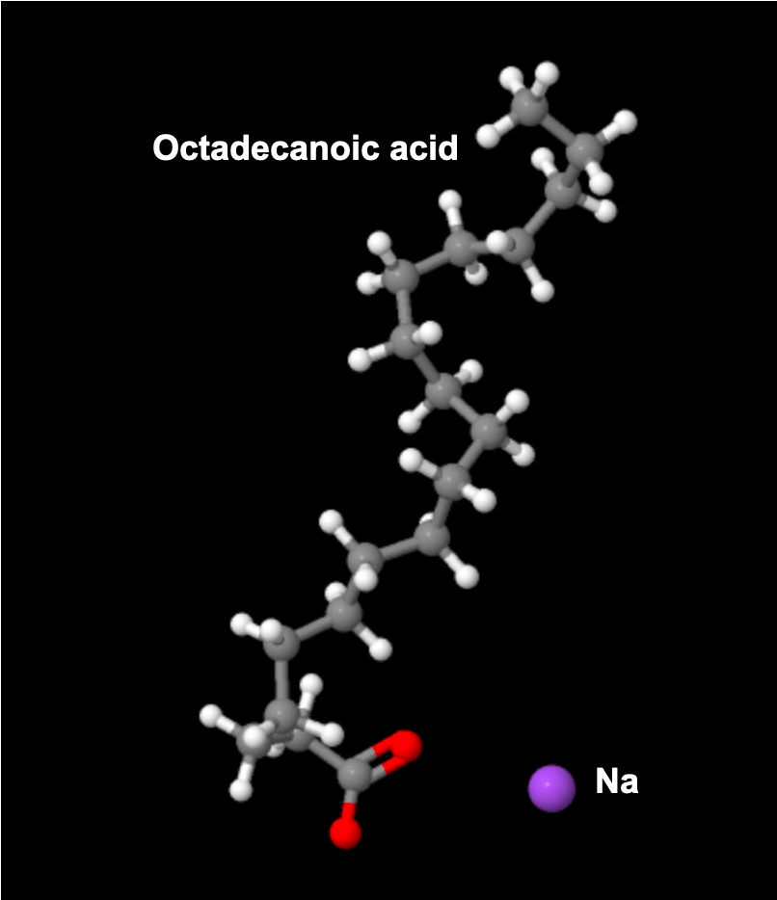
http://www.chemspider.com/Chemical-Structure.24532949.html

Note that Carbon and hydrogen atoms (shown in grey and white) do not like to mix with water, whereas oxygens (shown in red) and nitrogens (not shown here) like to interact with water molecules.

Q1. Explain the chemical nature of soap - is it hydrophilic or hydrophobic?

Q2. Why do you think washing hands with soap and water can help fight against coronavirus? (Hint: Think about the structure of soap and also of the virus particles)

- If you haven’t already done so, watch the video Fighting Coronavirus with Soap (http://pdb101.rcsb.org/learn/videos/fighting-coronavirus-with-soap)

- Discuss the following points:

Q3. Is washing your hand with water alone effective in destroying coronavirus? Explain why or why not?

Q4. What is the key ingredient of hand sanitizers? Draw the chemical structure of the ingredient and explain how it works?

Additional Resources:
- Can soap really ‘kill’ the coronavirus? https://youtu.be/K2pMVimI2bw
Source American Chemical Society Reactions videos
- How do hand sanitizers work? https://www.youtube.com/watch?v=245jz3ZqZqM#action=share
Source American Chemical Society Reactions videos
- When & How to Use Hand Sanitizer in Community Settings https://www.cdc.gov/handwashing/show-me-the-science-hand-sanitizer.html

