Name _____________________________________________________________ Date ________________

Sickle Cell Disease

Nicholas has sickle cell disease.
Watch his video (https://www.youtube.com/watch?v=iKQmQHh4E2w) to learn how he manages to live a reasonably active and normal life.

Q1. After watching the video list any two symptoms of sickle cell disease that Nicholas routinely experiences?

Ans1:

This activity focuses on exploring the literature, molecular structures and other data to develop and tell a molecular story explaining the basis of the disease and its symptoms. Use the following steps:
- Ask a question – this is the theme for the molecular storytelling
- Build model based on literature review – what will you explore in the PDB
- Investigate - Query/Browse PDB; Select PDB entries; Visualize
- Analyze - Explore interactions; Compare Structures
- Construct molecular explanations for original question
- Develop argument - relate structure to bioinformatics information (go back to the literature to see if the molecular explanation makes sense)
- Communicate - Tell a Molecular Story with Illustrations

Overview:
This activity focuses on a clinical condition, sickle cell disease, and provides an opportunity to explore and understand the molecular basis for this disease and its symptoms.

Learning Goals:
- Define a question/topic for exploration at a molecular level
- Explore the literature to find out about the topic
- Query the RCSB PDB website to find specific structure(s) for exploration.
- Explore relevant molecular structures to develop a molecular story explaining the topic.

Guided Molecular Storytelling:
- Ask a clear question - that will guide your molecular explorations:
e.g. What is the molecular basis for sickle cell anemia? Explain the main symptoms at a molecular level.

- Build a model:
Search for information about sickle cell anemia and try to identify its cause(s) and main symptom(s). Initial explorations may be conducted as follows:
- online – using your favorite search engine (Google, Bing etc.)
- in reliable public data resources – that archive information about human health and disease
- in text books – that you or your library owns; or check the NCBI bookshelf (online) at http://www.ncbi.nlm.nih.gov/books
- in review articles – you can search for these using the NCBI PubMed (online) at http://www.ncbi.nlm.nih.gov/pubmed

Q2. What is sickle cell anemia? What is its major cause and symptoms? Where did you get this information – list sources.

Ans2:

Q3. What molecules are involved in this disease? What molecule(s) would you like to explore in the PDB?

Ans3:

- Investigate:
Search for your molecule(s) of interest in the PDB using known properties – e.g. molecule name, disease name, mutation, presence of ligand etc.
Q4. List the PDB ID and Structure titles for up to 5 structures in the PDB that are relevant to answering the initial question. Sort the results and list 2 of the oldest structures, 2 newest structures, and any one other one that you find interesting.

Ans 4:

Teaching Note:
- Top bar search for “sickle hemoglobin” at rcsb.org yields 16 results (Aug 2023). This is because the query in quotes is for the phrase sickle hemoglobin vs hemoglobin sickle.
- Top bar search for “Sickle cell anemia” at rcsb.org yields 617 results (Aug 2023), many of which are unrelated to sickle cell disease. For more relevant search results names of proteins, sequences, specific sequence, structure, or chemical identifiers may yield better results than disease condition names.
- Another way to search for relevant structures would be to search by UniProt sequence - using annotations on the structures in the PDB matching a specific UniProt ID
  - Go to the structure summary page for a structure of human hemoglobin (e.g., PDB ID 1hbs)
  - In the macromolecules section of the page scroll down to the entity corresponding to the hemoglobin beta chain (shown below).
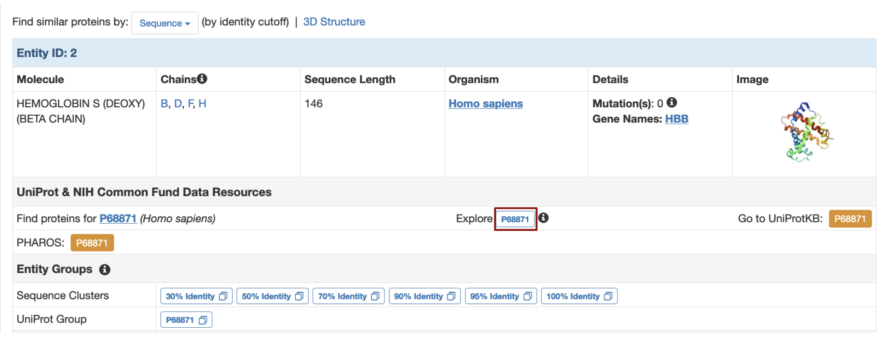
  - Click on the Explore UniProt box marked in a red outline to open the page shown below:
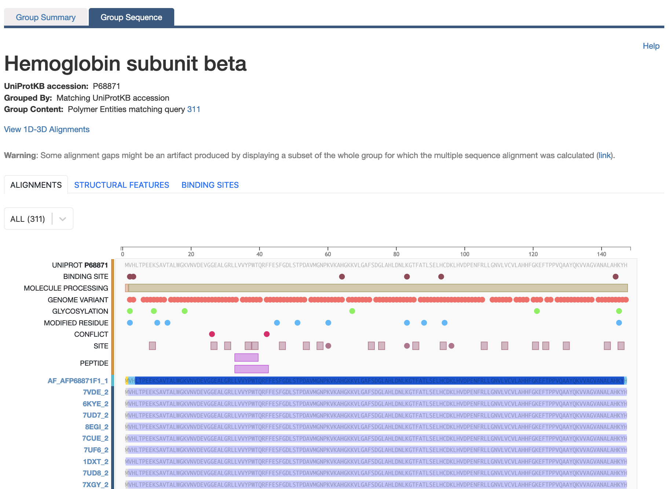
  - Zoom into the sequence on the top of the page and click on the amino acid residue 7.
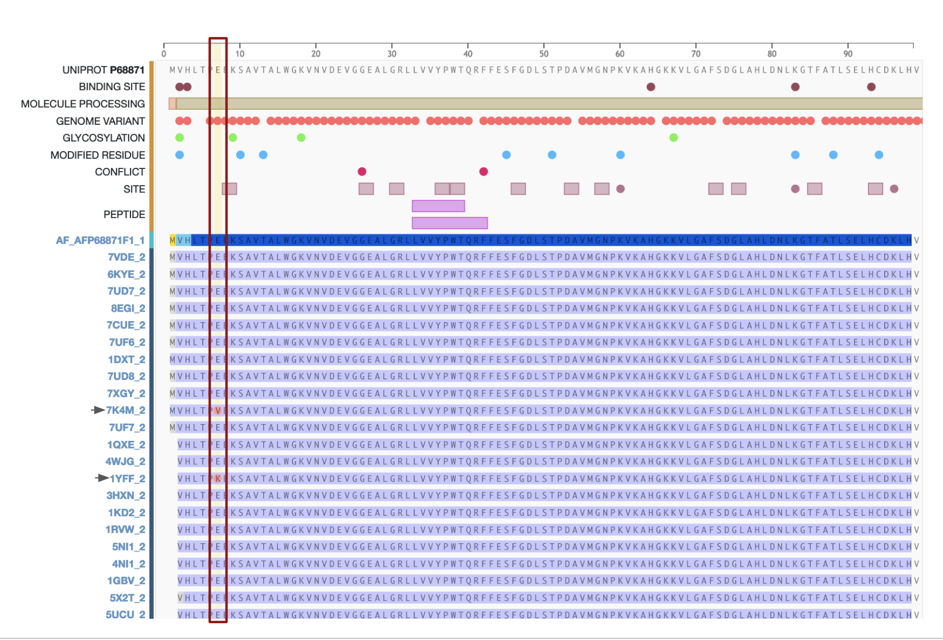
  - Note:
    - Even though the literature lists the sickle cell disease causing mutation as E6V, in the UniProt the residue of interest is numbered 7 so click on the residue 7 in the amino acid sequences and scroll down the page to identify polymer chains (with PDB IDs) that have a mutation at this position.
    - There are some structures where the mutation at this position in the sequence changes the E to V, and in some cases it is E to K.
  - The PDB structures list identified by this method are not identical to the results obtained from the top bar search query. It may be helpful to have multiple ways to query structures - by name, keywords, sequence etc. so that the structures, most relevant to your discussion, can be identified.

Q5. How did you perform the search on the RCSB PDB website? List your search options and any logic that you used to refine your search results.

Ans5:

Visualize the structure of one of the oldest PDB entries of sickle cell hemoglobin (PDB ID 2hbs) to explore the structure-function relationships.
- Open the structure summary page for the structure https://www.rcsb.org/structure/2hbs
- Click on the 3D view tab to view the structure in Mol*.
- in the left hand Controls panel under Structure, change the Type from Assembly (default) to Model (deposited coordinates).

Q6. What does/do your molecule(s) of interest look like? Save an image of the deposited coordinates (or Asymmetric Unit) and describe what you see there.

Ans 6:

- Analyze:
Sickle Cell Anemia is caused by a specific mutation. Focus on the areas in the vicinity of the mutation to explore the interactions.
(Hint: Identify chain H of PDB ID 2hbs in the sequence panel and click on the amino acid Val or V6 for this part of the exercise)

Q7. Visualize and examine the residues in the neighborhood of the mutated amino acid. List the residues involved in the molecular interactions that are unique to individuals with Sickle Cell Anemia.

Ans 7:

- Molecular explanations:
Based on the images included above and your explorations of the molecular structures – develop an explanation for the molecular basis for Sickle Cell Anemia.

Q8. What are the main differences between the molecule you are exploring in healthy individuals compared to that in individuals with Sickle Cell Anemia. Illustrate your answer with 1-2 illustrations based on your structural explorations. (Hint: you may use the PDB ID 2dn2 as an example of the native form of hemoglobin)

Ans 8:

- Argument:
Q9. What changes at the molecular level lead to “sickling” of the red blood cells? Substantiate your answer with at least one additional fact or observation about individuals with this condition.

Ans 9.

Q10. Based on your understanding of the molecular basis of sickle cell anemia – propose a treatment approach for it.

Ans 10:

Extension and Enrichment:
Q11. The hemoglobin A1C (A1C) test can be unreliable for diagnosing or monitoring diabetes and prediabetes in people with inherited hemoglobin variants, such as sickle cell disease. Describe the connections between sickle cell anemia and Diabetes monitoring and why the test results may be unreliable.

Ans 11:

