Molecular View of Vaccines: Read and Learn
There is an introductory and an advanced level article listed below. Select one based on your interest and read it carefully. If you encounter any new words, while reading the article, make a list of them and explore the web or the glossary at http://www.cdc.gov/vaccines/about/terms/glossary.htm. Answer the following questions.
Articles:
Introductory level:
Poliovirus and Rhinovirus (http://pdb101.rcsb.org/motm/20)

Advanced level:
Neutralizing antibody to human rhinovirus 14 penetrates the receptor-binding canyon
(http://www.ncbi.nlm.nih.gov/pmc/articles/PMC4167671/)

Questions:

- Write the title of the article that you read.

- What is the main idea being presented in this paper? (Describe in 3-4 sentences and provide at least one supporting detail)

- How would you apply or use your understanding of this idea (the one discussed in the article) to develop a new idea, tool or experiment?

- Select any two new words that you encountered in the article and fill in the attached Vocabulary map sheets (one word or phrase per sheet). Submit these sheets along with your answers.

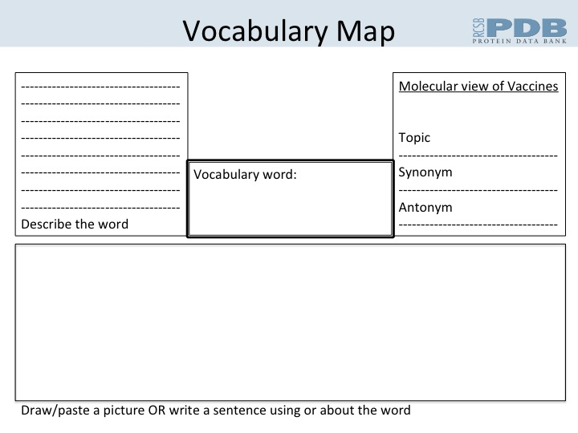
Vocabulary Check List:
Do you know the meanings of and how to use the following words?
A: Acellular vaccine, Adjuvant, Allergy, Anaphylaxis, Antigen, Antibody

B: Breakthrough infection

C: Combination vaccine, conjugate vaccine

D:

E: Epidemic, Endemic

F: Febrile

G: Guillain-Barre Syndrome

H: Hypersensitivity, Hyposensitivity

I: Immunization, Inactivated vaccine

J:

K:

L: Live vaccine

M: Memory cells,

N: Neuropathy

O: Outbreak

P: Polysaccharide vaccines

Q: Quarantine

R: Regulatory T-Cells

S: Seroconversion, Susceptible

T: Titer

U: Urticaria

V: Vaccine, Virulence, Viremia

W: Waning Immunity

X:

Y:

Z:

For additional help with vocabulary on this topic explore the glossary at http://www.cdc.gov/vaccines/about/terms/glossary.htm

