Exploring a Protein Structure in the RCSB PDB: Antibodies

Learning Goals:
- Visualize the structure of a given molecule using RCSB PDB resources.
- Explore the structure to understand its structure function relationships

Exercise:
- The molecular visualization Mol* is freely available to all users from www.rcsb.org.
- This worksheet provides instructions for visualization of a PDB entry, where you will learn to do the following:
  - Visualize the 3D structure of biomolecules using coordinates available from PDB.
  - Display the atomic coordinates in various formats.
  - Examine the structural details and interactions of specific regions of the structure.
  - Compare structures – superpose 2 (or more) structures
- To save images, click on the camera (iris) icon , Download and save a *.jpg file. Import the image in any image manipulation software of your choice (e.g., PowerPoint/ Photoshop) to add labels and additional text describing the images.
- Some key commands and functions of Mol* are included in the Appendix at the end of this document.

Immunoglobulin
Review the Molecule of the Month feature on Antibodies for background information (http://pdb101.rcsb.org/motm/21). Discuss main ideas of this feature with the students.

Note that there are a few PDB entries listed throughout the feature. For example, PDB entry 1igt can be linked from
Click on this to open the summary page for the PDB entry 1igt (http://www.rcsb.org/pdb/explore/explore.do?structureId=1igt).
- Explore the 3-D structure of this protein in Mol* by clicking on the Structure hyperlink next to the 3D View written below the structure snapshot or by clicking on the 3D View tab or as shown below
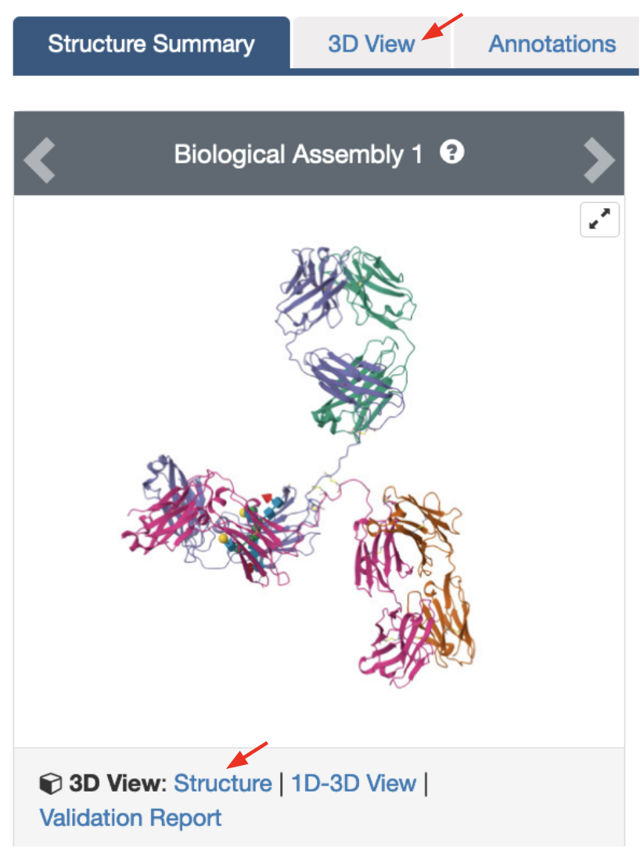

The default view is colored by chain (i.e. each protein (polymer) chain in the structure is colored in a different color).
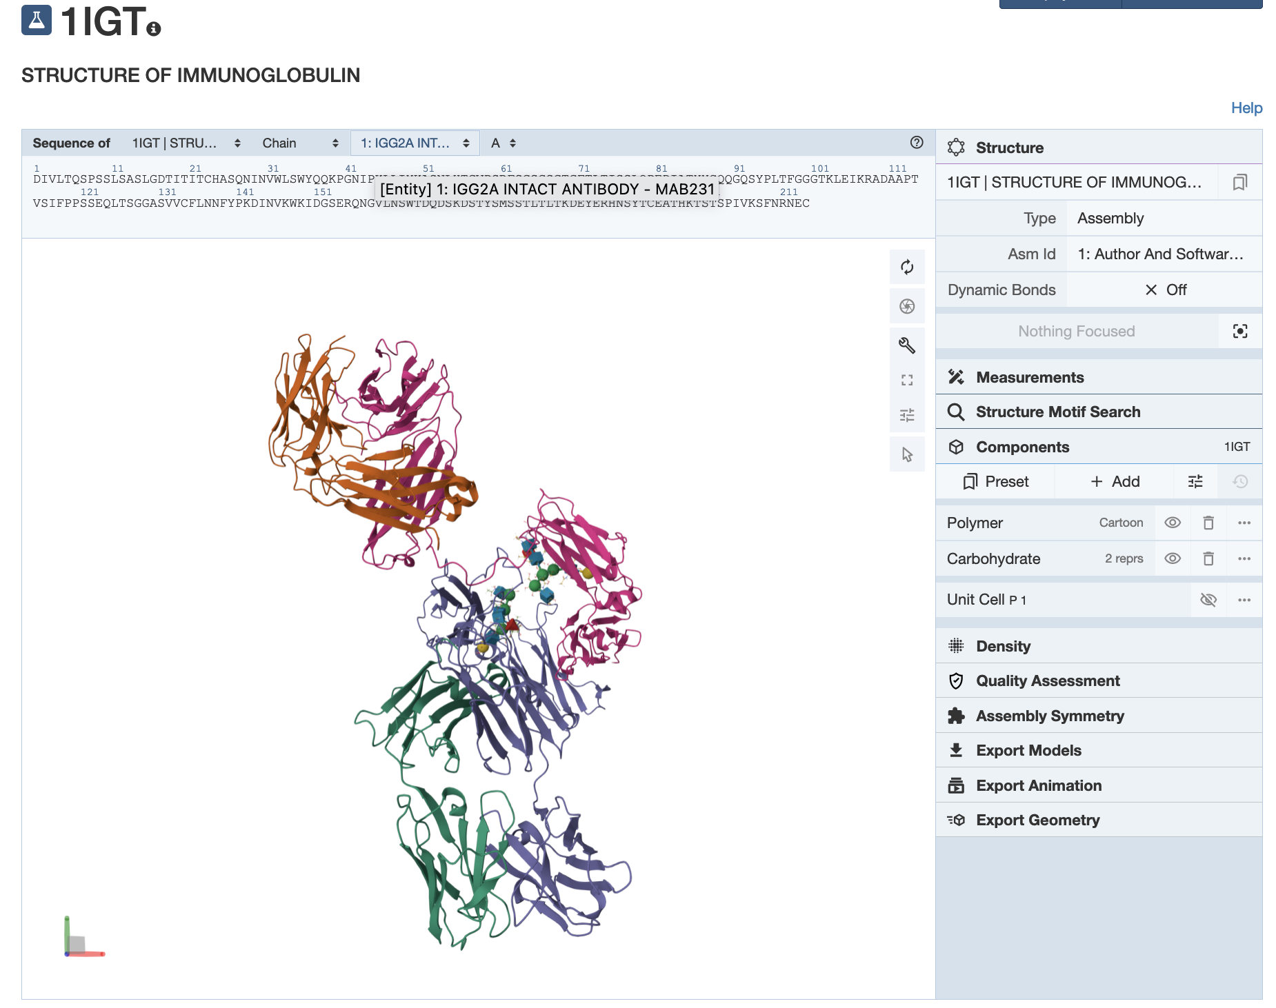
- Color the polymer chains in the structure by secondary structural elements using the following steps.
  - In the right hand Control Panel under Components click on the three dots on the right of the Polymer. From the options presented click on Set Coloring >> Residue Property >> Secondary structure. This should color the alpha helices one color and the beta strands in another color.

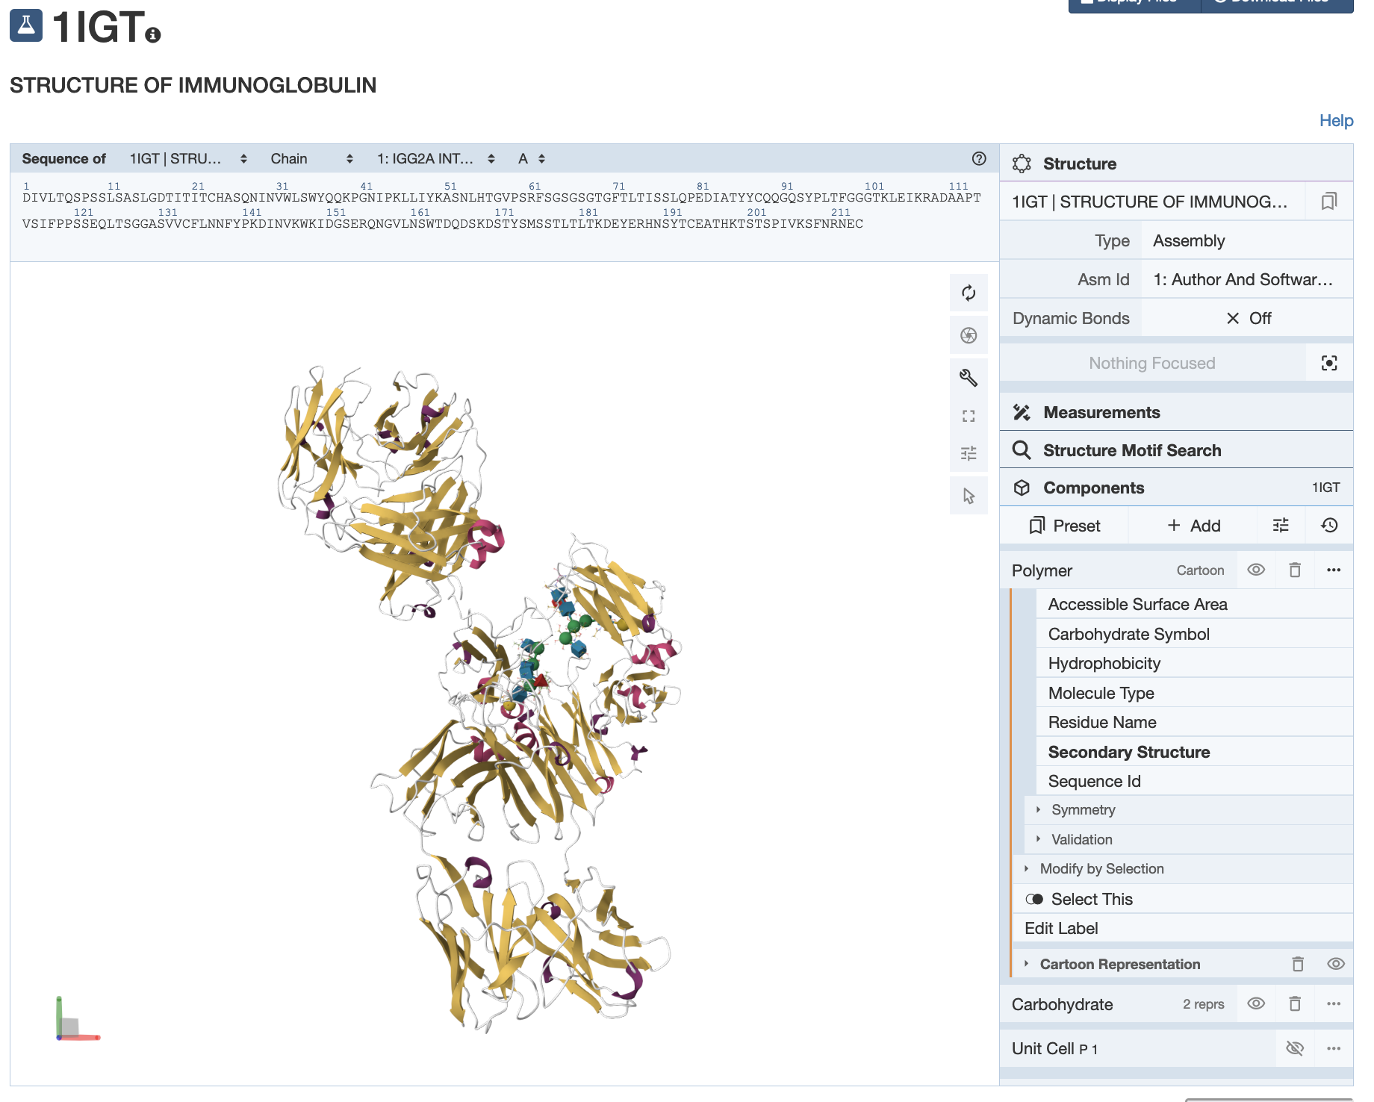

Q1. What is the predominant secondary structural element seen in the immunoglobulin structure?
Ans.

Q2. What are the cubes and spheres that you see in the structure? (Hint: Mouse over them to read their identity at the bottom right corner of the 3D canvas).
Ans:

Q3. Draw a picture of the immunoglobulin molecule and label the heavy and light chains. Save a suitable image and label it. Also label the antigen binding sites.
Ans:

- Compare this antibody structure to that in PDB entry 1igy.

Open the RCSB Pairwise Structure Alignment tool at https://www.rcsb.org/alignment and set up the structure comparison as follows:
- In the boxes fill in the PDB IDs 1igt and 1igy.
- Select chains D in the boxes provided for the comparison.
- Use the default search options to launch the comparison by clicking on the Compare button.
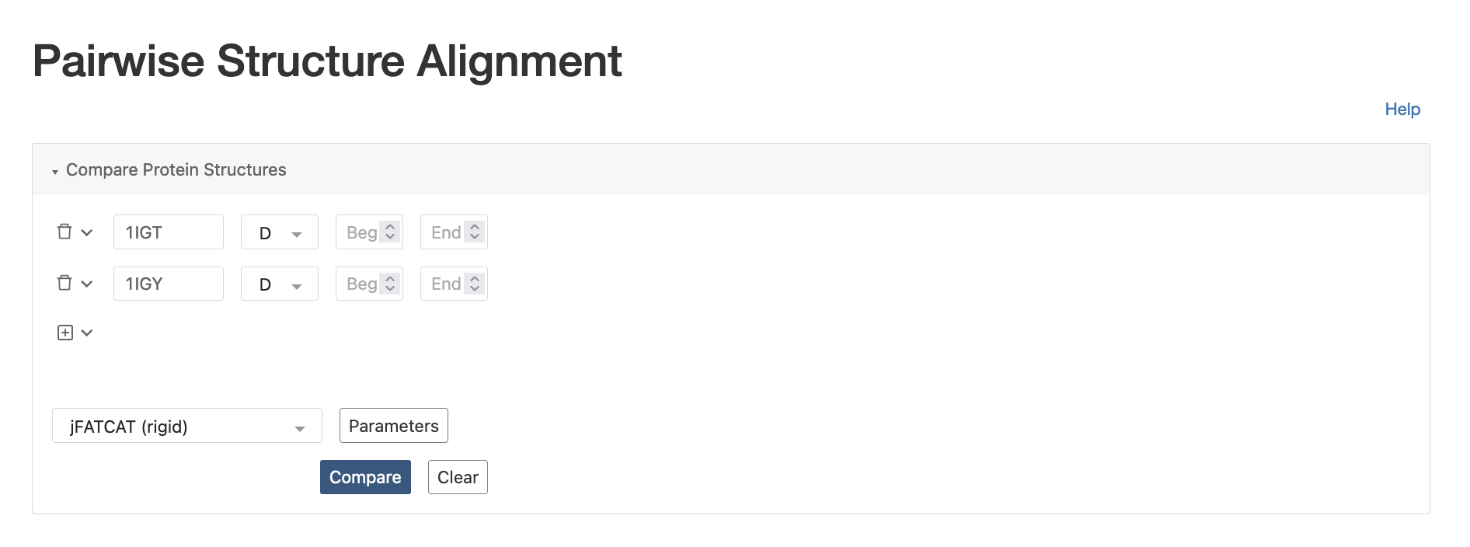
After a few moments, the alignment is complete. You should see the following.
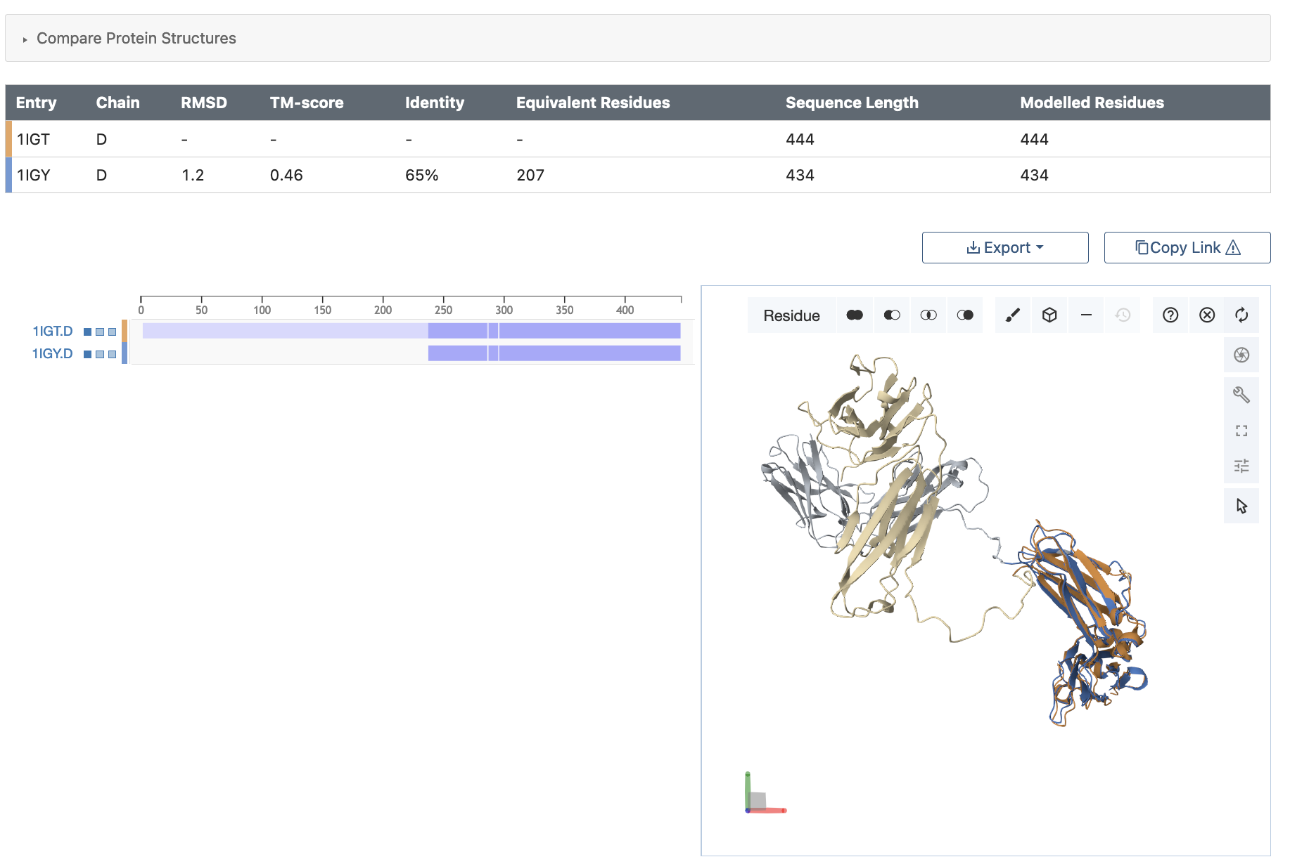
You can interactively view the aligned structure and see that part of the chain is superposed (shown in dark orange and blue), while the other part is not (shown in gray and beige).

- Click on the boxes to the left of the PDB IDs to display other polymer chains and ligands in the structure.
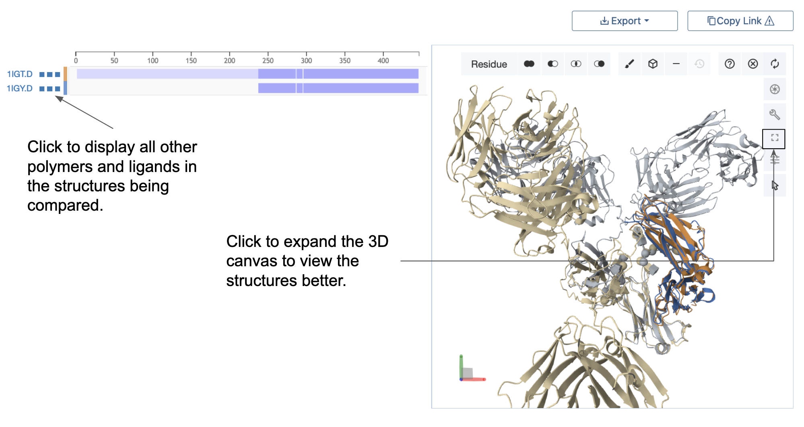
After expanding the viewport (3D canvas displaying the superposed structures) rotate the superposed molecules and save an image.

Q4. Which parts of the antibody structures match and which do not? Include a suitably labeled figure of the superposed structures here.
Ans:

Q5. What can you say about Antibody structures based on this comparison? (Hint: Are they rigid or flexible).
Ans:

Appendix: Mol* Quick Reference
1. Navigate the 3D Canvas:
a. Rotate
● Press left mouse button and move OR use Shift + left mouse button and drag.
b. Translate
● Press right mouse button and move OR use Control + the left mouse button and move. On a touchscreen device, use a two-finger drag.
c. Zoom
● Use the mouse wheel. On a touchpad, use a two-finger drag. On a touchscreen device, pinch two fingers.
d. Center and zoom
● Use right mouse button to click on the part of the structure you wish to see.
e. Change clipping planes
● Use Shift button + the mouse wheel. On a touchpad, use the Shift button + a two-finger drag.
2. Select: first open Selection Mode and change the Picking Level (if needed)
a. Select Picking Level
● Click on objects in the 3D canvas – such as atoms, residues, chains, etc.
b. Select object in 3D canvas
● Click on residues, chains etc. in the 3D canvas based on picking level
c. Select object from Sequence Panel
● Click on residues, ligands, or entire chain in the Sequence Panel
d. Custom Select combinations
● Use the Set Operations Menu in the Selection Mode toolbar
3. See or Hide:
a. To add representations
● Create a component of the region you wish to see/hide → Go to the Components Panel and press the “eye” icon next to the component you create
b. To hide/remove from view
● Select region you wish to hide → Click on the subtract/hide icon in the Selections toolbar
4. Color:
a. N-terminus to C-terminus (rainbow)
● Components → Polymer → Set Coloring → Residue Property → Sequence Id
b. Heteroatom
● Components → Polymer → Set Coloring → Atom Property → Element Symbol
c. Secondary structure
● Components → Polymer → Set Coloring → Residue Property → Secondary Structure
d. Hydrophobicity
● Components → Polymer → Set Coloring → Residue Property → Hydrophobicity
e. Domain
● Select domain → Selections Menu → Apply Theme to Selection → Color → Apply Theme
5. Compare Structures: first upload two or more structures at rcsb.org/3D-view
a. By chains
● Select 2 or more polymer chains/residues → Superposition → By Chains → Superpose
b. By atoms
● Select 1 or more atoms → Superposition → By Atoms→ Superpose
6. Make Measurements:
a. Distance
● Make 2 or more selections → Measurements → Add → Distance (for first 2 selections)
b. Angle
● Make 3 or more selections → Measurements → Add → Angle (for first 3 selections)
c. Dihedral
● Make 4 or more selections → Measurements → Add → Dihedral (for first 4 selections)

