Exploring a Protein Structure in the RCSB PDB: Antibodies

Learning Goals:
- Visualize the structure of a given molecule using RCSB PDB resources.
- Explore the structure to understand its structure function relationships

Exercise:
The molecular visualization software, UCSF Chimera, is freely available to academic users from http://www.cgl.ucsf.edu/chimera/. Instructions for downloading/installing the software and documentation for using it are also available from this site.

This worksheet provides instructions for visualization of a PDB entry, where you will learn to do the following:
- Fetch/load a PDB coordinate file
- Select specific regions of the coordinates
- Display the atomic coordinates in various formats
- Compare structures – superpose 2 (or more) structures

To save images that you make, select File… Save Image … provide a file name. While you can label atoms and residues in Chimera, it may be easier to import the saved image to a document or powerpoint where you can add labels and include additional text to describe the images.

Immunoglobulin
Review the MOM feature on Antibodies for background information.
(http://pdb101.rcsb.org/motm/21)

Launch the Chimera program and load PDB entry 1igt. Assuming your machine is connected to the internet, from the “File” menu choose File… Fetch by ID and type 1IGT in the box, make sure that the radio button next to “PDB” is selected, then click “Fetch.” You should see a ribbons view of the structure as follows:
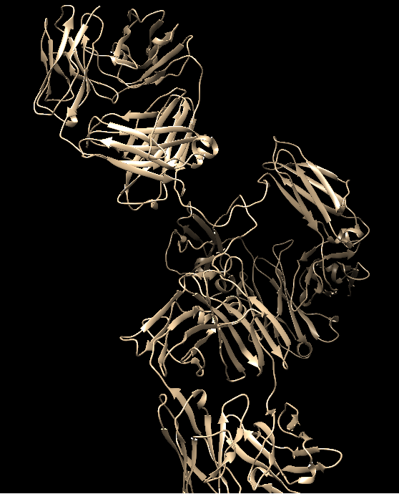
Color the ribbons as follows:
Choose Tools… Depiction… Color Secondary Structure from the menu. This should launch a new window with the color code for the helices and sheets (such as shown below):
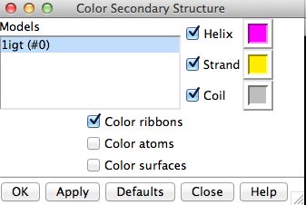
Note that the specific colors may be different in your installation. You can click on the colored box to change it to another color. When you click on Apply you should see the following in your structure display window.
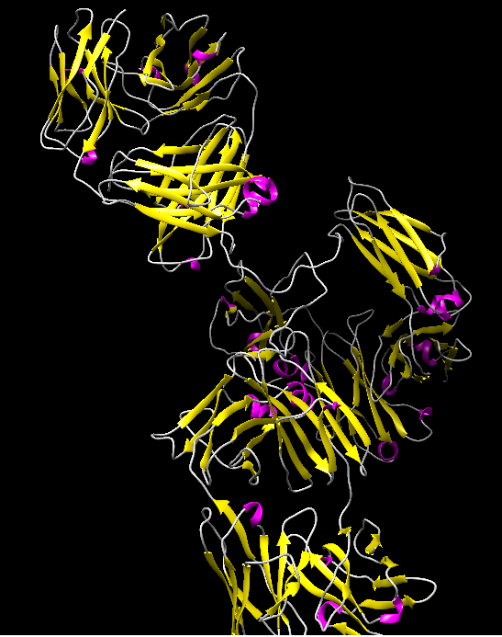
Q1. What is the predominant secondary structural element seen in the immunoglobulin structure?

Color all chains in the structure in a different color. Choose Tools… Depiction… Rainbow from the menu. This should launch a new window with various rainbow coloring options as shown here.
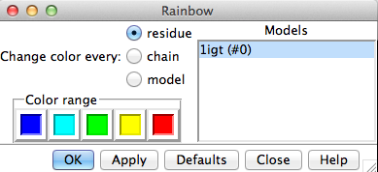
Select the Rainbow color scheme by chain. Click on the Apply button. You should see something like the following:
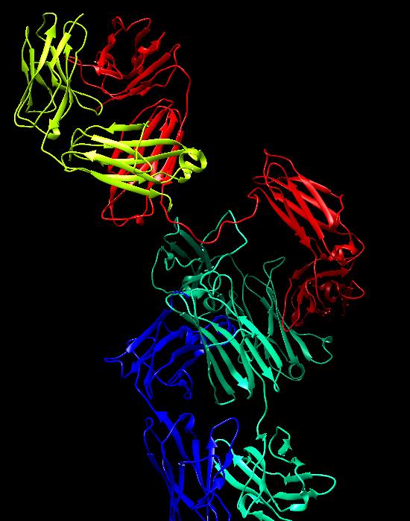
Move the molecule in the display to see the characteristic Y-shape of this molecule as shown below:
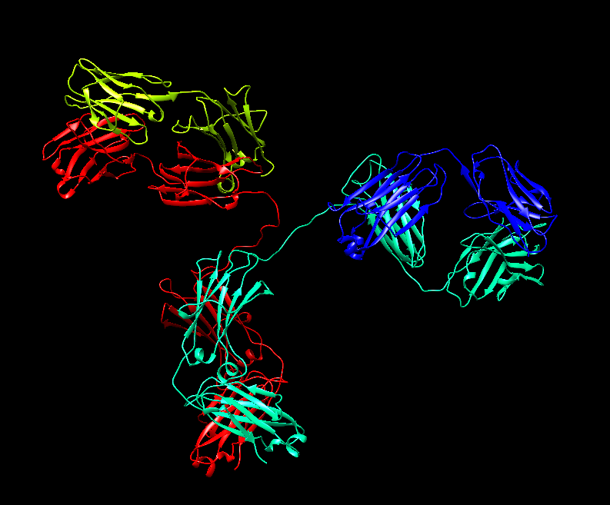

Select all the non-standard residues – using Menu Select … Residue … all non-standard. They show all the selected atoms using Menu Action … Atoms/Bonds … Show.
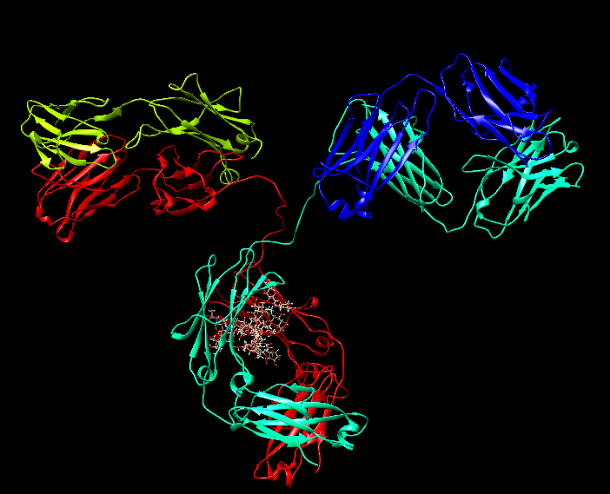

Q2. What do you think these residues are? What is their function?

Q3. Draw a picture of the immunoglobulin molecule and label the heavy and light chains. Save a suitable image and label it. Also label the antigen binding sites.

Select the Cys residues in the molecule – Menu Select … Residue … CYS. Display the side chains atoms by Menu Action … Atoms/Bonds … Show.
Q4. Where are these residues located? Can you explain the role that these residues play in the stability of the antibody structure?

Compare this antibody structure to that in PDB entry 1igy.
Upload the second antibody structure by choosing File… Fetch by ID… and type 1igy in the box
Superpose the 2 structures by clicking on Menu Tools… Structure Comparison… Matchmaker This brings up the structure alignment window: On the left side of the new window, under Reference Structure, highlight 1igt by clicking it once, then select structure 1igy in the right hand section (structure to match). Now press OK

After a few moments, the second antibody structure moves to and is aligned on the first structure. Save this image.
Q5. How well do the 2 structures match? Do they align? in which parts?

Q6. What can you say about Antibody structures based on this comparison? (Hint: Are they rigid or flexible).

To learn more about manipulating, selecting and analyzing the structures loaded in Chimera explore the UCSF Chimera documentation at http://www.cgl.ucsf.edu/chimera/docindex.html.

