Exploring a Protein Structure from the PDB: HIV-1 Protease

Learning Goals:
- Visualize the structure of a given molecule using RCSB PDB resources.
- Explore the structure to understand its structure function relationships

Exercise:
The molecular visualization software, UCSF Chimera, is freely available to academic users from http://www.cgl.ucsf.edu/chimera/. Instructions for downloading/installing the software and documentation for using it are also available from this site.

To save images that you make, select File… Save Image … provide a file name. While you can label atoms and residues in Chimera, it may be easier to import the saved image to a document or powerpoint where you can add labels and include additional text to describe the images.

A. HIV-1 Protease
Review the MOM feature on HIV-1 Protease for background information (http://pdb101.rcsb.org/motm/6)

Launch the Chimera program and load PDB entry 7hvp. Assuming your machine is connected to the internet, from the “File” menu choose File… Fetch by ID and type 7HVP in the box, make sure that the radio button next to “PDB” is selected, then click “Fetch.” You should see a ribbons view of the structure as follows:
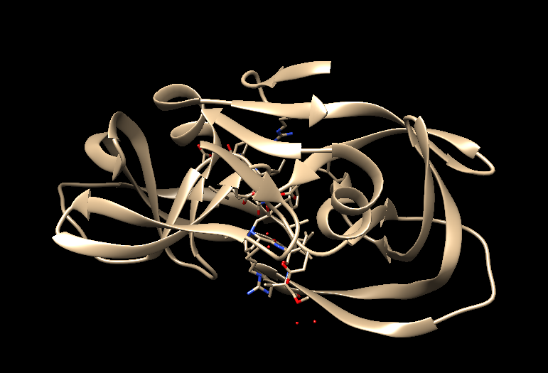
Color the ribbons as follows:
Choose Tools… Depiction… Color Secondary Structure from the menu. This should launch a new window with the color code for the helices and sheets (such as shown below):
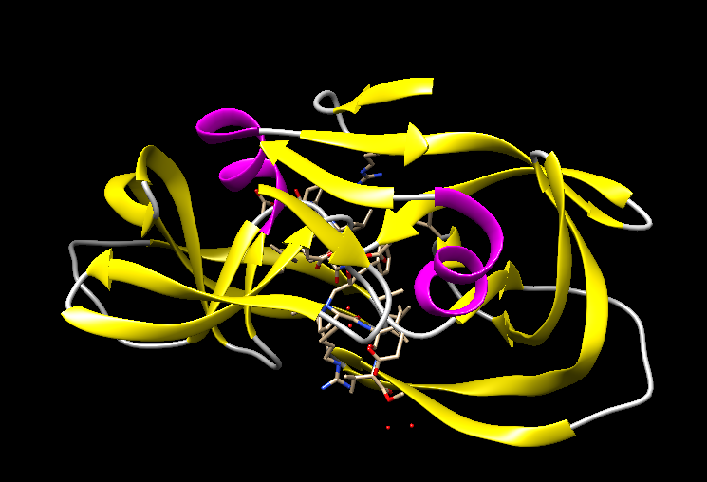

Color all chains in the structure in a different color (Preset … Interactive1).
Q1. How many polymer chains are there? What are they?
(Hint: Go to the RCSB PDB website at www.rcsb.org and type in the PDB ID 7hvp in the top search box. Once the structure summary page for this structure opens, read the descriptions/names of the proteins in the molecular descriptions section.)

Q2. Describe how the polymer chains are organized in the structure? Based on this description describe the function of HIV-1 Protease.

Select chain C by clicking on the Select menu… Chain… C. Notice that part of the structure in the display window lights up with a green halo. Color the atoms in chain C in yellow Click on Menu Action… Color… Yellow.
To find the atoms/residues neighboring the chain C: Click on the Menu Select… Zone… This should open a new window, select the window options as follows:

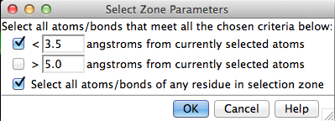

Click on OK to select all residues with atoms within 3.5 angstroms of the peptide. Display the sidechains of these residues and color the atoms by element. Click on Menu Action … Atoms/Bonds… Show. Then click Menu Actions … Color … all options …
This should open a new menu box with various options for coloring. Select the atoms/bonds radio button and then by element button. This should color the selected atoms by CPK coloring (blue for N, red for O, white for H etc. initially proposed by Robert Corey and Linus Pauling, and improved by Walter Koltun.)).

Explore the residues, whose side chains are shown as sticks in CPK coloring. Using your knowledge about the types of amino acid side chains, visually inspect the amino acid side chains shown here and identify which ones are hydrophobic, polar, charged etc.

To find H-bonds involving a given set of residues: Click on Menu Tools… Structure Analysis… FindHBonds. A new window should open, select options so that it looks as follows:
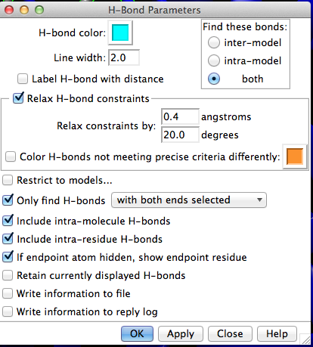

Q3. A. Based on your explorations of the above selected amino acids and hydrogen bonds, list at least 5 amino acids that are within hydrogen bonding distance of the atoms of chain C.

Q3.B. What type of amino acids are these. (Hint: think about the properties of the side chains of these residues).

Appendix: Key commands and functions of UCSF Chimera

- What is in the PDB file that I am looking at?
- Upload/fetch file >> Presets >> Interactive 1 >>
- Figure out number and kind of chain (protein/DNA/RNA/saccharide) >>
  - Type PDB ID in top search box at www.rcsb.org >> Open structure summary page >>
  - Read about contents by chain ID AND
  - Mouse over chains to identify chain ID >>

- To Select: See selection (atom, residue, chain etc.) highlighted with a green halo
  - An atom(*)
- Left click on atom in graphics display with Control button pressed
  - A specific residue
- Left click on any atom of residue (see above*) >> press up arrow OR
- Favorites >> Sequence >> see new window with sequence >>
- Mouse over amino acid sequence to see chain ID and residue number >>
- Click-drag on one or more specific amino acid residues in sequence window
  - All residues of a type(#)
    - Select >> Residue >> Standard (or Non-standard) >> select a specific one (or all) OR
    - Select >> Residue >> Amino acid category
  - A chain
    - Left click on any atom of residue (see above*) >> press up arrow twice OR
    - Select >> Chain >> select Chain ID (A or B or C etc.)
  - A specific type of residues within a selected group or chain($)
- Select group/chain (see above) >> Select >> Selection Mode >> Intersect >>
- Select specific type of residue (see above #) >>
- Reset selection mode >> (Select >> Selection Mode >> Replace)
  - A zone (%)
- Select a residue or chain (as above) around which to explore >> Select >> Zone >>
- New window opens >> input the distance within which all residue should be selected >>
- Input/select options to select zone (atoms/residues within specified distance)

- To See or Hide:
- Select residue(s)/chain(s) >> Actions >> Atoms/Bonds or Ribbons or Surface >> Show or Hide

- To explore interactions within or between polymer chains:
  - Find H-bonds
- To find all H-Bonds in structure: Tools >> Structure Analysis >> FindHBond >> OK
- To find ones in a selected set of residues: Tools >> Structure Analysis >> FindHbond >>
- Check on “Only find H-bonds” options (with at least one end or both ends selected) >> OK
  - Find hydrophobic interactions
- Select >> Residues either in entire structure or within a selected set (see above $ or %) >>
- Amino acid category >> hydrophobic >> Action >> Atoms/Bonds >> Show >>
- Examine residues >> Mouse over atoms or Left click on them to identify them
  - Find charge-based interactions
- Select >> Residue >> Amino Acid category >> Negative >> Actions >> Atoms/Bonds >> Show >>
- Actions >> Color >> select color 1
- Select >> Residue >> Amino Acid category >> Positive >> Actions >> Atoms/Bonds >> Show >>
- Actions >> Color >> select color 2
- Locate pairs of amino acid side chains with color 1 and color 2 within proximity of each other
  - Find pi-pi interactions
- Select >> Residue >> Amino Acid category >> Aromatic >> Actions >> Atoms/Bonds >> Show >>
- Examine location and orientation of aromatic rings >> Identify sandwiched, edge-to-face, displaced interactions

- To compare structures:
- Upload/Fetch PDB entry of interest >> Orient/understand all components (polymer chains, ligands) >>
- For complex structure, click on Presets >> Interactive 1 >> this colors the chains in the polymer >>
- Upload/Fetch one or more PDB entries to be compared >> Tools >> Structure comparison >>
- Matchmaker >> New window opens >> Click to select pairs of PDB IDs - Reference structure (in one column) and Structure(s) to match (in the other) >> OK >> Review the graphics window to see match

- To measure distances:
- Select two atoms – press Shift + Control + Left click on the atoms in the graphics window >>
- Tools >> Structure Analysis >> Distances >> Create - Distance reported in graphics and new window

- To label structures:
- Tools >> Utilities >> 2D Labels >> New Window opens >> Write text and select font, color etc. options >>
- Show or hide label and move to suitable location OR
- Actions >> Label >> select general or Residue options >>
- Edit label color options from Actions >> Color >> All Options >> select Label options in new window

