Insulin Resistance: Exploring the Structure and Functions of AKT

Learning Goals:
- Visualize the structure of a given molecule using RCSB PDB resources.
- Explore the structure to understand its structure function relationships

Exercise:
The molecular visualization software, UCSF Chimera, is freely available to academic users from http://www.cgl.ucsf.edu/chimera/. Instructions for downloading/installing the software and documentation for using it are also available from this site.

This worksheet provides instructions for visualization of a PDB entry, where you will learn to do the following:
- Fetch/load a PDB coordinate file
- Select specific regions of the coordinates
- Display the atomic coordinates in various formats
- Compare the structures of different PDB entries to visualize structure-function relationships
To save images that you make, select File… Save Image …, provide a file name. While you can label atoms and residues in Chimera, it may be easier to import the saved image to a document or power point where you can add labels and include additional text to describe the images.
Background review:
Review the learning materials (slides) on Cell Signaling and answer the following questions.

Q1. List three key responses that may be observed when insulin binds to its receptor(s)

Q2. List any 3 participants (proteins and/or small molecules) that play a role in the insulin signaling pathway.

Q3. Name two different proteins/complexes that can activate the protein AKT2. What is the activation step (e.g. influx of ions, phosphorylations etc.)?

Q4. List three possible fates that a single nucleotide change can have on protein structure.

Scientific Report:
A 2004 report published in Science described a family with autosomal dominant inheritance of severe insulin resistance and diabetes mellitus caused by a mutation in the gene encoding the protein kinase AKT2. This protein plays a key role in the signaling pathway activated by insulin binding to the insulin receptor. Sequencing of genomic DNA from the proband (a patient who is the initial member of a family to come under study) revealed a single G to A substitution (shown in the figure 1.A below), that changes Arginine-274 to Histidine (R274H) in the AKT2 protein. The Arg-274 residue is located in the kinase domain of the AKT2 protein and is highly conserved in all species (Figure 1.B).

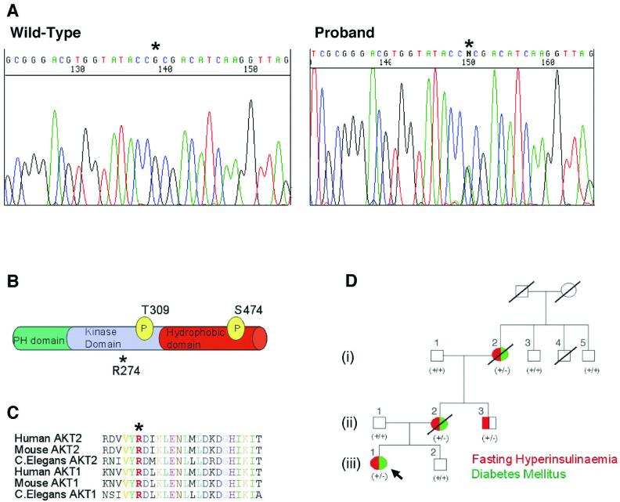
Figure 1: Taken from Science 304: 1325–1328, http://www.ncbi.nlm.nih.gov/pmc/articles/PMC2258004/.

Question 1 (Introductory): What is the structural and functional role of the invariant Arg 274? (Hint: examine the structure of the AKT2 protein in the PDB entry 1o6k.)
Question 2 (Intermediate): Why would the Arg 274 to His (R274H) mutation lead to insulin resistance? (Hint: compare the structures of the activated (PDB ID: 1o6k) and inactive (PDB ID: 1mrv) Akt-2 to develop a model.)
Question 3 (Advanced): Can you propose a strategy to make the AKT2 protein constitutively active? (Hint: Look at how the residue 474 is mutated in the structure 1o6k. Also look at the mutagenesis section of the UniProt page http://www.uniprot.org/uniprot/P31751)

Exercise Guide:

In order to answer the questions you will need to visualize the structures of the activated and inactive AKT2 molecules and figure out the structural and functional roles of R274. This will shed light on the possible consequences of the mutation R274H.

- Upload the coordinates of activated AKT2 in the UCSF Chimera software and click on Presets … Interactive 1 to color each polymer chain in the entry in a different color. What do you see? Can you figure out what molecules (proteins and small molecules) are being displayed?

- Locate the residue Arg 274, visualize it and explain its structural and functional role in this protein structure.

- List one direct consequence of changing the amino acid residue from Arg 274 to His.

- Upload the coordinates of the inactive Akt2 protein (PDB ID: 1mrv) and superimpose it on the active complex structure. How well do the structures align? Which parts of the protein are similar and which parts are different in the active and inactive proteins.

Based on your explorations complete answering the following questions for HW:

Question 1 (Introductory): What is the structural and functional role of the invariant Arg 274? (Hint: examine the structure of the AKT2 protein in the PDB entry 1o6k.)

Question 2 (Intermediate): Why would the Arg 274 to His (R274H) mutation lead to insulin resistance? (Hint: compare the structures of the activated (PDB ID: 1o6k) and inactive (PDB ID: 1mrv) Akt-2 to develop a model.)

Extension and Enrichment:
Question 3 (Advanced): Can you propose a strategy to make the AKT2 protein constitutively active? (Hint: Look at how the residue 474 is mutated in the structure 1o6k. Also look at the mutagenesis section of the UniProt page http://www.uniprot.org/uniprot/P31751)

