Exploring a Protein Structure in the RCSB PDB: Insulin

Learning Goals:
- Visualize the structure of a given molecule using RCSB PDB resources.
- Explore the structure to understand its structure function relationships

Exercise:
The molecular visualization software, UCSF Chimera, is freely available to academic users from http://www.cgl.ucsf.edu/chimera/. Instructions for downloading/installing the software and documentation for using it are also available from this site.

This worksheet provides instructions for visualization of a PDB entry, where you will learn to do the following:
- Fetch/load a PDB coordinate file
- Select specific regions of the coordinates
- Display the atomic coordinates in various formats

To save images that you make, select File… Save Image …, provide a file name. While you can label atoms and residues in Chimera, it may be easier to import the saved image to a document or power point where you can add labels and include additional text to describe the images.

Insulin
Review the Molecule of the Month feature on Insulin for background information.
(http://pdb101.rcsb.org/motm/14)

Launch the Chimera program and load PDB entry 4ins. Assuming your machine is connected to the internet, choose from the “File” menu File… Fetch by ID, type 4INS in the box, (make sure that the radio button next to “PDB” is selected), and then click “Fetch.” You should see a ribbons view of the structure as follows:
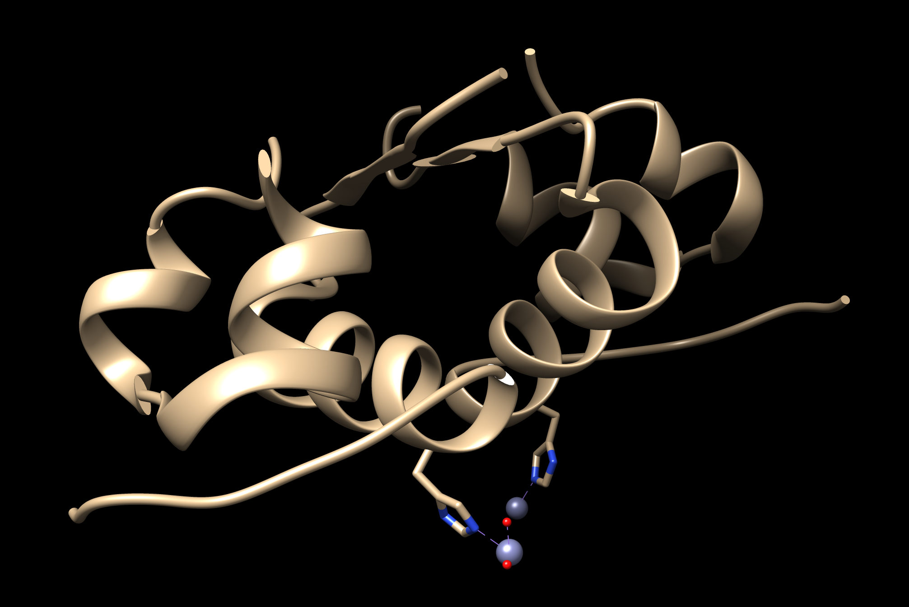
Color the ribbons as follows:
Choose Tools… Depiction… Color Secondary Structure from the menu. This should launch a new window with the helix and sheet color code (shown below):
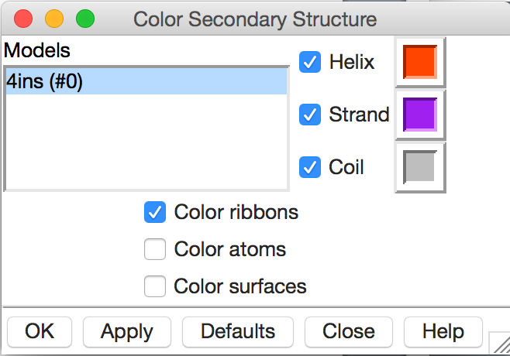
Note that the specific colors may be different in your installation, you can click on the colored box to change it to another color. When you click on Apply you should see the following in your structure display window.
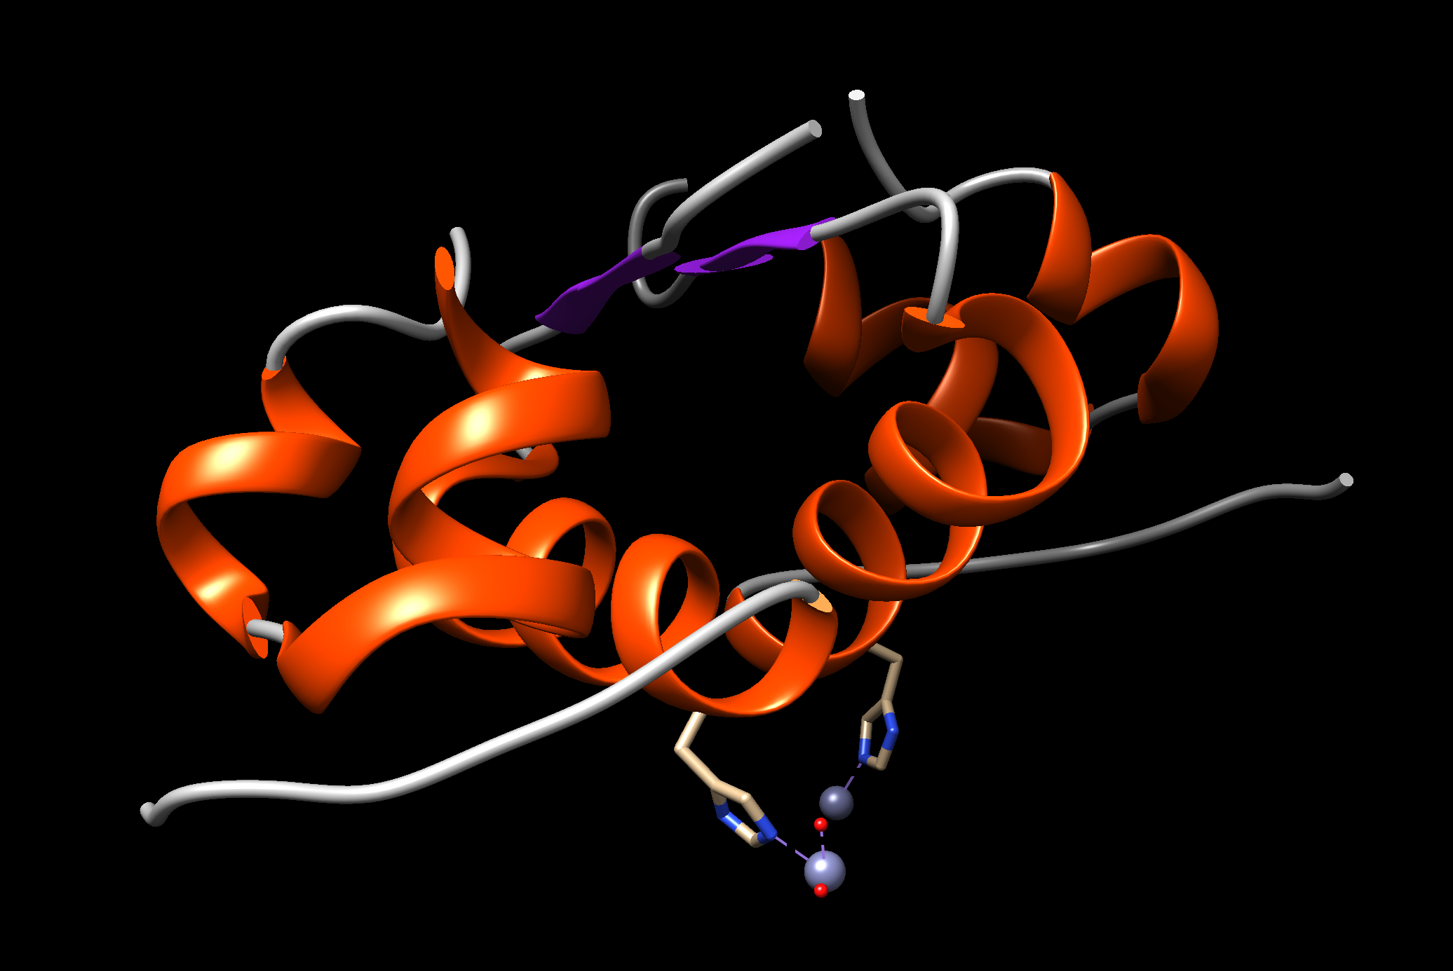
Q1. What is the predominant secondary structural element seen in the insulin structure?

Color all chains in the structure in a different color. Choose Tools… Depiction… Rainbow from the menu. This should launch a new window with various rainbow coloring options as shown here.
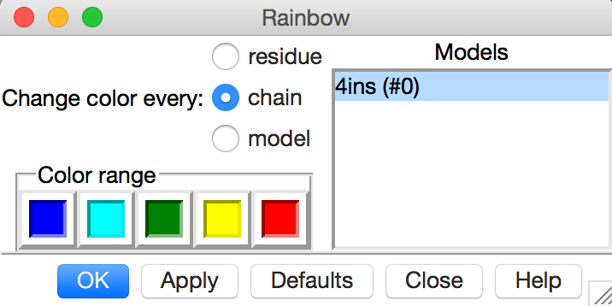
Select the Rainbow color scheme by chain. Click on the Apply button. You should see something like the following:
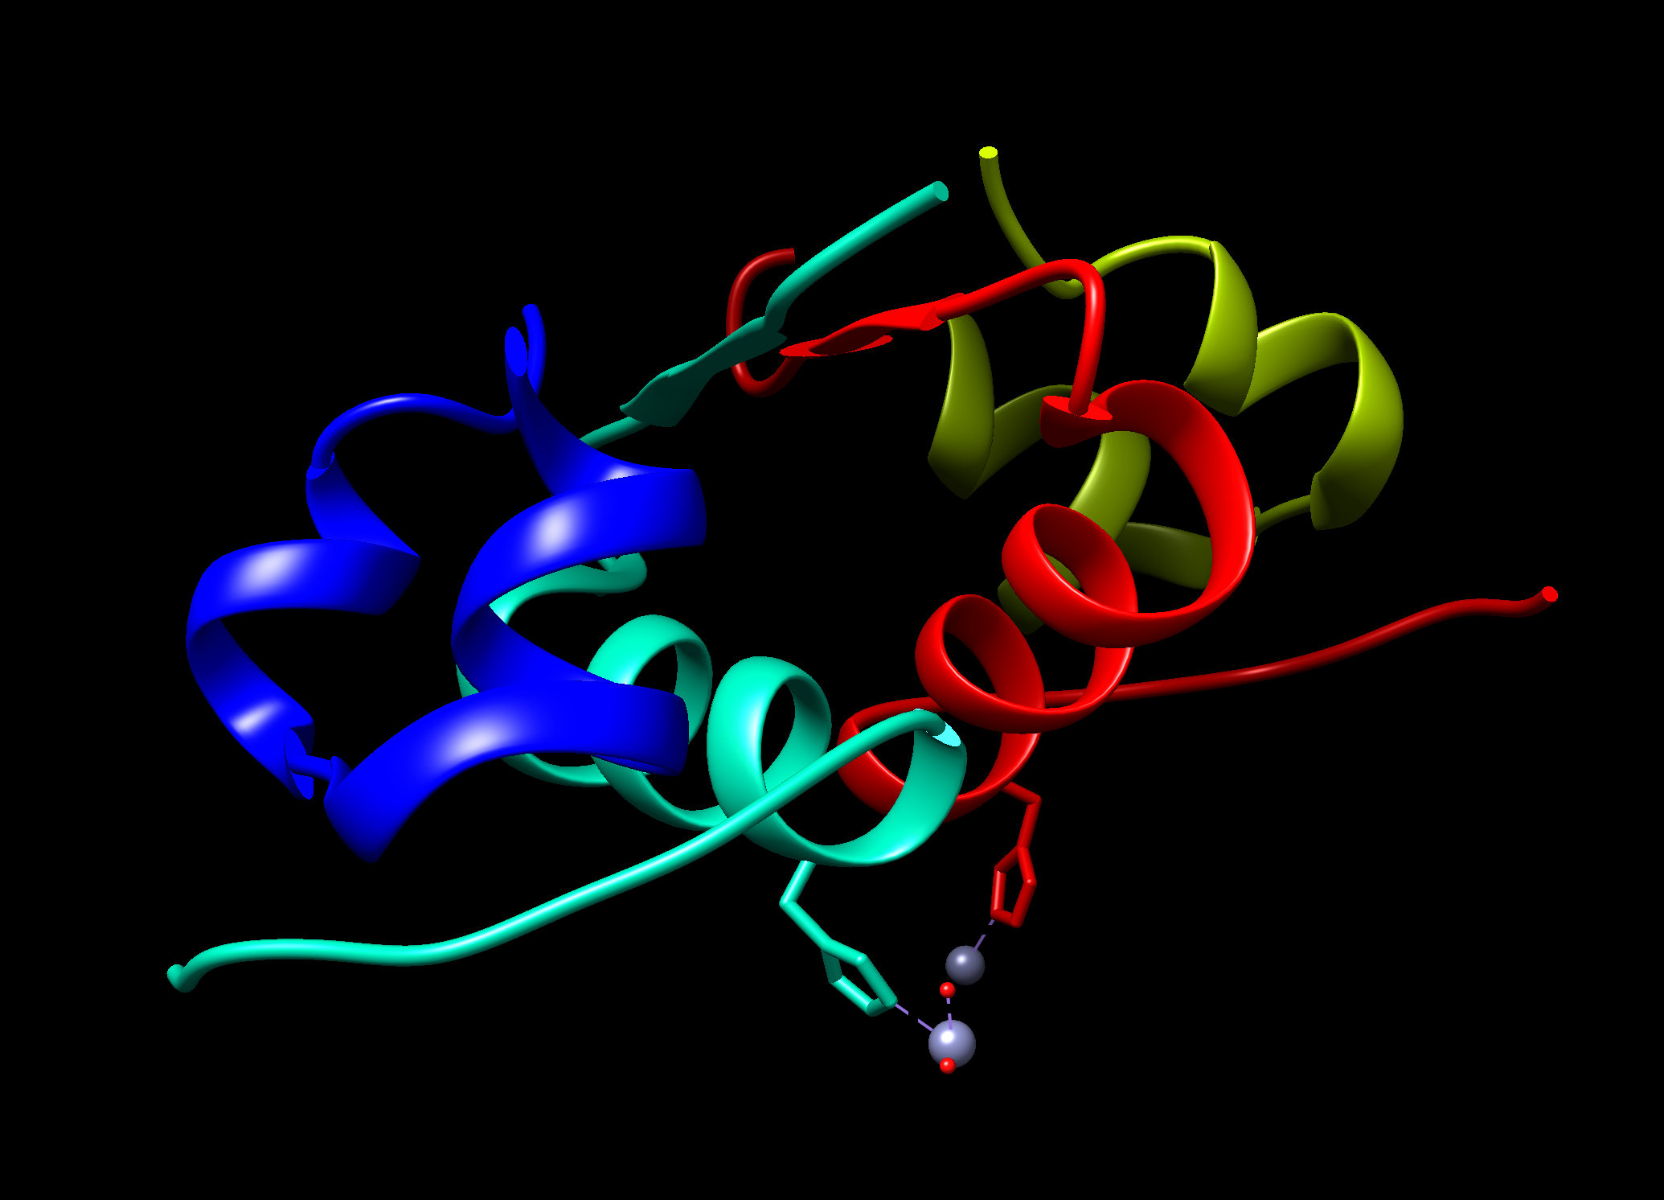
Move the molecule in the display to see the structure of this molecule as shown below:
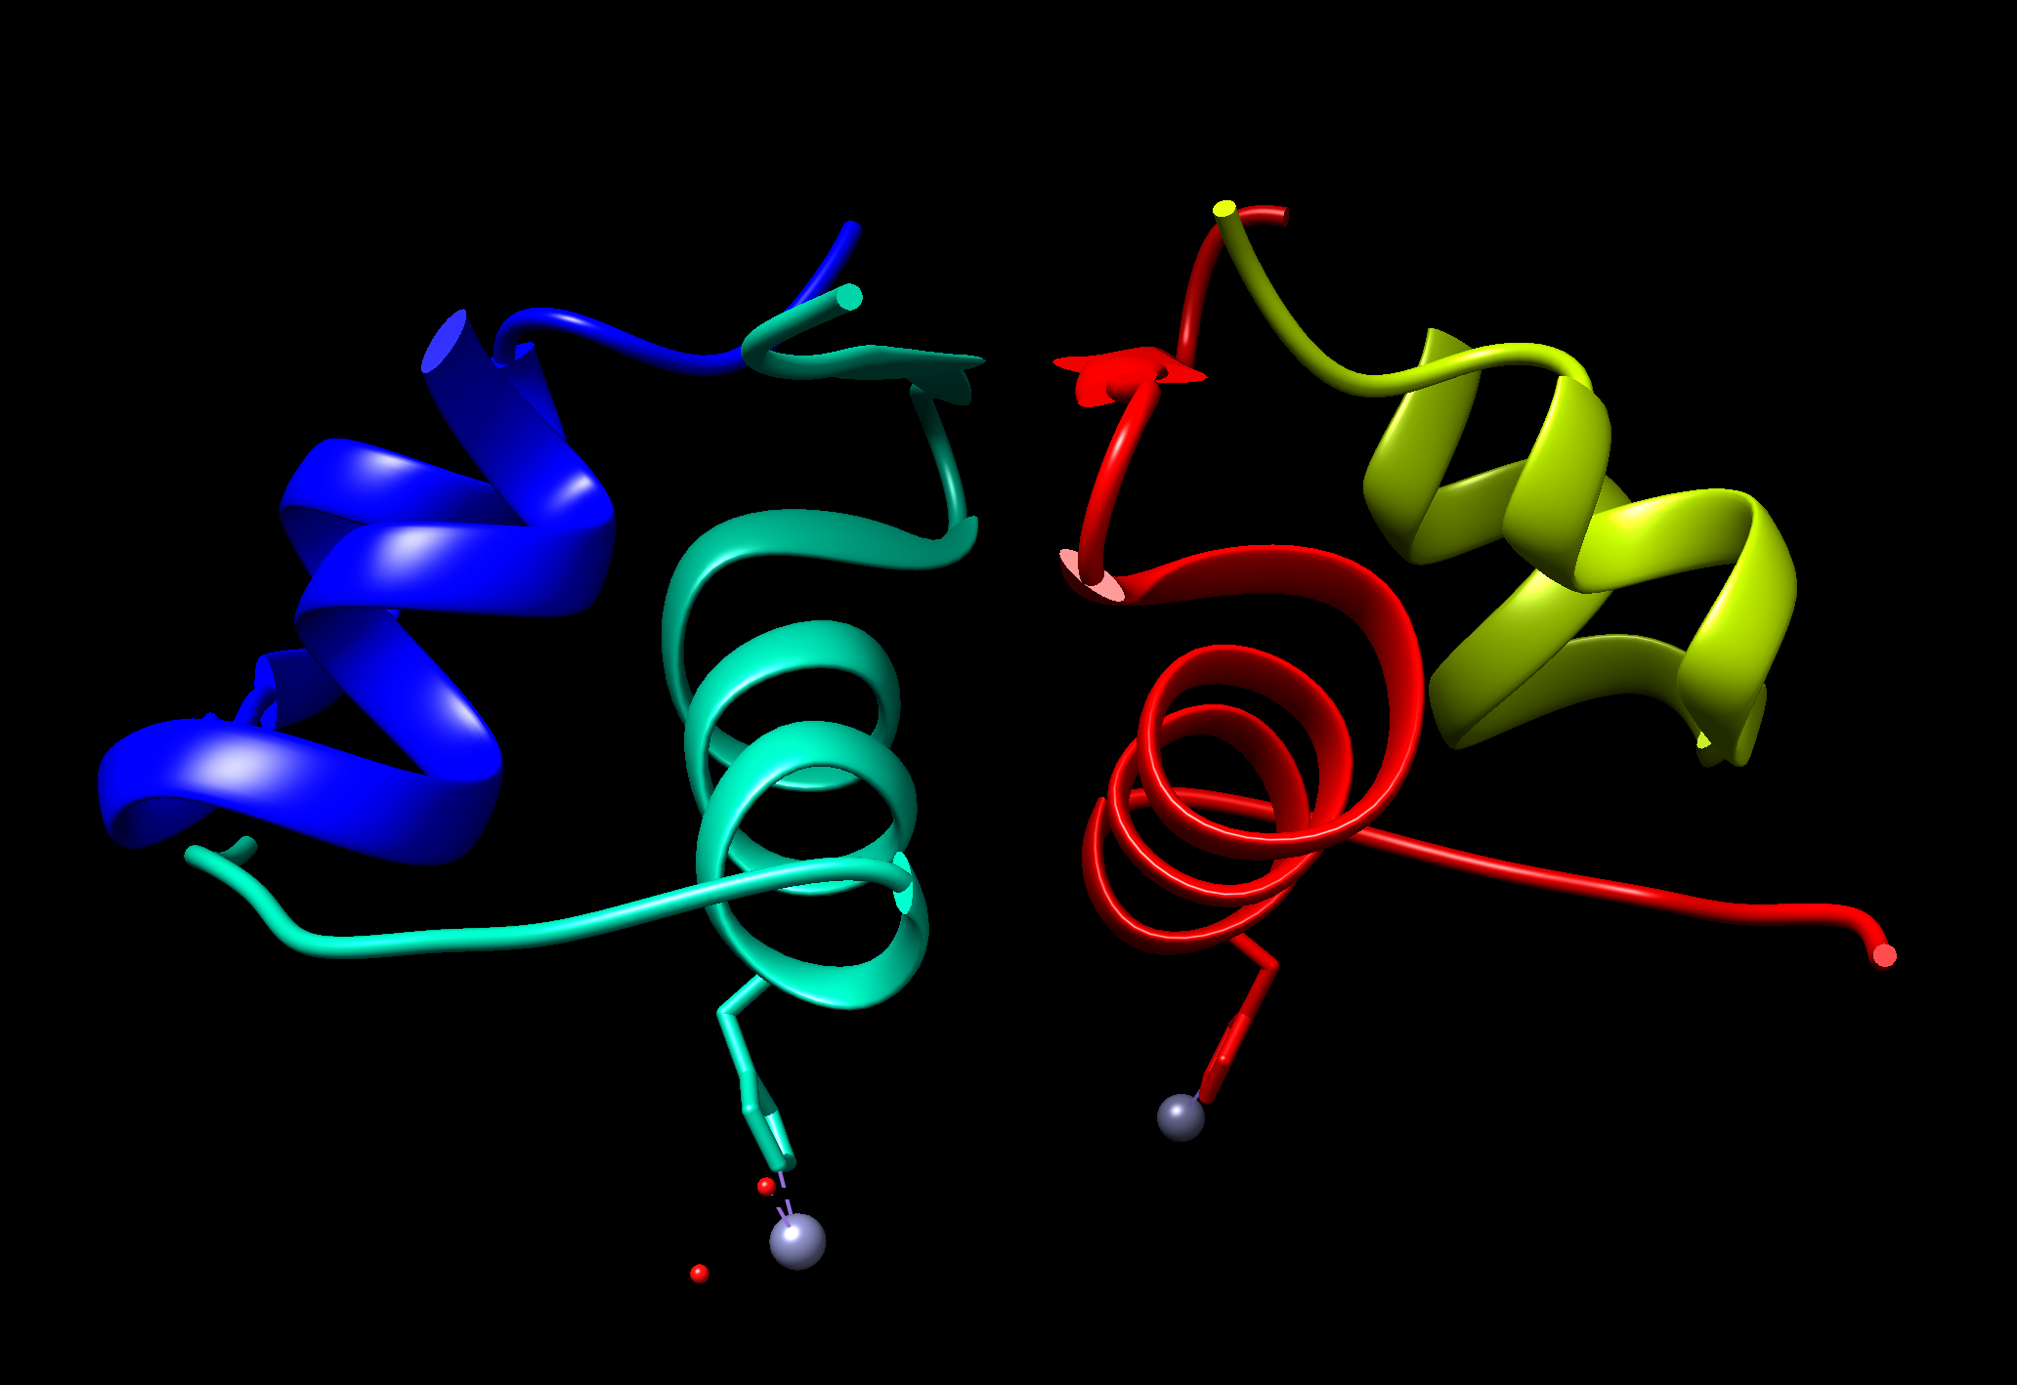

Q2. What do you think the grey spheres shown in the above images are? What is their function? (Hint: Read the title of the PDB entry and the abstract for clues).

Q3. How are these grey atoms interacting with the insulin protein? (Hint: Look at the side chains of amino acids from Insulin interacting with these atoms)

Select the Cys residues in the molecule – Menu Select … Residue … CYS. Display the side chains atoms by Menu Action … Atoms/Bonds … Show.
Q4. Where are these residues located? Can you explain the role that these residues play in the stability of the insulin structure?

Download the coordinates of biological assembly 3 of the PDB entry 4ins.
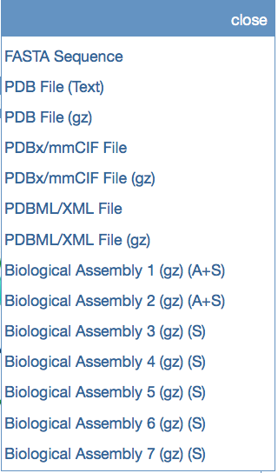
Upload this file (4INS.pdb3) in Chimera Menu File … Open … path to 4INS.pdb3. You should see something like the following:
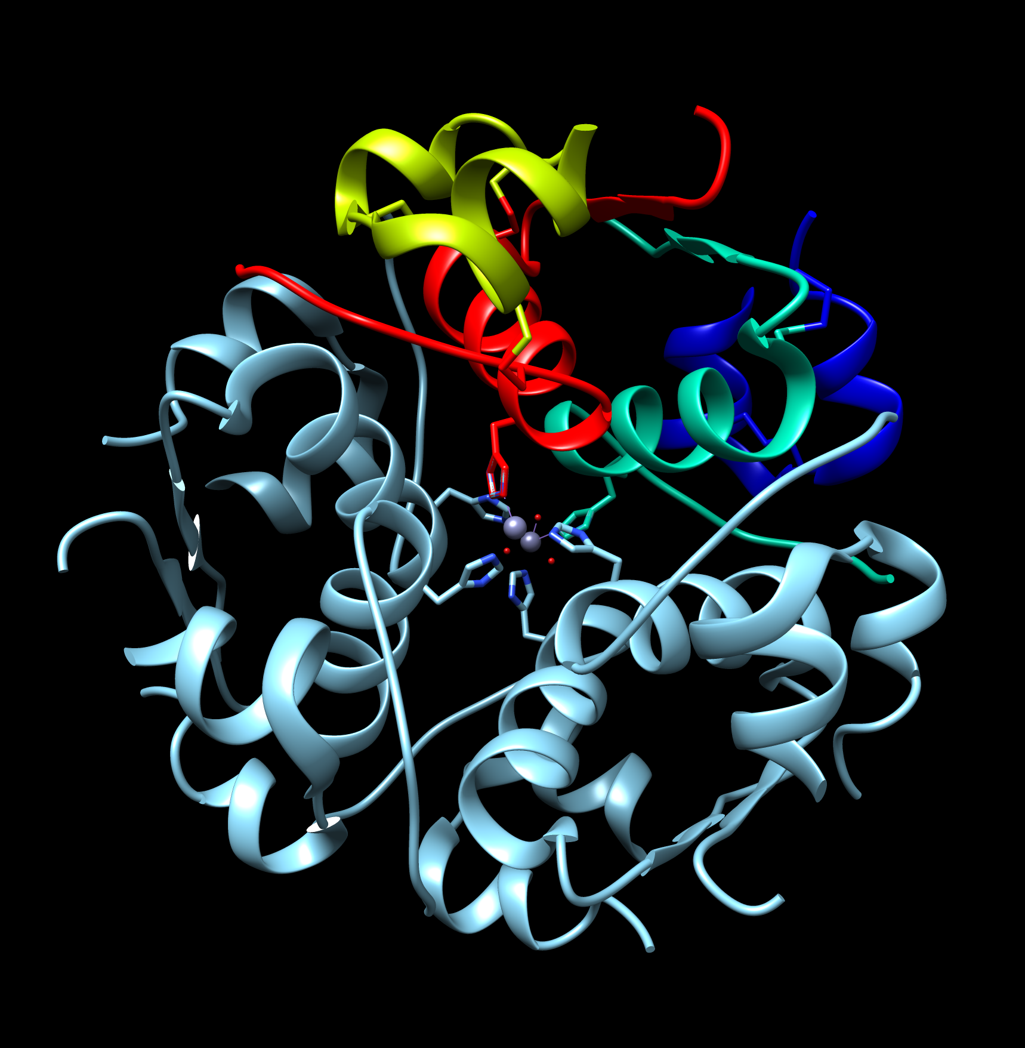
Now hide the multi-colored structure seen above to view the biological assembly image that you downloaded. Menu Favorites … Model Panel … check on the seen option of the molecules seen as below:
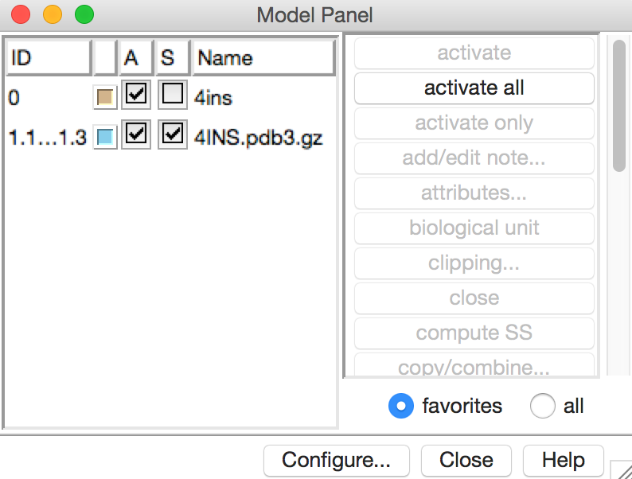
The Biological Assembly appears as follows:
Q5. How many insulin molecules are shown in the biological assembly shown above? What does this structure tell you about a functional assembly of insulin?

Q6. Based on the structure seen here, what do you think the role of Zinc is? (Hint: the active form of insulin is monomeric, composed of a single copy of disulfide linked A and B chains).

To learn more about manipulating, selecting and analyzing the structures loaded in Chimera explore the UCSF Chimera documentation at http://www.cgl.ucsf.edu/chimera/docindex.html.

