Exploring a Protein Structure from the PDB: Major Histocompatibility Complex

Learning Goals:
- Visualize the structure of a given molecule using RCSB PDB resources.
- Explore the structure to understand its structure function relationships

Exercise:
The molecular visualization software, UCSF Chimera, is freely available to academic users from http://www.cgl.ucsf.edu/chimera/. Instructions for downloading/installing the software and documentation for using it are also available from this site.

To save images that you make, select File… Save Image … provide a file name. While you can label atoms and residues in Chimera, it may be easier to import the saved image to a document or powerpoint where you can add labels and include additional text to describe the images.

A. Major Histocompatibility Complex (MHC)
Review the MOM feature on MHC for background information. (http://pdb101.rcsb.org/motm/62)

Launch the Chimera program and load PDB entry 2hla.
Color all chains in the structure in a different color (Preset … Interactive1).
Q1. How many polymer chains are there? What are they?
(Hint: Go to the RCSB PDB website at www.rcsb.org and type in the PDB ID 2hla in the top search box. Read the descriptions/names of the proteins in the molecular descriptions section.)

Select all Cys residues in the structure and show as Atoms/Bonds.
Q2. Where are the Cys residues located? Comment about how they are contributing to the stability of the structure.

Close the session.

B. Peptide bound MHC complex
In a fresh session open the PDB entry 1hhg. Color all chains in the structure in a different color (Preset … Interactive1). Note that there are 2 sets of MHC-I molecules, each complex with a peptide bound to it.

Select the chain C – a peptide from the HIV-1 GP120 protein. Explore the interactions stabilizing this peptide to the MHC-I complex.

To find the atoms/residues neighboring the peptide: Click on the Menu Select… Zone… This should open a new window, select the window options as follows:
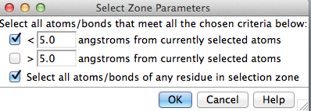
Click on OK to select all residues with atoms within 5 angstroms of the peptide. Display the sidechains of these residues and color the atoms by element. Click on Menu Action … Atoms/Bonds… Show. Then click Menu Actions … Color … all options …
This should open a new menu box with various options for coloring. Select the atoms/bonds radio button and then by element button. This should color the selected atoms by CPK coloring (blue for N, red for O, white for H etc. initially proposed by Robert Corey and Linus Pauling, and improved by Walter Koltun.)).

Explore the residues, whose side chains are shown as sticks in CPK coloring. Using your knowledge about the types of amino acid side chains, visually inspect the amino acid side chains shown here and identify which ones are hydrophobic, polar, charged etc.

To find H-bonds involving a given set of residues: Click on Menu Tools… Structure Analysis… FindHBonds. A new window should open, select options so that it looks as follows:
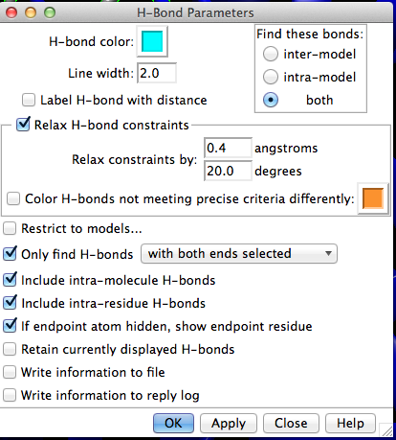

Q3. Based on your explorations above, list 3 types of interactions that are stabilizing the peptide in the MHC I molecule. List the residues involved in these interactions and show these interactions in 2-3 figures.

