Water: Importance in Biology
Authors: Keith Johnson, Bradley University, IL and Shuchismita Dutta, Rutgers University, NJ

Lesson Overview:
This lesson reviews the importance of water in biomolecular structure and function.

ASBMB Learning Objectives
(https://www.asbmb.org/education/core-concept-teaching-strategies/foundational-concepts/structure-function)
Macromolecular structure determines function and regulation
- Students should be able to explain and apply core concepts of macromolecular structure and function, including the nature of biological macromolecules, their interaction with water, the relationship between structure and function, and frequently encountered mechanisms for regulating their function.
__________________________________

This document introduces the chemical structure of water and some key functions it plays in biology. The nature and significance of interactions in water molecules, between water molecules and ions, proteins, and concepts such as pH and osmosis are discussed here. The transport of water molecules across membranes via aquaporin is also discussed.

Chemical makeup and bonding
- Water (or hydrogen oxide; H₂O) is an important molecule in biology. Look up the structure of this molecule as represented as HOH in the Chemical Component Dictionary (Figure 1).
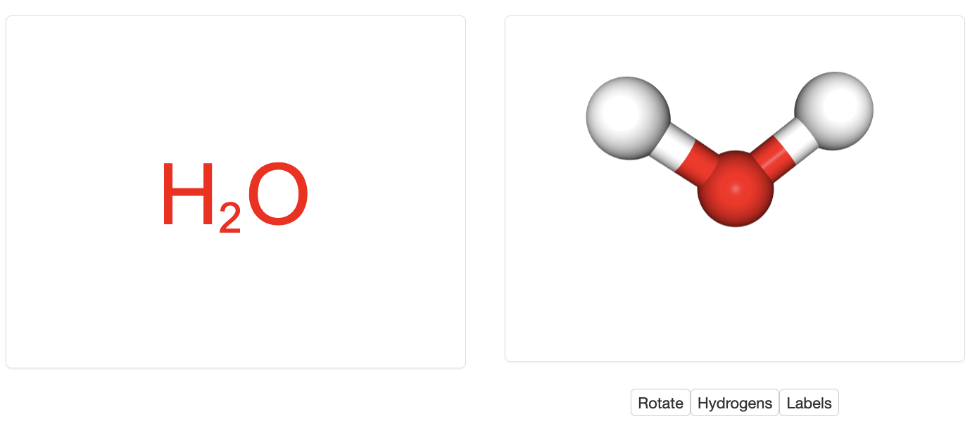
Figure 1: Chemical formula and 3D structure of a water molecule as seen on the ligand summary page for HOH.
Note: When you open the Ligand Summary page for HOH you will see that the interactive view only displays one red sphere (the oxygen atom of the water molecule). Click on the Hydrogens button below the image showing the red dot to view the hydrogen atoms covalently bound to the Oxygen atom in water.

- This simple, 3-atom water molecule is essential for life on Earth. Did you know that the search for water on other planets is the emphasis for astrobiology (i.e., the search for life on other planets)?
- The properties of water molecules have allowed life (as we understand it) to evolve.
  - It is important in chemical reactions,
  - It is a critical part of macromolecular structure.

Intramolecular bonds
- A molecule of water is composed of two hydrogen (H) atoms and one oxygen (O) atom.
- The O atom forms covalent bonds with each of the H atoms.
- There is uneven sharing of electrons (between H and O) - the O atom is more electronegative than the H atom, so the electrons spend more time around the O. This contributes to a polar covalent bond.
- The O therefore has a partial negative charge (delta -) and the H atoms have a partial positive charge (delta +) (Figure 1).
- A 3-D model of a water molecule can be viewed at The Water Molecule in 3D or on the ligand summary page for water.

Intermolecular bonds
The partial charges of the atoms in a molecule of water contribute significantly to the properties of water.
- The polar covalent bonds of the water molecule contribute to the formation of non-covalent bonds called hydrogen bonds (Figure 2).
- These bonds exist between H atoms of a molecule and (in biology) O and N atoms in the same or different molecules. Learn more about hydrogen bonds (video).

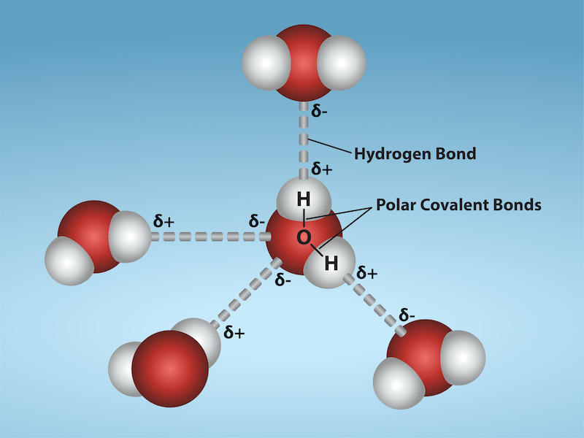
Figure 2: The polar covalent bonds with partial charges (d+ and d-) on water molecules and the hydrogen bonds that form between the water molecules. (Figure taken from Figure 2.13 from OpenStax Biology 2e.)

Properties
The bonds and interactions of water molecules provide them with some unique properties that play critical roles in biology. While ionization of water molecules form the foundation for the concept of pH, intermolecular interactions between water molecules contribute water’s ability to dissolve many molecules (cohesion), flow through channels (adhesion), and its different phases (liquid water and ice). These properties and their implications in biological functions are described here.

Ionization of water and pH
Atoms of the water molecules can ionize or dissociate to create H+ (protons) and hydroxide ions (OH-). The protons, or more specifically the protons interacting with another water molecule to create a hydronium ion (H₃O⁺) has a positive charge while the hydroxides have a negative charge. In pure water, the dissociation is in equilibrium with 1x10⁻⁷ M H+ (or H3O⁺) and 1x10⁻⁷ M OH-. This equilibrium is a dynamic process, with dissociation and reassociation continually occurring.
The pH (potential of hydrogen) is a measure of the free H+ ion concentration in a solution. The pH value is calculated as the -log([H+]), or the negative log of the H+ (proton) concentration. Using this equation, pure water in equilibrium should have a pH of 7 (-log[10-7 M]). pH of other solutions can be calculated based on the free H+ concentration within the solution (Figure 3).

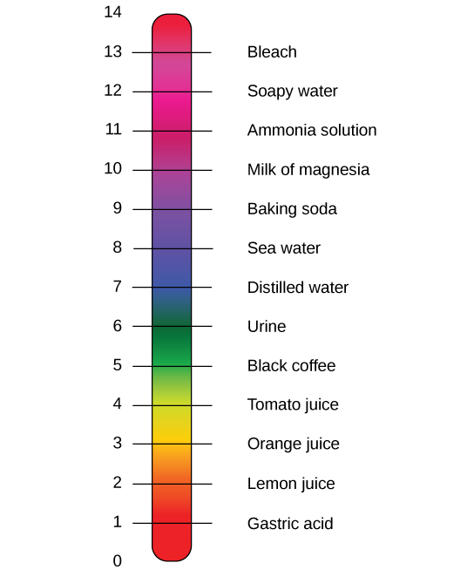 | Figure 3. pH range of various solutions. (Image from the video https://m.youtube.com/watch?time_continue=42&v=u837KYKyr9c&feature=emb_logo.)

Additional information on pH can be found in OpenStax Chemistry: Atoms First (https://openstax.org/books/chemistry-atoms-first-2e/pages/14-2-ph-and-poh?query=Ph%20water&target=%7B%22index%22%3A0%2C%22type%22%3A%22search%22%7D#fs-idm103103632.)

Phases of water
Atoms within the water molecule form hydrogen bonds with atoms within other water molecules (intramolecular hydrogen bonds). In liquid water, the hydrogen bonds between the water molecules are forming and breaking - the water molecules are constantly in motion (kinetic energy). Within increasing temperatures, the water molecules are in increasing motion. At boiling temperatures (100℃; 1 atm), the motion of the water molecules breaks the hydrogen bonds and the water molecules escape into the air as a gas. At freezing temperatures (0℃; 1 atm), the movement of the water molecules decreases, making the hydrogen bonds more stable and water freezes to form ice and form more uniform angles (Figure 3). Additionally and importantly, the distances of the hydrogen bonds are greater in ice, which creates the property that ice is less dense than water, allowing ice to float. The floating property of ice allowed life to form in bodies of water since the ice formed on the surface of the body of water and effectively insulated the water (and life) below. If ice was more dense than water, bodies of water would have frozen from the bottom up and life as we understand may never have formed.
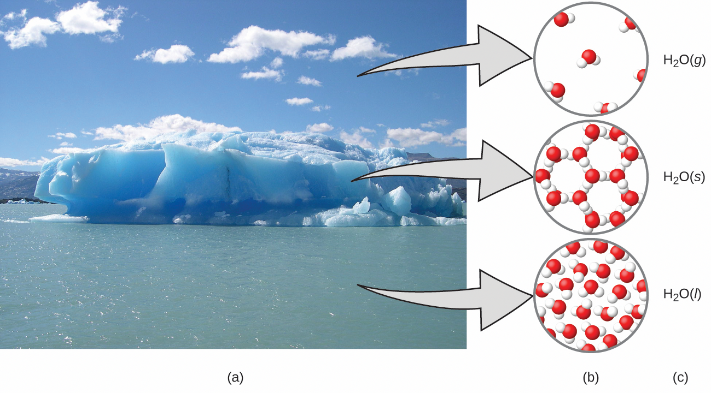
Figure 3. Phases of water showing the spacing of the hydrogen bonds (right side). (Figure 1.15 from OpenStax Biology 2e.)

Table 1. Links for chemical structures of phases of water.
Phase | Links
Ice | https://www.biotopics.co.uk/jsmol/ice.html
Liquid | https://www.biotopics.co.uk/jsmol/waterHbonds.html
Gas | https://www.biotopics.co.uk/jsmol/watermoving.html.

Water as a Solvent
The polar covalent bonds in the water molecule create biologically important properties for water. The partial charges on the O atom (delta -) and H atoms (delta +) contribute to the excellent solvent properties of water. Salts and other molecules stabilized by ionic interactions between the atoms are soluble in water due to the interactions between the partial charges in the atoms of the water molecule and the ions (Figure 4).

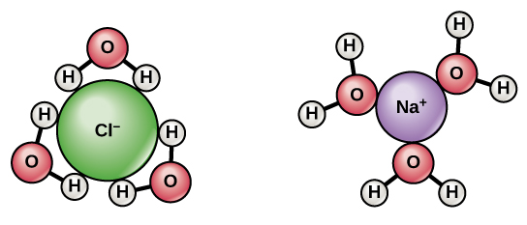
Figure 4. Solubility of salt (NaCl) in water due to interactions between the ions and the partial charges on the atoms of the water molecule. (Image from OpenStax Biology 2e - Figure 2.15).

Water binding to macromolecules
The ability of water to form hydrogen bonds also plays a role in its ability to dissolve molecules with polar groups such as polar amino acids, nucleic acids (see Figure 5 for an example), and sugars. While non-polar groups including lipids do not dissolve in water and form cage-like or clathrate structures of waters around it.

Water stabilizes the helical structure of DNA creating the image that was first characterized by Rosalind Franklin (1953). The level of hydration (interactions with water) varies in different forms of DNA (Figure 5). Note that most crystal structures do not show locations of hydrogen atoms so water molecules are represented by the oxygen atoms (shown as red spheres).

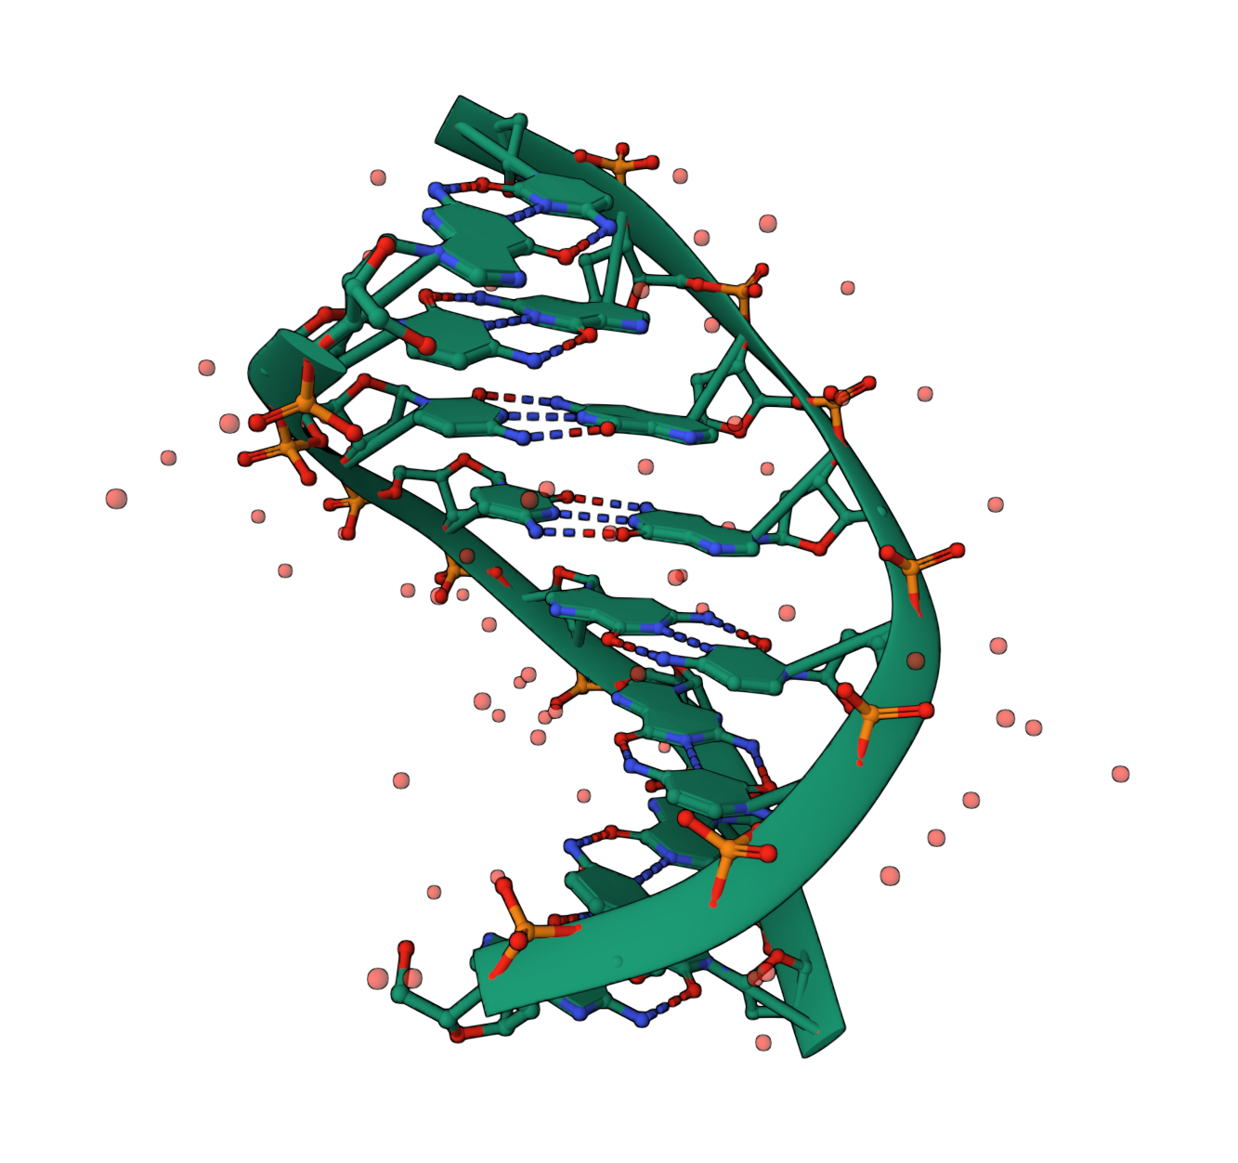 | 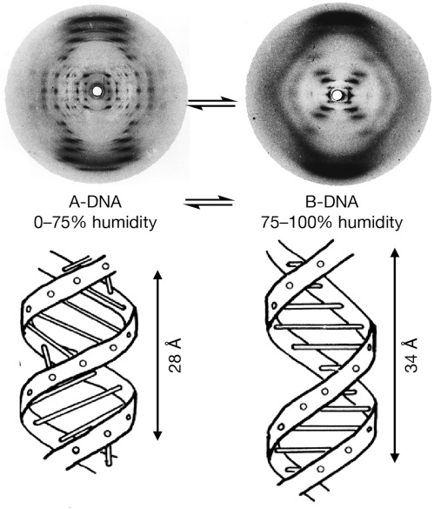
Figure 5. a) Water molecules (red spheres) bound to helical DNA molecule’s phosphodiester backbone and in the major groove (PDB ID 9bna, Heineman et al., 1987). b) Photo 51 taken by Rosalind Franklin (from https://www.sciencedirect.com/science/article/pii/S2451929421001005)

Cohesion and Adhesion
The polar covalent bonds of the water molecule contribute to the cohesive and adhesive properties of water.
Cohesion is the attraction of a water molecule to other water molecules. This involves the hydrogen bonds between the water molecules (Figure 6). Cohesion contributes to surface tension in water and also to transpiration, which allows water to travel through plant vasculature from the roots into the leaves (Figure 7).
Adhesion is the attraction (hydrogen bond) between a water molecule and another molecule (not a water molecule). This property of water also contributes to transpiration.
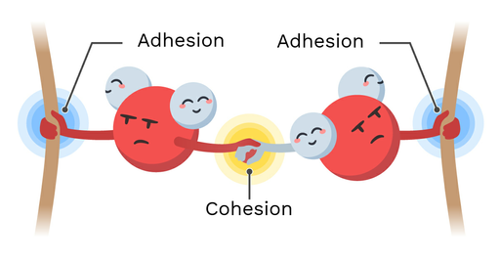
Figure 6. Cohesion and adhesion of water molecules. (Image taken from https://theory.labster.com/adhesion-cohesion/).

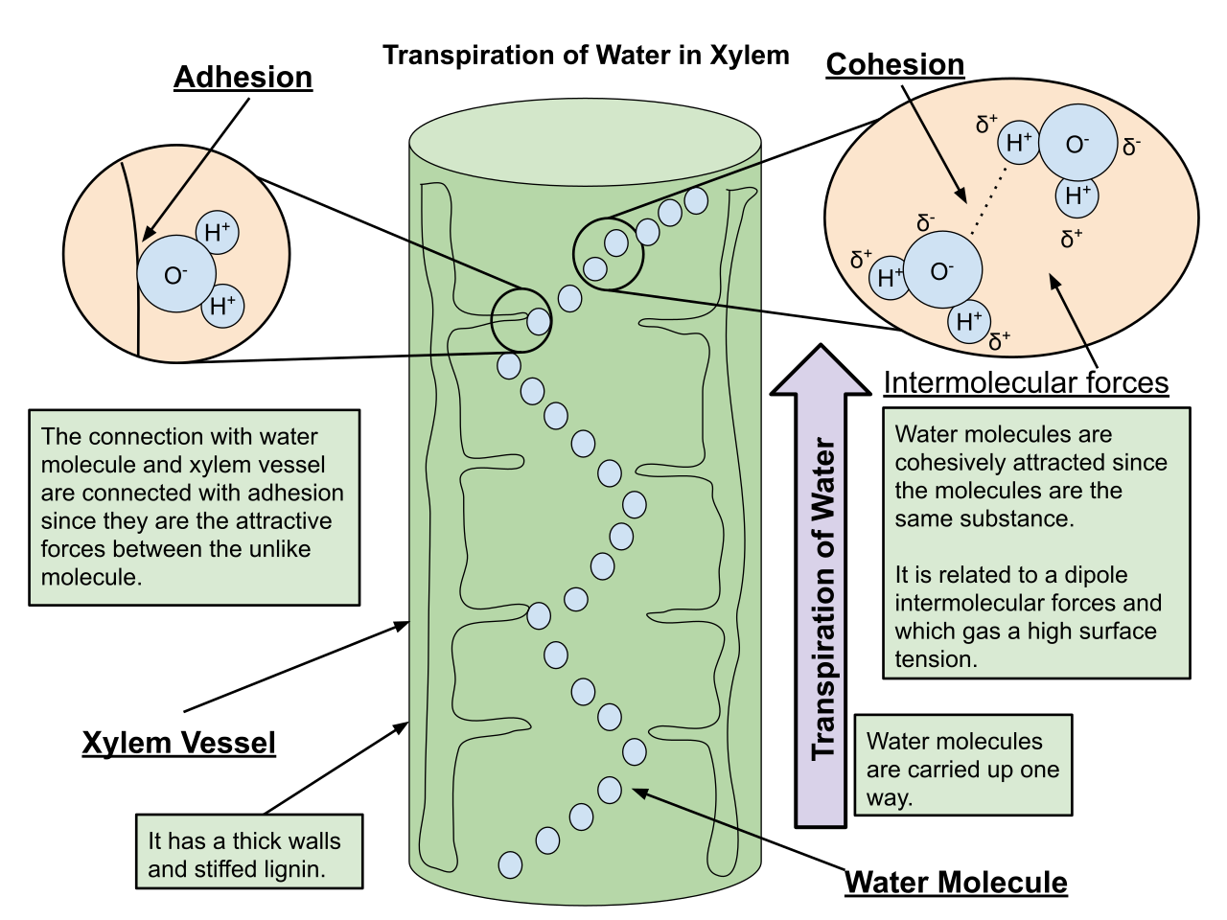
Figure 7. Cohesion and adhesion play a role in plant transpiration. (Image from https://commons.wikimedia.org/wiki/File:Transpiration_of_Water_in_Xylem.svg.)

Water molecules are also an important part of the structure of many macromolecules. They stabilize by interacting with polar and/or charged groups exposed on the surface of these macromolecules and prevent them from aggregating or precipitating out of solution.

A majority of crystal structures present in the PDB include water molecules. Commonly these waters may be hidden and ignored in structure explorations. However, in a few cases specific water molecules may play critical structural and functional roles. For example in the structure of the Aspartic protease Pepsin, a water molecule interacts with both the active site Asp residues and plays a key role in the enzyme function (Figure 8a). An inhibitor bound structure of the enzyme shows that the water in between the active site Asp residues is occupied by an inhibitor atom (Figure 8b).

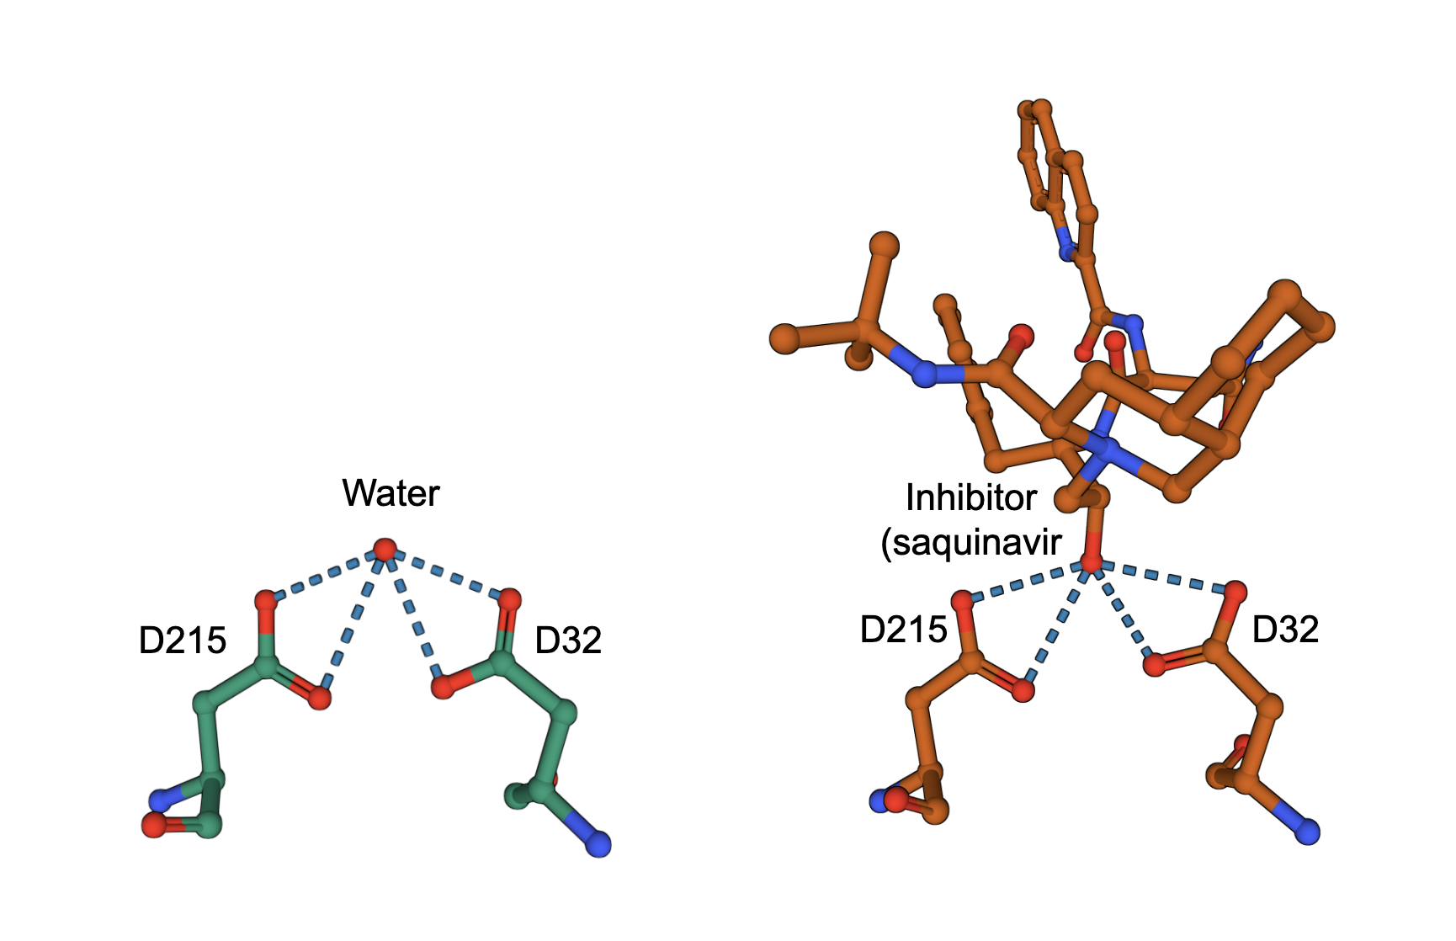
Figure 8a: Active site Asp bound to water molecule (PDB ID 5pep, Cooper et al., DOI: 10.1016/0022-2836(90)90156-G) | Figure 8b: Active site Asp bound to inhibitor Saquinavir, (PDB ID 6xct, Vuksanovic, N., Silvaggi, N.R.)

Functions

Osmosis and water transport
The cell membrane is a selectively permeable barrier, restricting the movement of materials across the membrane. Small molecules, such as CO₂, and sterols may easily pass through a phospholipid bilayer due to their nonpolar properties, but the polar water molecule does not pass readily through many membranes. The movement of molecules such as CO₂ and cholesterol across a membrane involves diffusion, the molecule moving from an area of higher concentration to an area of lower concentration.
In some cells, water may be able to be moved across a membrane. The diffusion of water is called osmosis, and moves water from an area of high concentration of water to an area of low concentration (down the water concentration gradient). More commonly, water molecules cross a membrane with the help of a protein - this process is called facilitated transport or facilitated diffusion. Water may move through specialized water channels called aquaporins or may move as part of the movement of ions or small molecules.
Osmosis involves the movement of water molecules down their concentration gradient (from an area of high water concentration to an area of low water concentration). It is important to remember that typically, when scientists discuss concentrations of solutions, the concentration refers to the solute, not the solvent. A 5 M NaCl solution has a higher concentration of salt than a 1 M NaCl solution, but the first solution has a lower water concentration than the second (1 M) solution.
Tonicity refers to the pairwise comparison of two solutions. Most simply, an isotonic solution has the similar concentrations in both solutions (prefix iso- means same). Solutions with a higher concentration are considered to be hypertonic (prefix hyper- mean above) to solutions with a lower concentration being hypotonic (prefix hypo- means below). In the previous example, the 5 M NaCl solution is hypertonic to the 1 M NaCl solution - the 1 M NaCl solution is hypotonic.
In erythrocytes (red blood cells), water movement across the plasma membrane involves aquaporins (water channels - more below). If a red blood cell is placed in an isotonic solution, there is movement of water molecules across the membrane, but there is no net movement. If an erythrocyte is placed in an hypertonic solution (solution with a higher salt concentration than the red blood cells). Water movement (osmosis) moves water from the hypotonic erythrocyte into the solution. The erythrocytes lose water (crenate) and shrink (Figure 10). An erythrocyte placed in a hypotonic solution (such as water) would lead to water moving into the erythrocyte leading to swelling and lysis of the erythrocyte (Figure 10).

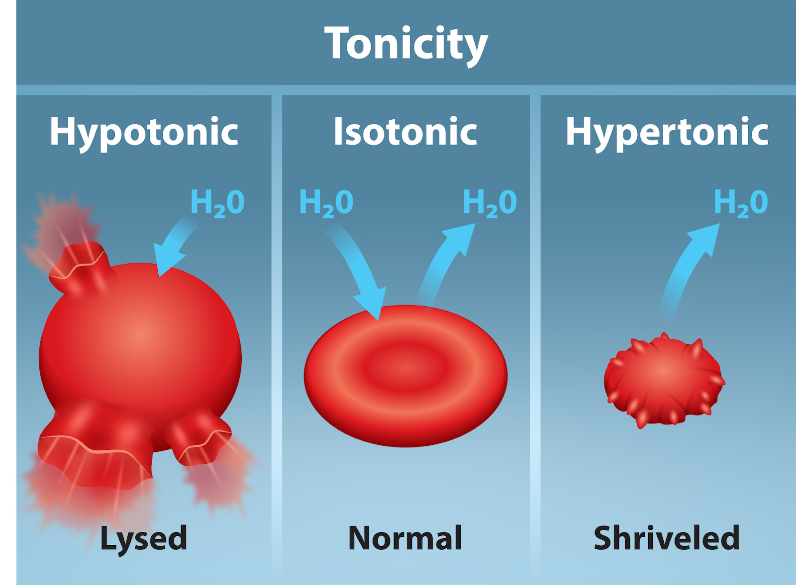
Figure 10. Erythrocytes in different solutions. https://openstax.org/books/biology-2e/pages/5-2-passive-transport?query=Osmosis&target=%7B%22index%22%3A0%2C%22type%22%3A%22search%22%7D#fs-id1538230

Aquaporins
Aquaporins, first identified in 1992, are water channels. In humans, aquaporins make up a gene family with at least ten different genes encoding aquaporins. These genes are expressed in different cell types - aquaporin 1 is expressed in erythrocytes or red blood cells. The proteins provide a facilitated channel for water movement across the cell membrane. In the case of erythrocytes, aquaporin 1 allows for osmosis, or the movement of water, down the water concentration gradient.

Learn more about Aquaporins and explore their structure and function.

